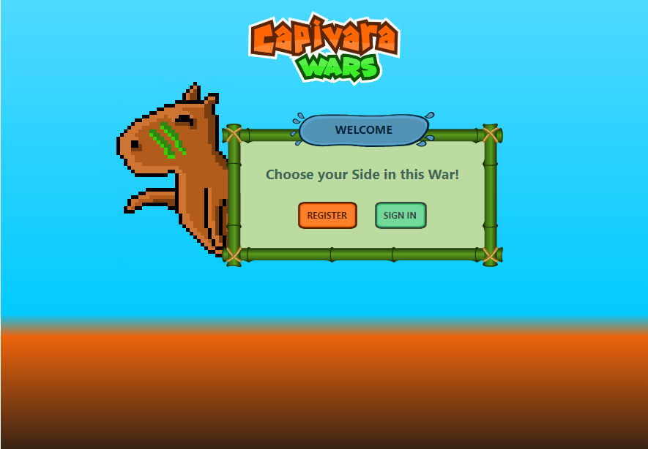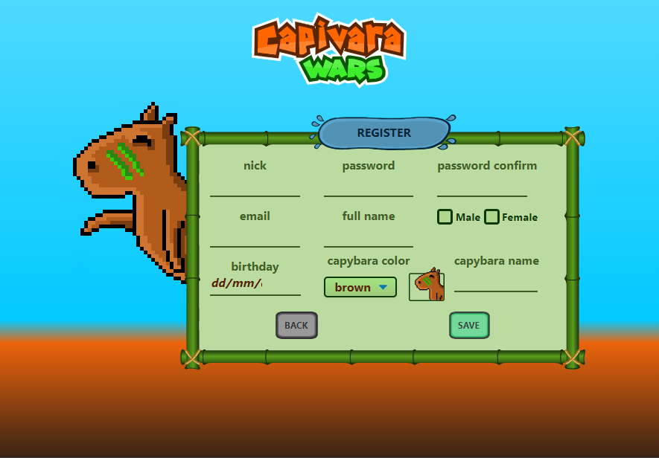

TELA 02: REGISTRY

TELA 01: START

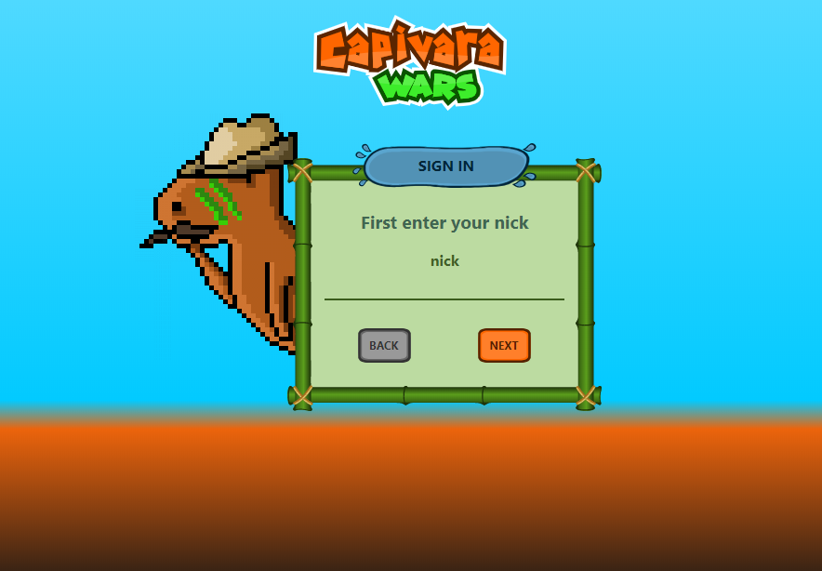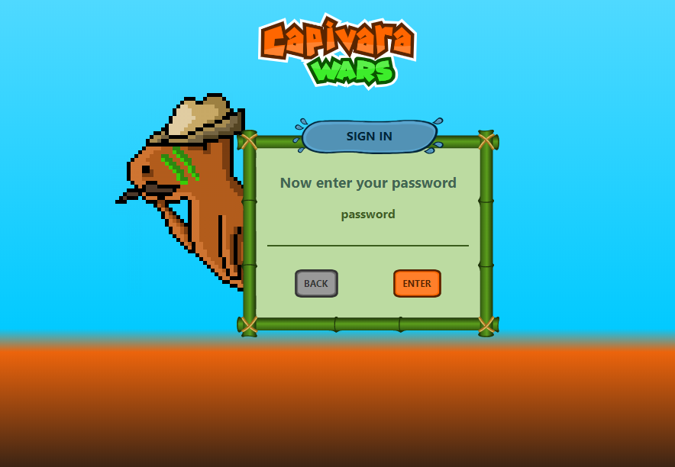

TELA 03: LOGIN -> USER

TELA 04: LOGIN -> PASSWORD

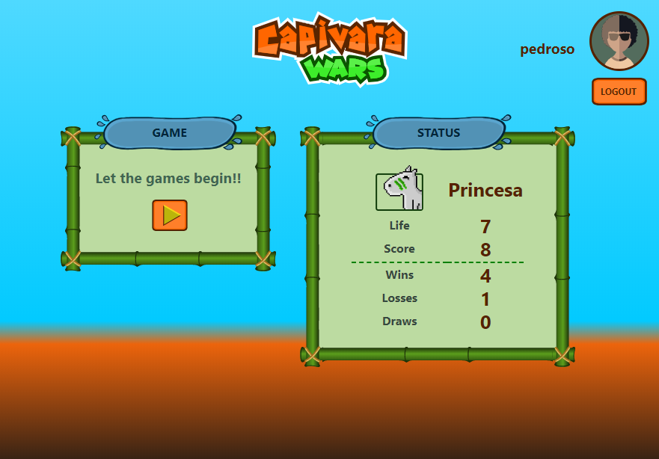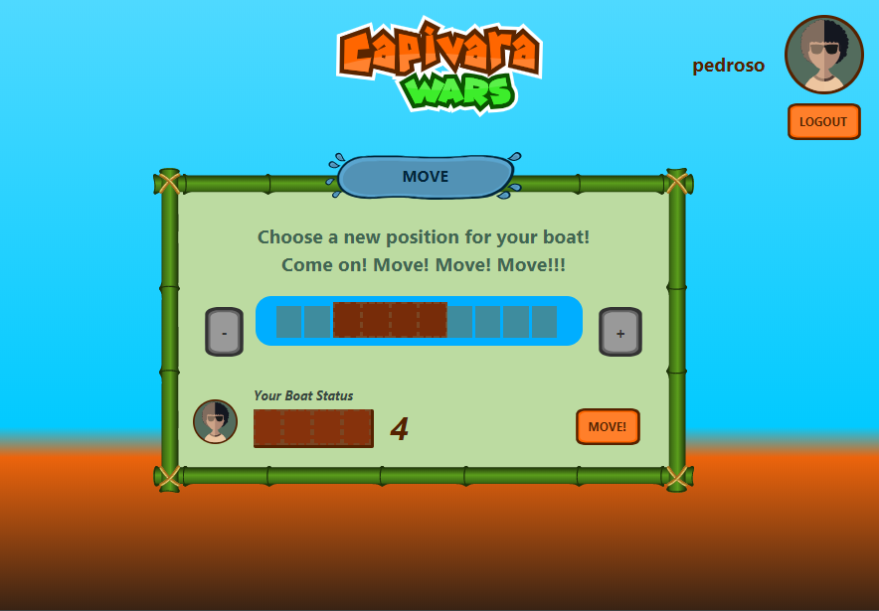

TELA 05: HOME

TELA 06: GAME -> MOVE

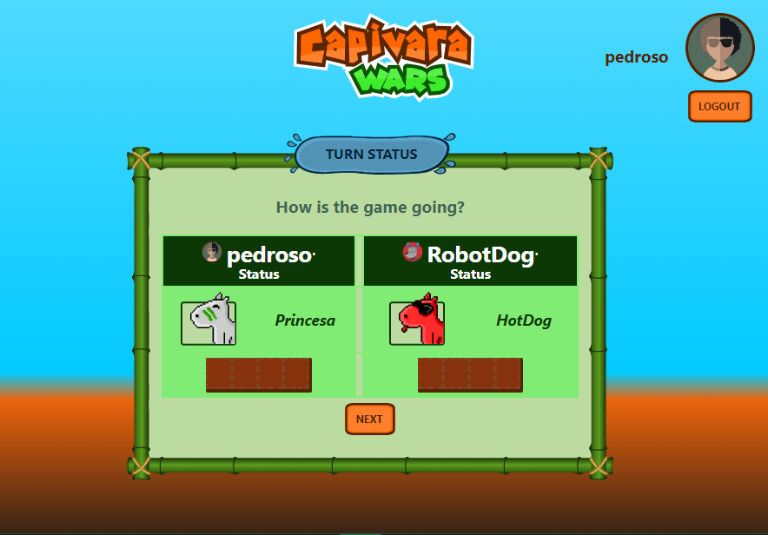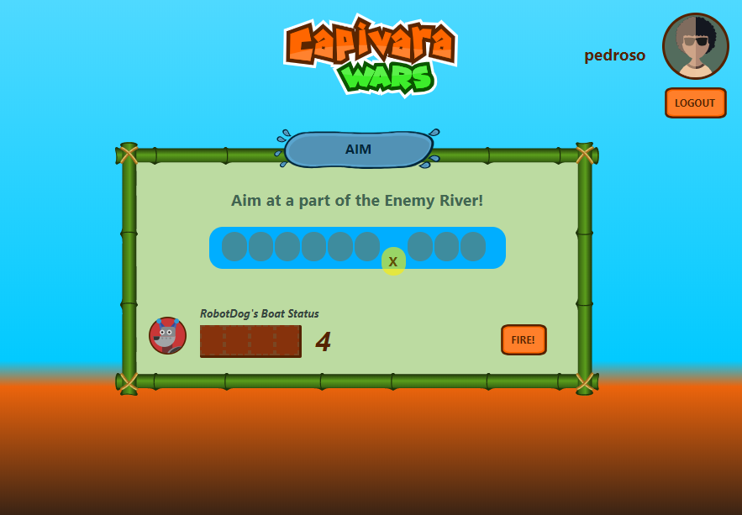

TELA 08: GAME -> TURN STATUS

TELA 07: GAME -> SHOOT



TELA 09: GAME -> RESULT