|  |  |  |  |  |  |
| --- | --- | --- | --- | --- | --- |
|  | INTERNATIONAL TELECOMMUNICATION UNION  **TELECOMMUNICATION STANDARDIZATION SECTOR**  STUDY PERIOD 2025-2028 | | SG21-C096 | | |
| STUDY GROUP 21 | | |
| Original: English | | |
| **Question(s):** | | 9/21 | | Geneva, 13-24 January 2025 | |
| **CONTRIBUTION** | | | | | |
| **Source:** | | China Telecommunications Corporation | | | |
| **Title:** | | F.CAR-reqs on “Requirements and framework of cloud-based augmented reality systems”: Proposal text for consent | | | |
| **Contact:** | | XiaoJun Liu China Telecom China | | | Tel: +86-18902274773 E-mail: liuxiaoj6@chinatelecom.cn |
| **Contact:** | | Liuyihui QIAN China Telecommunications Corporation China | | | Tel: +86 13352812050 E-mail: [qianlyh@chinatelecom.cn](mailto:qianlyh@chinatelecom.cn) |

|  |  |
| --- | --- |
| **Abstract:** | This contribution proposes to consent the recommendation F.CAR-reqs “Requirements and framework of cloud-based augmented reality systems”. |

**1 Introduction**

On the last SG16 Q21 E-Meeting, 2024-08-20/22, reviewed and accepted the contribution to progress this ongoing work item. This contribution proposes to consent the recommendation F.CAR-reqs.

All the changes are based on the output of Q21/16-DOC18-R1 (240820), at the SG16 Q21 meeting, E-Meeting, 2024-08-20/22.

**2 Proposal**

This contribution is proposed to consent the recommendation F.CAR-reqs.

**CONTENTS**

| **Page** |
| --- |
| 1. Scope 4  2. References 4  3. Definitions 5  3.1 Terms defined elsewhere 5  3.2 Terms defined in this Recommendation 5  4. Abbreviations and acronyms 5  5. Conventions 6  6. Overview 6  6.1 The characteristics of cloud-based AR systems 6  6.2 Two modes of cloud-based AR systems 7  6.2.1 The cloud-based AR with the integration of cloud and terminal capabilities 7  6.2.2 The cloud-based AR relying on cloud processing capabilities 8  7. Framework of cloud-based augmented reality systems 8  8. Requirements of cloud-based augmented reality systems 10  8.1 General requirements 10  8.1.1 Virtual scene quality requirements 10  8.1.2 Interaction requirements 10  8.1.3 Compatibility requirements 10  8.1.4 Stability requirements 11  8.2 Content layer’s requirements 11  8.3 Control layer 11  8.3.1 Cloud-based AR capability scheduling 11  8.3.2 Cloud-based AR capability interaction 12  8.3.3 Cloud-based AR capability distribution 14  8.4 Resource layer 14  8.4.1 Computational resources 14  8.4.2 Running environment 14  8.4.3 Resources collaboration 14  8.5 Terminal layer 15  8.5.1 Hardware 15  8.5.2 Software 15  8.6 Network layer 16  8.7 Operation, administration and management 16  8.8 Security 17  Appendix I 18  I.1 Cloud-based AR medical assistance 18  I.2 Cloud-based AR navigation 19  I.3 Cloud-based AR industrial maintenance 20  Bibliography 22 |

**List of Tables**

| **Page** |
| --- |
| **No table of figures entries found.** |

**List of Figures**

| **Page** |
| --- |
| Figure 7-1 –Framework for cloud-based AR systems 9  Figure I-1 –Cloud-based AR medical assistance process 18  Figure I-2 –Cloud-based AR navigation process 19  Figure I-3 –Cloud-based AR industrial maintenance process 20 |

**Draft new Recommendation ITU-T F.CAR-reqs**

**Requirements and framework of cloud-based augmented reality systems**

**Summary**

Based on the cloud computing capabilities and massive data collaborative processing, the cloud-based augmented reality systems can effectively support large-scale physical scene recognition and digital processing, provide more flexible virtual scene integration, and support multi-person interactive scenarios. This Recommendation doesn't change the cloud computing’s functions, presents basic concept of cloud-based augmented reality, specifies requirements and framework of cloud-based augmented reality systems.

**Keywords**

cloud-based augmented reality systems, augmented reality, requirements, framework

1. **Scope**

This Recommendation specifies requirements and framework of cloud-based augmented reality systems. The scope of this Recommendation includes:

* Overview
* Framework of cloud-based augmented reality systems
* Requirements of cloud-based augmented reality systems

1. **References**

The following ITU-T Recommendations and other references contain provisions which, through reference in this text, constitute provisions of this Recommendation. At the time of publication, the editions indicated were valid. All Recommendations and other references are subject to revision; users of this Recommendation are therefore encouraged to investigate the possibility of applying the most recent edition of the Recommendations and other references listed below. A list of the currently valid ITU-T Recommendations is regularly published. The reference to a document within this Recommendation does not give it, as a stand-alone document, the status of a Recommendation.

[ITU-T J.301] Recommendation ITU-T J.301 (10/2014) *Requirements for augmented reality smart television systems.*

[ITU-T F.740.2] Recommendation ITU-T F.740.2 (07/2022) *Requirements and reference framework for digital representation of cultural relics and artworks using augmented reality.*

[ITU-T J.302] Recommendation ITU-T J.302 (10/2016) *System specifications of augmented reality smart television service.*

[ITU-T G.1036] Recommendation ITU-T G.1036 (07/2022) *Quality of experience influencing factors for augmented reality services.*

1. **Definitions**

**3.1 Terms defined elsewhere**

This Recommendation uses the following terms defined elsewhere:

**3.1.1 augmented reality [ITU-T J.301]:** A type of mixed reality where graphical elements are integrated into the real world in order to enhance user experience and enrich information.

**3.1.2 augmented content [ITU-T J.301]:** A binary object, such as 2D images, 3D animated models or audio/video streaming files, to be augmented into a predefined augmentation region.

**3.1.3 application** [**b-ITU-T Y.101**]: A structured set of capabilities, which provide value-added functionality supported by one or more services.

**3.2 Terms defined in this Recommendation**

This Recommendation defines the following terms:

1. **Abbreviations and acronyms**

This Recommendation uses the following abbreviations and acronyms:

|  |  |
| --- | --- |
| 2D | Two Dimensions |
| 3D  AI | Three Dimensions  Artificial Intelligence |
| APP  AR | Application  Augmented Reality |
| AVI | Audio Video Interleaved |
| CDN | Content Delivery Network |
| CPU | Central Processing Unit |
| DoF | Degree of Freedom |
| FOV | Field of View |
| GPU | Graphic Processing Unit |
| NIC | Network Interface Card |
| OA&M  RDRSC&VPVRFOT  SDK  SLAM  VDRDC&VRFOT  WDM | Operation, Administration and Management  Real-scene Digital Results Sharing by Cloud and Virtual-scene Processing/ Virtual-Real Fusion Output by Terminal  Software Development Kit  Simultaneous Localization and Mapping  Virtual-scene Digital Result Delivery by Cloud and Virtual-Real Fusion Output by Terminal  Wavelength Division Multiplexing |

1. **Conventions**

In this Recommendation:

* The keywords "**is required**" indicate a requirement which must be strictly followed and from which no deviation is permitted if conformance to this Recommendation is to be claimed.
* The keywords "**is recommended**" indicate a requirement which is recommended but which is not absolutely required. Thus this requirement needs not be present to claim conformance.
* The keywords "**can optionally**" indicate an optional requirement which is permissible, without implying any sense of being recommended. These terms are not intended to imply that the vendor's implementation must provide the option and the feature can be optionally enabled by the network operator/service provider. Rather, it means the vendor may optionally provide the feature and still claim conformance with the specification.

1. **Overview**

Cloud-based AR, based on the super computing power of the cloud, completes complex real scene understanding, 3D modelling, multi-terminal data sharing, cloud edge collaboration and other processing, builds a continuous combination of point cloud map and real world coordinates, realizes real-time and updated 3D digital world model for real world scanning, and provides the terminal with the ability to index and integrate virtual information.

Cloud-based AR requires the collaborative provision of services based on various systems, collectively referred to as cloud-based AR systems. Cloud-based AR systems require the real-time collection of multi-terminal collaboration, the low latency transmission of network uplink, the capabilities of cloud-edge collaboration, and the integration capabilities of various multimedia processing, the efficient distribution of services/content, and the control and coordination of various capabilities.

**6.1 The characteristics of cloud-based AR systems**

Compared with the AR terminal local operation mode, the cloud-based AR systems have the characteristics of low terminal capacity requirements, multi-person interactive sharing, and integrated AI processing capabilities.

* The low terminal capacity requirements are mainly manifested in the completion of scene understanding, three-dimensional modelling and other processing through the cloud, and the use of multimedia streaming delivery and other modes, which can reduce the processing pressure of the terminal on logic operations and graphics rendering, thereby reducing the intensity of terminal operations and extending the battery life of terminals.
* The multi-person interactive sharing is mainly manifested in the digital processing of super-large scenes and multi-person data sharing. For the processing of ultra-large scenarios, based on the cloud-edge collaborative processing mechanism, the multi-terminal crowdsourcing collection mode is adopted to obtain a wide range of map information, and realize the digital processing of ultra-large outdoor scenes through intelligent understanding, resource aggregation, and repositioning in the cloud. For multi-person data sharing, based on the cloud-unified large-scale real-world digital processing results and super virtual world construction capabilities, it provides high-end AR multi-person interactive services for terminals with basic functions such as display.
* The integrated AI processing capabilities, first of all, AI model training needs the super-scale computing power support of cloud response, and accurate recognition of real scenes also needs cloud capabilities. Therefore, the cloud-based AR can effectively integrate AI and other capabilities, and improve the quality of AR user experience.

**6.2 Two modes of cloud-based AR systems**

The cloud-based AR, based on the different tasks undertaken by the cloud and terminal, can be divided into two modes: the cloud-based AR with the integration of cloud and terminal capabilities, and the cloud-based AR relying on cloud processing capabilities.

**6.2.1 The cloud-based AR with the integration of cloud and terminal capabilities**

The cloud-based AR with the integration of cloud and terminal capabilities is based on the AR terminals with certain local rendering processing capabilities or real-scene digital correction capabilities; the cloud of the mode is used to complete the relevant digital processing processes such as real-scene spatial positioning, plane detection, coordinate binding and map construction in advance or real time, form a cloud-based real-scene digital resource library. Subsequently, by reusing the real-scene digital resource library, cloud-based AR services are realized that integrate multi-person cloud and terminal integration.

According to whether the virtual-scene rendering processing is carried out through the cloud, it can be subdivided into: the cloud-based AR mode which based on real-scene digital results sharing by cloud and virtual-scene processing/ virtual-real fusion output by terminal (cloud-based AR RDRSC&VPVRFOT); the cloud-based AR mode which based on virtual-scene digital result delivery by cloud and virtual-real fusion output by terminal (cloud-based AR VDRDC&VRFOT).

**6.2.1.1 Cloud-based AR RDRSC&VPVRFOT**

The cloud-based AR RDRSC&VPVRFOT, as a cloud-based collaborative AR implementation method, the terminal’s location information is collected,including the relevant positioning coordinates or the distance and angular between the terminal and base station; and the relevant location information is sent to the cloud management node, so that the management node in the cloud determines the target edge computing node that matches the terminal location information according to the principle of proximity, and forwards the terminal location information to the target edge computing node. The target edge computing node determines the target real-scene digitization result that matches the terminal location information, and returns the target real-scene digitization result to the terminal.

After obtaining the corresponding target real-scene digitization result, the terminal corrects the position and posture of the target real-scene digitalization result based on the position and posture information of the local sensor, obtains the corrected target real-scene digitization result, and determines the reconstructed coordinate data of real-scene map of the corrected target real-scene digitalization result. At the same time, based on the terminal location information，the corresponding virtual-scene material is extracted,and the real-scene coordinate data of the corrected target real-scene digitization result is determined. Base on the real-scene coordinate data, the virtual-scene is rendered graphically to obtain and generate the virtual-scene result. Then the virtual-scene result and the corrected target real-scene digital results were layer overlay and fused to obtain and output the cloud AR virtual-real fusion results.

If the terminal location information changes, the updated terminal location information is collected. If the updated terminal location information meets the pre-set difference conditions, the updated terminal location information is sent to the cloud, and the cloud real-scene digital results are called and delivered, and the terminal completes the virtual-scene rendering and outputs the cloud AR virtual-real fusion result.

**6.2.1.2 Cloud-based AR VDRDC&VRFOT**

The cloud-based AR VDRDC&VRFOT, as an augmented reality implementation method, the cloud and terminal are used to generate optimized real-scene digital results, and the virtual-scene is processed by the cloud, and is executed by the cloud server as the computing body.

The cloud server determines the target real-scene based on the augmented reality request is send by the user terminal, and verifies the target real-scene to determine whether there is information related to the target real-scene in the resource library of the cloud resource pool; If the target real-scene is verified, obtain the real-time coordinate information of the target real-scene and the graphic directional data including the position, orientation, and preliminary distance related to the target real-scene.

Among them, constructing a virtual-scene by interacting with user terminals includes: After the access permission is verified, the cloud server queries whether the virtualization accuracy of the corresponding virtual-scene data meets the pre-set conditions in the resource library, based on the real-scene coordinate information reported by the user terminal; If the virtualization accuracy meets the pre-set conditions, the data is synchronized with the user terminal to obtain the initial real-scene digitization results generated by the SLAM capability of the user terminal calling its own real-time positioning and map construction; The cloud server utilizes the initial digitalization results of the real-scene, pre-set public datasets, and artificial intelligence recognition results of the real-scene to construct multi-source data, and generates optimized real-scene digitalization results with higher accuracy using multi-source data; The cloud server utilizes the optimized digital results of the real-scene, to construct virtual-scene, and stores the corresponding virtual-scene data in the resource library.

**6.2.2 The cloud-based AR relying on cloud processing capabilities**

The mode of cloud-based AR entirely relies on cloud processing capabilities. The AR terminal uploads the current real-scene, completes the corresponding real-scene digitization in real time by the cloud, and then realizes cloud-based virtual-scene rendering, virtual-scene and real-scene digitization fusion output by calling the virtual-scene materials related to the cloud resource pool. Then the virtual-scene and real-scene digitization fusion output is sent to the terminal, and the terminal displays the cloud AR virtual-real fusion results.

1. **Framework of cloud-based augmented reality systems**

In the ITU-T G.1036, the reference framework for digital representation of cultural relics and artworks using augmented reality, includes AR cloud creator, AR cloud management platform, mobile device.

The digital representation of cultural relics and artworks using augmented reality, is mainly to establish a digital communication mechanism between visitors and physical cultural relics/artworks, and there is no cross-regional large-scale multi-person interaction, more complex cloud processing and multiple edge computing collaboration, such as multi-person cross-regional cloud-based AR navigation, cloud-based AR tourism, etc.

In order to widely adapt to cloud-based AR service scenarios, we need to refine the end-to-end cloud-based AR system composition. We believe that the cloud-based AR systems consist of content layer, control layer, resource layer, network layer, terminal layer, security and cloud-based AR OA&M, etc.

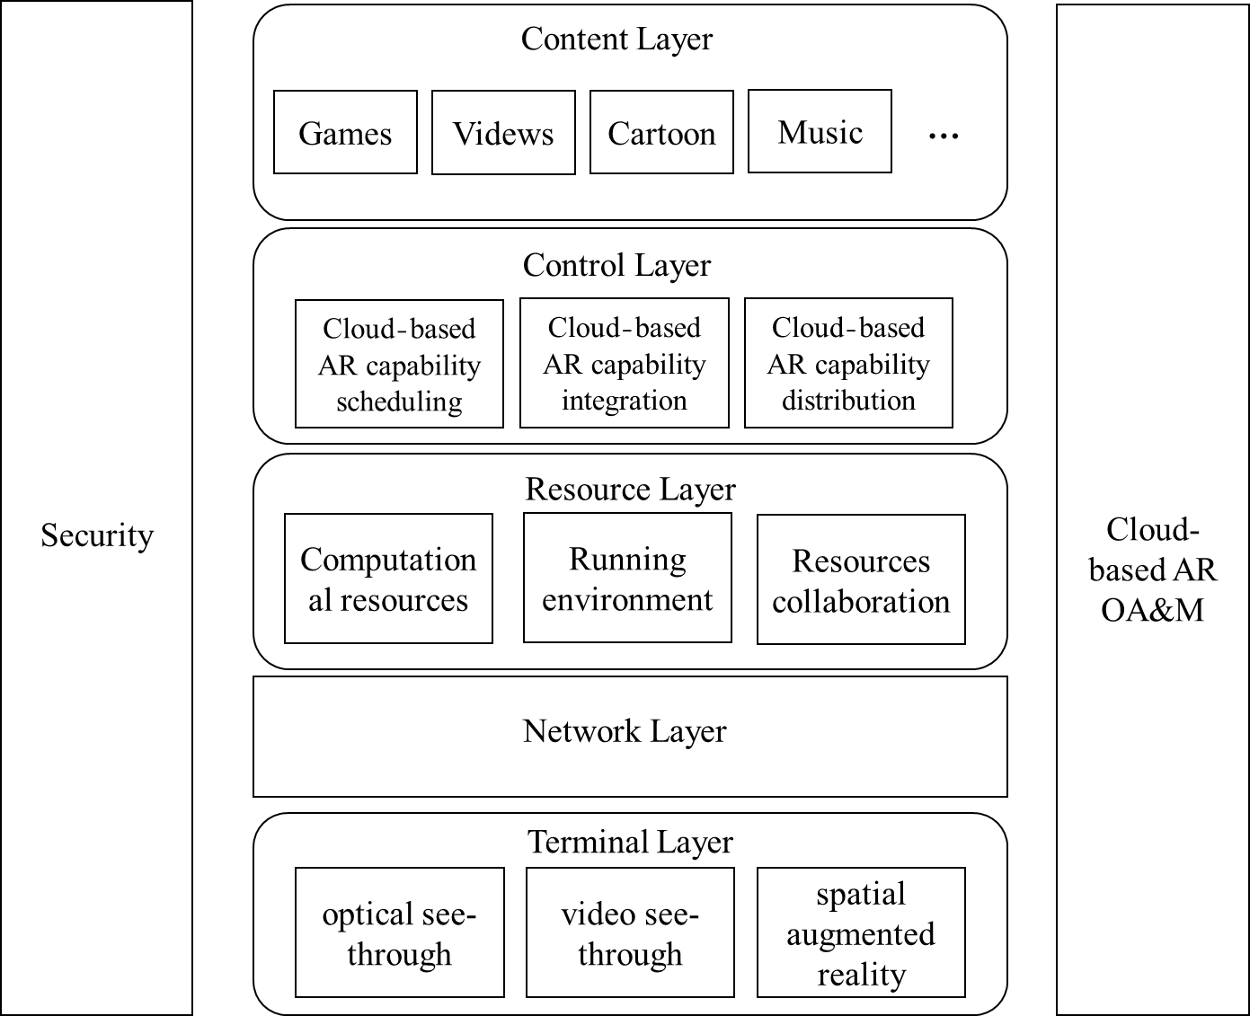

**Figure 7-1 –Framework for cloud-based AR systems**

The content layer mainly provides a variety of cloud-based AR application content. Based on the application presentation mode, it can be divided into cloud-based AR games, cloud-based AR videos, cloud-based AR cartoons, cloud-based AR music, etc. Based on the perspective of industry application, cloud-based AR content can be divided into cloud-based AR education, cloud-based AR social networking, cloud-based AR entertainment, cloud-based AR tourism, cloud-based AR industrial manufacturing, etc.

The control layer mainly provides cloud-based AR capability scheduling, cloud-based AR capability integration, cloud-based AR capability distribution, etc.

* Cloud-based AR capability scheduling: provide various cloud-based AR capability docking, coordination and other functions, including channel docking, resource scheduling, service allocation, operation mapping, location collaboration, etc.
* Cloud-based AR capability integration: provide integrated services of various technical capabilities related to cloud-based AR, including real scene understanding, 3D modelling, point cloud map, manipulation conversion, location service, AI processing, multi-terminal data sharing, etc.
* Cloud-based AR capability distribution: provide cloud-based AR capability distribution from resource pool to cloud-based AR users or terminals

The resource layer mainly provides computational resources, running environment and resources collaboration.

The network layer provides the communication capabilities for cloud-based AR, such as QoS service, uplink services, network optimization, etc.

The terminal layer, provides the cloud-based AR built-in services based on different types of terminals, including cloud-based AR services clients/ APPs, pug-ins/SDK, etc. It also provides service presentation on the terminals and collects manipulations of the terminals to return the control layer. It also provides the function of crowdsourcing collection about the real world.

The OA&M provides centralized operating, management and maintenance functions of cloud-based AR, such as the managements of content, user, technology integration, operation, resource, network capability docking and terminal.

The security of cloud-based AR provides multi-dimensional security mechanisms, such as the securities of content, service, data, and cloud resource pool, network and user experience.

1. **Requirements of cloud-based augmented reality systems**

**8.1 General requirements**

**8.1.1 Virtual-scene quality requirements**

AQ-01: The output virtual-scene is required to have 2D audio-video processing capabilities, and have the ability to carry colour or transparent background information

AQ-02: The output virtual-scene is recommended to have 3D audio-video processing capabilities, and the ability to carry colour and transparent background information.

AQ-03: The image quality of the output virtual-scene is required to meet the 1080P quality requirements.

AQ-04: The output virtual-scene is recommended to achieve the same refresh rate as the AR terminal display.

**8.1.2 Interaction requirements**

IR-01: It is required to be smooth human-computer interaction, and at least one common control method is required to be supported, such as handle, joystick, gesture, voice.

IR-02: It is required to meet the 3DOF interaction capability, and it is recommended to support the 6DOF interaction capability.

**8.1.3 Compatibility requirements**

CR-01: It is required to be compatible with general-purpose cloud resource pools.

CR-02: It is required to support common cloud resource pool service modes, such as physical machines, virtual machines, and containers.

CR-03: It is required to be compatible with different cloud-based AR technology solutions.

CR-04: It is required to support mainstream AR platform related content.

CR-05: It is required to be compatible with network access methods that meet transmission conditions.

CR-06: It is required to be compatible with various types and brands of AR terminals.

CR-07: It is required to be compatible with software versions. When the software version is upgraded or modified, it is required to be compatible with the content of cloud AR applications previously based on it.

CR-08: It is required to be compatible with the application contents developed based on a common AR framework.

**8.1.4 Stability requirements**

SR-01: It is required to support system recovery after software and hardware failures, including data backup/recovery and service node switchover.

SR-02: It is required to meet the design life requirements of more than 10 years about cloud-based AR services.

SR-03: It is required to provide fault isolation mechanism between different modules;

SR-04: It is required to provide 7*24-hour stable operation performance and 99.9% availability;

SR-05: It is required to meet with an overall service downtime of no more than 2 hours over a three-month period;

SR-06: It is required to meet that short-term failures of related servers and other equipment do not cause alerts and service data.

**8.2 Content layer’s requirements**

CL-01: The content of cloud-based AR is required to support the porting of all or part of the tasks such as reality scene digitization, virtual scene rendering, and data streaming of processing results to the cloud to achieve cloud-based execution.

CL-02: The content of cloud-based AR is required to support the ability that capture and execute remote control instructions.

CL-03: The content of cloud-based AR is required to have the ability to connect with the control layer and manage according to unified scheduling to complete distribution to various edge nodes and related AR terminals.

CL-04: The content of cloud-based AR is required to support data synchronization, storage, and on-demand calling, such as data distribution and scheduling to edge nodes and cloud AR terminals.

CL-05: The content of cloud-based AR required to connect with the cloud control layer and resource layer, and completing the docking of authentication, cloud operation, data synchronization and other capabilities.

CL-06: The content of cloud-based AR is recommended to have the ability to flexibly adjust the screen output quality based on cloud and terminal processing capabilities.

CL-07: The content of cloud-based AR is recommended to have a variety of flexible operation guidelines in order to improve user experience.

CL-08: The content of cloud-based AR is recommended to have the ability to adjust the position, angle, and lighting of virtual scenes according to changes in real scene position, angle, and lighting.

**8.3 Control layer**

**8.3.1 Cloud-based AR capability scheduling**

**8.3.1.1 Service node deployment and scheduling**

ND-01: It is required to support the access of multiple service nodes and have the ability to flexibly expand according to the increase of service bearing requirements.

ND-02: It is required to have the ability to allocate and invoke service nodes in accordance with the principles of proximity, capability matching, and load balancing.

ND-03: It is required to support data synchronization and update between different service nodes, and seamless service migration.

**8.3.1.2 Server resource scheduling**

RC-01: Within the service node, the server capacity is required to be flexibly expanded according to the increase in service bearing requirements.

RC-02: Within the service node, it is required to have the ability to allocate and call server resources according to the principles of capability matching and load balancing.

RC-03: It is required to support data synchronization, update, and seamless service migration between different servers in the same service node.

**8.3.1.3 Running environment scheduling**

EC-01: Among different servers, it is required to have the ability to flexibly expand the cloud-based AR operating environment according to the increase in service carrying demands.

EC-02: In the server, according to the principle of capability matching, it is required to be assigned a running environment to match cloud-based AR users, such as the entire physical host, service virtual machine, container, and service process.

EC-03: It is required to support data synchronization, update and seamless migration between different servers in the same service node.

**8.3.1.4 Service capability scheduling**

CS-01: It is required to have the ability to adapt to cloud-based AR requests in order to call services such as authentication, billing, distribution, and deployment in accordance with the resource allocation principle of load balancing.

CS-02: It is required to have the ability to flexibly expand its software and hardware environment according to the bearing requirements of different service modules.

CS-03: It is recommended to support data synchronization, update and seamless migration between different servers in different service nodes and within the same service node.

**8.3.1.5 Content resource scheduling**

RS-01: It is required to have the ability to schedule cloud-based AR content related to different service nodes or different servers in the same node base on cloud-based AR requests.

RS-02: It is required to have the ability to schedule corresponding software and hardware environments, and support the operation of cloud-based AR content base on cloud-based AR requests.

RS-03: It is required to have the ability to support progress files related to cloud-based AR content, and complete data synchronization, update, and seamless migration according to user requirements.

**8.3.2 Cloud-based AR capability interaction**

**8.3.2.1 Service construction**

SC-01: It is required to have the ability to build cloud-based AR technology services based on cloud resource pools.

SC-02: It is required to have the ability to build cloud-based AR technology service nodes based on edge nodes.

SC-03: It is required to have the ability to build cloud-based AR running environment for users, based on cloud resource pool server or server cluster.

**8.3.2.2 Operating environment requirements**

OE-01: It is required to have support for mainstream AR interface specifications, such as OpenXR, ARkit, ARcore, AR Engine.

OE-02: It is required to have the ability to support multi-socket parallel hosting, such as virtual machines, containers, and multi-process parallelism.

OE-03: It is required to have the ability to support the isolation of operating environments.

OE-04: It is required to be supported to flexibly adjust the output of cloud-based AR services about the resolution, frame rate, and field of view (FOV).

OE-05: It is required to be supported about the ability to seamlessly migrate cloud-based AR services based on different operating environments.

OE-06: It is required to be supported about the ability to call cloud-based AR content progress files based on the operating environment.

**8.3.2.3 Ability requirements**

AL-01: It is recommended to have the ability to support graphics rendering, video encoding.

AL-02: It is required to have the ability to seamless migration about cloud-based AR capabilities.

AL-03: It is required to have the ability to support the digital processing of real-scenes, including spatial coordinate anchoring, plane detection, and point cloud map construction.

AL-04: It is required to have the ability to complete real-time tracking, and update the processing or call the appropriate digital processing results for the location information or real-scene data in real time about the cloud-based AR terminal.

AL-05: For the cloud-based AR relying on cloud processing capabilities mode, it is required to have the ability to complete virtual-scene material call, virtual-scene rendering output and sound effect fusion based on real-scene digital results.

AL-06:For the cloud-based AR relying on cloud processing capabilities mode, it is required to have the ability to render virtual-scene based on the real-scene digital result, and fusion the sound effect to complete the virtual-real output.

AL-07: For cloud-based AR RDPRS mode, it is required to have the ability to provide cloud virtual-scene output data encoding, streaming processing, and deliver to the terminal.

AL-08: For cloud-based AR VSPRD mode, it is required to be provided about the ability to share and update reality digital processing resources.

AL-09: It is recommended to have the ability to recognize real objects, and be able to accurately identify and subsequently digital process based on AI capabilities.

**8.3.2.4 Support butt**

SB-01: It is required to have the ability to connect with cloud-based AR operation services and provide cloud AR technology integration services.

SB-02: It is required to have functions such as docking with cloud-based AR terminals, obtaining location information, and control instructions.

SB-03: It is required to have the ability to connect with OA&M to realize the management functions related to technical integration.

**8.3.3 Cloud-based AR capability distribution**

**8.3.3.1 Content distribution**

CD-01: It is required to provide the abilities about cloud-based AR content download or online operation.

CD-02: It is required to provide CDN functions for cloud AR-related audio and video services as needed.

CD-03: It is required to provide storage capabilities matched to cloud-based AR content distribution.

CD-04: It is required to have the function of distributing AR content installation files and progress files to multiple service nodes and different servers of the same service node.

**8.3.3.2 Resource distribution**

RD-01: It is required to provide multi-terminal and multi-edge node distribution function with real-scene digital processing results.

RD-02: It is required to provide multi-terminal distribution function of virtual-scene digital results completed in the cloud.

RD-03: It is required to provide cloud-based AR materials’ distribution function to multi-edge nodes and multi-terminal.

**8.3.3.3 Technical competency distribution**

TD-01: It is required to have the ability to distribute the technical function modules and updated versions related for cloud-based AR to each service node and different servers of the same service node on demand, so as to complete the deployment and update of related functional modules.

TD-02: It is required to have the ability to distribute the technical functions and updated versions related for cloud-based AR to each terminal on demand, and implement the deployment of cloud-based AR services based on terminals.

**8.4 Resource layer**

**8.4.1 Computational resources**

CR-01: It is required to provide general-purpose hardware resources such as physical or virtual CPUs, GPUs, storage, and NICs.

CR-02: It is required to provide a common software system including a secure operating system, hardware drivers, and a common graphics interface.

CR-03: It is required to provide general functions such as configuration, expansion, migration, and management of cloud resource pools.

**8.4.2 Running environment**

RE-01: It is required to provide compatible mechanisms for concurrent reuse of virtual machine, container, or application virtualization and other software and hardware resources.

RE-02: It is required to provide secure and reliable virtualization, one-click migration, and secure data synchronization mechanisms for virtual machines, containers, or applications.

RE-03: For large-scale digital processing, it is recommended to have the ability to collaborate across different service nodes, as well as the ability to share and organize data.

**8.4.3 Resources collaboration**

RC-01: It is required to provide data storage and data backup.

RC-02: It is recommended to have remote storage and other capabilities to improve the high-speed sharing of data between different service nodes.

**8.5 Terminal layer**

**8.5.1 Hardware**

HW-01: It is required to use general-purpose CPU architectures such as X86 and ARM, with complete computing, rendering, storage and other processing capabilities, which is suitable for cloud-based AR services.

HW-02: It is required to provide sufficient computing power, including CPU and GPU.

HW-03: It is required to provide sufficient storage capacity.

HW-04: It is required to provide display capability.

HW-05: It is required to provide real-time collection capabilities for 3DOF and related data.

HW-06: It is required to provide effective controls, such as touch screens, gestures, sounds.

HW-07: It is required to provide precise spatial positioning capability.

HW-08: It is required to provide high-definition reality capture capability via built-in or external camera.

HW-09: It is required to provide network access capability of more than 100Mbit/s.

HW-10: It is recommended to provide real-time collection capabilities for 6DOF and related data.

**8.5.2 Software**

SW-01: It is recommended to provide common operating system such as Windows, Linux, Android, and Harmony.

SW-02: It is required to provide hardware driver installation.

SW-03: It is required to support interconnection with the control layer to implement functions such as cloud-based AR functions, resource and content distribution, location information upload, receiving cloud-based AR service media streams, and uploading control commands.

SW-04: It is required to have the ability to upload real-time collected real-scenes to the cloud.

SW-05: It is recommended to have the ability to combine rendering output and sound effects of virtual-scene materials based on reality digital results and virtual-scene logic.

SW-06: It is recommended to have the ability to locally store such as real-scene digital results and virtual-scene materials.

SW-07: It is required to complete the processing virtual-scene based on local output or cloud delivery to fusion real-scene output.

SW-08: It can optionally have AI prediction capability, which can provide real-scene recognition capabilities.

SW-09: It is recommended to have real-scene digital processing capabilities such as plane detection, spatial recognition, and coordinate anchoring;

SW-10: It is required to adjust the coordinate mapping relationship of real-time digital processing according to the angle, position, distance of the collection, so as to lay the foundation for the virtual-real fusion output.

SW-11: It is recommended to support multiple codecs, such as H.264, H.265, AVI, and VP9.

SW-12: It is recommended to be less than 40ms about the overall terminal operation delay and processing delay

SW-13: It is recommended to be less than 20ms about graphics and audio data decoding by the terminal local.

**8.6 Network layer**

CN-01: The uplink bandwidth of cloud-based AR terminals is required to be able to upload real-time location information and changes related to location information, such as orientation, angle, and distance.

CN-02: The uplink bandwidth for cloud-based AR terminals is recommended to meet the requirements for real-time upload of real-time shooting real-scene data to the cloud.

CN-03: The downstream bandwidth for cloud-based AR terminals is required to meet the requirements for fusing and delivering virtual scene rendering results with audio data.

CN-04: The overall delay of network transmission is required to be less than or equal to 100ms.

CN-05: It is required to provide a redundant packet transmission mechanism and a low packet loss rate, with the ability to stabilize data transmission.

CN-06: FTTH access technology is recommended for the use of wired access for cloud-based AR terminals.

CN-07: For cloud-based AR terminals under Wi-Fi network, it is recommended to use Wi-Fi 6 or above access mode.

CN-08: For the use of wireless cellular access of cloud-based AR terminals, it is recommended to use 5G and above network access standards.

CN-09: It is recommended to have deterministic network access guarantees such as bandwidth and latency for cloud-based AR services.

CN-10: It is recommended to have network transmission optimization mechanisms such as link path selection and network acceleration.

CN-11: It is recommended to use fibre or WDM direct connection between cloud-based AR service nodes to reduce the delay of multi-person remote interaction.

CN-12: In the data centre, it is required to have network interconnection of more than 1 Gbit/s, and is recommended to have more than 10 Gbit/s.

**8.7 Operation, administration and management**

CO-01: It is required to provide the ability about cloud-based AR operation management based on cloud basic resource pools or general-purpose servers.

CO-02: It is required to provide the ability to manage cloud resource pools related to the resource layer.

CO-03: It is required to have interface management capabilities that provide various functions of cloud-based AR, including the ability to import and publish cloud-based AR.

CO-04: It is required to have management capabilities such as access, authentication, and removal for cloud-based AR capability interaction.

CO-05: It is required to have management capabilities such as access, authentication, and removal for cloud-based AR capability scheduling.

CO-06: It is required to have management capabilities such as access, authentication, and removal for cloud-based AR capability distribution.

CO-07: It is required to complete user authentication, service billing, data analysis, operation and maintenance capabilities.

CO-08: It is required to have the ability to connect with cloud-based AR terminals, complete user authentication, content synchronization, and billing functions.

CO-09: It is recommended to have built-in cloud-based AR terminals in the form of SDKs or APIs, and have operation/maintenance capabilities.

**8.8 Security**

SR-01: It is required to have the ability to divide security domains based on function or service nodes, deploy firewalls, intrusion detection, anomalous traffic detection, and filtering.

SR-02: It is required to have anti-virus capabilities and process (logical) security assurance, including access restrictions, security audits, and other capabilities.

SR-03: It is required to provide copyright protection capabilities for cloud-based AR content to avoid problems such as recompilation and piracy.

SR-04: It is required to have the ability to ensure service security through user management, permission management, log management, and other means.

SR-05: It is required to have security protection capabilities for metadata, user access data, business operation data, etc., and use encryption technology to encrypt important data transmitted on the Internet.

**Appendix I**

**Use cases**

**(This Appendix does not form an integral part of this Recommendation.)**

The cloud-based AR has the characteristics of adding colourful virtual-scene based on real-scene digitization, and can achieve enhanced effects such as auxiliary information, interactive attributes, and hidden attributes of real-scene.

In order to fully demonstrate the features of cloud-based AR, the cloud-based AR medical assistance, the cloud-based AR navigation, and the cloud-based AR industrial maintenance are selected as typical cases of cloud-based AR mode, representing the cloud-based AR relying on cloud processing capabilities mode, the cloud-based AR RDRSC&VPVRFOT mode, the cloud-based AR VDRDC&VRFOT mode.

**I.1 Cloud-based AR medical assistance**

Cloud-based AR medical assistance is to use AR technology to virtually annotate and display patients' lesions, and at the same time, through telemedicine experts, to complete virtual content such as disease diagnosis and surgical program, so as to effectively improve the level of medical treatment and support medical training for students.

Cloud-based AR medical assistance involves more complex etiological analysis and high-definition three-dimensional display, and at the same time needs to increase the assistance of telemedicine experts. The cloud-based AR medical assistance involves the accurate analysis and labelling of user lesions, three-dimensional display of surgery, etc., which requires relatively powerful computing, rendering and AI computing power as support, and the terminal side cannot meet the requirements of computing power and flexibility, so it is necessary to complete the digital processing of lesions based on the cloud, and carry out flexible annotation, expert guidance and suggestions based on the digital processing results, three-dimensional display, simulation of surgical program, etc.

As a typical application of the cloud-based AR relying on cloud processing capabilities mode, the processing process of cloud-based AR medical assistance is shown in Figure I-1.

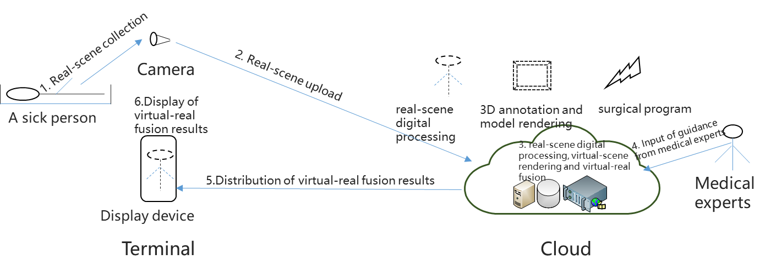

Figure I-1 –Cloud-based AR medical assistance process

The cloud-based AR medical assistance mainly consists of two parts: terminal and cloud, of which the cloud part corresponds to the resource layer, control layer, and QA&M. The terminal mainly includes the patient, the camera that collects the real-scene and the corresponding display terminal, and the cloud mainly provides real-scene digital processing, 3D annotation, virtual-scene model rendering, and surgical plan injection. Among them, the cloud also needs to support the input of medical experts' guidance. The overall process of cloud AR medical assistance is as follows:

* Real-scene collection: Real-scene collection is carried out for patient-related lesions.
* Real-scene upload: The terminal uploads the real-scene results to the cloud.
* Cloud processing: The cloud dispatches computing resources at the resource layer through the control layer to complete the digital processing of real-scene, virtual-scene rendering, and virtual-real fusion output.
* Expert opinion input: The cloud completes the input of relevant guidance of medical experts by connecting with medical experts;
* Processing result delivery: The cloud delivers the relevant virtual-real fusion results to the terminal side.
* Result display: The terminal completes the display of the corresponding virtual-real fusion results.

**I.2 Cloud-based AR navigation**

The cloud-based AR navigation relies on a wide range of real-scene digital results, and adds virtual guidance information according to the user's relevant travel purposes, because the real-scene digital results have multi-user sharing attributes, and the addition of virtual guidance information does not require special computing power support, so it can be used as a typical application of the cloud-based AR RDRSC&VPVRFOT mode.

The cloud-based AR navigation needs to be based on the digital processing of massive traffic roads, transportation facilities, vehicles and surrounding buildings, and the digital processing results of this part of the real-scene have the characteristics of shared use by multiple people, which is suitable for unified real-scene digital data aggregation, data distribution and data update operations through the cloud. At the same time, the virtual-scene rendering part related to cloud-based AR navigation has its own personalized characteristics for different users, and its rendering difficulty is not large, so it is more suitable to realize related virtual-scene processing and virtual-reality fusion output on the terminal side.

The overall process of cloud-based AR navigation is shown in Figure I-2.

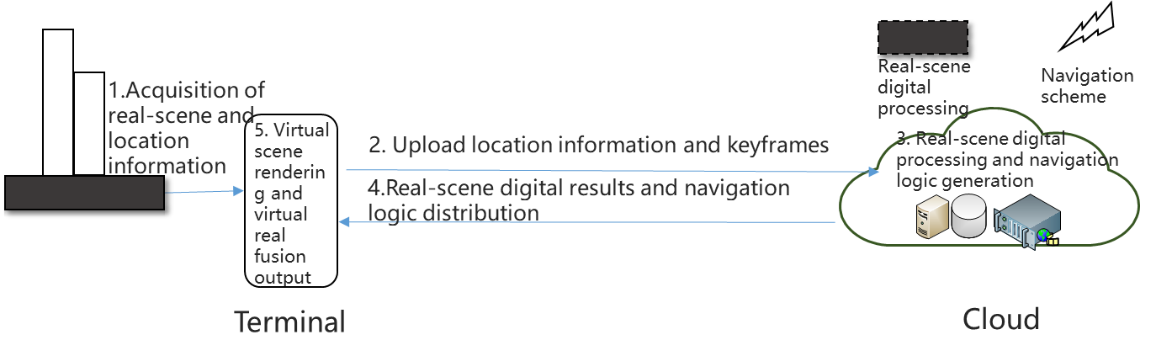

Figure I-2 –Cloud-based AR navigation process

The overall process of cloud AR navigation is as follows:

* Real-scene and location information collection: The terminal completes the corresponding real-scene and the current location information collection.
* Upload location information and key frames: The terminal uploads the location information and real-scene key frames to the cloud.
* Cloud processing: The cloud dispatches computing resources at the resource layer through the control layer to complete the digital processing of real-scene and the generation of navigation logic.
* Processing result delivery: The cloud delivers the relevant real-scene digital results and navigation logic to the terminal side.
* Terminal processing and display: The terminal completes the rendering of virtual-scene and the output of virtual-real fusion.

**I.3 Cloud-based AR industrial maintenance**

The cloud-based AR industrial maintenance refers to the use of cloud-based AR capabilities to realize virtual enhanced dismantling of industrial equipment and amplification of fault points, so as to improve the fault location accuracy of on-site maintenance personnel and equipment maintenance efficiency. Because cloud-based AR industrial maintenance requires professional knowledge background and rich maintenance experience as the foundation, it is impossible to directly complete the real-scene logic related to professional maintenance based on the terminal side, and at the same time, it is necessary to correct and adjust the relevant virtual-scene rendering points, lines, surfaces, and stereoscopic imaging through specific fault situations during the maintenance process, and at the same time, the virtual-scene rendering needs to be placed in the cloud for processing.

Based on the characteristics of cloud-based AR industrial maintenance mentioned above, the cloud-based AR industrial maintenance is a typical application of the cloud-based AR VDRDC&VRFOT mode.

The overall process of cloud-based AR industrial maintenance is shown in Figure I-3.

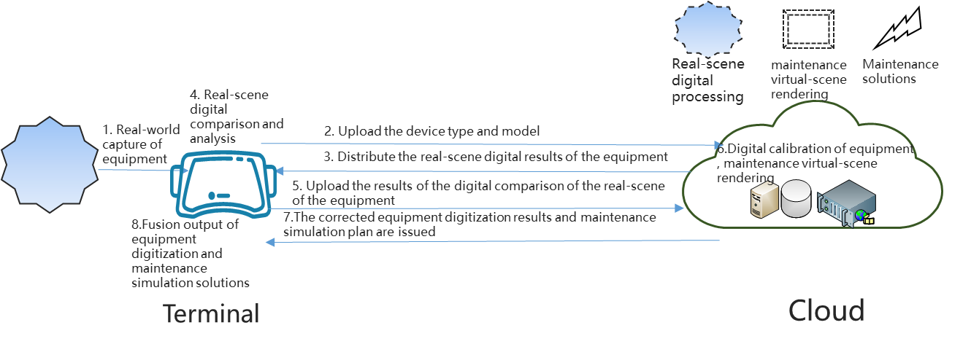

Figure I-3 –Cloud-based AR industrial maintenance process

The cloud-based AR industrial maintenance has the universality of equipment parts, and at the same time has the difference of its faults, and the corresponding maintenance plans are also very different, including terminal collection of equipment real-scene, reporting equipment type and model, comparison and analysis of the real-scene digital results, and uploading the corresponding analysis and comparison results to the cloud, by obtaining the maintenance plan of virtual rendering issued by the cloud, to complete the localized final output; the cloud needs to complete the equipment real-scene digital correction and complete the maintenance virtual-scene rendering according to the maintenance plan.

The overall process of cloud-based AR industrial maintenance is as follows:

* Obtain the real-scene of the equipment: The terminal obtains the real-scene of the equipment through its built-in or external camera.
* Upload equipment type and model: The terminal uploads the equipment type and model to the cloud.
* Delivery out digital results of the real-scene: The cloud distributes the digital processing results according to the relevant types and models of the equipment.
* Matching and analysis of real-scene digital results: After the terminal obtains the digital results of the equipment delivered by the cloud, it matches them with the current real-scene equipment and conducts corresponding comparison and analysis.
* Update the comparison results of the real-scene digital results of the equipment: The terminal reports the comparison results to the cloud, so that the cloud can locate the relevant equipment faults.
* Equipment digitization result correction and maintenance virtual-scene rendering: The cloud completes the equipment digital result correction and maintenance virtual-scene rendering processing according to the terminal upload result.
* Cloud processing result issuance: The cloud will deliver the calibrated equipment digitization results and maintenance simulation scheme to the terminal side.
* Terminal output: the terminal will obtain the equipment real-scene digital results and maintenance simulation scheme virtual-real fusion output.

**Bibliography**

[b-ITU-T Y.101] ITU-T Y.101 (03/2000), *Global Information Infrastructure terminology: Terms and definitions*.

_______________________