MEMS

1. Introduction
   1. Successful MEMS product
   2. Cleanroom 超净间
      1. Contamination problems in microfabrication
         1. Particles
         2. Metallic ions
         3. Unwanted chemicals
      2. Affection
         1. Device Yield
         2. Device performance
         3. Device reliability
      3. Contamination source
         1. Air
            1. Remained as aerosols
            2. Designed by class number
            3. Dressing protocol
         2. Process water
            1. Deionisation that gives a high resistivity
         3. Process chemicals & gases
            1. Metallic mobile ion contaminants are the most serious impurities in process chemicals, a concentration<1ppm is desired
            2. Gas quality

Percentage of purity

Water vapor content

Particulates

Metallic ions

* + 1. Cleanroom strategy: two approaches
       1. Work station, laminar flow hood for local clean air conditions
          1. HEPA (high-efficiency particulate arrestence) filter with filtered air
          2. Vertical & horizontal laminar flow
       2. Total cleanroom
          1. Continuous laminar flow from the ceiling to the floor, also through tabletops with perforations
          2. Tight control of

Temperature

Humidity

Smog

1. Chemical Vapor Deposition (CVD) 化学气相沉积
   1. Basic principles of CVD & CVD reactors
      1. Factors controlling film thickness
         1. Temperature
         2. Pressure: low gas pressure is beneficial for good film uniformity and step coverage
         3. Gas flow
      2. Classification of CVD by reactors
         1. Hot wall tube reactor
         2. Cold wall tube reactor
         3. Showerhead reactor
         4. Conveyor belt reactor
      3. Classification of CVD by pressure
         1. Atmospheric pressure CVD (APCVD): 1 bar
         2. Sub-atmospheric pressure CVD (SACVD): 1000 mbar>P>10 mbar
            1. Reduction of unwanted gas phase reactions: 1 mbar>P> 0.1 mbar
            2. Improvement of film uniformity across the wafer
         3. Low-pressure CVD (LPCVD)
         4. Ultrahigh vacuum CVD (UHV/CVD)
      4. Plasma-enhanced CVD: growth becomes possible at lower temperature, less restrictions to the used substrate
      5. Metal-organic CVD / Metal-organic vapor phase epitaxy
   2. Theoretical concepts in CVD
      1. Velocity boundary layer near substrate
      2. Concentration boundary layer
      3. Laminar & turbulent flow:
         1. CVD is normally operated in the laminar flow boundary layer regime
         2. Transition from laminar to turbulent is determined by critical value of $Re\#=5*{10}^{-5}$, which can be interpreted as the ratio of inertia to viscous shear forces
      4. Mass transport in the boundary layer
         1. Advection
         2. Diffusion
   3. Examples of CVD processes
      1. LPCVD of polycrystalline & amorphous Si
      2. LPCVD of Si3N4 & SixNyHz
      3. LPCVD low-temperature oxide
      4. PECVD of diamond
2. Physical Vapor Deposition (PVD) 物理气相沉积
   1. Thermal/vacuum evaporation图示

      描述已自动生成
      1. Vapor creation: Hertz-Knudsen equation to describe
         1. Heating up
            1. By resistive heater: simple but may cause contamination
            2. By electron beam: more complex but easy to control
      2. Vapor flux towards substrate
         1. Mean free path $λ$: 气压越大， $λ$ 越小，碰撞越激烈
      3. Condensation on the substrate
         1. Nonuniformity issues
         2. Shadowing
      4. Other equipment specs
         1. Shutter: block the flux between the crucible & the wafers, allows precise timing of the position instead of just turning on and off the heat source
         2. Thickness monitor
         3. Temperature control
         4. Pressure control
         5. Gas inlets for reactive evaporation
         6. Stress optimization
      5. Pro & cons
         1. Pro
            1. Simple, fast & affordable technique
            2. No surface damage
            3. Electrically conducting & insulating
            4. Materials
            5. High purity films
         2. Con
            1. Shadowing
            2. Poor step coverage of non-planar
            3. Structures
            4. Non-uniformity over large areas
            5. Difficult to evaporate compounds
   2. Sputtering 溅射
      1. Working principle
      2. Physical principle
         1. Physics of DC plasma
         2. Spatial zones in DC glow discharge
         3. Paschen’s law: breakdown voltage
      3. Sputter variation
         1. DC sputtering
            1. Advantage: simple setup
            2. Limitations

Substrate cooling is required

Only for electrically-conductive materials

* + - 1. RF sputtering图示

         描述已自动生成
         1. RF sputtering conditions
         2. Advantages

Dielectric deposition

Higher deposition rate than DC

Lower power consumption than DC

* + - * 1. Limitations

Target cooling is required

Substrate cooling is required

* + - 1. Magnetron sputtering: Magnet to confine the plasma图示

         描述已自动生成
    1. Ions-target interactions
    2. Pros & cons of sputtering
       1. Pros
          1. Wide choice of materials
          2. Good adhesion due to relatively higher kinetic energy
          3. Good step coverage & uniformity
          4. Deposition of large amount of material
          5. Surface cleaning & activation
       2. Cons
          1. Substrate heating
          2. Surface damage
          3. Complex & expensive
          4. High purity films are not possible
    3. Sputter examples
    4. Other PVD methods
  1. Film growth
     1. Atoms arrival
        1. Adsorption
           1. Chemisorption
           2. Physisorption
        2. Stay
        3. Diffuse
        4. Desorb
     2. Film-substrate interface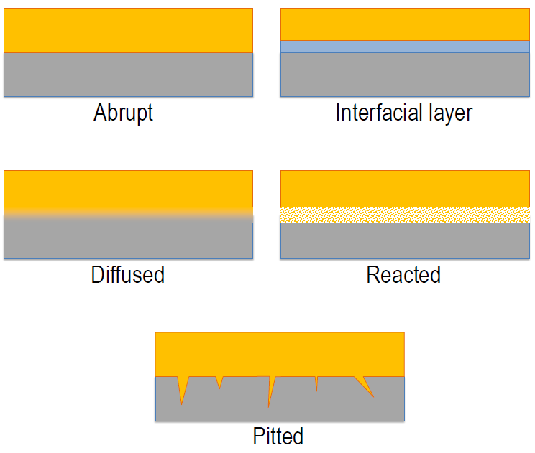
     3. Adhesion
        1. Substrate cleanliness is important
        2. Deposit method: The adhesion of sputtering is better than that of evaporation since the molecules impact surface with high energy
        3. Interface compatibility: Noble metals such as Au’s adhesion is poor (inert)
           1. Adhesion layer Cr is required (chosen according to the ability to form chemical bond) 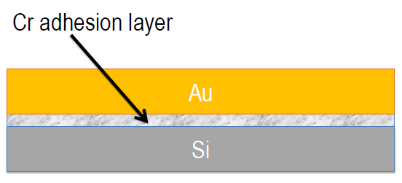
     4. Growth modes
        1. 2D/Layer-by-Layer mode
           1. Strong atom-surface bond
           2. MBE, ALD, PLD
        2. 3D/Island mode
           1. Strong atom-atom bonds
           2. Evaporation & sputtering with heated substrate or ionic bombardment
        3. Columnar mode
           1. Not enough energy to merge islands together
           2. Deposition @ room temperature
     5. Crystal structure
     6. Stress in thin films: Stoney equation
        1. Extrinsic stress
           1. Missmatch between the film
           2. Substrate’s coefficient of thermal expansion CTE
        2. Intrinsic stress (remove by annealing)
           1. Lattice mismatch
           2. Voids & incorporated foreign atoms
           3. Bombardment
           4. Stress gradient over film thickness

1. Lithography 光刻
   1. General concepts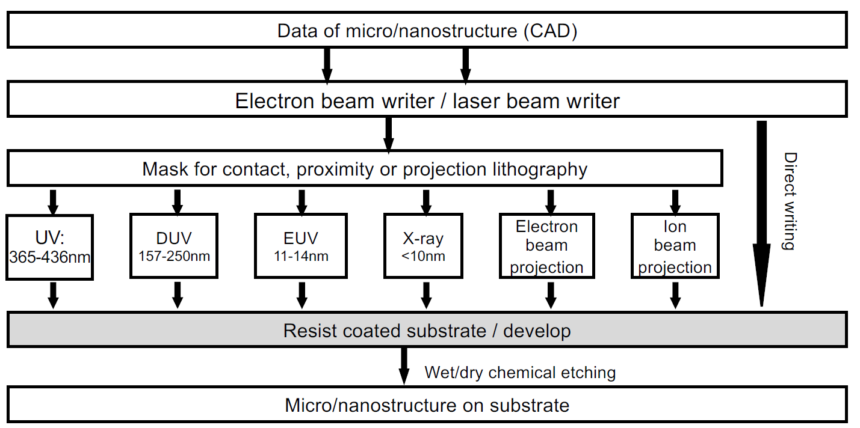
      1. Definition: Transfer geometric shape from design to a thin layer of radiation-sensitive material which is called resist 光刻胶/光阻剂, which is covering the wafer substrate
         1. Fundamental step in microfabrication
            1. From design to physical pattering
            2. Enabling step for local dry etching or metal deposition
         2. The lithography step is based on electromagnetic interaction & modification of a resist via photons or electrons, followed by development
         3. In a cleanroom & under yellow light
      2. Lithography process flow
         1. Substrate preparation
            1. Surface cleaning
            2. Resist adhesion 涂胶
         2. Resist coating 光阻涂布 & pre-baking
            1. Spin coating
            2. Spray coating
            3. Casting
            4. Lamination 层压: Transfer an already formed coating directly to the substrate
         3. Resist exposure
         4. Resist development 显影
         5. Pattern transfer (etching, lift-off)
         6. Resist stripping
      3. Exposure methods
         1. Exposure brings localized energy in the form of photons, electrons, or ions
         2. Resist is sensitive to the energy used
         3. Optical lithography uses photons (resolution limited by diffraction 衍射 ~ wavelength/2)
         4. Electron beam lithography uses electrons (limited by scattering 散射)
         5. X-ray lithography (complicated mask)
         6. Ion beam lithography (complicated tool)
      4. Photoresist
         1. Photoresist tones 紫外光刻胶
            1. Positive tone resist 正性光刻胶: breaking bonds

Base resin

Photosensitizer

Organic solvent

* + - * 1. Negative tone resist 负性光刻胶: creating bonds

Polymers

Photosensitizer

* + - 1. Photoresist contrast
    1. Pattern transfer
       1. Ion implantation
       2. Isotropic etching (wet & dry)
       3. Thin film etching
       4. Moulding
       5. Anisotropic etching (wet & dry)
       6. Electro-plating
       7. PVD thin film coating (lift-off)
  1. UV lithography
     1. Mask making & direct laser writing: 2 approaches in photolithography: serial laser writing VS parallel using photomasks
        1. Photo mask process flow
           1. Serial laser exposure
           2. Resist development
        2. Direct laser writer
        3. From the CAD to the mask
     2. Mask-based lithography
        1. Alignment & exposure tool
        2. Contact & proximity
           1. Contact exposure

Mask in in physical contact with substrate

Best resolution (diffraction limited)

Risk of contamination

* + - * 1. Proximity exposure

Mask is a few micrometers above the substrate

Loss in resolution

No risk of contamination

* + - * 1. Projection lithography

Mainly used today for IC industry

Picture of the mask is projected

No contact

No deterioration

Excellent resolution

Reduction of errors

Stepper, x-y movement, from field to field

* + - 1. Resolution limit & enhancement
         1. Immersion lithography 浸没式光刻
  1. Electron beam lithography/EBL 电子束光刻
     1. Pro & cons
        1. Pro
           1. Overcome the optical diffraction limit
           2. Sub-20 nm features are feasible
           3. Writing tool for UV/DUV masks
        2. Cons
           1. Expensive
           2. Slow when compared to projection lithography systems
     2. Tool overview
        1. Key components
        2. Vacuum levels
           1. Electron source: highest level of vacuum to avoid source contamination by residual gas molecules
           2. Electron optics column
           3. Substrate transfer & stage
     3. Electron optics & beam deflection
     4. Electron-sample interactions
     5. Resist development
     6. Wet etching of chromium
     7. Resist stripping
     8. Mask drying
     9. Use in mask aligner
  2. Alternative lithography methods
     1. Scanning probe lithography
     2. Nanoimprint lithography
     3. Soft-lithography
     4. Stencil lithography

1. Dry etching 干法刻蚀
   1. General concept
      1. Dry etching in a gas plasma:
         1. Inert CF4 becomes reactive when it is brought into plasma state, the active CF3+ will react with Si and do etching in an isotropic way. However, a carbon-rich gas like C4F8 will lead to deposition of polymer passivating film rather than etching.
         2. Ar will also become reactive when negative voltage is applied to wafer, Ar+ will impact Si physically in an anisotropic way.
      2. Directionality of etching & etching anisotropy
         1. General concept 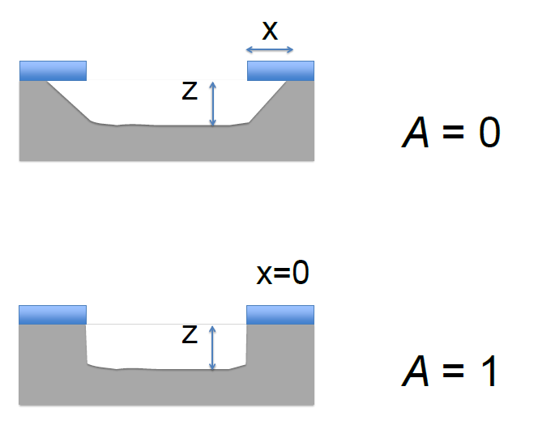
            1. Anisotropic ratio $A=\frac{z-x}{z}$
            2. Isotropic: A=0
            3. Anisotropic A=1
         2. Methods to change directionality
            1. Increasing the anisotropy by sidewall protection
            2. Effect of adding H2 to CF4 gas
      3. Simple rules for choosing dry etching processes
         1. Fluorine-to-Carbon ratio (F/C)
         2. Selective VS unselective dry etching
         3. Substrate bias
         4. Metal etching
         5. Organic films
      4. Deep dry etching of Si
         1. Simultaneous etching & passivation with SF6 & C4F8
            1. Low etch rate, high selectivity
            2. Smooth sidewalls and very anisotropic process
         2. Pulsed process/Bosch process
            1. Apply SF6 & C4H8 in sequence so that etching & passivation alternate
            2. High etch rate, high selectivity
         3. Characteristic parameters of an etching profile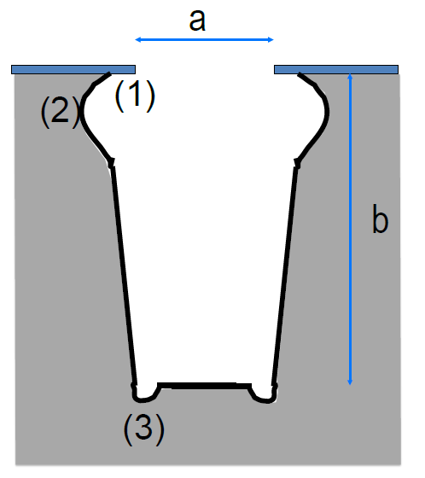
            1. Selectivity 选择性: Etching rate ratio of the substrate with respect to the mask
            2. Etch rate

Depth b

Aspect ratio 长宽比 b/a

Shape of the trench

Undercut

Bowing

Sidewall

Bottom (microtrenching due to forward scattering of ions)

* + - 1. Process variables & their effect
         1. Gas mixture: etch rate, etch profile
         2. Gas flow rate: etch rate
         3. Pressure: etch rate, etch profile, selectivity mask
         4. RF power: etch rate
         5. Wafer temperature: etch profile
         6. Bias of the wafer: etch rate, etch profile
    1. Example of a dry etching equipment
    2. Dry retching without a plasma
       1. XeF2 etching of Si
       2. HF vapor phase-based etching of SiO2
  1. Theoretical concept of plasma generation: Glow discharge plasma/Cold plasma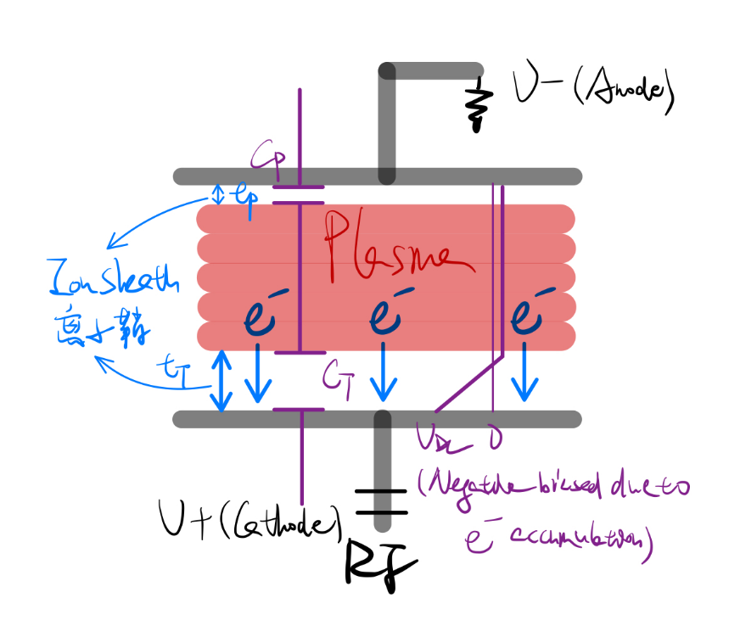
     1. Plasma equivalent electric circuit $\frac{V_{T}}{V_{p}}={\left(\frac{A_{p}}{A_{T}}\right)}^{4}$
     2. Design rule
        1. To maximize etching rate on the lower electrode, one should choose lower electrode area smaller than upper area
        2. But such asymmetric electrode system will generate non-uniform plasma, resulting in different etching between the center & edges
  2. Dry etching equipment
     1. Types of dry etching equipment
     2. Types of plasma sources
  3. Ion beam etching
     1. Pros & cons
        1. Pros
           1. 45-degree etching shapes are possible
           2. Focused Ion Beam (FIB) for local etching at high resolution
        2. Cons
           1. In sensitive processes, to main the etch rate, a high ion flux is needed, which is difficult to obtain with a remote ion source
           2. Etching processes that consume/generate a significant quantity of gas are not possible

1. Wet etching 湿法刻蚀
   1. Purpose
      1. Thin films
      2. Thick Si substrate
         1. Anisotropic etching
         2. Isotropic etching
         3. Thin membrane microfabrication
      3. Application
         1. Wafer cleaning
         2. Removing sacrificial layers to realize free-standing structures
         3. Electrochemical etching for porous Si
   2. General concept
   3. HF bath for SiO2 & glass wet etching
   4. Isotropic wet etching of silicon in the HNA bath
      1. Chemistry of isotropic wet etching in a HNA bath
         1. HNA bath: HF+HNO3+CH3COO (diluting agent) while HF bath for electrochemical etching & for creating porous Si
         2. Overall reaction
      2. Electrochemical etching in a HF bath
      3. Realization of porous Si by electrochemical etching in a HF bath
   5. Anisotropic wet etching of silicon in alkaline baths: Si is single crystalline that has an ordered lattice structure