机械精度设计

1. Interchangeability and measuring technology foundation
   1. Interchangeability 互换性

定义 Definition: Interchangeability is a property of parts or assembly units to provide operability and reliability of mechanisms and machines under conditions of fittingless assembling or at repair.

Interchangeability can also be defined as the ability to select components for assembly at random and fit them together within proper tolerances

* + 1. Operability: operability is a state of an item, at which values of all actual parameters correspond to the requirements of technical specifications.
    2. Reliability: reliability is a property of an item to keep in time the values of all parameters in specified limits to ensure operability with time.
    3. Tolerance: tolerance is permissible limits of variation in an object(the difference between the maximum and minimum limits)
    4. 互换性参数 Parameters of interchangeability
       1. 几何参数 Geometric
          1. Dimension, shape, relative position of surfaces and others
       2. 物理和机械参数 Physical and mechanical
          1. Specific gravity, hardness, strength and others
       3. 化学参数
          1. Chemical composition, admixtures
       4. 电子参数
  1. Types of interchangeability
     1. 完全互换 Complete (functional) interchangeability
     2. 不完全互换 Incomplete (restricted) interchangeability
        1. 组互换 Group interchangeability (selective assembling)
        2. 分离组件可调整尺寸位置 Assembling in which dimensions or positions of separate parts can be adjusted
        3. 部分部件配合 Assembling with fitting of one of several parts
     3. 完全互换的优势 Advantages of complete interchangeability
        1. 设计新设备更简单、快速和便宜，因为基本元素都是标准化的。Designing of new items is easier, faster, and cheaper, because basic elements are standardized (threads, splines, gears, etc)
        2. 设备的生产更简单便宜 Manufacturing of items is easier and cheaper (accuracy of blanks is specified, improved inspection methods, easier assembling, etc)
        3. 利用更便宜 Exploitation is cheaper (shortening of repair period and providing high quality)
  2. Measurement technology foundation
     1. Definition: Measurement is a comparison of a given quantity with one of its predetermined standard values opted as a unit. The science about precision measurements is known as metrology.
     2. Requirements of the measurement
        1. 比较所用的标准必须精确而且国际通用 The standards used for comparison must accurate and internationally accepted.
        2. 用于提供信息的仪器或仪器及其过程必须是可证明的 The apparatus or instrument and the process used for information must be provable.
        3. 确保被测量的部分对应了已建立的标准 To ensure that the part to be measured corresponds to the established standard.
        4. 符合生产的互换性 To meet the interchangeability of manufacture
        5. 确保没有失败的产品到达客户以确保客户满意度 To provide customer satisfaction by ensuring that no faulty product reaches the customers.
        6. 协调组织质量控制、生产、采购等部门的职能 To coordinate the functions of quality control, production and other departments of the organization.
        7. 判断在进行小修后，是否有可能使某些有缺陷的部件变得可接受。To judge the possibility of making some of the defective parts acceptable after minor repairs.
     3. Methods of measurement
        1. 直接测量 Method of direct measurement
        2. 间接测量 Method of indirect measurement
        3. 无接触测量 Method of measurement without contact
        4. 比较测量 Method of measurement by comparison
        5. 重合测量 Method of measurement by coincidence
        6. 偏差测量 Deflection method of measurement
        7. 零位测量法 Null method of measurement
        8. 插值测量法 Method of measurement by interpolation
        9. 外推测量法 Method of measurement by extrapolation
        10. 互补测量法 Complimentary method of measurement
        11. 单元法 Element method、
     4. Terms in measurement
        1. 灵敏度 Sensitivity is the ability of the instrument to detect small variation in the input signal
        2. 可读性 Readability
        3. 精确率 Accuracy
        4. 准确率 Precision, refers to repeatability or consistency
        5. 修正值 Correction
        6. 修正 Calibration
        7. 重复性 Repeatability
     5. Elements of a measuring system
        1. 标准 Standards
           1. 标准等级 Classification of standards

最高级 Primary standard: only used for comparison with secondary standard

第二级 Secondary standard

第三级 Tertiary standard

工作等级 Working standard

* + - 1. 工件 Workpiece
      2. 工具 Instrument
      3. 人 Person
      4. 环境 Environment
    1. 测量工具 Measuring instruments
       1. 测量工具功能 The functions of the measuring instruments
          1. 指示功能 Indicating function
          2. 记录功能 Recording function
          3. 控制功能 Controlling function
       2. 角测量工具 Angle measuring Instruments
          1. 角度计 Angle gauges
          2. 分划尺 Divided scales
          3. 带卡尺的正弦杆 Sine bar with slip gauges
          4. 自动准直仪 Autocollimator
          5. 工具显微镜 Tool Maker Microscope
       3. 长度测量工具 Length measuring instruments
          1. 钢尺 Steel rule
          2. 卡尺 Caliper
          3. 深度计 Depth gauge
          4. 千分表 Dial indicator
          5. 千分尺 Micrometer
          6. 比较器 Comparators
       4. 表面处理仪器 Instruments for surface finish
          1. 表面粗糙度测量 Surfaces roughness measurements
       5. 偏差测量仪
          1. Coordinate measuring machine 坐标测量仪
    2. 测量误差 Measurements errors
       1. 定义 definition: Error = True size – Actual size
       2. 分类 Types of measurement errors
          1. 绝对误差 Absolute error = True size – Actual size
          2. 相对误差 Relative error = Absolute error/Actual size
          3. 过失误差、粗差 Gross error: caused by mistake in using instruments, calculating measurement and recording data results
          4. 系统误差、偏差 Systematic (bias) error: are consistent, repeatable errors which occur due to fault in the measuring device

工具误差 Instrumental error

仪器本身缺陷 Inherent shortcomings of instruments

仪器误用 Misuse of instrument

负载效应

环境误差 Environmental error

压力 Pressure

温度 Temperature

湿度 Humidity

灰尘 Dust

振动 Vibration

电磁场 Magnetic or electrostatic fields

观测误差 Observational error

度数误差 Reading error

视差 Parallax error

内插误差 Interpolation error

理论误差 Theoretical error

* + - * 1. 随机误差 Random (precision) error

1. Tolerance and fits 公差与配合
   1. 图片包含 文字, 地图

      描述已自动生成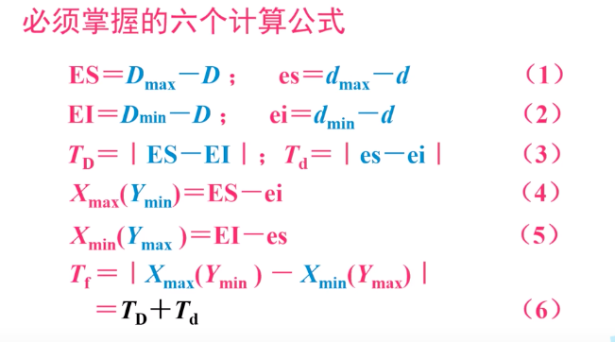
   2. Definition
      1. Nominal size, Basic size: the designed size 名义尺寸（公称尺寸）、基本尺寸：设计给定的尺寸
      2. Actual size 实际尺寸（局部尺寸）
      3. Limit size
   3. Limits: upper & lower, the largest & smallest permissible size
   4. Tolerance $T=L_{max}-L_{min}$
      1. Definition: tolerance is the total amount that a specific dimension is permitted to vary
      2. Tolerance types
         1. Limit dimensions $ϕ_{9.999}^{10.001} or ϕ9.999-10.001$
         2. Plus or minus tolerance ${10.0}_{-0.2}^{+0.1}$
         3. Page or block tolerance
   5. Hole and shaft assembly
      1. Hole, use capital letter to represent
      2. Shaft use lower letter to represent
      3. Allowance 加工余量
   6. MMC & LMC
      1. 最大间隙 $Max clearance={LMC}_{hole}-{LMC}_{shaft}$
      2. 最小间隙 $Min clearance={MMC}_{hole}-{MMC}_{shaft}$
   7. Deviation
      1. Definition: the size of deviation from nominal size/basic size
      2. Fundamental deviation
      3. Limit deviation ES: hole’s upper limit-nominal size es: shaft’s upper limit-nominal size. EI: hole’s lower limit-nominal size ei: shaft’s lower limit-nominal size
      4. Actual deviation Ea: hole’s upper actual size-nominal size
   8. Tolerance designation
      1. Tolerance designation
         1. 公差：允许尺寸的变动范围 Tolerance: the range of size changing
         2. 公差带 Tolerance zone: 基本偏差+IT值（公差等级）
            1. 公差带大小标准化
            2. 公差等级IT值
            3. 公称尺寸
         3. 公差带位置标准化—基本偏差系列
      2. Fits 配合
         1. 间隙配合X 有相对运动 D-d Clearance fits
            1. 最大间隙 Maximum clearance $X_{max}=D_{max}-d_{min}=ES-ei$
            2. 最小间隙 Minimum clearance $X_{min}=D_{min}-d_{max}=EI-es$
            3. 平均间隙 Average clearance $X_{av}=\frac{1}{2}(X_{max}+X_{min})$
         2. 过盈配合Y 传递扭矩D-d Interference fits
            1. 最大过盈 Maximum interference $Y_{max}=D_{max}-d_{min}=EI-es$
            2. 最小过盈 Minimum interference $Y_{min}=D_{min}-d_{max}=ES-ei$
            3. 平均过盈 Average interference $Y_{av}=\frac{1}{2}(Y_{max}+Y_{min})$
         3. Transition fits 过渡配合
         4. Line fits 线性配合
         5. 配合公差 $T_{f}=X_{max}\left(Y_{min}\right)-X_{min}\left(Y_{max}\right)=\left(ES-ei\right)-\left(EI-es\right)=T_{D}+T_{d}$
      3. Basic fit systems 配合制
         1. Hole basis fit system 基孔制H 最小孔径为基础 优先选择（钻头、铰刀）
         2. Shaft basis fit system 基轴制h 最大轴径为基础 （车刀、砂轮）
      4. 未注尺寸公差
2. Geometrical tolerance

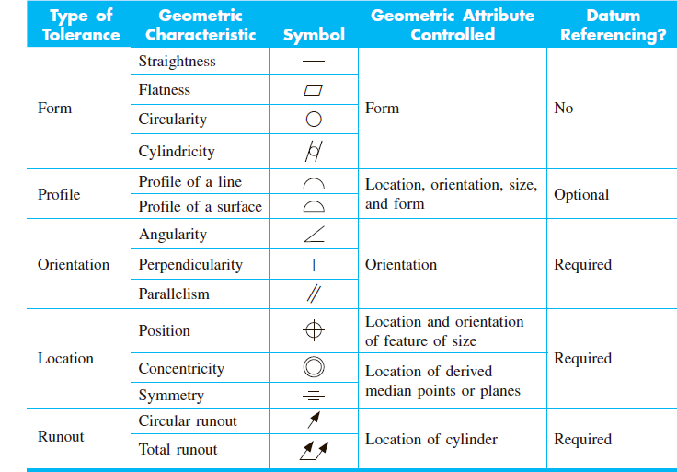

* 1. 几何公差的研究对象--几何要素 Attributes of features
     1. 定义：构成零件几何特征的点线面
     2. 分类
        1. 结构特征
           1. 组成要素：指零件的表面或表面上的线
           2. 导出要素：由一个或几个组成要素得到的中心点、中心线或中心面
        2. 检测关系
           1. 被测要素

（按功能关系分）单一要素

关联要素

* + - * 1. 基准要素 用来确定被测要素的方向和位置的要素
  1. 基准 Datum
     1. 大写的英文字母不许用E,I,J,M,O,P,L,R,F
     2. 用脚标满足多个
     3. 字母必须水平书写
     4. 被测要素为线素的标注 标记LE
  2. 几何公差
     1. 形状公差 Form
        1. 直线度 Straightness： Any extracted (actual)generating line, shall be contained between two parallel lines XX apart
        2. 平面度 Flatness: The extracted (actual) surface shall be contained between two parallel planes XX apart
        3. 圆度 Circularity: The extracted circumferential line, shall be contained between two concentric circles with ad difference in radius of XX apart or shall be contained in a conical zone limited by two circles XX apart.
        4. 圆柱度 Cylindricity: The extracted cylindrical line shall be contained between two coaxial cylinders with a difference in radii of XX
     2. 轮廓公差 Profile
        1. 直线轮廓 Profile of a line: The extracted profile line shall be contained between two equidistant lines enveloping circles of diameter XX, the centers of which are situated on a line having the theoretically exact geometrical form with respect to datum plane A
        2. 表面轮廓 Profile of a surface: The extracted profile surface shall be contained between equidistant surfaces enveloping spheres of diameter XX
     3. 方向公差 Orientation
        1. 平行度 Parallelism: The extracted line shall be contained between two parallel plane XX apart which are parallel to datum A.
        2. 垂直度 Perpendicularity: The extracted line shall be contained between two parallel planes XX apart, which are perpendicular to datum A.
        3. 倾斜度 Angularity: The extracted line shall be contained between two parallel planes XX apart which are inclined at a theoretically exact angle of XX degree to the datum
     4. 位置公差 Location
        1. 位置度 Position
        2. 同轴度 Concentricity(for central points)

Or Coaxiality(for axes)

* + - 1. 对称度 Symmetry: The extracted median surface shall be contained between two parallel planes XX apart, which are symmetrically disposed about datum plane A
    1. 跳动公差 Runout
       1. 圆跳动 Circular runout: The extracted line in any cross section plane perpendicular to datum axis A shall be contained between two coplanar concentric circles with a difference in radii of
          1. 径向
          2. 轴向
          3. 斜向
       2. 全跳动 Total runout The extracted surface shall be contained between two
  1. 延伸公差带 P

1. 表面粗糙度 Surface texture
   1. 定义 Definition: Surface texture is the allowable deviation from a perfectly flat surface that is made by some manufacturing process.
   2. 影响表面粗糙度的主要原因 The main factors which affect the surface texture
      1. 工件材料Material of the workpiece
      2. 加工过程种类 Type of machining process
         1. 粗磨 Grinding
         2. 抛光 Polishing
         3. 研磨(加工对象为面) Lapping
         4. 喷砂 Abrasive blasting
         5. 珩磨 Honing
      3. 机械振动 Vibrations of machines
      4. 切削工具 Cutting tool properties (material, properties, sharpness, etc)
      5. 切削条件 Cutting conditions (speed, feed, depth of cut)
      6. 使用冷却液类型 Type of coolant used
   3. Texture
      1. 粗糙度 Roughness (Primary texture)
      2. 不平度（波度） Waviness (Secondary texture)
      3. 表面纹理（花纹方向）Lay

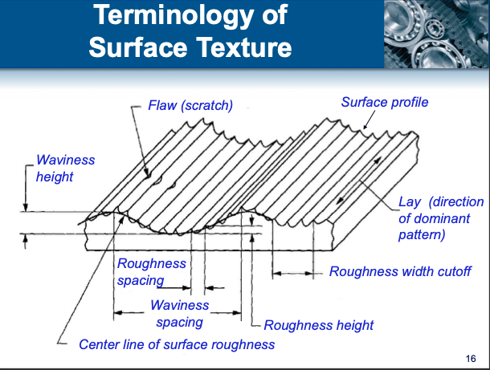

* 1. 表面粗糙度的评定参数 Analysis of surface traces
     1. 表面粗糙度评定的基本术语
        1. 取样长度 $l_{r}$ 基准线长度，至少含5个波峰和波谷。 Sample length, at least contain 5 crests and 5 troughs.
        2. 评定长度 $l_{n}$ 最小的测量长度，一般包括5个取样长度。 Evaluation length, smallest measurling length, normally contains 5 sample length.
        3. 轮廓算数平均中线，在取样长度内，划分实际轮廓为上下面积相同的两部分。 Average roughness index (Center line average)
  2. 表面粗糙度的评定参数
     1. 幅度（高度）参数（越小越好）
        1. 轮廓算数平均偏差 $R_{a}$ Average roughness index (Center line average) $R_{a}=\frac{1}{l_{r}}\int_{0}^{l_{r}}{\left|y\right|dx}$
        2. 轮廓最大高度 $R_{z}$ Mean peak to valley index $R_{z}=Z_{Pmax}+Z_{Vmin}$ or $R_{z}=\frac{\left|R_{1}+R_{3}+R_{5}+R_{7}+R_{9}\right|-\left|R_{2}+R_{4}+R_{6}+R_{8}+R_{10}\right|}{5}$
     2. 间距参数（反应间距特性）（越小越好，密封性、涂装性能好） $RSm=\frac{1}{m}\sum_{i=1}^{m}{Xs_{i}}$
     3. 形状参数-轮廓的支承长度率（值越大越好 耐磨性、接触刚度好） $Rmr\left(C\right)=\frac{\sum_{i=1}^{n}{b_{i}}}{l_{n}}=\frac{ml\left(C\right)}{l_{n}}$
  3. Indication of surface texture 表面粗糙度的标注
     1. 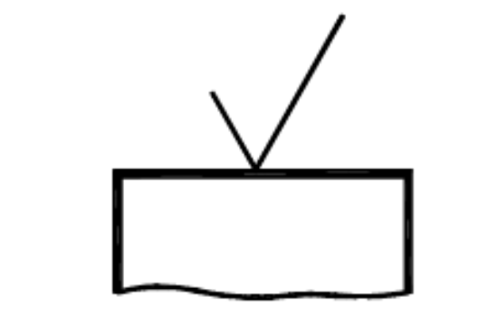 APA- Any process allowed
     2. 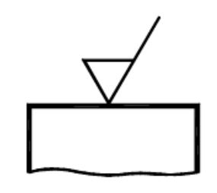 MRR- Material removal required
     3. 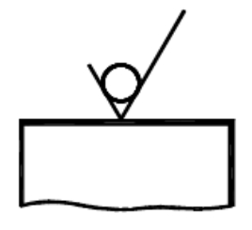 NMR- No material removed
     4. 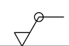When the same surface texture is required on all surfaces around a workpiece a circle shall be added to the complete graphical symbol.

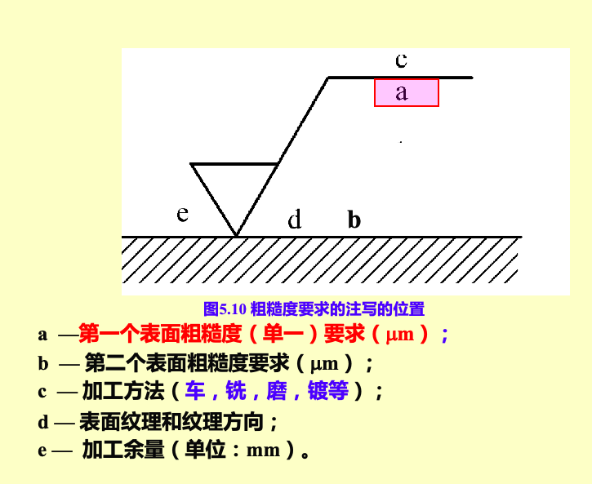

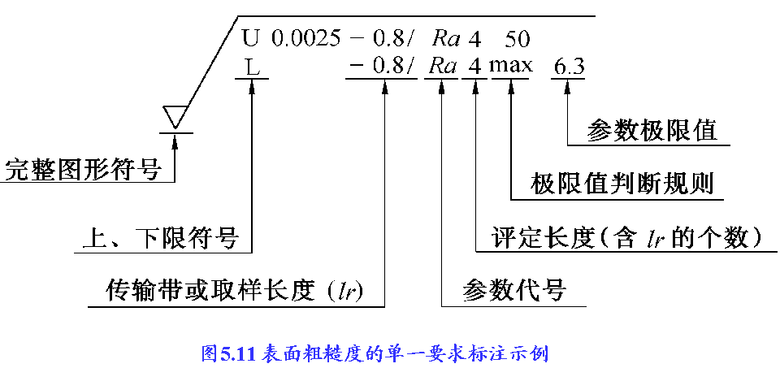

1. 滚动轴承
2. 键精度
3. 螺纹精度
4. 齿轮精度
5. Dimensional chain
   1. Definition: 机器装配过程相互连接尺寸形成的封闭尺寸组。
   2. Consist elements
      1. Link 环
         1. Closing link 封闭环（装配工艺完成后自然形成）
         2. Consisting link 组成环（装配工艺自然形成）
            1. Increasing link $A_{i(+)}$ 增环
            2. Decreasing link $A_{i(-)}$ 减环
   3. Classification
      1. 零件尺寸链
      2. 装配尺寸链
      3. 工艺尺寸链
   4. Calculation
      1. 极值计算公式
         1. 公称尺寸 $A_{0}=\sum_{1}^{m}{A_{i(+)}}-\sum_{m+1}^{n-1}{A_{i(-)}}$
         2. 极限尺寸 $A_{0max}=\sum_{1}^{m}{A_{i(+)max}}-\sum_{m+1}^{n-1}{A_{i(-)min}}$ $A_{0min}=\sum_{1}^{m}{A_{i(+)min}}-\sum_{m+1}^{n-1}{A_{i(-)max}}$
         3. 极限偏差 $ES_{0}=\sum_{1}^{m}{ES_{i(+)}}-\sum_{m+1}^{n-1}{EI_{i(-)}}$ $EI_{0}=\sum_{1}^{m}{EI_{i(+)}}-\sum_{m+1}^{n-1}{ES_{i(-)}}$
         4. 公差（校验公式） $T_{0}=\left|ES_{0}-EI_{0}\right|=\sum_{i=1}^{n-1}{T_{i}}$

封闭环的公差等于所有组成换的公差之和