PCI DSS NETWORK SEGMENTATION REVIEW
CloudNative
Scope of Review | Network segmentation supporting PCI DSS scope reduction
Assessment Date | 2026-08-25
Assessed By | GRC Analyst — CloudNative
Overall Result | Segmentation is effective, with one finding identified and remediated (SEG-07)
1. Executive Summary
CloudNative uses Stripe to handle all card payments — customers enter card details directly into a Stripe-hosted iframe, and CloudNative's own systems never receive, process, or store the actual card number. That design choice already removes most of CloudNative's environment from PCI DSS scope. This review tests whether the network segmentation around that design actually holds up — specifically, whether any internal system could reach cardholder data even though it isn't supposed to. Testing found the segmentation is sound, with one real finding: a maintenance-access firewall rule was left open longer than intended. It didn't expose card data, but it did mean one segmentation claim wasn't accurate at the time of testing. It's since been remediated.
2. Cardholder Data Flow
A customer enters card details into a Stripe-hosted iframe embedded in CloudNative's web application. The iframe content is served directly by Stripe — the card data never passes through CloudNative's servers, network, or logs. Stripe returns a payment token to CloudNative's application, which is what CloudNative stores and uses for subscription billing. Stripe also sends webhook events back to a CloudNative endpoint (handled by the Support Tooling system) confirming payment status and including limited metadata — such as the last 4 digits of the card and the billing outcome — but never the full card number.
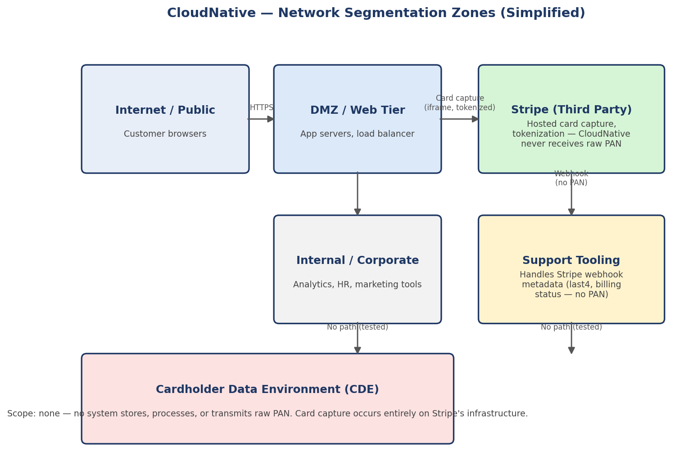
3. Scope Determination
Because CloudNative never receives, transmits, or stores full PAN, no system in CloudNative's own environment qualifies as part of the Cardholder Data Environment (CDE) — card capture happens entirely on Stripe's infrastructure. This is the easy part of the determination. The harder question is what to do about the Support Tooling system, which does receive Stripe webhook data.
Support Tooling is not part of the CDE, because it never receives PAN — only tokenized/truncated data (last 4 digits) and non-sensitive billing status. Per PCI DSS guidance, truncated PAN (first six/last four digits or less) is not considered cardholder data requiring CDE-level protection. However, Support Tooling is treated as a system that INTERACTS with the payment flow, and is held to a higher standard than an unrelated internal system — network segmentation from Support Tooling to the rest of the internal network is tested explicitly (see SEG-05, SEG-07), not assumed.
4. Segmentation Testing
Full test-by-test results are in CloudNative_PCI_Segmentation_Test_Results.xlsx. Summary: 6 of 7 tested paths matched the expected segmentation exactly. One (SEG-07) found an unexpected reachable path from Support Tooling to an internal corporate jump host via a leftover maintenance SSH rule. This did not expose cardholder data — Support Tooling holds no PAN — but it meant the segmentation claim for that specific path was inaccurate at test time, which matters regardless of whether card data was directly at risk.
5. Anticipating Assessor Questions
A generic control list doesn't survive a real assessor conversation — the actual skill is being ready for the follow-up question. These are the ones I'd expect to be asked, and how I'd answer them:
Q: You say Stripe handles all card capture, so how do you know CloudNative's iframe integration isn't leaking PAN into your own logs or request payloads?
A: Because the iframe is served and controlled entirely by Stripe — the parent page (CloudNative's) never has DOM access to the card fields inside it, by design of Stripe's client-side integration. We reviewed CloudNative's application logs and confirmed no card-number-shaped data appears anywhere in request logs, error logs, or application logs. That log review is itself evidence worth keeping alongside this report for the next assessment.
Q: The SEG-07 finding — how do you know that jump host access wasn't used to reach cardholder data before it was closed?
A: Because Support Tooling itself never held PAN, so even full access to a host inside Support Tooling's zone would not have exposed cardholder data — the finding is a segmentation-hygiene issue, not a cardholder-data exposure. That said, we did check network flow logs for the affected window and found no unusual traffic on that path, which we'd present alongside this finding, not just assert it was fine.
Q: Why isn't Support Tooling itself in the CDE, given it directly interacts with Stripe's payment flow?
A: Because CDE scope under PCI DSS is defined by whether a system stores, processes, or transmits PAN — not by whether it interacts with a payment provider at all. Support Tooling receives truncated card data (last 4 digits) and non-sensitive status metadata, which PCI DSS explicitly does not treat as cardholder data requiring CDE controls. We still test its segmentation explicitly rather than assuming it's safe by association, which is what SEG-05 and SEG-07 are for.
Q: How often is this segmentation testing repeated, and what stops another rule like the SEG-07 one from going unnoticed for months?
A: PCI DSS requires segmentation testing at least annually, and after any significant network change. The SEG-07 finding specifically drove a new control: a scheduled quarterly automated re-test of the same segmentation paths (rather than only testing during the annual assessment cycle), specifically to catch rule drift like this faster next time.
6. What This Review Does Not Cover
This review addresses network segmentation and CDE scope determination only. It is not a full PCI DSS assessment (which would additionally cover requirements such as vulnerability management, access control, and logging across whatever remains in scope) and does not replace a Qualified Security Assessor's (QSA) formal validation, which is required for full PCI DSS compliance attestation.

