# 4.0 RESULTS AND APPLICATION

### PHASE 4

**RESULTS AND APPLICATION**

In this project, the user first needs to head to our website i.e. CarGenie. After the website has loaded, the user will be greeted with the attributes page on which they can enter their car details. Various attributes like Company Name, Car Model, Fuel type, Year of Purchase, Kilometers driven are shown. The user will have to individually select each component according to their car from the dropdown list. The list will fetch data from the excel dataset that we provided. The button in the end when clicked on display the estimated price of the car.

### Website of our car price estimator (CarGenie):

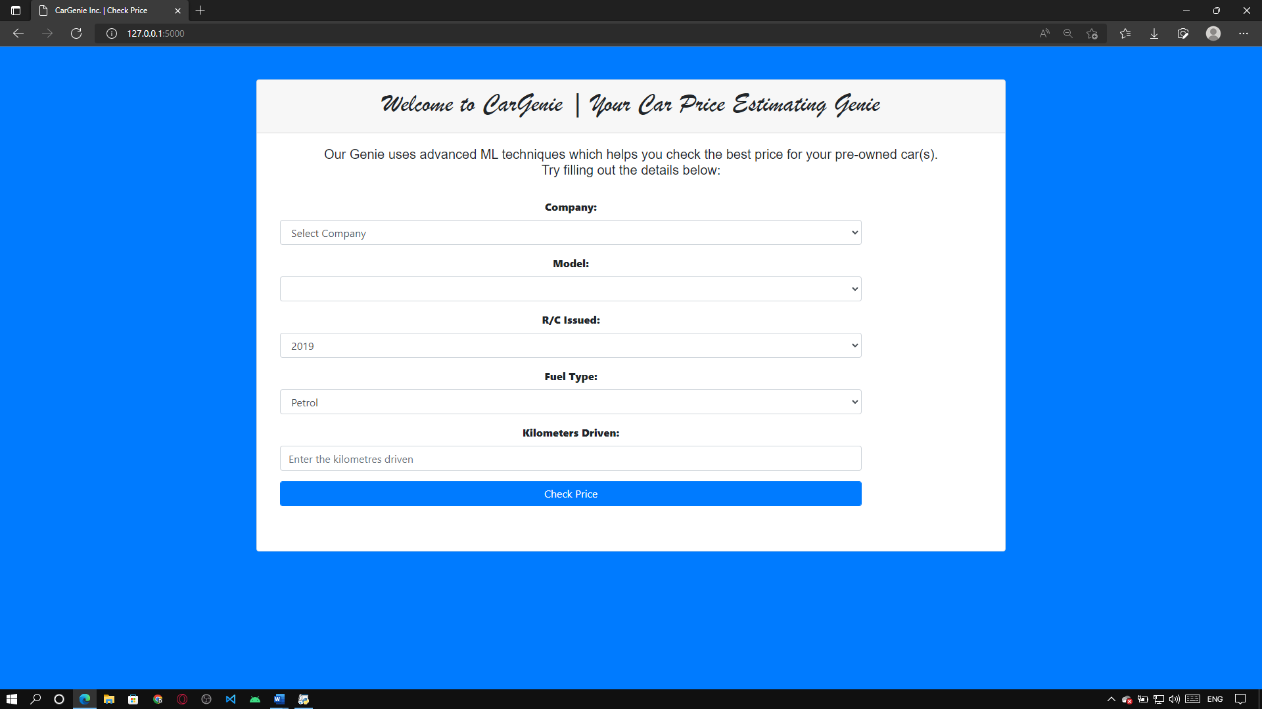

The above figure shows the Graphical User Interface (GUI) of our website (CarGenie). It show the various attributes to be selected by the user.

### Selecting Car Company name:

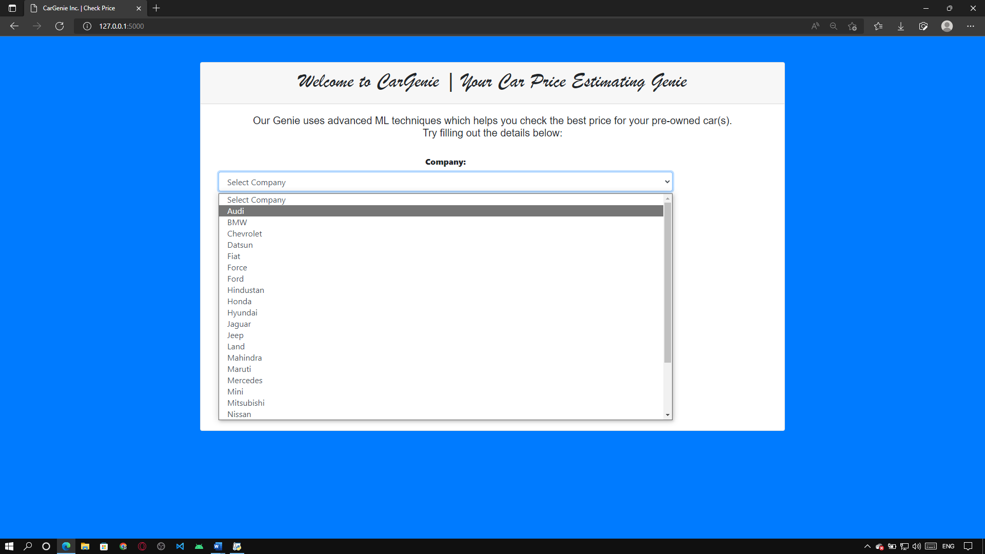

When we first visit the website, we have to select the company name of the car which we own in order to proceed further and get an estimate of the car. There are many companies through which we can choose from in the dropdown list if we want to get an estimate of a car for educational purposes

### Selecting the Car Model:

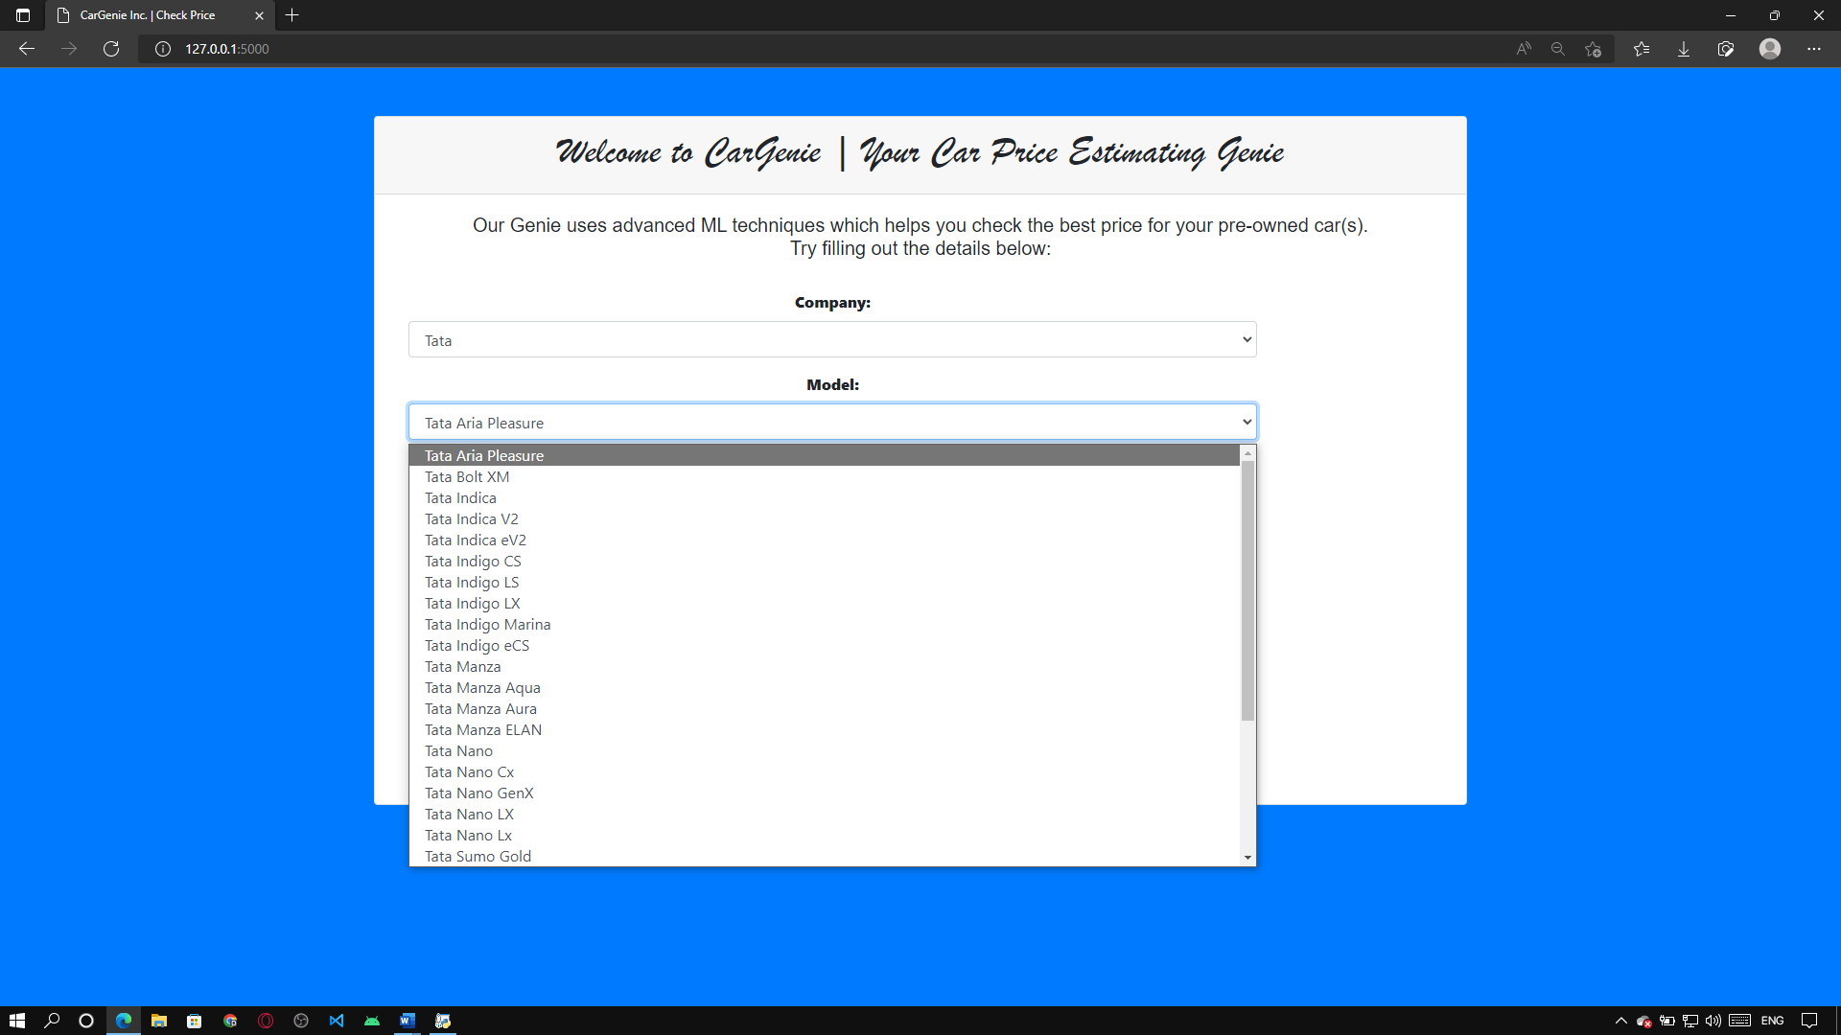

Next, we have to select the model of the car. Models vary as per the company of the car. There are a lot of models to choose from and the user can select their preferred model.

Note that model are different for each company so you’ll have to properly select the company name in order to be able to select the model accurately.

**Selecting the Year of Purchase:**

### 

### Here the user has to select the year in which they purchased the car. We have labelled it as RC issued which is registration in the year the car was registered.

### Selecting the Fuel Type:

### 

### Fuel type is an important factor while determining the price of our car . As many of us know that the prices of fuel are increasing at a very high rate almost every week it is increasing due to which people while buying cars are giving emphasis on fuel type as well.

### Entering the Kilometers Driven:

### 

### Here the user has to enter the kilometers their car has travelled in order to predict the price accurately .

### Check Price:

### 

### Finally after entering all of the above attributes correctly, the user can then click on the check price button through which he will be shown the estimated price for the car. This varies very differently upon every attribute for eg if we even change the year of purchase or even the distance the car has travelled, the estimated price will change.

### 