HO CHI MINH CITY UNIVERSITY OF TECHNOLOGY

DEPARTMENT OF TELECOMMUNICATIONS ENGINEERING

——————– * ———————

ANALOG SIGNAL PROCESSING

PROJECT REPORT

**MATLAB SOLVER PROGRAM**

**FOR OPERATION AMPLIFIER CIRCUITS**

**Lecturer:** Assoc. Prof. Hà Hoàng Kha

**Class:** TT04

**Semester:** 211

**Members:** Lương Triển Thắng 2051194

Nguyễn Ngọc Minh Anh 2051033

Phạm Nguyễn Trung Tín 2051203

*Hồ Chí Minh City – 7th November, 2021*

Table of Contents

I. Introduction to OpAmp 3

1. A brief look at OpAmp 3

2. Open-loop vs. closed-loop operation 4

a. Open-loop 4

b. Closed-loop 4

II. General Knowledge for several ideal OpAmp circuits 5

1. Inverting amplifier circuit 5

2. Non-inverting amplifier circuit 5

3. Summing inverting amplifier circuit 6

4. Summing non-inverting amplifier circuit 7

III. MATLAB Solving Program 8

1. Features and instructions 8

a. Features 8

b. Instructions 9

2. Examples 9

3. GUI designing and coding 11

IV. Appendix 27

V. References 27

VI. Table of Figures 27

# Introduction to OpAmp

## A brief look at OpAmp

|  |  |
| --- | --- |
|  |  |
| UA741CN IC | UA741CN Pinout |

Figure ‑: UA741CN IC and pinout

*Operational Amplifiers*, also known as Op-amps or OpAmps, are basically a voltage amplifying device designed to be used with components like capacitors and resistors, between its in and out terminals. They are essentially a core part of analog devices. OpAmp has positive and negative inputs which allow circuits that use feedback to achieve a wide range of functions. Feedback components like these are used to determine the operation of the amplifier. The amplifier can perform many different operations (resistive, capacitive, or both), giving it the name *Operational Amplifier*.

|  |  |
| --- | --- |
|  | **Terminology**  : non-inverting input voltage  : inverting input voltage  : output voltage  : non-inverting input voltage  : non-inverting input current  : inverting input current  : positive and negative DC supply voltages used to power the OpAmp ()  : difference voltage |

Figure ‑: OpAmp Schematic

Using OpAmp, it's easy to make amplifiers, comparators, log amps, filters, oscillators, data converters, level translators, references, and more. Mathematical functions like addition, subtraction, multiplication, and integration can be easily accomplished.

The operational amplifier is arguably the most useful single device in analog electronic circuitry. With only a handful of external components, it can be made to perform a wide variety of analog signal processing tasks. It is also quite affordable, most general-purpose amplifiers selling for under a dollar apiece. Modern designs have been engineered with durability in mind as well: several “op-amps” are manufactured that can sustain direct short-circuits on their outputs without damage.

Figure ‑: Schematic of LM741 from its datasheet of Texas Instruments

One key to the usefulness of these little circuits is in the engineering principle of feedback, particularly negative feedback, which constitutes the foundation of almost all automatic control processes. Its numerous practical applications include instrumentation amplifiers, digital-to-analog converters, analog computers, level shifters, filters, calibration circuits, inverters, summers, integrators, differentiators, subtractors, logarithmic amplifiers, comparators, gyrators, oscillators, rectifiers, regulators, voltage-to-current converters, current-to-voltage converters, and clippers.

## Open-loop vs. closed-loop operation

### Open-loop

* Rarely used.
* OpAmp specification may be important.

|  |  |
| --- | --- |
|  | **Properties**  : differential input voltage  : open-loop gain  (typical value: )  In general:  or |

Figure ‑: Open-loop circuit and its properties

### Closed-loop

* Most used.
* Some sort of feedback from output to input exists.
* The input voltage is defined according to the application.

|  |  |
| --- | --- |
|  | **Properties**  : closed-loop gain |

Figure ‑: Closed-loop circuit and its properties

# General Knowledge for several ideal OpAmp circuits

The ideal op-amp is an amplifier with infinite input impedance, infinite open-loop gain, zero out-put impedance, infinite bandwidth, and zero noise. It has positive and negative inputs which allow circuits that use feedback to achieve a wide range of functions.

Assumptions for ideal OpAmp:

* Assume that negative feedback: .
* Assume the input(s) resistance is finite, so .

## Inverting amplifier circuit

An Inverting Amplifier is a type of Operational Amplifier circuit which produces an output which is out of phase with respect to its input by 180°.

This mean that if the input pulse is positive, then the output pulse will be negative and vice versa.

* 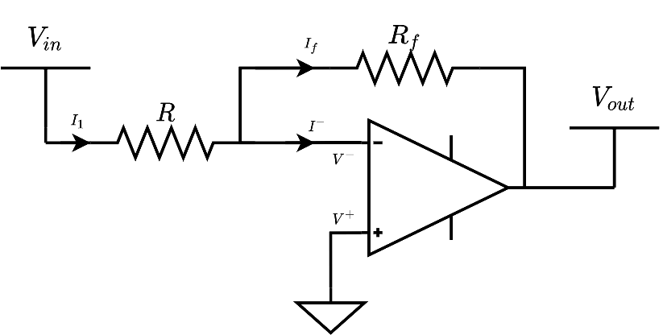Since is connected to the ground, then
* Apply KCL:

Figure ‑: Inverting OpAmp Circuit

## Non-inverting amplifier circuit

A non-inverting Amplifier is an OpAmp circuit configuration that produces an amplified output signal which is in phase with the applied input signal. In other words, a non-inverting amplifier behaves like a voltage follower circuit. A non-inverting amplifier also uses a negative feedback connection, but instead of feeding the entire output signal to the input, only a part of the output signal voltage is fed back as input to the inverting input terminal of the OpAmp.

Apply KCL:

Figure ‑: Non-inverting OpAmp Circuit

## Summing inverting amplifier circuit

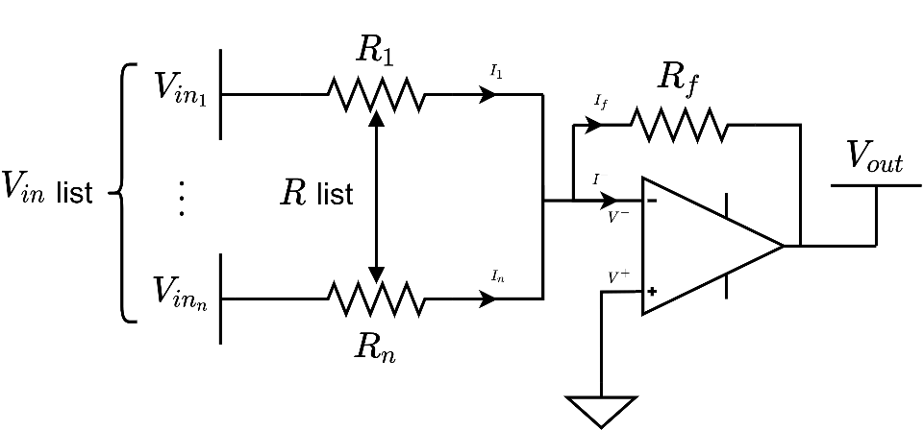A summing amplifier is an example of an inverting amplifier with multiple inputs, enabling to effectively add several individual input signals, which proves to be useful in audio mixing applications. Its output is the sum of each input scaled by the corresponding resistor ratio.

Figure ‑: Summing Inverting OpAmp Circuit

* Since is connected to the ground, then
* Apply KCL:

## Summing non-inverting amplifier circuit

The non-inverting summing amplifier is based on around the configuration of a non-inverting operational amplifier circuit in that the input (either DC or AC) is applied to the non-inverting terminal, while the required negative feedback and gain is achieved by feeding back some portion of the output signal () to the inverting terminal.

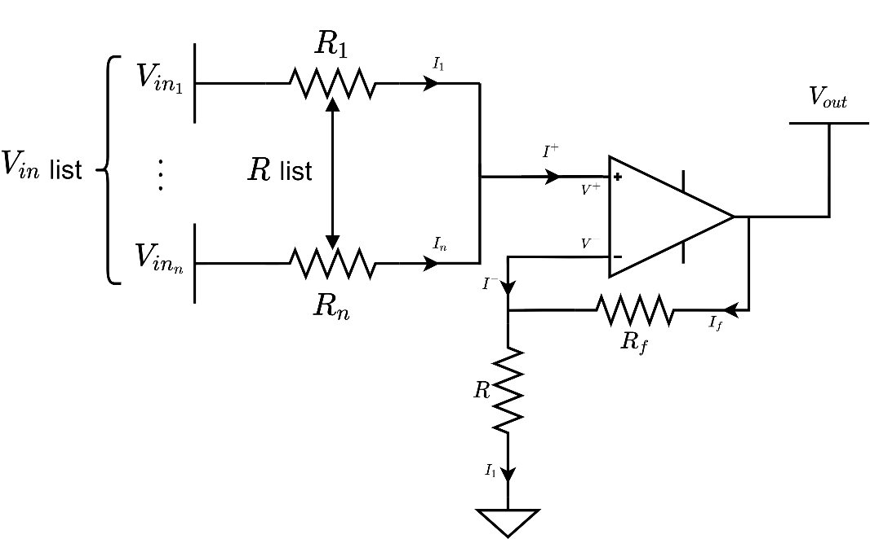

Figure ‑: Summing Non-inverting OpAmp Circuit

Apply KCL:

|  |  |
| --- | --- |
|  |  |

# MATLAB Solving Program

## Features and instructions

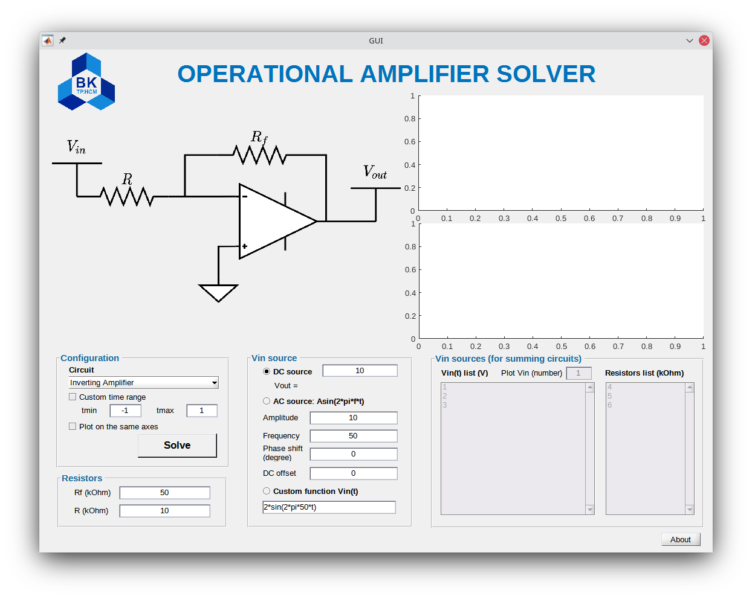

Figure ‑: GUI for Operational Amplifier Solver

### Features

* Includes four different circuits:
  + Inverting Amplifier
  + Non-inverting Amplifier
  + Summing Inverting Amplifier
  + Summing Non-inverting Amplifier
* Three different types of source signals:
  + DC source
  + AC source
  + Custom function
* For Summing circuits, input can be maximum of 100 sources.
* Time domain can be adjusted for the graphs.
* Input and output can be plotted on a single axes.
* Resistor (potentiometer) can be a function that changes over time (must not be negative).
* All inputs accept basic operations, e.g.,

### Instructions

* **Step 1:** Choose the circuit.
* **Step 2:** 
  + If non-summing circuit is chosen:  
    Choose the source in “Vin source” panel then fill the value.
  + If summing circuit is chosen:  
    Fill in the value of the source and resistors in “Vin sources (for summing circuits)” panel in the exact order.  
    *Note:* The number of the Vin and the number of resistors must be equal.
* **Step 3:** Fill in the value and (if needed) in “Resistors” panel.
* **Step 4:** (optional)
  + Custom the time range (tmin, tmax) to plot Vin and Vout in that range only.
  + Tick “Plot on the same axes” to plot Vin and Vout on the same axes.
* **Step 5:** Press the “Solve” button and the results will shown up.[1]

## Examples

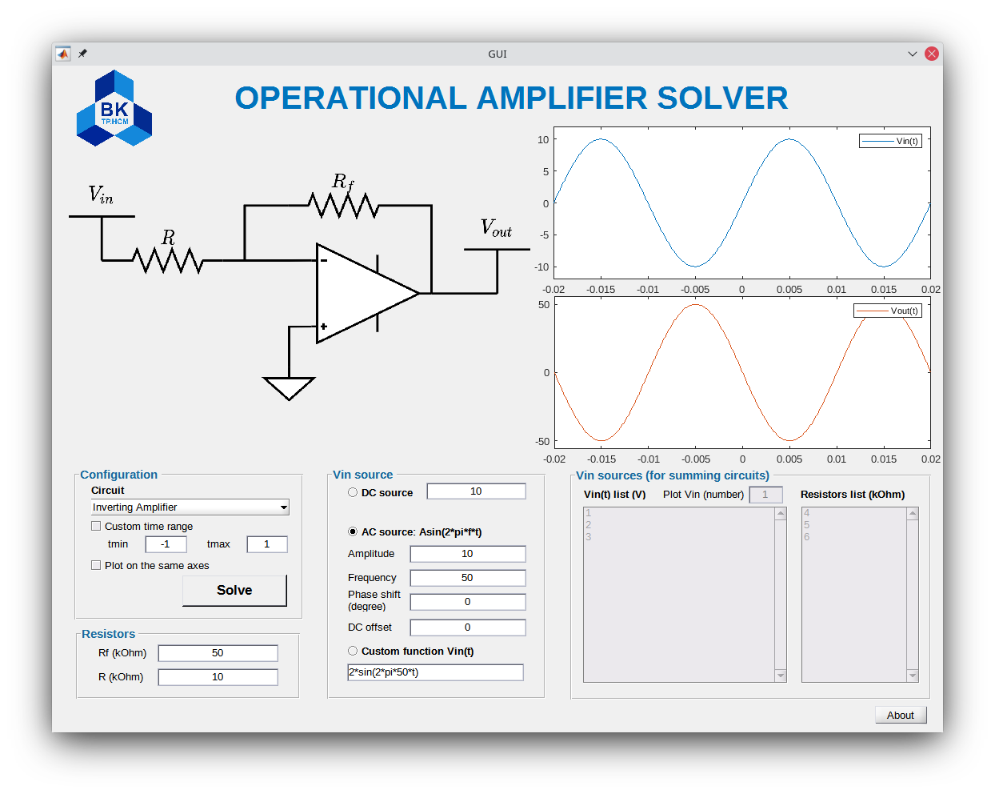

Figure ‑: Inverting Amplifier with AC source

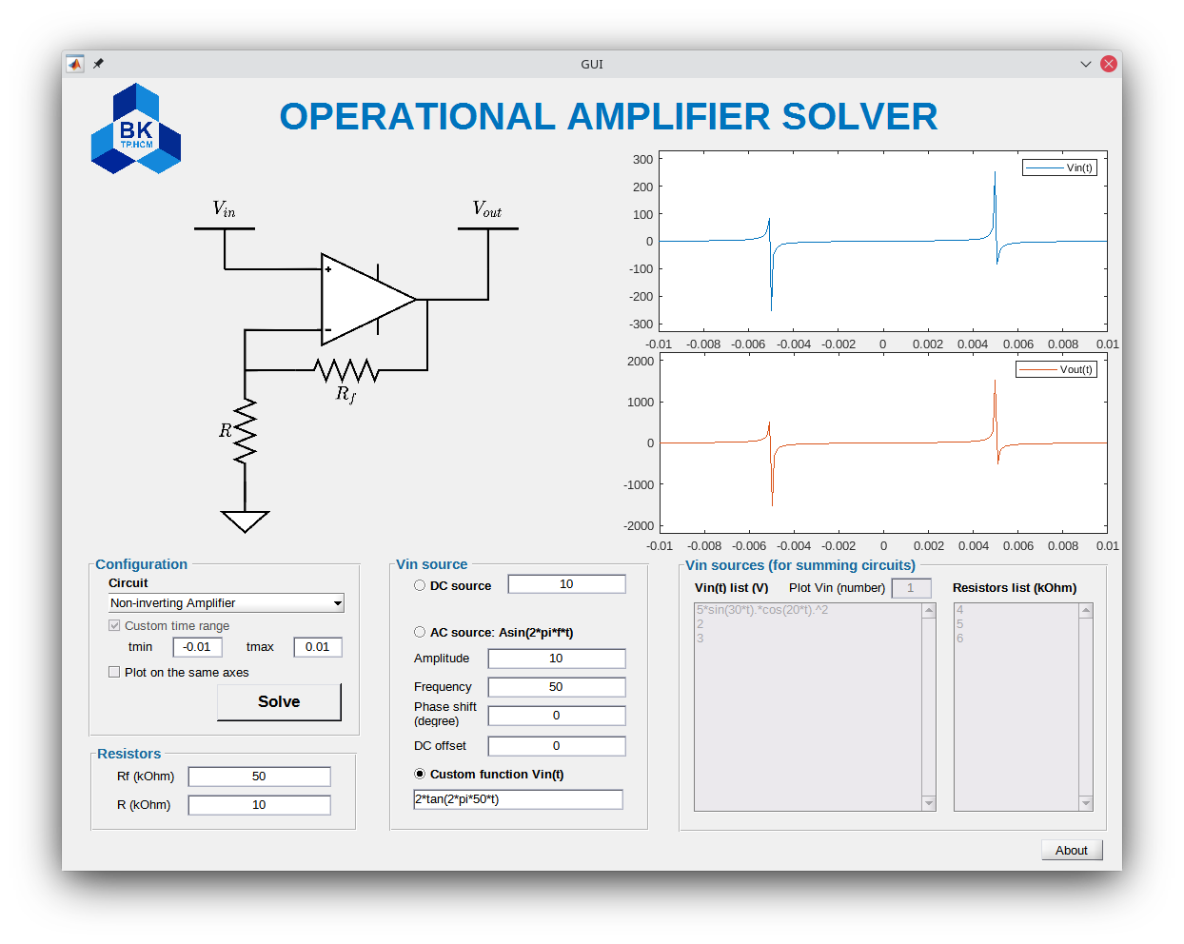

Figure ‑: Non-inverting Amplifier with custom function

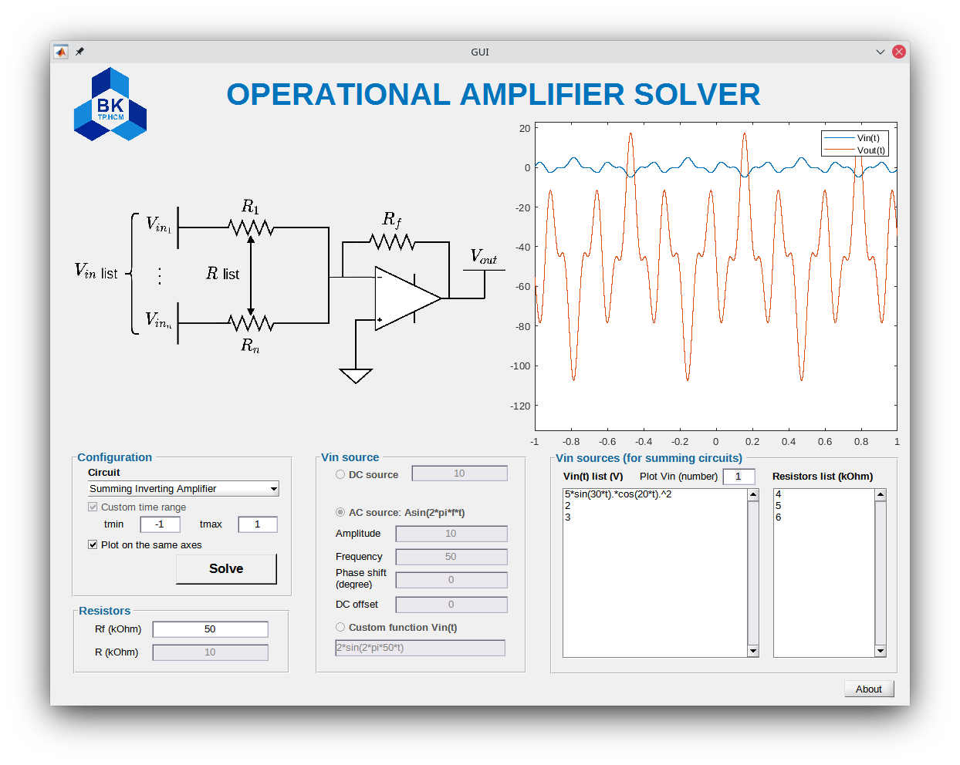

Figure ‑: Summing Inverting Amplifier with a list of 3 Vins, 3 resistors

## GUI designing and coding

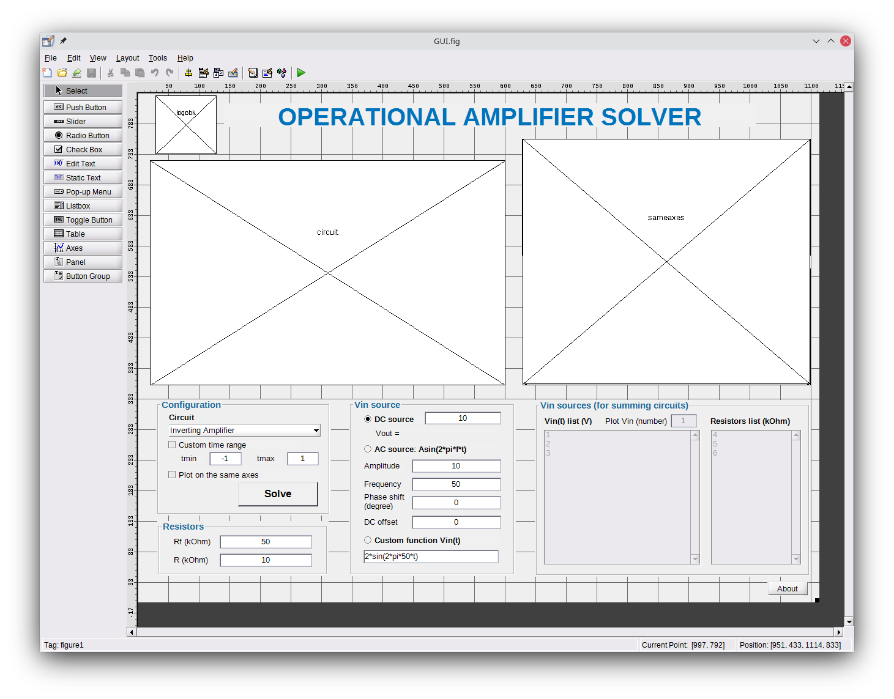

Figure ‑: GUI designing in GUIDE

To achieve “Plot on the same axes” feature, a new axes is put on top of vin and vout graph.

After finish designing the GUI, it’s time for the code.

When looking closely into the code below, the first function is GUI_OpeningFcn which clarifies the initial user interface.

Then, code lines are all “Callback” functions which are the procedures that will be performed when the users interact.

All green code lines are “comments”, are also the notes about how these code’s procedure is employed for and then follow pre-programming sequence. The page will be rotated to better showing the comments.

function varargout = GUI(varargin)

% GUI MATLAB code for GUI.fig

% GUI, by itself, creates a new GUI or raises the existing

% singleton*.

%

% H = GUI returns the handle to a new GUI or the handle to

% the existing singleton*.

%

% GUI('CALLBACK',hObject,eventData,handles,...) calls the local

% function named CALLBACK in GUI.M with the given input arguments.

%

% GUI('Property','Value',...) creates a new GUI or raises the

% existing singleton*. Starting from the left, property value pairs are

% applied to the GUI before GUI_OpeningFcn gets called. An

% unrecognized property name or invalid value makes property application

% stop. All inputs are passed to GUI_OpeningFcn via varargin.

%

% *See GUI Options on GUIDE's Tools menu. Choose "GUI allows only one

% instance to run (singleton)".

%

% See also: GUIDE, GUIDATA, GUIHANDLES

% Edit the above text to modify the response to help GUI

% Last Modified by GUIDE v2.5 06-Nov-2021 22:29:48

% Begin initialization code - DO NOT EDIT

gui_Singleton = 1;

gui_State = struct('gui_Name', mfilename, ...

'gui_Singleton', gui_Singleton, ...

'gui_OpeningFcn', @GUI_OpeningFcn, ...

'gui_OutputFcn', @GUI_OutputFcn, ...

'gui_LayoutFcn', [] , ...

'gui_Callback', []);

if nargin && ischar(varargin{1})

gui_State.gui_Callback = str2func(varargin{1});

end

if nargout

[varargout{1:nargout}] = gui_mainfcn(gui_State, varargin{:});

else

gui_mainfcn(gui_State, varargin{:});

end

% End initialization code - DO NOT EDIT

% --- Executes just before GUI is made visible.

function GUI_OpeningFcn(hObject, ~, handles, varargin)

% This function has no output args, see OutputFcn.

% hObject handle to figure

% eventdata reserved - to be defined in a future version of MATLAB

% handles structure with handles and user data (see GUIDATA)

% varargin command line arguments to GUI (see VARARGIN)

% Choose default command line output for GUI

handles.output = hObject;

% Update handles structure

guidata(hObject, handles);

% UIWAIT makes GUI wait for user response (see UIRESUME)

% uiwait(handles.figure1);

axes(handles.circuit);

[im, ~, alpha] = imread('invert.png');

f = imshow(im);

set(f, 'AlphaData', alpha);

axes(handles.logobk);

[im, ~, alpha] = imread('logobk.png');

f = imshow(im);

set(f, 'AlphaData', alpha);

% --- Outputs from this function are returned to the command line.

function varargout = GUI_OutputFcn(~, ~, handles)

% varargout cell array for returning output args (see VARARGOUT);

% hObject handle to figure

% eventdata reserved - to be defined in a future version of MATLAB

% handles structure with handles and user data (see GUIDATA)

% Get default command line output from handles structure

varargout{1} = handles.output;

% % % START HERE !!!

% ---------------------- CONFIGURATION PANEL ----------------------

% CIRCUIT SELECTING MENU

% When changing the circuit

% - Change the circuit diagram (png transparent).

% - Change back to AC source to avoid bugs.

% - If the summing circuit is selected, custom time range must be on.

function circuitselect_Callback(hObject, ~, handles)

axes(handles.circuit);

if(get(hObject,'Value') == 1)

set(handles.customtimechkbox, 'Enable','on');

set(handles.rtxtbox, 'Enable','on');

set(handles.acsourcebtn, 'Value', 1);

[im, ~, alpha] = imread('invert.png');

summingon(false,handles);

elseif(get(hObject,'Value') == 2)

set(handles.customtimechkbox, 'Enable','on');

set(handles.rtxtbox, 'Enable','on');

set(handles.acsourcebtn, 'Value', 1);

[im, ~, alpha] = imread('noninvert.png');

summingon(false,handles);

elseif(get(hObject,'Value') == 3)

set(handles.customtimechkbox, 'Value',1);

set(handles.customtimechkbox, 'Enable','off');

set(handles.rtxtbox, 'Enable','off');

set(handles.acsourcebtn, 'Value', 1);

[im, ~, alpha] = imread('invert_sum.png');

summingon(true,handles);

elseif(get(hObject,'Value') == 4)

set(handles.customtimechkbox, 'Value',1);

set(handles.customtimechkbox, 'Enable','off');

set(handles.rtxtbox, 'Enable','on');

set(handles.acsourcebtn, 'Value', 1);

[im, ~, alpha] = imread('noninvert_sum.png');

summingon(true,handles);

end

f = imshow(im);

set(f, 'AlphaData', alpha);

function circuitselect_CreateFcn(hObject, ~, ~)

if ispc && isequal(get(hObject,'BackgroundColor'), get(0,'defaultUicontrolBackgroundColor'))

set(hObject,'BackgroundColor','white');

end

% CUSTOM TIME RANGE CHECKBOX

function customtimechkbox_CreateFcn(~, ~, ~)

function customtimechkbox_Callback(~, ~, ~)

% TMIN TEXTBOX

% FEATURES:

% - Can use some simple mathematical operation, eg. +, -, *, /, ^, ...

% - Avoid some unexpected input, eg. text

% IDEAS:

% - Create of a list of text that need to be ignore.

% - If one or more ignore text contained in the text:

% + Try to evaluate it.

% + If the evaluation failed, set the text to '0'.

% - If there is no ignore text:

% + Try to convert it into (double).

% + If the conversion failed, set the text to '0'.

function tmintxtbox_Callback(hObject, ~, handles)

value = get(hObject, 'String');

ignore = ["+","-","*","/","pi","^","exp","log","abs","mod"];

if(contains(value,ignore))

try

value = eval(value);

set(handles.tmintxtbox, 'String', string(value));

catch ME

set(handles.tmintxtbox, 'String', '0');

end

else

value = str2double(value);

if(isnan(value))

set(handles.tmintxtbox, 'String', '0');

end

end

function tmintxtbox_CreateFcn(hObject, ~, ~)

if ispc && isequal(get(hObject,'BackgroundColor'), get(0,'defaultUicontrolBackgroundColor'))

set(hObject,'BackgroundColor','white');

end

% TMAX TEXTBOX

% FEATURES:

% - Can use some simple mathematical operation, eg. +, -, *, /, ^, ...

% - Avoid some unexpected input, eg. text

% IDEAS:

% - Create of a list of text that need to be ignore.

% - If one or more ignore text contained in the text:

% + Try to evaluate it.

% + If the evaluation failed, set the text to '0'.

% - If there is no ignore text:

% + Try to convert it into (double).

% + If the conversion failed, set the text to '0'.

function tmaxtxtbox_Callback(hObject, ~, handles)

value = get(hObject, 'String');

ignore = ["+","-","*","/","pi","^","exp","log","abs","mod"];

if(contains(value,ignore))

try

value = eval(value);

set(handles.tmaxtxtbox, 'String', string(value));

catch ME

set(handles.tmaxtxtbox, 'String', '0');

end

else

value = str2double(value);

if(isnan(value))

set(handles.tmaxtxtbox, 'String', '0');

end

end

function tmaxtxtbox_CreateFcn(hObject, ~, ~)

if ispc && isequal(get(hObject,'BackgroundColor'), get(0,'defaultUicontrolBackgroundColor'))

set(hObject,'BackgroundColor','white');

end

% PLOT ON THE SAME AXES CHECKBOX

function sameaxeschkbox_Callback(~, ~, ~)

% ---------------------- RESISTORS PANEL ----------------------

% RF TEXTBOX

% FEATURES:

% - Can use some simple mathematical operation, eg. +, -, *, /, ^, ...

% - Avoid some unexpected input, eg. text (except "t")

% IDEAS:

% - Create of a list of text that need to be ignore.

% - If one or more ignore text contained in the text:

% + Try to evaluate it.

function rftxtbox_Callback(hObject, ~, handles)

value = get(hObject, 'String');

ignore = ["+","-","*","/","pi","^","exp","log","abs","mod"];

if(contains(value,ignore))

try

value = eval(value);

set(handles.rftxtbox, 'String', string(value));

catch ME

end

end

function rftxtbox_CreateFcn(hObject, ~, ~)

if ispc && isequal(get(hObject,'BackgroundColor'), get(0,'defaultUicontrolBackgroundColor'))

set(hObject,'BackgroundColor','white');

end

% R TEXTBOX

% FEATURES:

% - Can use some simple mathematical operation, eg. +, -, *, /, ^, ...

% - Avoid some unexpected input, eg. text (except "t")

% IDEAS:

% - Create of a list of text that need to be ignore.

% - If one or more ignore text contained in the text:

% + Try to evaluate it.

function rtxtbox_Callback(hObject, ~, handles)

value = get(hObject, 'String');

ignore = ["+","-","*","/","pi","^","exp","log","abs","mod"];

if(contains(value,ignore))

try

value = eval(value);

set(handles.rtxtbox, 'String', string(value));

catch ME

end

end

function rtxtbox_CreateFcn(hObject, ~, ~)

if ispc && isequal(get(hObject,'BackgroundColor'), get(0,'defaultUicontrolBackgroundColor'))

set(hObject,'BackgroundColor','white');

end

% ---------------------- VIN SOURCE PANEL ----------------------

% DC SOURCE TEXTBOX

% FEATURES:

% - Can use some simple mathematical operation, eg. +, -, *, /, ^, ...

% - Avoid some unexpected input, eg. text

% IDEAS:

% - Create of a list of text that need to be ignore.

% - If one or more ignore text contained in the text:

% + Try to evaluate it.

% + If the evaluation failed, set the text to '0'.

% - If there is no ignore text:

% + Try to convert it into (double).

% + If the conversion failed, set the text to '0'.

function dcsourcetxtbox_Callback(hObject, ~, handles)

value = get(hObject, 'String');

ignore = ["+","-","*","/","pi","^","exp","log","abs","mod"];

if(contains(value,ignore))

try

value = eval(value);

set(handles.dcsourcetxtbox, 'String', string(value));

catch ME

set(handles.dcsourcetxtbox, 'String', '0');

end

else

value = str2double(value);

if(isnan(value))

set(handles.dcsourcetxtbox, 'String', '0');

end

end

function dcsourcetxtbox_CreateFcn(hObject, ~, ~)

if ispc && isequal(get(hObject,'BackgroundColor'), get(0,'defaultUicontrolBackgroundColor'))

set(hObject,'BackgroundColor','white');

end

% DC SOURCE RADIO BUTTON

% If selected, custom time range must be using and does not allow turning

% it off and vice versa.

function dcsourcebtn_Callback(hObject, ~, handles)

if(get(hObject,'Value') == 1)

set(handles.customtimechkbox, 'Value',1)

set(handles.customtimechkbox, 'Enable','off')

else

set(handles.customtimechkbox, 'Enable','on')

end

% AC SOURCE RADIO BUTTON

% If selected, custom time range can be or not be using and allow turning

% it on or off and vice versa.

function acsourcebtn_Callback(hObject, ~, handles)

if(get(hObject,'Value') == 0)

set(handles.customtimechkbox, 'Value',1)

set(handles.customtimechkbox, 'Enable','off')

else

set(handles.customtimechkbox, 'Enable','on')

end

% AMPLITUDE TEXTBOX

% FEATURES:

% - Can use some simple mathematical operation, eg. +, -, *, /, ^, ...

% - Avoid some unexpected input, eg. text, negative value

% IDEAS:

% - Create of a list of text that need to be ignore.

% - If one or more ignore text contained in the text:

% + Try to evaluate it, get the absolute value of it's negative.

% + If the evaluation failed, set the text to '0'.

% - If there is no ignore text:

% + Try to convert it into (double), get the absolute value of it's negative.

% + If the conversion failed, set the text to '0'.

function atxtbox_Callback(hObject, ~, handles)

value = get(hObject, 'String');

ignore = ["+","-","*","/","pi","^","exp","log","abs","mod"];

if(contains(value,ignore))

try

value = eval(value);

if(value < 0)

set(handles.atxtbox, 'String', abs(value));

else

set(handles.atxtbox, 'String', string(value));

end

catch ME

set(handles.atxtbox, 'String', '0');

end

else

value = str2double(value);

if(isnan(value))

set(handles.atxtbox, 'String', '0');

end

if(value < 0)

set(handles.atxtbox, 'String', abs(value));

end

end

function atxtbox_CreateFcn(hObject, ~, ~)

if ispc && isequal(get(hObject,'BackgroundColor'), get(0,'defaultUicontrolBackgroundColor'))

set(hObject,'BackgroundColor','white');

end

% FREQUENCY TEXTBOX

% FEATURES:

% - Can use some simple mathematical operation, eg. +, -, *, /, ^, ...

% - Avoid some unexpected input, eg. text, negative value, zero

% IDEAS:

% - Create of a list of text that need to be ignore.

% - If one or more ignore text contained in the text:

% + Try to evaluate it, get the absolute value of it's negative.

% + If it's 0 or the evaluation failed, set the text to '1'.

% - If there is no ignore text:

% + Try to convert it into (double), get the absolute value of it's negative.

% + If it's 0 or the conversion failed, set the text to '1'.

function freqtxtbox_Callback(hObject, ~, handles)

value = get(hObject, 'String');

ignore = ["+","-","*","/","pi","^","exp","log","abs","mod"];

if(contains(value,ignore))

try

value = eval(value);

if(value < 0)

set(handles.freqtxtbox, 'String', abs(value));

elseif(value == 0)

set(handles.freqtxtbox, 'String', '1');

else

set(handles.freqtxtbox, 'String', string(value));

end

catch ME

set(handles.freqtxtbox, 'String', '1');

end

else

value = str2double(value);

if(isnan(value) || value == 0)

set(handles.freqtxtbox, 'String', '1');

end

if(value < 0)

set(handles.freqtxtbox, 'String', abs(value));

end

end

function freqtxtbox_CreateFcn(hObject, ~, ~)

if ispc && isequal(get(hObject,'BackgroundColor'), get(0,'defaultUicontrolBackgroundColor'))

set(hObject,'BackgroundColor','white');

end

% PHASE SHIFT TEXTBOX

% FEATURES:

% - Can use some simple mathematical operation, eg. +, -, *, /, ^, ...

% - Avoid some unexpected input, eg. text

% IDEAS:

% - Create of a list of text that need to be ignore.

% - If one or more ignore text contained in the text:

% + Try to evaluate it.

% + If the evaluation failed, set the text to '0'.

% - If there is no ignore text:

% + Try to convert it into (double).

% + If the conversion failed, set the text to '0'.

function phasetxtbox_Callback(hObject, ~, handles)

value = get(hObject, 'String');

ignore = ["+","-","*","/","pi","^","exp","log","abs","mod"];

if(contains(value,ignore))

try

value = eval(value);

if(value < 0)

set(handles.phasetxtbox, 'String', abs(value));

else

set(handles.phasetxtbox, 'String', string(value));

end

catch ME

set(handles.phasetxtbox, 'String', '0');

end

else

value = str2double(value);

if(isnan(value))

set(handles.phasetxtbox, 'String', '0');

end

if(value < 0)

set(handles.phasetxtbox, 'String', abs(value));

end

end

function phasetxtbox_CreateFcn(hObject, ~, ~)

if ispc && isequal(get(hObject,'BackgroundColor'), get(0,'defaultUicontrolBackgroundColor'))

set(hObject,'BackgroundColor','white');

end

% DC OFFSET TEXTBOX

% FEATURES:

% - Can use some simple mathematical operation, eg. +, -, *, /, ^, ...

% - Avoid some unexpected input, eg. text

% IDEAS:

% - Create of a list of text that need to be ignore.

% - If one or more ignore text contained in the text:

% + Try to evaluate it.

% + If the evaluation failed, set the text to '0'.

% - If there is no ignore text:

% + Try to convert it into (double).

% + If the conversion failed, set the text to '0'.

function dctxtbox_Callback(hObject, ~, handles)

value = get(hObject, 'String');

ignore = ["+","-","*","/","pi","^","exp","log","abs","mod"];

if(contains(value,ignore))

try

value = eval(value);

set(handles.dctxtbox, 'String', string(value));

catch ME

set(handles.dctxtbox, 'String', '0');

end

else

value = str2double(value);

if(isnan(value))

set(handles.dctxtbox, 'String', '0');

end

end

function dctxtbox_CreateFcn(hObject, ~, ~)

if ispc && isequal(get(hObject,'BackgroundColor'), get(0,'defaultUicontrolBackgroundColor'))

set(hObject,'BackgroundColor','white');

end

% CUSTOM FUNCTION RADIO BUTTON

% If selected, custom time range must be using and does not allow turning

% it off and vice versa.

function customfuncbtn_Callback(hObject, ~, handles)

if(get(hObject,'Value') == 1)

set(handles.customtimechkbox, 'Value',1)

set(handles.customtimechkbox, 'Enable','off')

else

set(handles.customtimechkbox, 'Enable','on')

end

% CUSTOM FUNCTION TEXTBOX

function customfunctxtbox_Callback(~, ~, ~)

function customfunctxtbox_CreateFcn(hObject, ~, ~)

if ispc && isequal(get(hObject,'BackgroundColor'), get(0,'defaultUicontrolBackgroundColor'))

set(hObject,'BackgroundColor','white');

end

% ---------------------- VINS AND RESISTORS (for summing circuit) PANEL ----------------------

% VIN SUM LIST TEXTBOX

% PROBLEMS:

% - If the list has 5 itmes, and plot the 5th vin is selected, when

% removing items, the vinplottxtbox should be updated as the new max.

function vinsumlist_Callback(hObject, ~, handles)

value = str2double(get(handles.vinplottxtbox,'String'));

vinlist = get(hObject,'String');

[row, ~] = size(vinlist);

if(isnan(value))

set(handles.vinplottxtbox,'String',1);

elseif(value > row)

set(handles.vinplottxtbox,'String',string(row));

elseif (value < 1)

set(handles.vinplottxtbox,'String','1');

end

function vinsumlist_CreateFcn(hObject, ~, ~)

if ispc && isequal(get(hObject,'BackgroundColor'), get(0,'defaultUicontrolBackgroundColor'))

set(hObject,'BackgroundColor','white');

end

% R SUM LIST TEXTBOX

function rsumlist_Callback(~, ~, ~)

function rsumlist_CreateFcn(hObject, ~, ~)

if ispc && isequal(get(hObject,'BackgroundColor'), get(0,'defaultUicontrolBackgroundColor'))

set(hObject,'BackgroundColor','white');

end

% PLOT VIN SELECT TEXTBOX

% Selecting Vin to plot (summing circuit)

% FEATURES:

% - Only allow user input numbers that in the range of 1 to max of textbox

function vinplottxtbox_Callback(hObject, ~, handles)

value = str2double(get(hObject,'String'));

vinlist = get(handles.vinsumlist,'String');

[row, ~] = size(vinlist);

if(isnan(value))

set(hObject,'String',1);

elseif(value > row)

set(hObject,'String',string(row));

elseif (value < 1)

set(hObject,'String','1');

end

function vinplottxtbox_CreateFcn(hObject, ~, ~)

if ispc && isequal(get(hObject,'BackgroundColor'), get(0,'defaultUicontrolBackgroundColor'))

set(hObject,'BackgroundColor','white');

end

% ---------------------- SELF-DEFINED FUNCTIONS ----------------------

% IF THE PROGRAM IS SOLVING

% Lock the "Solve" button and change the text into "Please wait..." and

% revert if done.

function isSolving(True, handles)

if(True == false)

set(handles.solvebtn, 'String', 'Solve');

set(handles.solvebtn, 'Value', 0);

set(handles.solvebtn, 'Enable', 'on');

else

set(handles.solvebtn, 'String', 'Please wait...');

set(handles.solvebtn, 'Value', 1);

set(handles.solvebtn, 'Enable', 'off');

end

% IF SUMMING CIRCUIT IS SELECTED

% Turn off all items which don't belongs to summing circuit and turn on

% all items which belongs to summing circuit and vice versa.

function summingon(istrue,handles)

if(istrue == false)

set(handles.vinsumlist,'Enable','off');

set(handles.rsumlist,'Enable','off');

set(handles.vinplottxtbox,'Enable','off');

set(handles.dcsourcetxtbox,'Enable','on');

set(handles.atxtbox,'Enable','on');

set(handles.freqtxtbox,'Enable','on');

set(handles.phasetxtbox,'Enable','on');

set(handles.dctxtbox,'Enable','on');

set(handles.customfunctxtbox,'Enable','on');

set(handles.dcsourcebtn,'Enable','on');

set(handles.acsourcebtn,'Enable','on');

set(handles.customfuncbtn,'Enable','on');

else

set(handles.vinsumlist,'Enable','on');

set(handles.rsumlist,'Enable','on');

set(handles.vinplottxtbox,'Enable','on');

set(handles.dcsourcetxtbox,'Enable','off');

set(handles.atxtbox,'Enable','off');

set(handles.freqtxtbox,'Enable','off');

set(handles.phasetxtbox,'Enable','off');

set(handles.dctxtbox,'Enable','off');

set(handles.customfunctxtbox,'Enable','off');

set(handles.dcsourcebtn,'Enable','off');

set(handles.acsourcebtn,'Enable','off');

set(handles.customfuncbtn,'Enable','off');

end

% IF PLOTING ON THE SAME AXES

% Turn off vin and vout axes and turn on sameaxes and vice versa.

function isSameAxes(~, handles)

value = get(handles.sameaxeschkbox,'Value');

cla(handles.vin);

cla(handles.vout);

cla(handles.sameaxes);

if(value == 1)

set(handles.vin,'Visible','Off');

set(handles.vout,'Visible','Off');

set(handles.sameaxes,'Visible','On');

else

set(handles.vin,'Visible','On');

set(handles.vout,'Visible','On');

set(handles.sameaxes,'Visible','Off');

end

% ---------------------- CREDITS ----------------------

% ABOUT BUTTON

% Credits!!! Do not remove or modify. Thanks.

function aboutbtn_Callback(~, ~, ~)

CreateStruct.Interpreter = 'tex';

CreateStruct.WindowStyle = 'non-modal';

message = sprintf('{\\bfHo Chi Minh City University of Technology}\n{\\bfProject:} Operational Amplifier Solver\n{\\bfSubject:} Analog Signal Processing\n{\\bfLecturer:} Assoc Prof. Ha Hoang Kha\n{\\bfClass:} TT04 - 211\n{\\bfMembers:}\n+ Luong Trien Thang - 2051194\n+ Nguyen Ngoc Minh Anh - 2051033\n+ Pham Nguyen Trung Tin - 2051203');

uiwait(msgbox(message,CreateStruct));

% ---------------------- MAIN PROGRAM ----------------------

% SOLVE BUTTON (MAIN)

function solvebtn_Callback(hObject, ~, handles)

if(get(hObject, 'Value') == 1) % If the button is clicked

isSolving(true, handles); % Triggger "isSolving(true)" function.

freq = str2double(get(handles.freqtxtbox,'String')); % Get the value of "freq".

if(get(handles.customtimechkbox,'Value') == 0) % If "custom time range" is not checked

period = 1/freq; % Get the period

t = linspace(-period,period,round(exp(2*period)+1000)); % exp(delta t)+1000 is used to more percise on large interval of delta t.

else % Else

tmin = str2double(get(handles.tmintxtbox,'String')); % Get tmin and tmax

tmax = str2double(get(handles.tmaxtxtbox,'String'));

if(tmin > tmax) % If tmin > tmax

set(handles.tmintxtbox,'String',string(tmax)); % Swap tmin and tmax

set(handles.tmaxtxtbox,'String',string(tmin));

t = linspace(tmax,tmin,round(exp(abs(tmin-tmax))+1000)); % t = linspace...

elseif(tmin == tmax) % If tmin == tmax

message = sprintf('tmin and tmax must not be equal.'); % Showing error message

uiwait(errordlg(message));

isSolving(false, handles);

return;

else % Else

t = linspace(tmin,tmax,round(exp(abs(tmin-tmax))+1000)); % t = linspace...

end

end

if(get(handles.dcsourcebtn,'Value') == 1) % If DC source is selected

vin = eval(get(handles.dcsourcetxtbox,'String')); % vin = value of dctxtbox

elseif(get(handles.acsourcebtn,'Value') == 1) % If AC source is selected

dc = str2double(get(handles.dctxtbox,'String')); % Get amplitude, phase and dc offset in the textboxes

amplitude = str2double(get(handles.atxtbox,'String'));

phase = deg2rad(str2double(get(handles.phasetxtbox,'String')));

vin = amplitude*sin(2*pi*freq*t + phase) + dc; % vin = A*sin(2*pi*f*t + phase shift) + DC offset

elseif(get(handles.customfuncbtn,'Value') == 1) % If custom function is selected

try

vin = eval(get(handles.customfunctxtbox,'String')); % Try to evaluate the function

catch ME % If failed, show the error message

message = sprintf('Error in Vin custom function:\n%s', ME.message);

uiwait(errordlg(message));

isSolving(false, handles); % Triggger "isSolving(false)" function.

end

end

try

rf = eval([get(handles.rftxtbox,'String'),'*1000']); % Try to evalute Rf

catch ME % If failed, show the error message.

message = sprintf('Error in Rf:\n%s', ME.message);

uiwait(errordlg(message));

isSolving(false, handles); % Triggger "isSolving(false)" function.

end

try

r = eval([get(handles.rtxtbox,'String'),'*1000']); % Try to evalute R

catch ME % If failed, show the error message.

message = sprintf('Error in R:\n%s', ME.message);

uiwait(errordlg(message));

isSolving(false, handles); % Triggger "isSolving(false)" function.

end

if(isempty(find(rf<0, 1)) == 0 || isempty(find(rf<0, 1)) == 0) % If Rf or R is/contains negative value(s), show the error message.

message = sprintf('Resistors must not be negative.\nTry to change the time range or resistor functions.');

uiwait(errordlg(message));

isSolving(false, handles); % Triggger "isSolving(false)" function.

return; % Stop the function.

end

if(get(handles.circuitselect, 'Value') == 1) % If inverting circuit is selected

vout = -rf.*vin/r; % Calculate vout.

elseif(get(handles.circuitselect, 'Value') == 2) % If non-inverting circuit is selected

vout = (rf/r+1).*vin; % Calculate vout.

elseif(get(handles.circuitselect, 'Value') == 3) % If summing inverting circuit is selected

vinlist = get(handles.vinsumlist,'String'); % Get values of vinlist and rlist.

rlist = get(handles.rsumlist,'String');

[row, ~] = size(vinlist); % Get the number of rows of two of them

[row2, ~] = size(rlist);

if(row ~= row2) % If row of vinlist is not equal to row of rlist, show the error message.

message = sprintf('The number of Vins and the number of resistors must be equal.');

uiwait(errordlg(message));

isSolving(false, handles); % Triggger "isSolving(false)" function.

return; % Stop the function.

end

sum = 0; % Initiate sum.

for i=1:row % For each row

try

r_ = eval([rlist{i,:},'*1000']); % Try to evaluate r line i

catch ME % If failed, show the error message

message = sprintf('Error in Resistors list line %d:\n%s', i, ME.message);

uiwait(errordlg(message));

isSolving(false, handles); % Triggger "isSolving(false)" function.

end

if(isempty(find(eval(rlist{i,:})<0, 1)) == 0) % If R line i is/contains negative value, show the error message.

message = sprintf('Resistors must not be negative.\nTry to change the time range or resistor functions.');

uiwait(errordlg(message));

isSolving(false, handles); % Triggger "isSolving(false)" function.

return; % Stop the function.

end

try

vin_ = eval(vinlist{i,:}); % Try to evaluate vin line i

catch ME % If failed, show the error message

message = sprintf('Error in Vin list line %d:\n%s', i, ME.message);

uiwait(errordlg(message));

isSolving(false, handles); % Triggger "isSolving(false)" function.

end

sum = sum + vin_./r_; % sum = sum + vin_line_i/r_line_i

end

vout = -sum.*rf; % vout = -sum*rf

vin = eval(vinlist{str2double(get(handles.vinplottxtbox,'String')),:}); % Set vin plot according to the vinplottxtbox

elseif(get(handles.circuitselect, 'Value') == 4)

vinlist = get(handles.vinsumlist,'String');

rlist = get(handles.rsumlist,'String');

[row, ~] = size(vinlist);

[row2, ~] = size(rlist);

if(row ~= row2)

message = sprintf('The number of Vins and the number of resistors must be equal.');

uiwait(errordlg(message));

isSolving(false, handles); % Triggger "isSolving(false)" function.

return; % Stop the function.

end

sum1 = 0; % Initiate sum1 and sum2.

sum2 = 0;

for i=1:row

try

r_ = eval([rlist{i,:},'*1000']); % Try to evaluate r line i

catch ME % If failed, show the error message

message = sprintf('Error in Resistors list line %d:\n%s', i, ME.message);

uiwait(errordlg(message));

isSolving(false, handles); % Triggger "isSolving(false)" function.

end

if(isempty(find(eval(rlist{i,:})<0, 1)) == 0) % If R line i is/contains negative value, show the error message.

message = sprintf('Resistors must not be negative.\nTry to change the time range or resistor functions.');

uiwait(errordlg(message));

isSolving(false, handles); % Triggger "isSolving(false)" function.

return; % Stop the function.

end

try

vin_ = eval(vinlist{i,:}); % Try to evaluate vin line i

catch ME % If failed, show the error message

message = sprintf('Error in Vin list line %d:\n%s', i, ME.message);

uiwait(errordlg(message));

isSolving(false, handles); % Triggger "isSolving(false)" function.

end

sum1 = sum1 + vin_./r_; % sum1 = sum1 + vin1/r1 + vin2/r2 + ...

sum2 = sum2 + 1./r_; % sum2 = sum2 + 1/r1 + 1/r2

end

vout = (rf/r + 1).*sum1./sum2; % Calculate vout.

vin = eval(vinlist{str2double(get(handles.vinplottxtbox,'String')),:});

end

sameAxes = get(handles.sameaxeschkbox,'Value'); % Get "plot on the same axes" value.

isSameAxes(sameAxes,handles); % Trigger isSameAxes(true);

if(isequal(size(vin),[1 1])) % If vin is a constant

if(sameAxes == true) % If sameAxes is selected

axes(handles.sameaxes); % Select sameaxes.

plot(t, vin*ones(size(t))); % Generate vin as an array with the size of t and the same value.

hold on;

else % Else

axes(handles.vin); % Select vin axes.

plot(t, vin*ones(size(t))); % Generate vin as an array with the size of t and the same value.

legend('Vin(t)');

end

else % Else (vin is not a constant)

if(sameAxes == true) % Same as above but plot vin directly.

axes(handles.sameaxes);

plot(t,vin);

hold on;

else

axes(handles.vin);

plot(t,vin);

legend('Vin(t)');

end

end

if(isequal(size(vout),[1 1])) % Same as above but vout.

if(sameAxes == true)

axes(handles.sameaxes);

plot(t, vout*ones(size(t)));

hold off;

legend('Vin(t)','Vout(t)');

else

axes(handles.vout);

plot(t, vout*ones(size(t)),'Color',[0.8500 0.3250 0.0980]);

legend('Vout(t)');

end

else

if(sameAxes == true)

axes(handles.sameaxes);

plot(t,vout);

hold off;

legend('Vin(t)','Vout(t)');

else

axes(handles.vout);

plot(t,vout,'Color',[0.8500 0.3250 0.0980]);

legend('Vout(t)');

end

end

gapsRatio = 0.1; % Gaps for 2 bound of y-axis.

if(sameAxes == true) % If sameaxes is selected

set(handles.sameaxes, 'XLim', t(size(t))); % Set x-axis limit = size of t.

ylimsameaxes = get(handles.sameaxes, 'YLim'); % Get y-axis limit then add a bit and set it to the axes.

minsameaxes = ylimsameaxes(1);

maxsameaxes = ylimsameaxes(2);

set(handles.sameaxes, 'YLim', [minsameaxes-gapsRatio*abs(minsameaxes) maxsameaxes+gapsRatio*abs(maxsameaxes)]);

else % Else

set(handles.vin, 'XLim', t(size(t))); % Same as above but for vin and vout.

set(handles.vout, 'XLim', t(size(t)));

ylimVin = get(handles.vin, 'YLim');

ylimVout = get(handles.vout, 'YLim');

minVin = ylimVin(1);

maxVin = ylimVin(2);

minVout = ylimVout(1);

maxVout = ylimVout(2);

set(handles.vin, 'YLim', [minVin-gapsRatio*abs(minVin) maxVin+gapsRatio*abs(maxVin)]);

set(handles.vout, 'YLim', [minVout-gapsRatio*abs(minVout) maxVout+gapsRatio*abs(maxVout)]);

end

if(get(handles.dcsourcebtn, 'Value') == 1 && isequal(size(vout),[1 1]))% If DC source select and vout is a constant

set(handles.voutdctxt,'String', 'Vout = ' + string(vout)); % Show the vout constant value.

else % Else

set(handles.voutdctxt,'String', ''); % Show nothing.

end

end

isSolving(false, handles); % Solving done! Triggger "isSolving(false)" function.

# Appendix

* The source code will be available on Github after 7th November, 2021 via this [link](https://github.com/superzeldalink/MATLAB-OpAmp-Solver-GUI/tree/code).
* Ability to plot all on the same axes (for summing circuit) will be added soon.
* Ability to plot resistor function will also be added soon.

# References

|  |  |
| --- | --- |
| [1] | Assoc. Prof. H. H. Kha, HCMC Univerity of Technology, "Operational Amplifier". |
| [2] | Assoc. Prof. H. H. Kha, HCMC Univerity of Technology, "Project OpAmp Sample". |
| [3] | R. Teja, "Summing Amplifier," Electronics Hub, 22 April 2021, <https://www.electronicshub.org/summing-amplifier/>. |
| [4] | M. Safwat, "How to draw any function using GUI MATLAB.," YouTube, 12 April 2017, <https://www.youtube.com/watch?v=ZjH1i9SfNa0>. |
| [5] | user3797886, rayryeng, "How do I make a png with transparency appear transparent in MatLab?," Stack Overflow, 07 August 2014, <https://stackoverflow.com/questions/25172389/how-do-i-make-a-png-with-transparency-appear-transparent-in-matlab>. |
| [6] | MATLAB, "MATLAB Documentation," MathWorks, <https://www.mathworks.com/help/matlab/>. |
| [7] | Maxim Integrated, "GLOSSARY DEFINITION FOR OP AMP," Maxim Integrated, 2020, <https://www.maximintegrated.com/en/glossary/definitions.mvp/term/Op%20amp/gpk/883>. |
| [8] | All About Circuits, "Introduction to Operational Amplifiers (Op-amps)," EETech Media, LLC., <https://www.maximintegrated.com/en/glossary/definitions.mvp/term/Op%20amp/gpk/883>. |

# Table of Figures

Figure I‑1: UA741CN IC and pinout 3

Figure I‑2: OpAmp Schematic 3

Figure I‑3: Schematic of LM741 from its datasheet of Texas Instruments 4

Figure I‑4: Open-loop circuit and its properties 4

Figure I‑5: Closed-loop circuit and its properties 5

Figure II‑1: Inverting OpAmp Circuit 5

Figure II‑2: Non-inverting OpAmp Circuit 6

Figure II‑3: Summing Inverting OpAmp Circuit 6

Figure II‑4: Summing Non-inverting OpAmp Circuit 7

Figure III‑1: GUI for Operational Amplifier Solver 8

Figure III‑2: Inverting Amplifier with AC source 9

Figure III‑3: Non-inverting Amplifier with custom function 10

Figure III‑4: Summing Inverting Amplifier with a list of 3 Vins, 3 resistors 10

Figure III‑5: GUI designing in GUIDE 11

1. Solving speed depends on your computer specs.