# **[Android官方架构组件指南](http://www.cnblogs.com/zqlxtt/p/6895717.html)**

<http://www.cnblogs.com/zqlxtt/p/6895717.html>

# **[Android官方架构组件介绍之ViewModel](http://www.cnblogs.com/zqlxtt/p/6888507.html)**

<http://www.cnblogs.com/zqlxtt/p/6888507.html>

# **[Android官方架构组件介绍之LiveData](http://www.cnblogs.com/zqlxtt/p/6887940.html)**

<http://www.cnblogs.com/zqlxtt/p/6887940.html>

# **[Android官方架构组件介绍之LifeCycle](http://www.cnblogs.com/zqlxtt/p/6887938.html)**

<http://www.cnblogs.com/zqlxtt/p/6887938.html>

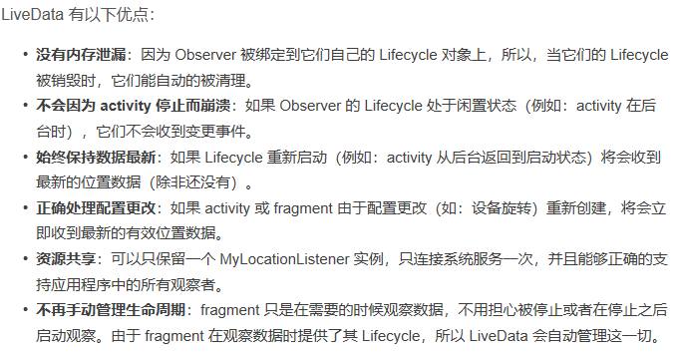

Lifecycle-aware Components 源码分析

<http://chaosleong.github.io/2017/05/27/How-Lifecycle-aware-Components-actually-works/>