**List of Use Cases (sort by priority)**

1. Search for an item

2. Sort Items by distance or price

3. Login/ Register (option to use Gmail/facebook login)

4. Add an item (name, price, and picture)

5. Update item (price, name or image)

6. Delete item

7. Update profile (By user or admin)

8. Delete profile (By user or admin)

9. Navigate to the store (optional)

10. Give feedback (optional)

Use Case Diagrams

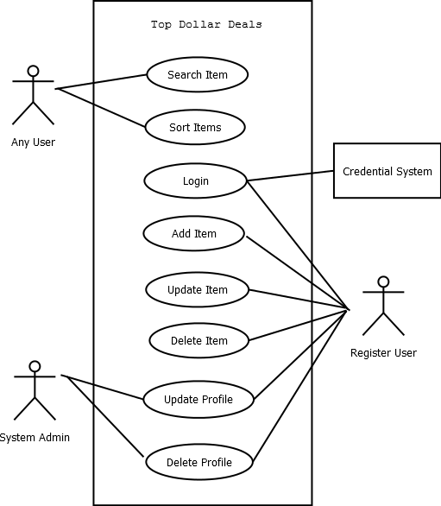

**Use Case UC1:** Search for grocery item

**Scope:** Grocery Pricing Application

**Level:** User goal

**Primary Actor:** Any user (registered or unregistered)

**Stakeholders and Interests:**

* User: Wants to be able to find grocery item information quickly and accurately via this search.

**Preconditions:** None – you do not have to be logged in in order to search.

**Success Guarantee (or Postconditions):** Search results (item, price, store location) are shown on the screen.

**Summary:** User searches for grocery item. If applicable results are found, results are displayed on the screen.

**Main Success Scenario (or Basic Flow):**

1. User searches for grocery item.
2. Result is found.
3. The resulting grocery item information (item, price, store location) is displayed on the screen.

**Extensions (or Alternative Flow):**

2a. No result found.

1. User is informed that there is no information for the resulting item.
2. Asks user if they would like to start a new search.

**Special Requirements:**

* Web application is responsive design.

**Frequency of Occurrence:** Could be nearly continuous.

**Open Issues:**

* Searching functionality – use of predictive text?

**Use case UC4**: Add Item

**Scope:** Grocery Pricing Application

**Level:** user goal

**Primary Actor:** Registered user

**Stakeholders and Interests:**

* Registered user: Want to easily add an item and its price to the list of a certain grocery store.

**Preconditions:** Registered user is identified and authenticated.

**Success Guarantee (or Postconditions):** The item is saved. The item is added to the system. The item shows up correctly after it’s saved.

**Main Success Scenario (or Basic Flow):**

1. Registered user login

2. Registered user adds an item.

3. System adds item and its price.

4. The system logs completed adding or updating item.

5. The system shows the item in the search list.

**Extensions (or Alternative Flows):**

1a. Invalid authenticated.

1. Unregistered user tries to add an item.
2. User register as a new member
3. Invalid user or password

2a. System searches for duplicate item.

1. System found a match, then user can update the price for a certain store

3a. User add wrong item

1. User can delete the item and add the correct one

4a. User cancel adding item

1. User cancel adding item, go back to the previous page

**Special Requirements:**

* + Web application is responsive design.

**Technology and Data Variations List:**

1a. User has a choice of create a new registrations or login with Gmail account.

**Frequency of Occurrence:** Could be nearly continuous.

**Open Issues:**

* + Can users upload their profile picture on the registration page?
  + Can users upload pictures of the item?