**Notes from the project doc – needed for inception phase:**

**Use Case Model**

The process of use case development starts by identifying actors and use cases from the requirements data followed by writing brief descriptions of each use case and analyzing the connections between use cases. This should be an iterative process, as the process of developing one use case will often lead to the identification of new use cases. Your system must have at least the number of use cases as twice as the number of your group members.

The Use Case Model documents the entire set of use cases with a use case context diagram (see the example in Figure 6.3 of the textbook), fully dressed versions of at least half of use cases using the template in Section 6.8 of the textbook, and brief descriptions for all of the remaining use cases.

Figure from the text:

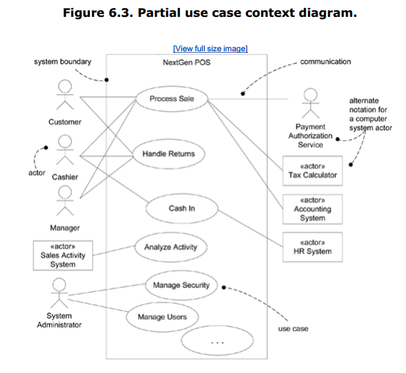

**Our Use Cases as of 1/22/15:**

1. All users are able to search items – [Rachel]

2. Registered users are able to add items – [King]

3. Registered users can upload picture of the item they add (only if we want to deal with it)

4. Registered ​users can update the price of  any items.

5. All users are able to click on the map and take them to navigation

6. All users are able to give feedback about the app (rank the app from 1 - 5 stars)

7. Registered users are able to delete their account​

8. (new) Log in with gmail