**CSC440TopDollarDeals Design Document**

Sequence Diagrams

<<Hadi>>

Class Diagram

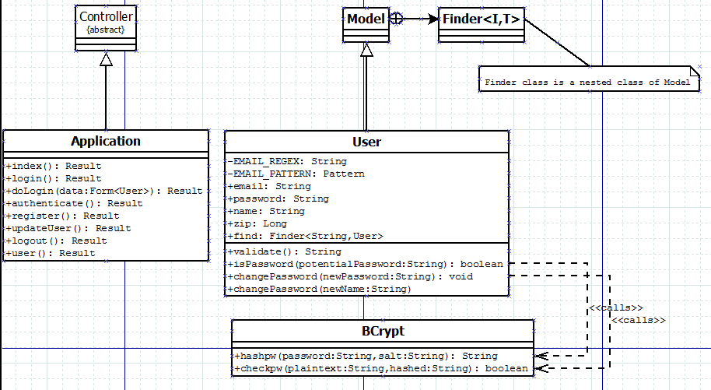

Activity Diagrams

