**CSC440TopDollarDeals Design Document**

Sequence Diagrams

SD Register user/User from the Home Page click on register button. Then register pag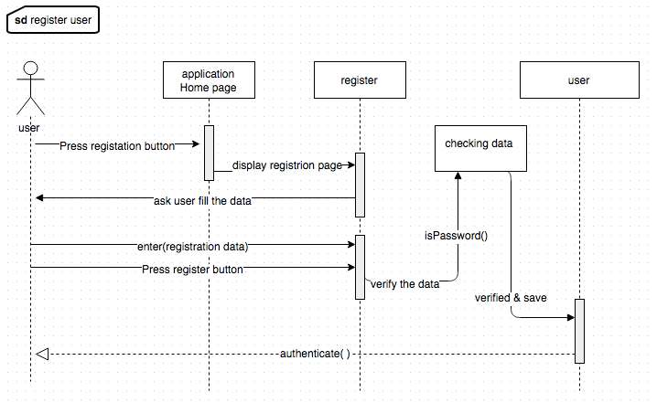e will open and user will Enter registration data(Name,Email,Password,Zip code). Afterthat, system will verify the data and add new member.

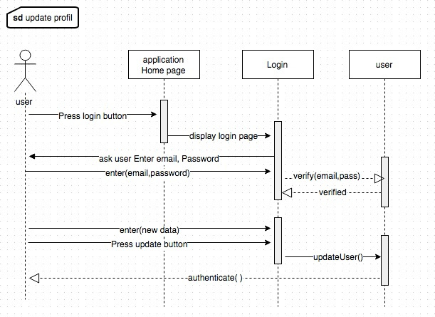

SD Update Profil/user after login can up date his data by enter a new data and press update button. System will verify the data and update a profile.

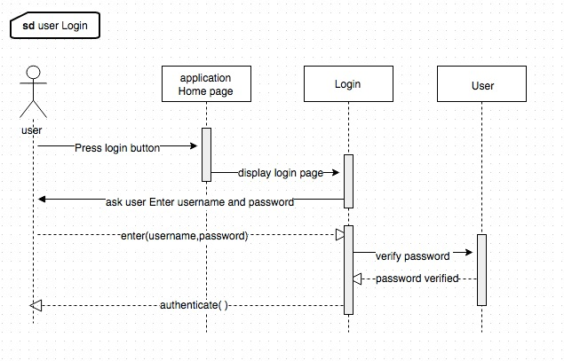

SD user login/User from the Home Page click on login button. Then login page will open and user will Enter login data(Email,Password). After that, system will verify the data and login member.

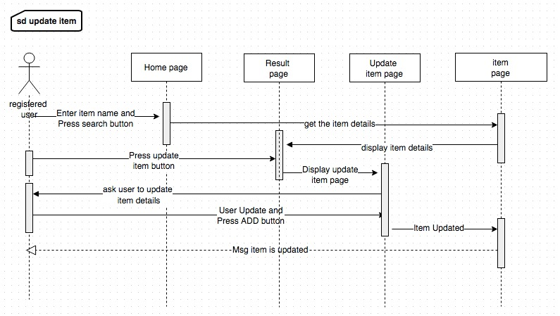

SD Update item/ Registered user from the Home Page will Enter the item name and press search. System will take the keyword and check the Item listed in item page (it’s items database) if the item is found. system will display the item details in the result page. user will click on update button. Then update item page will displayed and user will update the data and press add to add and to store a new data of item in item page.

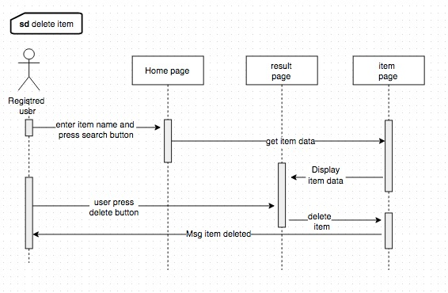

SD Delete item/ Registered user from the Home Page will Enter the item name and press search. System will take the keyword and check the Item listed in item page, if the item is found. system will display the item details in the result page. user will click on delete button. Then the item will deleted from item page.

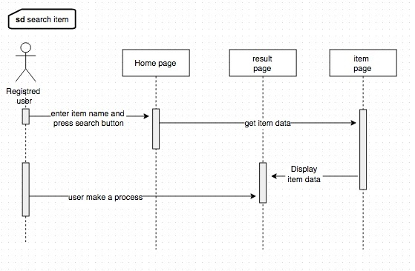

SD search item/ user from the Home Page will Enter the item name and press search. System will take the keyword and check the Item listed in item page (it’s items database) if the item is found. system will display the item details in the result page. After that user can display or make a process on the data.

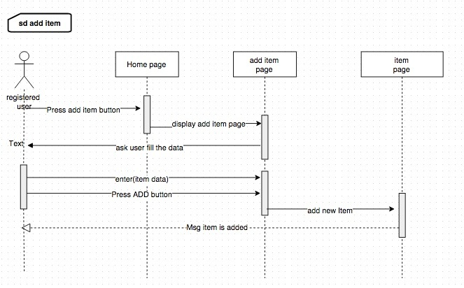

SD Add item/ Registered user from the Home Page will click on add new item button. Then add item page will open and user will Enter a new item data(itemName,itemPrice,storeName,Address,city,state,ZipCode). After that, system will verify the data and add new item.

Class Diagram

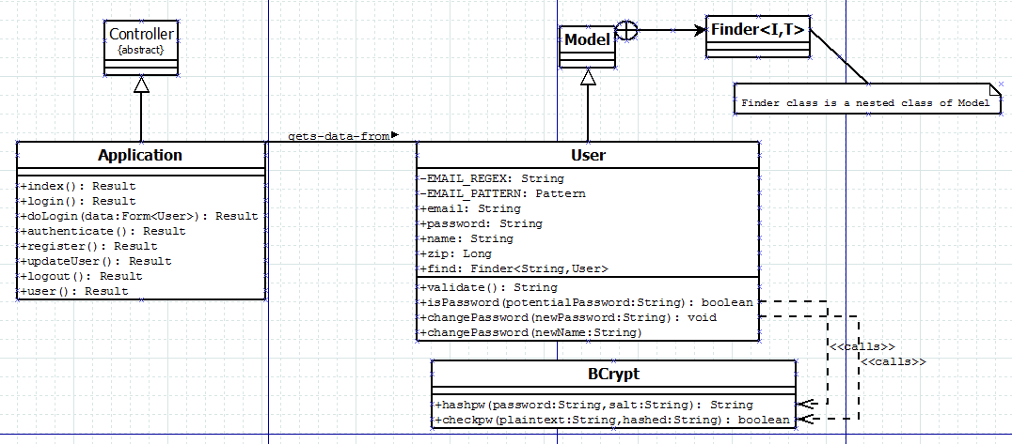

Activity Diagrams