**CSC440TopDollarDeals Design Document**

Sequence Diagrams

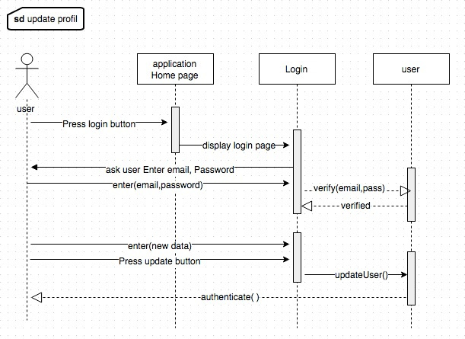SD Register user/User from the Home Page click on register button. Then register pag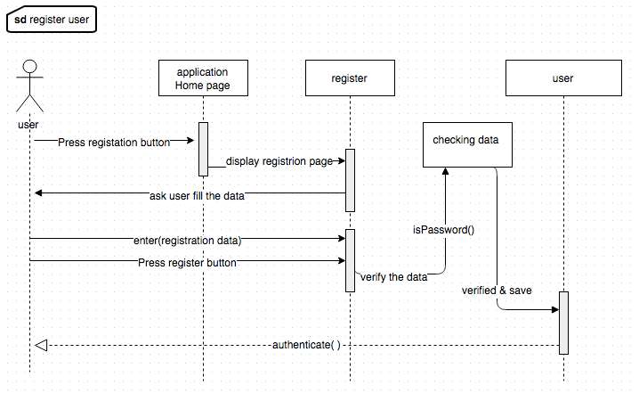e will open and user will enter registration data (Name, Email, Password, Zip code). After that, system will verify the data and add new member.

SD Update Profile/user after login can update his data by enter a new data and press update button. System will verify the data and update a profile.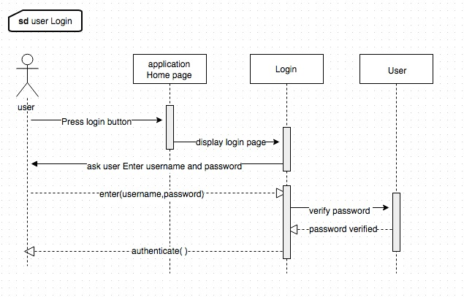

SD user login/User from the Home Page click on login button. Then login page will open and user will Enter login data (Email, Password). After that, system will verify the data and login member.

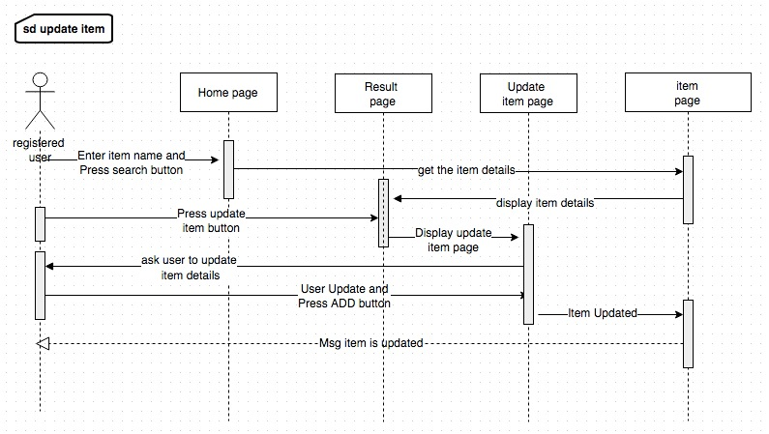SD Update item/ Registered user from the Home Page will enter the item name and press search. System will take the keyword and check the Item listed in item page (its items database) if the item is found. System will display the item details in the result page. User will click on update button. Then update item page will displayed and user will update the data and press add to add and to store a new data of item in item page.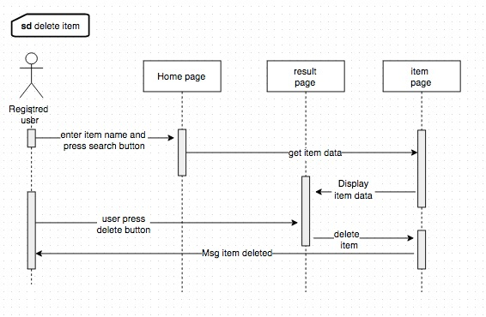

SD Delete item/ Registered user from the Home Page will Enter the item name and press search. System will take the keyword and check the Item listed in item page, if the item is found. System will display the item details in the result page. User will click on delete button. Then the item will deleted from item page.

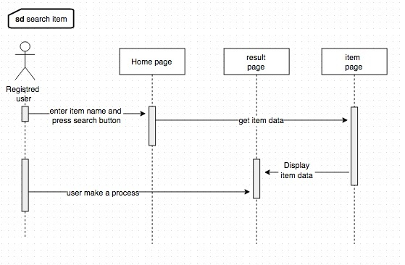

SD search item/ user from the Home Page will enter the item name and press search. System will take the keyword and check the Item listed in item page (its items database) if the item is found. System will display the item details in the result page. After that user can display or make a process on the data.

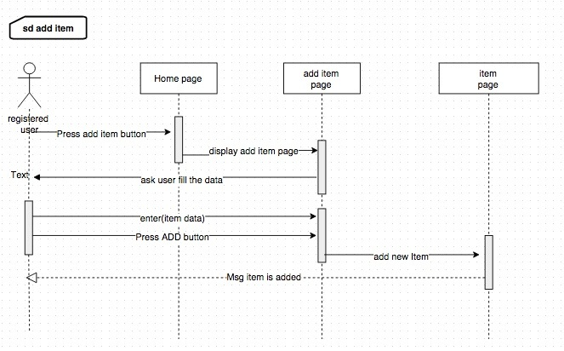

SD Add item/ Registered user from the Home Page will click on add new item button. Then add item page will open and user will enter a new item data (itemName, itemPrice, storeName, Address, city, state, ZipCode). After that, system will verify the data and add new item.

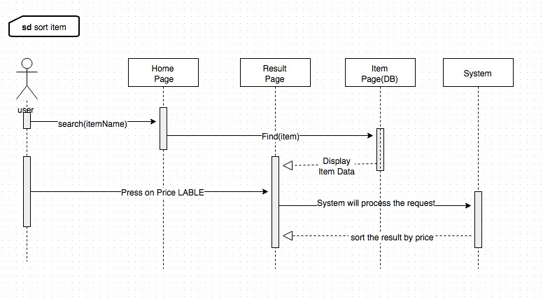

SD Sort item/ When the user did a search for item, and system displayed the item details in the result page. After that user can sort the search result according the item’s price by pressing on PRICE label. When the user Press on Price label system will process that and resort item by its price.

Class Diagram

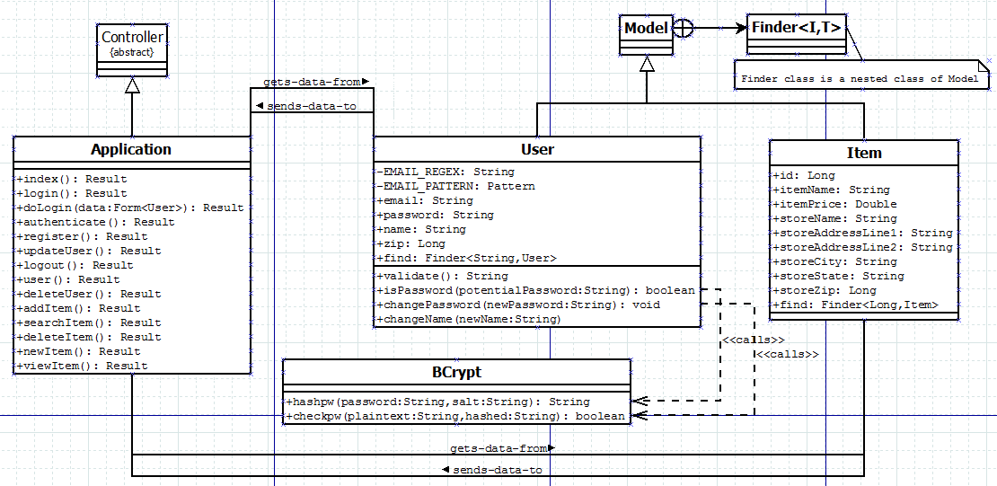

Our Grocery pricing app uses the Controller GRASP design pattern. The Application class extends the abstract Controller interface. The Application class works so that the logic of our app is not handled in the GUI presentation layer. As we continue to add additional functionality, we can do so in one place. The Application class controls how information is sent to and received from our data classes – User and Item. It controls the operations of all the system events, where it then receives messages from the UI and delegates operations, while calling on the User and Item classes for the data that needs to be stored or is already stored.

Our app also has low coupling. The User and Item class know nothing about one another, but they both interact via the Application class, which sends commands to and receives data from the two classes. This allows User and Item to be independent and easier to support. We only have the Application class that needs to know how to interact with the other classes. Both the User and Item classes can be updated, if necessary, with no impact on one another.

We have high cohesion in that the responsibilities of our app are broken up into the UI (the .html user facing portion), the main app logic (the Application class), and the storage (or the Data and Item classes). This allows for a clear and concise design with the ability to easily maintain and expand for upcoming iterations.