CloudCart
Cloud-Native E-Commerce Platform Deployment Using Kubernetes
Project Report

Submitted by: Suphin Hassainar
Technologies: React.js, Node.js, Express.js, TypeScript, MongoDB, Redis, Docker, Kubernetes, AWS EC2, NGINX Ingress
Date: June 2026

Table of Contents
1. Project Overview
2. Project Objectives
3. Technologies Used
4. System Architecture
5. Kubernetes Cluster Setup
6. Docker Containerization
7. Kubernetes Deployments
8. Service Discovery and Networking
9. Ingress Configuration
10. MongoDB Persistent Storage
11. Authentication Implementation
12. Redis Caching
13. Kubernetes Self-Healing Demonstration
14. Rolling Updates
15. Horizontal Scaling
16. Application Walkthrough (UI Screenshots)
17. Challenges Faced
18. Project Outcomes
19. Conclusion

1. Project Overview
CloudCart is a cloud-native e-commerce application developed using a microservices architecture and deployed on a Kubernetes cluster running on AWS EC2 instances.
The project demonstrates modern DevOps practices including containerization, orchestration, service discovery, ingress management, persistent storage, self-healing, rolling updates, and horizontal scaling.

2. Project Objectives
The primary objectives of this project are:
- Deploy a microservices-based e-commerce application.
- Implement containerized services using Docker.
- Orchestrate workloads using Kubernetes.
- Configure persistent storage for MongoDB.
- Implement API Gateway-based routing.
- Deploy services on AWS EC2 infrastructure.
- Demonstrate Kubernetes self-healing and scalability.
- Implement JWT-based authentication and authorization.

3. Technologies Used
Category | Technologies
Frontend | React.js
Backend Services | Node.js, Express.js, TypeScript
Database | MongoDB
Caching | Redis
Containerization | Docker
Orchestration | Kubernetes (Kubeadm)
Cloud Platform | AWS EC2
Networking | NGINX Ingress Controller
Authentication | JWT (JSON Web Token)
Version Control | GitHub

4. System Architecture
The system consists of multiple microservices deployed inside a Kubernetes cluster. All external requests are routed through the API Gateway and the NGINX Ingress Controller.
Microservices:
- Gateway Service
- Authentication Service
- Product Service
- Cart Service
- Order Service
- Payment Service
- Notification Service
- MongoDB
- Redis

5. Kubernetes Cluster Setup
The Kubernetes cluster was created using kubeadm.

Cluster Components
Master Node:
- API Server
- Scheduler
- Controller Manager
- etcd
Worker Nodes:
- Application Workloads
- Service Pods
Cluster Configuration: 1 Control Plane Node and 2 Worker Nodes.
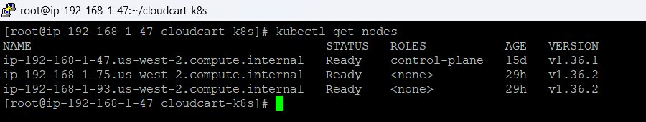
Figure 1: Kubernetes cluster nodes (kubectl get nodes) - 1 control-plane and 2 worker nodes, all in Ready state

6. Docker Containerization
Each microservice was containerized using Docker.
Steps:
- Created Dockerfiles for each microservice.
- Built Docker images for all services.
- Pushed images to Docker Hub.
- Pulled images inside the Kubernetes cluster for deployment.
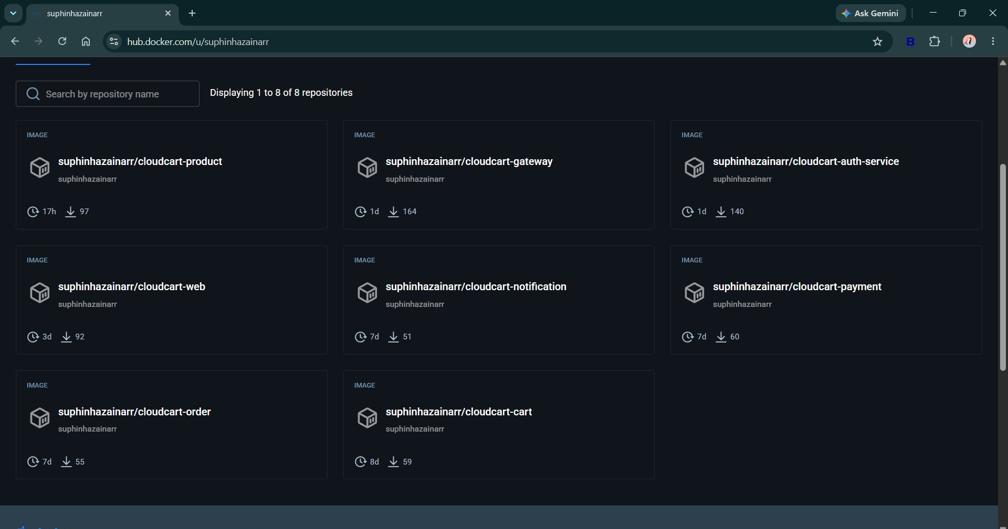
Figure 2: Docker Hub repositories for CloudCart microservices (product, gateway, auth-service, web, notification, payment, order, cart)

7. Kubernetes Deployments
Each service was deployed using Kubernetes Deployments.
Benefits:
- Automatic Pod Management
- Self-Healing
- Rolling Updates
- Scaling
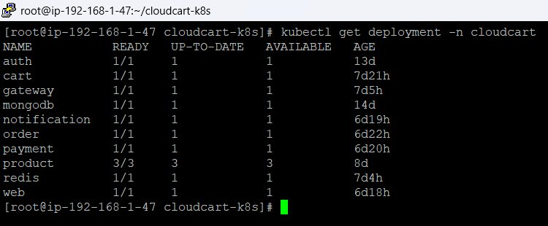
Figure 3: Kubernetes Deployments in the cloudcart namespace - all services Ready, with the Product service scaled to 3/3 replicas

8. Service Discovery and Networking
Kubernetes Services were used for internal communication between microservices.
Benefits:
- Dynamic Service Discovery
- Stable Internal Endpoints
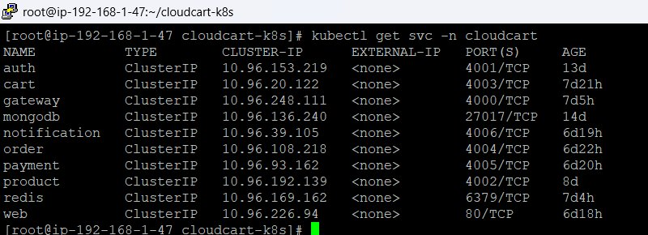
Figure 4: Kubernetes Services (ClusterIP) for each microservice, including auth, cart, gateway, mongodb, product, redis and web

9. Ingress Configuration
The NGINX Ingress Controller was configured to expose application services externally via the following hosts:
- auth.cloudcart.local
- cart.cloudcart.local
- gateway.cloudcart.local
- notification.cloudcart.local
- order.cloudcart.local
- payment.cloudcart.local
- product.cloudcart.local
- web.cloudcart.local
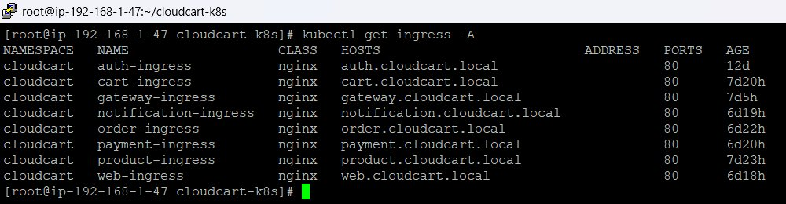
Figure 5: NGINX Ingress resources configured for all CloudCart microservices

10. MongoDB Persistent Storage
Persistent storage was implemented using a Persistent Volume (PV) and a Persistent Volume Claim (PVC).
Resource | Name | Capacity | Access Mode | Reclaim Policy
Persistent Volume | pv-test | 1Gi | RWO | Retain
Persistent Volume Claim | pvc-test | 1Gi | RWO | -

Purpose: Ensure application data survives pod restarts and recreation.
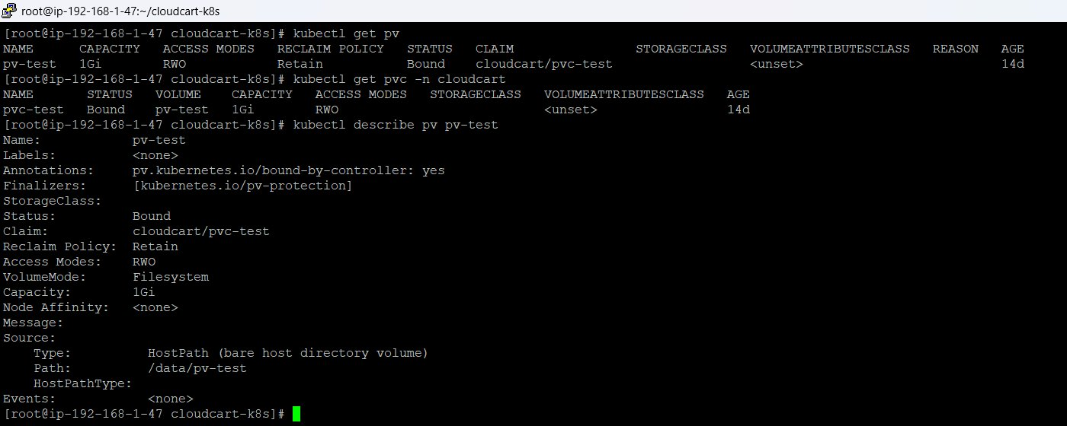
Figure 6: PV and PVC status (Bound) and PV details showing hostPath storage at /data/pv-test

11. Authentication Implementation
JWT-based authentication was implemented across the platform.
Features:
- Access Token
- Refresh Token
- Secure Cookie Storage
- Protected Routes
Authentication Flow:
User Login -> Auth Service -> JWT Generation -> Gateway Validation -> Authorized Access
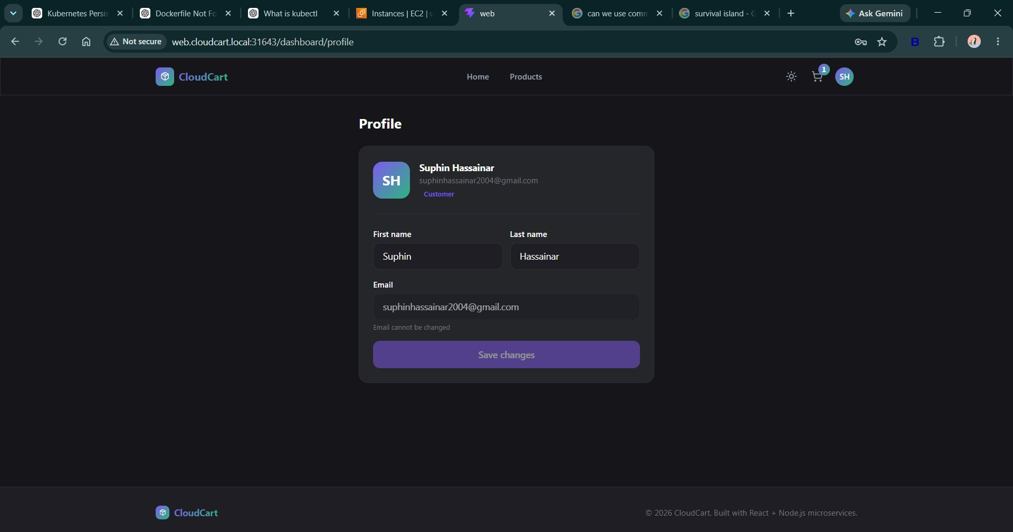
Figure 7: Authenticated user profile page showing logged-in customer details (Suphin Hassainar)

12. Redis Caching
Redis was integrated to improve application performance.
Benefits:
- Reduced Database Load
- Faster Product Retrieval
- Cached Frequently Accessed Data

13. Kubernetes Self-Healing Demonstration
A Product Service pod was manually deleted to test Kubernetes self-healing.
Result:
- Kubernetes detected the pod failure.
- A new pod was automatically created to replace it.
- The service remained available throughout.
Command Used:
kubectl delete pod <product-pod>

14. Rolling Updates
Rolling updates were demonstrated using Deployment updates.
Benefits:
- Zero Downtime
- Safer Deployments
- Automated Rollback Capability
Command Used:
kubectl set image deployment/product product=suphinhazainarr/cloudcart-product:v2

15. Horizontal Scaling
The Product Service was scaled from 1 replica to multiple replicas to handle increased load.
Command:
kubectl scale deployment product --replicas=3
Benefits:
- Improved Availability
- Better Load Handling
This scaling can be confirmed in Figure 3, where the Product deployment shows 3/3 replicas ready.

16. Application Walkthrough (UI Screenshots)
The CloudCart storefront was accessed through the configured ingress host (web.cloudcart.local), demonstrating the end-to-end customer experience.
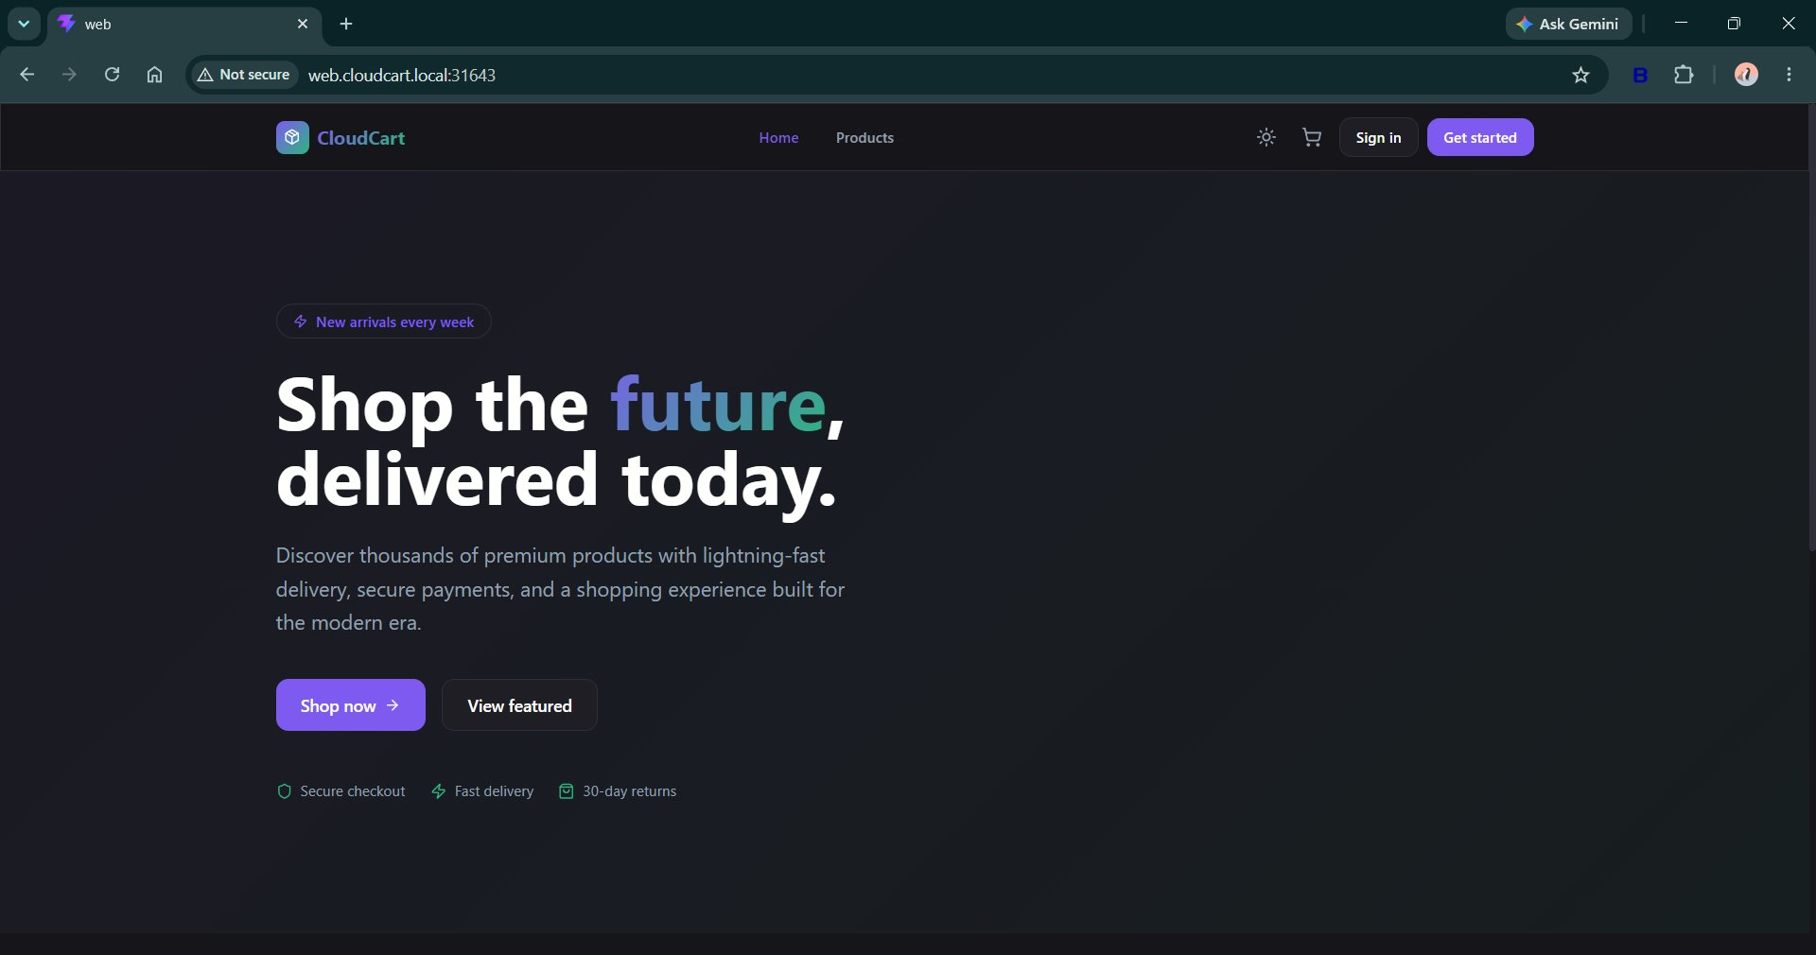
Figure 8: CloudCart storefront home page
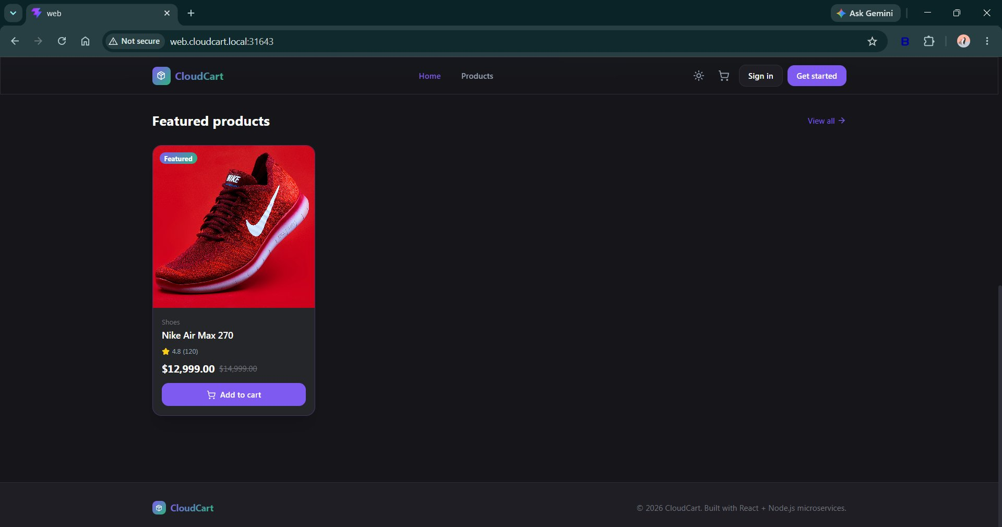
Figure 9: Featured products section showing the Nike Air Max 270 listing
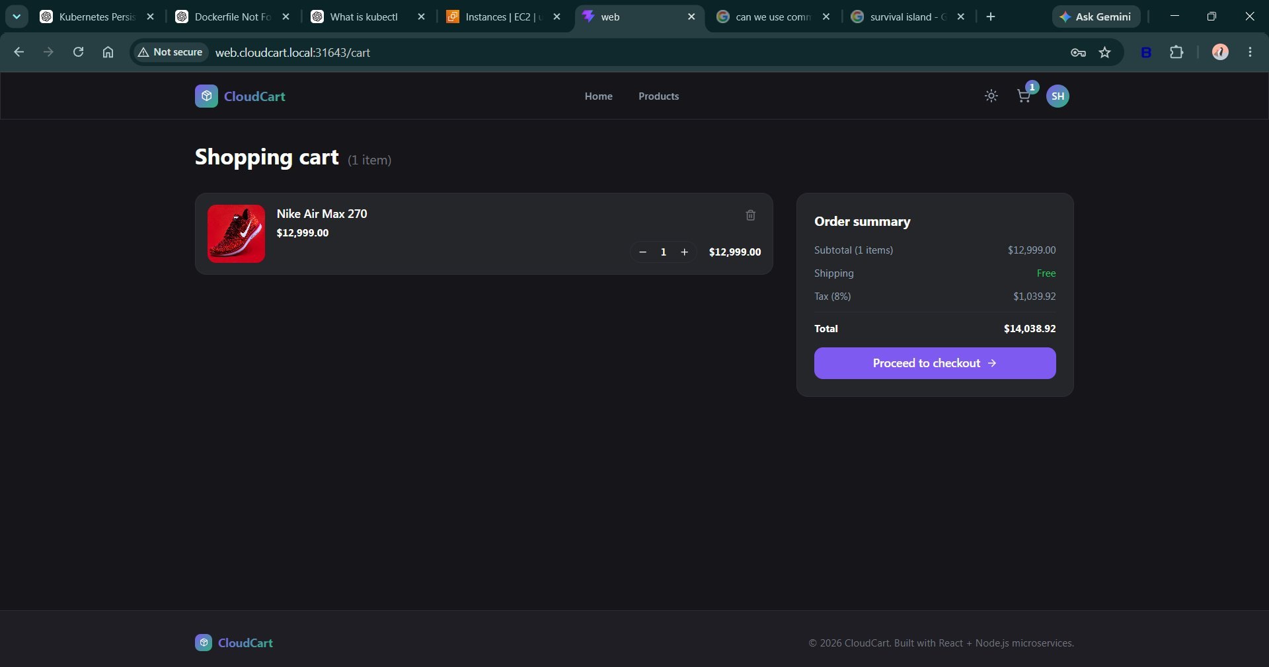
Figure 10: Shopping cart with order summary, tax calculation and total
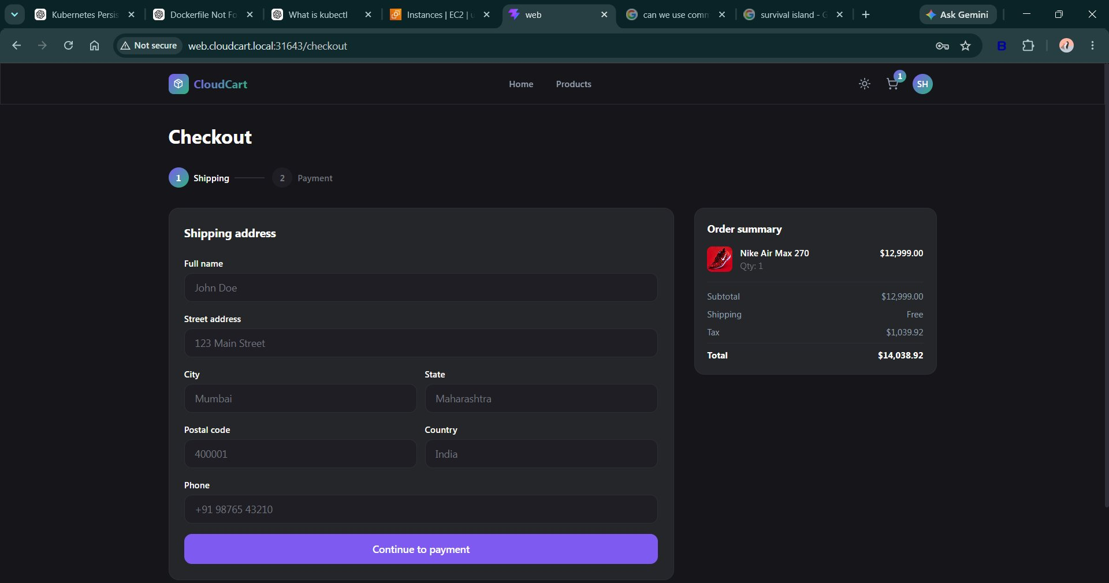
Figure 11: Checkout page with shipping address form and order summary
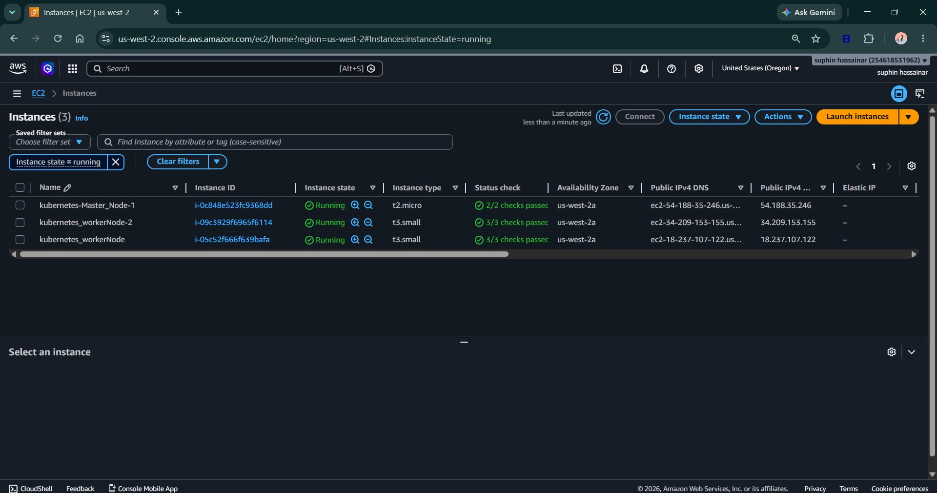
Figure 12: AWS EC2 console showing the running Kubernetes master and worker node instances

17. Challenges Faced

Worker Node Failure
Issue: Worker nodes became NotReady.
Resolution: Created new worker nodes and joined them to the cluster using kubeadm.

Control Plane Instability
Issue: Controller Manager and Scheduler entered CrashLoopBackOff.
Resolution: Restarted kubelet and restored cluster components.

JWT Authentication Issue
Issue: Users were automatically logged out.
Root Cause: Cookie headers were removed in the Gateway Proxy.
Resolution: Updated Gateway configuration to forward authentication cookies.

MongoDB Storage Configuration
Issue: Database persistence was not functioning correctly.
Resolution: Configured the PVC mount path and verified persistent storage.

18. Project Outcomes
Successfully deployed a production-style microservices application using Kubernetes. The following capabilities were implemented:
- Docker Containerization
- Kubernetes Orchestration
- Persistent Storage
- Service Discovery
- Ingress Routing
- JWT Authentication
- Redis Caching
- Self-Healing
- Rolling Updates
- Horizontal Scaling

19. Conclusion
CloudCart demonstrates the deployment and management of a cloud-native e-commerce platform using Kubernetes and AWS. The project provided hands-on experience with modern DevOps practices including container orchestration, networking, scaling, monitoring, persistent storage, and application lifecycle management.

