

**SOEN 6011**

**Software Engineering Processes**

**Summer 2016**

**Assignment #3**

**Requirements Document and Use Case Analysis**

**By:**

**Group-8 (LIONS)**

**Team Members**

|  |  |  |
| --- | --- | --- |
| Mona | Movahedi | 26979327 |
| Supreetha | Mudarajappa | 27682417 |
| Heya | Na | 27208243 |
| Amandeep | Narula | 27359950 |
| Dhruv | Ohri | 27149220 |
| Parth | Patel | 40014231 |
| Prashanth | Ramesh | 27382006 |
| Sukhjit | Singh | 40009670 |

**Table of Content**

1. **Domain Model** 
   1. Domain Model Syntax 1
   2. Description of Domain Model 2

## Domain model

1.1 Domain Model Syntax:

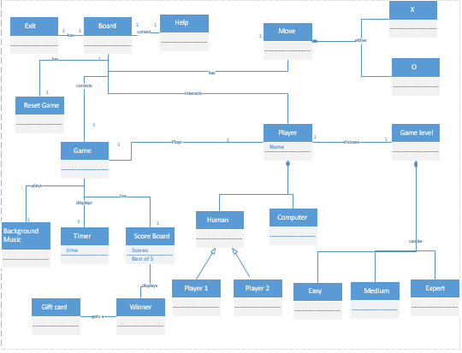

1.2 Domain Model Clarity and Design:

|  |  |
| --- | --- |
| **Concept**  **(Class Name)** | **Description** |
| Game | Represents an interaction with the user, which contains a board made up of 3X3 grid where user will play the game. |
| Move | Represents 2 different symbols used to play the game which are X and O |
| Player | Represents an entity who will play the game by interacting with the board and making use of the 2 symbols. Player can be either 2 human players or one human and one computer. |
| Game Level | Represents 3 different levels of gameplay which the user can choose while playing against a computer player. Easy level will contain a function for computer to make a move randomly considering the empty spaces while the more difficult levels will contain heuristic developed in order to make difficult for the user to win against the computer player. |
| Reset Game | Represents the option to player to reset the game. |
| Help | Represents guidelines for how to play the tic tac toe game. |
| Exit | Represents option for Exit from the game. |
| Score Board | Represents an area on the game board which shows the score of all the players. |
| Timer | Represents the time interval during which players have to make a move before they timeout. |
| Background Music | Represents default music that is going to played in the background while game is being played. |