01 · CONSULTATION · TREATMENT PLANNING
Before the Treatment: Why Thoughtful Aesthetic Care Begins with a Consultation
Before I recommend a treatment, I want to understand the person in front of me: what is bothering them, how their skin behaves and what kind of change would genuinely make sense. That conversation is where good aesthetic care begins.
By Franciele Sofiati · Biomédica · Esteticista · Cosmetologista · CRBM 6277

Photo: Anna Shvets / Pexels

AT A GLANCE
A consultation is not a formality; it is where suitability, priorities and expectations are clarified.
The same visible concern can have several causes and may not require the same treatment in every person.
A good plan considers skin history, current products, medications, previous procedures, lifestyle and available recovery time.
The aim is not to recommend the greatest number of procedures, but to choose the fewest useful steps in the right order.
Some concerns require medical or dermatological assessment before aesthetic treatment begins.

What a before-and-after photograph cannot show
Before-and-after photographs are useful, but they show only the most visible part of care. They do not show the questions I asked first, the detail that changed my recommendation, the treatment I preferred to postpone or the moment when a medical referral was more appropriate than a procedure.
This quieter work matters. Aesthetic care involves living tissue, individual healing patterns and concerns that may appear similar while behaving very differently. A consultation creates the space to understand what is actually being treated and why. It also protects the patient from choosing a procedure because it is popular, new or widely advertised rather than because it is suitable.
A concern is not yet a diagnosis
A patient may arrive describing “spots”, “open pores”, “sagging”, “redness” or “hair loss”. These words are useful starting points, but they do not automatically identify the cause. Brown marks may relate to sun exposure, post-inflammatory pigmentation, melasma or another condition. Redness may be temporary sensitivity, visible vessels, rosacea or irritation from an overloaded routine. Hair shedding can be seasonal, nutritional, hormonal, inflammatory or patterned.
For this reason, an ethical consultation does not begin by matching a complaint to a machine. It begins by observing patterns, listening to the history and identifying when aesthetic assessment is sufficient and when medical investigation is necessary.
What I look at before recommending anything
A careful consultation brings several pieces of information together:
• Your main concern — when it began and what makes it better or worse.
• Your history — previous treatments, allergies, medications and current skincare.
• Your skin’s behaviour — recent sun exposure, sensitivity and the way it normally reacts.
• Important safety details — pregnancy or breastfeeding, cold sores, active infection and a tendency to form raised scars.
• Anything unexplained — especially a new or changing concern that has not yet been medically assessed.
The conversation should extend beyond the skin. Work commitments, travel, exercise, social events and tolerance for visible recovery can determine whether a treatment is practical at a particular time. A procedure can be technically appropriate and still be poorly timed.
Priorities create better plans than wish lists
Many people arrive with several concerns at once. They may want clearer tone, smoother texture, less redness, reduced hair, firmer contours and a simpler routine. Trying to address everything simultaneously often creates unnecessary complexity.
A stronger plan establishes priorities. The first step may be calming sensitivity before treating pigmentation, controlling active acne before addressing scars, or creating consistent sun protection before investing in a light-based procedure. Sequencing is part of treatment. It allows each stage to support the next instead of competing with it.
Realistic expectations are a clinical tool
Clear expectations are not pessimistic; they are protective. Most aesthetic treatments improve rather than perfect. Some results are gradual, some require a series and some need maintenance because the underlying biological process continues. Pigmentation may recur. Hormonal facial hair may regrow. Collagen-stimulating treatments develop over time and do not reproduce the effect of surgery. Scars can become softer and less noticeable without disappearing completely.
A useful consultation explains what change is realistic, what cannot be promised, how long improvement may take and what the patient must do to support the result.

“Good aesthetic planning is not about doing more. It is about understanding more before deciding what deserves to be done.”

When the best decision is to wait
Treatment may be postponed when the skin is inflamed, sunburned, infected, recently tanned or reacting unpredictably. It may also be delayed when a patient cannot follow the aftercare, has an important event too close to the recovery period or has started a medication that changes the risk profile.
Waiting is not a failure to treat. It is often evidence that the plan is being guided by safety rather than urgency.
When referral comes before aesthetics
Aesthetic professionals should recognise the limits of aesthetic care. New or changing pigmented lesions, persistent wounds, unexplained bruising, severe or sudden hair loss, signs of infection, intense pain, rapidly worsening inflammation or symptoms suggesting an underlying medical condition should be assessed by an appropriate physician.
Referral does not interrupt good care; it is part of good care. Once a concern has been properly investigated, aesthetic treatment may become clearer, safer and more effective.
A plan that can evolve
Skin changes with seasons, hormones, stress, health, age and routine. The best treatment plan is therefore structured but not rigid. It can be reviewed after each stage, adjusted according to the response and simplified when the original objective has been reached.
This is the difference between procedure-led care and the way I prefer to work. I am less interested in asking, “What can we do today?” than in asking, “What makes the most sense for this person now?”

Questions patients often ask
01 Do I need a consultation if I already know which treatment I want?
Yes. A preferred treatment can be discussed, but suitability still depends on your skin, history, objective and the timing of the procedure.
02 Can treatment happen on the same day as the consultation?
Sometimes, when the procedure is appropriate and no preparation is required. In other cases, the safest plan begins with skincare changes, medical review or a later appointment.
03 Should I bring a list of my skincare products?
Yes. Photographs or a written list of products, medications and supplements can make the assessment more accurate.
04 What if I have several concerns?
They can all be discussed, but the plan will usually prioritise the concerns that influence the others or offer the greatest practical benefit.
05 Will I be told exactly how many sessions I need?
An initial estimate may be possible, but the final number often depends on the response observed after treatment begins.
06 Can a consultation confirm a medical skin diagnosis?
Aesthetic assessment can identify concerns and warning signs, but medical diagnosis belongs to an appropriately qualified physician or dermatologist.
07 Why might a treatment be postponed?
Common reasons include active irritation, infection, recent tanning, unsuitable medication, insufficient preparation or an upcoming event that conflicts with recovery.
08 Do previous cosmetic procedures matter?
Yes. Previous lasers, injectables, peels, surgery and prescription treatments may affect timing, settings and safety.
09 What makes a treatment plan personalised?
It is adapted to the concern, skin characteristics, previous response, lifestyle, recovery tolerance, budget and long-term priorities.
10 What should I expect after the consultation?
You should understand the proposed priorities, realistic outcomes, preparation, recovery, alternatives and any reason for medical referral before deciding how to proceed.
  Franciele Sofiati  Biomédica · Esteticista · Cosmetologista  CRBM 6277 · Londrina, Paraná | ABOUT THE AUTHOR  Care, clarity and realistic expectations.  I begin with questions because a good treatment plan should make sense for the person, not only for the concern written on the booking form. I write these articles in the same way I speak to patients in the clinic: clearly, carefully and without promising more than a treatment can deliver.  Begin with context, not assumptions. Personalised consultations are available in Londrina.

02 · SKIN HEALTH · PROFESSIONAL CLEANSING
A Clearer Starting Point: What Professional Skin Cleansing Can — and Cannot — Do
A professional cleansing should never feel like a competition to remove as much as possible. I see it as a careful starting point: observe the skin, treat only what can be treated safely and leave it calmer than I found it.
By Franciele Sofiati · Biomédica · Esteticista · Cosmetologista · CRBM 6277

Photo: Anna Shvets / Pexels

AT A GLANCE
Professional cleansing can remove surface residue and selected blackheads or whiteheads when extraction is appropriate.
It does not cure hormonal acne, inflammatory acne or recurrent congestion by itself.
More pressure is not better; aggressive extraction can increase inflammation, marks and healing time.
The session should be adapted to sensitivity, barrier condition and current acne activity.
Persistent, painful or scarring acne should be assessed medically.

Why cleansing still matters in a treatment-led clinic
Professional cleansing can look simple beside lasers and other advanced technologies, but simple does not mean unimportant. For congested or unsettled skin, a careful cleansing appointment can give us a clearer view of what is happening and what should come next.
The purpose is not to make the skin feel aggressively “scrubbed clean”. Healthy skin is not sterile, and its surface barrier should not be stripped. A well-planned cleansing session aims to remove what can be removed safely, reduce avoidable obstruction and leave the skin more comfortable rather than more reactive.
Congestion is not one single problem
Blackheads, closed comedones, inflamed papules and small cysts may all be described as clogged pores, but they do not respond to the same approach. A blackhead is an open comedone in which material within the follicle is exposed to air. A closed comedone is covered by a thin layer of skin. Inflamed lesions are already part of an active inflammatory process and may be damaged by forceful manipulation.
This distinction matters because extraction is selective. The goal is not to empty every visible pore. It is to identify which lesions can be managed safely and which should be left alone or medically treated.
What happens during a professional cleansing session
A professional cleansing is usually organised in a calm, selective sequence:
• Observe and cleanse — begin with a close look at the skin and gentle surface cleansing.
• Adapt the products — choose according to oiliness, dehydration, sensitivity and recent procedures.
• Soften only where appropriate — prepare selected areas without overworking the whole face.
• Extract selectively — manage only the comedones that can be treated safely.
• Calm and protect — finish with hydration, soothing care and appropriate protection.
A professional should continually reassess the skin during the appointment. If redness increases quickly, the barrier appears fragile or extraction becomes traumatic, the plan should become more conservative.
Why I do not believe deeper always means better
The word deep can create the expectation that stronger pressure produces a better result. In practice, excessive pressure can injure the follicle wall and surrounding tissue. This may intensify redness, create scabs, increase post-inflammatory pigmentation and prolong recovery.
I do not measure a successful cleansing by how much was extracted or how red the skin became. I measure it by whether the skin was respected, whether congestion was managed safely and whether the next step is now clearer.
Why pores do not permanently open and close
Pores are normal follicular openings. Their visibility is influenced by oil production, accumulated material, skin texture, sun-related changes and genetics. Warmth may soften surface material and make extraction easier, but it does not literally open a pore like a door. Cold products may temporarily change the way the skin looks or feels, but they do not permanently close pores.
The most realistic goal is to keep follicles clearer, improve surrounding texture and reduce factors that make pores appear more prominent.

“The aim of professional cleansing is not to remove everything visible. It is to remove only what can be managed safely and leave the skin calmer than it was found.”

Cleansing and acne are not the same treatment
A professional cleansing session may help with selected comedones, but recurrent acne usually requires a broader strategy. Active acne can involve follicular obstruction, oil production, inflammation, bacteria, hormones and individual susceptibility. Skincare, prescription treatment and lifestyle or hormonal investigation may be relevant depending on severity.
Painful nodules, widespread inflammation, sudden adult-onset acne or acne that is leaving scars should be assessed by a dermatologist. Delaying medical care while relying only on extractions can allow scarring to progress.
How often should professional cleansing be performed?
There is no universal calendar. Someone with significant comedonal congestion may initially need closer follow-up, while another person may only benefit occasionally. Frequency should respond to the skin rather than to a fixed monthly rule.
Home care is equally important. A gentle cleanser, suitable moisturiser, daily sun protection and targeted products recommended for the person’s skin often do more for long-term stability than frequent aggressive sessions.
Aftercare: the quiet part of the result
Immediately after extraction, the skin may be pink or tender. Touching, picking, friction, intense heat, heavy makeup and unplanned active products can increase irritation. The safest aftercare is usually simple: gentle cleansing, soothing hydration and reliable sun protection, following the instructions given for the session.
The days after treatment also provide useful information. If congestion returns rapidly, the next step may be reviewing products, haircare, makeup, hormones or active acne rather than repeating extraction alone.
A useful beginning, not a promise of perfection
Professional cleansing can offer visible freshness and a clearer surface, but its greatest value may be diagnostic and preparatory. It reveals how the skin responds, identifies patterns of congestion and creates a better foundation for a realistic care plan.
When it is done well, cleansing respects the skin. It should not feel as though the face has been scrubbed, squeezed or punished in the name of being “perfectly clean”.

Questions patients often ask
01 Is deep skin cleansing suitable for sensitive skin?
It may be, but the products, extraction and duration must be adapted. Some highly reactive skin is better served by a calming session without extensive extraction.
02 Will cleansing remove every blackhead?
No. Some lesions are not ready for safe extraction, and trying to remove all of them can cause unnecessary trauma.
03 Does professional cleansing cure acne?
No. It can support care for selected comedones, but inflammatory, hormonal or scarring acne usually needs a broader plan and may require dermatological treatment.
04 How long will redness last?
Mild redness may settle within hours, but extracted areas can remain visible for longer. Recovery varies with skin sensitivity and the amount of extraction performed.
05 Can I wear makeup afterwards?
It is often preferable to keep the skin clean and avoid makeup for the period recommended after the session, especially over freshly extracted areas.
06 Can I exercise after cleansing?
Heavy exercise, heat and sweating may irritate recently treated skin. Follow the specific aftercare advice given for your session.
07 Will cleansing make my pores smaller?
It can make congested pores look less noticeable, but pore size is also influenced by genetics, oil production, skin structure and sun damage.
08 Can I extract blackheads at home?
Repeated squeezing can damage the skin and increase inflammation or pigmentation. Persistent congestion is better assessed professionally.
09 How often should I schedule a session?
Frequency should be individualised. It depends on congestion, sensitivity, home care, acne activity and how the skin responds.
10 When should I see a dermatologist instead?
Seek medical assessment for painful or cystic acne, widespread inflammation, sudden changes, scarring, infection or acne that is not responding to appropriate care.
  Franciele Sofiati  Biomédica · Esteticista · Cosmetologista  CRBM 6277 · Londrina, Paraná | ABOUT THE AUTHOR  Care, clarity and realistic expectations.  Even the simplest procedure deserves careful observation. My aim is always to do what the skin can benefit from, not everything that can be done. I write these articles in the same way I speak to patients in the clinic: clearly, carefully and without promising more than a treatment can deliver.  Give your skin a considered starting point. Personalised consultations are available in Londrina.

03 · SKIN HEALTH · BARRIER CARE
When More Is Not Better: Rebuilding a Skin Barrier Overwhelmed by Skincare
I often meet people who are trying very hard to care for their skin, yet every new product seems to make it more reactive. In those moments, the kindest and most effective step is usually not to add more, but to simplify.
By Franciele Sofiati · Biomédica · Esteticista · Cosmetologista · CRBM 6277
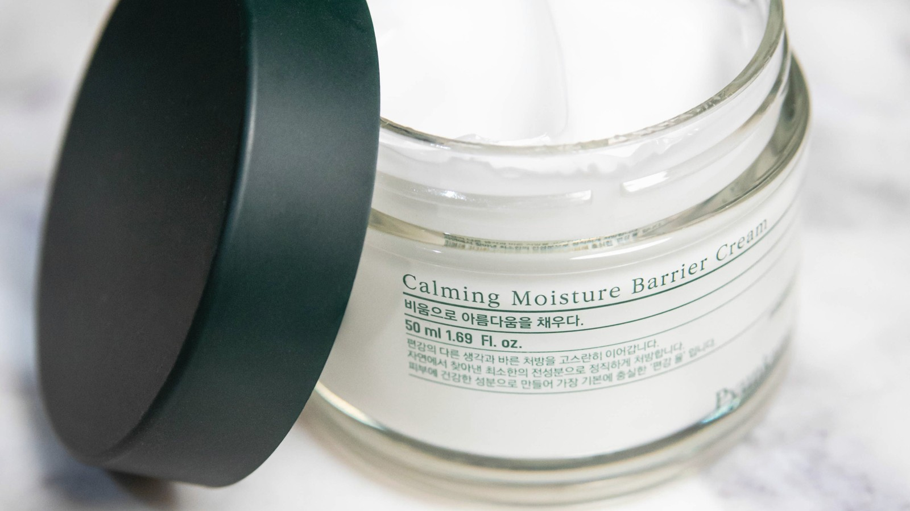
Photo: B Phet / Pexels

AT A GLANCE
Persistent stinging, tightness, flaking and redness can indicate irritation or barrier disruption.
Overuse of exfoliants, retinoids and multiple active products is a common contributor.
A simplified routine usually prioritises gentle cleansing, moisturising and sun protection.
New symptoms are not always ‘purging’ and should not automatically be pushed through.
Severe, persistent or spreading symptoms need medical assessment.

The modern pressure to keep adding
It is very easy for a skincare routine to become a collection of “good” products that do not work well together. Another acid, a stronger retinoid, a brightening serum and a weekly peel may all sound helpful, yet the skin becomes tighter, shinier, more sensitive and harder to understand.
These changes are sometimes interpreted as proof that the routine is “working”. In reality, discomfort can be a sign that the skin’s protective function has been challenged.
What the skin barrier actually does
The outermost layer of the skin helps reduce water loss and limits the entry of irritants, allergens and microorganisms. It is not an inert surface waiting to be removed. It is an active protective structure made of skin cells and lipids arranged in a way that supports resilience.
When this structure is disrupted, water escapes more easily and substances that were previously tolerated may suddenly cause burning or redness. The result can be a confusing combination of dryness, sensitivity, roughness and increased reactivity.
Common signs of an overwhelmed barrier
An overwhelmed barrier can show itself in several ways:
• Stinging or burning — even when applying products that once felt comfortable.
• Persistent tightness or flaking — especially after cleansing.
• Unusual redness or tenderness — with greater reactivity than usual.
• Rough, unsettled texture — sometimes with small inflamed bumps.
• More oil but less comfort — because irritated skin can still be dehydrated.
These signs are not specific to barrier damage. Dermatitis, rosacea, allergies, infection and other conditions can look similar, which is why persistent or severe symptoms should not be self-diagnosed indefinitely.
How good products become too much
An individual product may be well formulated and still be unsuitable when combined with several other active products. Exfoliating acids, retinoids, benzoyl peroxide, scrubs and strong cleansing products can all have a place, but frequency and combination matter.
The problem often develops gradually. A person increases use because there was no immediate irritation, introduces another active ingredient and continues exfoliating through the first signs of sensitivity. Climate, sun exposure, hormonal changes and recent procedures can then reduce tolerance further.
Purging is not a universal explanation
The idea of purging is frequently used to justify almost any negative reaction. Certain ingredients that influence cell turnover can temporarily bring existing comedones to the surface more quickly, but persistent burning, swelling, intense itching, spreading rash or worsening sensitivity should not be dismissed.
A reaction may be irritant, allergic or related to an unrelated skin condition. Continuing every product in the hope that the skin will adapt can deepen the problem.

“A strong routine is not the one with the greatest number of active ingredients. It is the one the skin can tolerate consistently enough to benefit from.”

The value of a deliberately boring routine
When the skin is overwhelmed, a short routine is often more useful than a sophisticated one. The exact products must be individualised, but the general direction is gentle cleansing, a well-tolerated moisturiser and daily broad-spectrum sun protection. Fragrance, scrubs, multiple acids and unnecessary active layers may be paused.
The purpose is not to abandon skincare forever. It is to create a stable baseline from which products can later be reintroduced one at a time, with enough time to observe the response.
Why moisturising is not merely cosmetic
A suitable moisturiser helps reduce water loss and supports the comfort of the outer skin. Texture matters: a light lotion may suit one person, while another needs a richer cream or ointment in selected areas. Applying moisturiser soon after gentle cleansing can help retain water.
More expensive is not automatically more reparative. The best choice is the product the skin can consistently tolerate and the patient will actually use.
Procedures require a stable starting point
Treating an already irritated face with an aggressive peel, laser or intensive extraction can increase the risk of prolonged inflammation and pigmentation changes. Before many procedures, the skin needs to be calm, intact and protected from recent sun exposure.
A consultation may therefore lead to a preparation phase rather than immediate treatment. This is not lost time. A stable barrier makes later care more predictable.
How to reintroduce active products
Once comfort has returned, products can be added gradually. One change at a time makes it easier to identify what helps and what causes irritation. Frequency can begin lower than the final target and increase only if the skin remains comfortable.
The routine should serve the skin’s priorities. A person does not need every fashionable ingredient, and a product should not remain in the routine simply because it is popular.
When sensitivity needs medical investigation
Seek medical assessment for facial swelling, blistering, intense itching, crusting, oozing, eye involvement, spreading rash, severe pain or symptoms that do not improve after suspected irritants are stopped. Recurrent episodes may require evaluation for allergic contact dermatitis, rosacea, eczema or another condition.
I can help simplify a routine and support the skin while it settles, but persistent or severe symptoms should never be hidden beneath another cosmetic product when a medical diagnosis may be needed.

Questions patients often ask
01 How long does a damaged skin barrier take to recover?
There is no fixed timeline. Mild irritation may settle relatively quickly, while significant inflammation can take longer and may need medical treatment.
02 Should I stop every skincare product?
Not necessarily. A simplified routine usually keeps essential gentle cleansing, moisturising and sun protection, but individual advice is important.
03 Can oily skin have a disrupted barrier?
Yes. Oiliness does not prevent dehydration or irritation, and aggressive degreasing can make reactivity worse.
04 Is stinging from an active ingredient normal?
Brief mild sensation can occur with some products, but persistent burning, marked redness or worsening sensitivity should not be ignored.
05 Can I exfoliate dry flakes away?
Scrubbing or adding acids may worsen irritation. Flaking skin often needs gentler care and moisturising rather than more exfoliation.
06 What is the difference between purging and irritation?
Purging is limited to certain cell-turnover ingredients and typically affects acne-prone areas. Burning, itching, swelling and widespread sensitivity suggest irritation or allergy rather than purging.
07 Can I have a laser treatment while my skin is irritated?
Often it is safer to postpone until the skin is stable. Suitability must be assessed before the procedure.
08 Does fragrance-free always mean non-irritating?
No product is universally tolerated, but fragrance-free formulas may reduce one common source of irritation for sensitive skin.
09 How should I restart retinoids or acids?
Reintroduce one product at a time at a low frequency after the skin is comfortable, following professional or medical guidance.
10 When should I see a dermatologist?
Seek medical review for severe, persistent or recurrent symptoms, swelling, blistering, oozing, eye involvement, signs of infection or an uncertain diagnosis.
  Franciele Sofiati  Biomédica · Esteticista · Cosmetologista  CRBM 6277 · Londrina, Paraná | ABOUT THE AUTHOR  Care, clarity and realistic expectations.  When the skin is overwhelmed, I prefer to slow down, simplify and rebuild comfort before asking it to tolerate more. I write these articles in the same way I speak to patients in the clinic: clearly, carefully and without promising more than a treatment can deliver.  Simplify before you intensify. Personalised consultations are available in Londrina.

04 · PIGMENTATION · LONG-TERM CARE
Uneven Tone Is Not One Condition: A More Careful Conversation About Pigmentation
Pigmentation is rarely just a matter of choosing something to “lighten the spots”. Before treating colour, I look at the pattern, the history, the skin’s sensitivity and the factors that may be recreating it.
By Franciele Sofiati · Biomédica · Esteticista · Cosmetologista · CRBM 6277
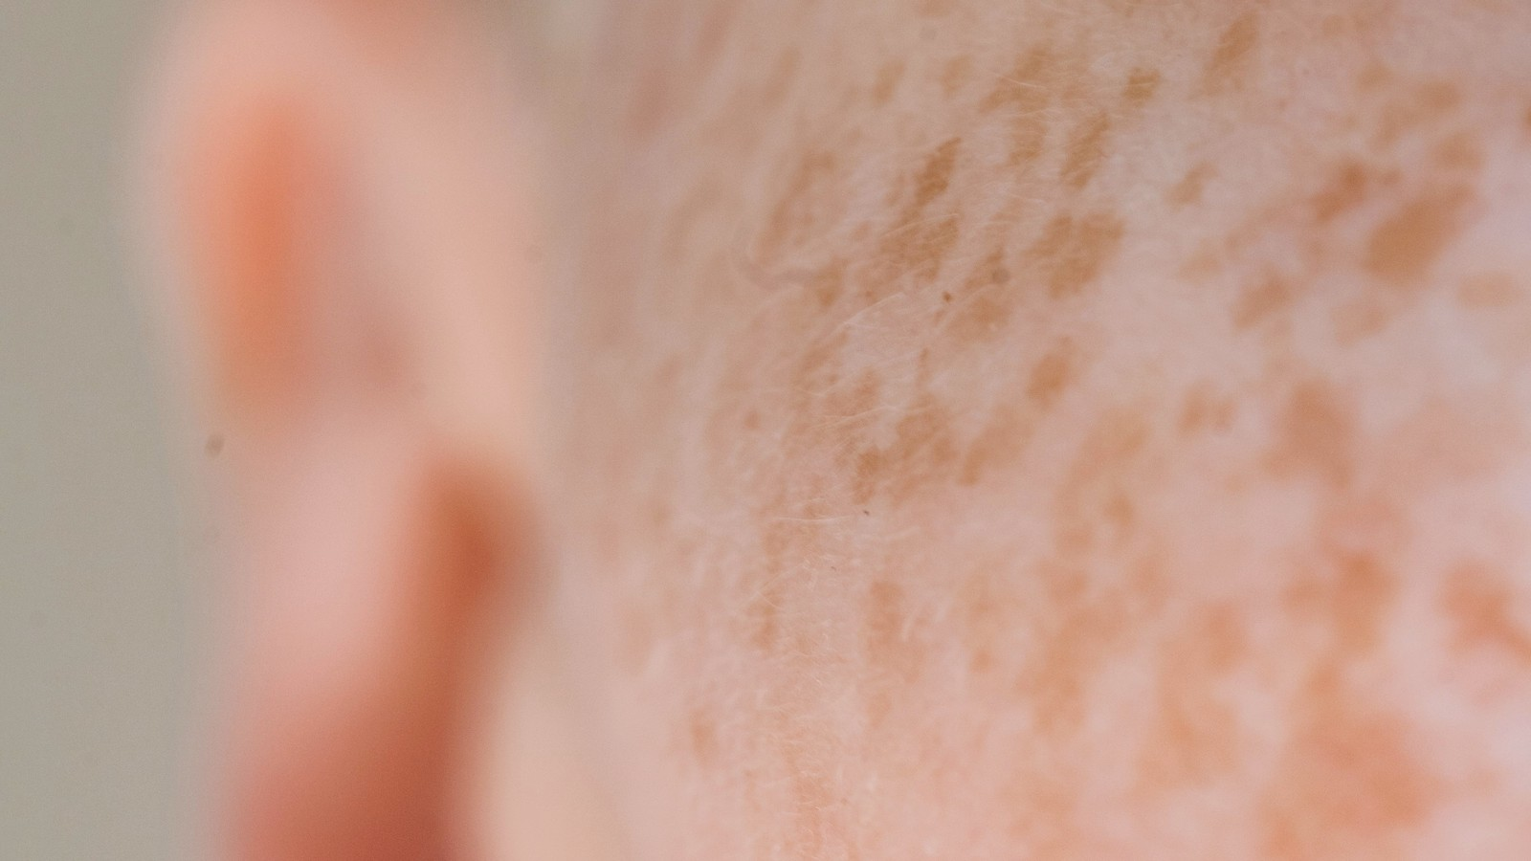
Photo: Angela Roma / Pexels

AT A GLANCE
Dark marks can arise from melasma, sun exposure, inflammation, acne, irritation or other causes.
Correct identification is essential because the same treatment can help one pigment pattern and aggravate another.
Sun and visible-light protection are central to melasma management and maintenance.
Procedures are usually part of a broader plan rather than a standalone cure.
New, changing or irregular pigmented lesions need medical evaluation before cosmetic treatment.

Why “dark spots” does not tell the whole story
Pigmentation is one of the concerns I discuss most often, and it is also one of the easiest to oversimplify. Two marks may look similar in a photograph and still need completely different care, because colour alone does not tell us the cause.
A mark left after acne behaves differently from melasma. A sun-related spot is not managed in exactly the same way as pigmentation caused by irritation. A changing lesion should not be approached as a cosmetic spot at all until it has been medically assessed. The first responsibility is therefore identification, not removal.
Melasma is influenced by more than the sun
Melasma commonly appears as symmetrical brown-to-grey patches on sun-exposed areas of the face. Ultraviolet radiation is important, but visible light, hormones, genetic susceptibility and changes within the skin’s vascular and dermal environment may also contribute.
This complexity helps explain why melasma can be persistent and why an isolated procedure rarely provides a permanent answer. Improvement is possible, but maintenance and trigger management are part of the treatment rather than optional extras.
Post-inflammatory pigmentation tells a different story
After acne, picking, dermatitis, a burn or an overly aggressive procedure, the skin may produce excess pigment while healing. This is called post-inflammatory hyperpigmentation. The mark is not active acne or ongoing injury, but it reflects the inflammation that came before it.
Treating the pigment without controlling the source of inflammation invites new marks to appear. For acne-prone skin, this means the plan must address active breakouts and discourage picking while gradually improving the colour that remains.
Why aggressive treatment can make pigmentation worse
Pigment-producing cells respond to inflammation. A treatment that creates more heat or injury than the skin can tolerate may lead to darker post-inflammatory marks, particularly in skin tones that pigment easily. This does not mean procedures should never be used. It means selection, preparation, settings and aftercare matter.
The strongest available treatment is not automatically the best treatment. A lower-intensity, staged approach may produce a more reliable result than one dramatic session.
Light protection is treatment, not an afterthought
For melasma and many pigment concerns, daily broad-spectrum sun protection is fundamental. Shade, hats and behavioural protection also matter because no sunscreen compensates for unrestricted exposure. Tinted products containing iron oxides may be discussed for people whose pigmentation is influenced by visible light.
Consistency is more important than perfection. Protection must continue after improvement, because the biological tendency to pigment may remain.

“Pigmentation is rarely managed well by chasing colour alone. The plan must also reduce the inflammation, light exposure or biological tendency that keeps recreating it.”

Where skincare fits
Topical plans may include ingredients intended to reduce pigment production, increase cell turnover or calm inflammation. Prescription options require medical guidance, and even non-prescription brightening products can irritate when combined carelessly.
A barrier-conscious routine is essential. If the face is stinging, peeling or inflamed, adding more brightening acids can create exactly the irritation that sustains uneven tone.
Where lasers and light-based treatments fit
Selected laser and light treatments can be useful for specific pigment concerns, but the device must match the target. Some light-based approaches may complement an established melasma plan, while other pigment patterns may respond differently. The presence of recent tanning, active irritation and the person’s tendency to develop pigmentation affect suitability.
A procedure should be presented as one element in a long-term strategy, not as a guarantee that pigment will never return.
The importance of colour, depth and pattern
Before treating pigmentation, I look at the complete pattern:
• Colour — brown, grey, red-brown or mixed.
• Depth — whether the pigment appears superficial or deeper.
• Distribution — symmetrical, localised or linked to a particular area.
• History — whether it followed acne, irritation, sun exposure or another inflammatory event.
• Change over time — including the borders, evolution and any feature that needs medical assessment.
This is why a personalised plan may look slower than an online recommendation. It is trying to treat the actual pattern rather than the category of “spots”.
What realistic improvement looks like
Pigmentation often changes gradually. The first sign of progress may be a more uniform background tone rather than the disappearance of every mark. Some areas respond faster than others, and photographs taken in consistent lighting are more useful than daily mirror inspection.
Recurrence is not always evidence that treatment failed. It may reflect renewed sun exposure, hormonal influence, inflammation or the chronic nature of melasma. The plan then shifts towards maintenance.
When a dark mark is not an aesthetic matter
A new or changing mole, an irregularly shaped lesion, a spot with several colours, bleeding, persistent crusting or a lesion that looks different from the others should be assessed medically. No aesthetic procedure should be used to remove or disguise a lesion that has not been appropriately evaluated.
For me, good pigmentation care is patient care: knowing when to treat, when to protect, when to slow down and when to refer.

Questions patients often ask
01 Is every dark facial patch melasma?
No. Dark marks may come from sun exposure, acne, irritation, inflammation, medication or other conditions. Assessment is important before treatment.
02 Can melasma be permanently cured?
Melasma can often be improved, but it may recur. Long-term light protection and maintenance are commonly needed.
03 Can laser make pigmentation worse?
Yes, if the wrong treatment, settings or timing create excess inflammation. Careful selection and aftercare reduce risk but cannot remove it completely.
04 Why do acne marks stay after the breakout clears?
Inflammation can stimulate excess pigment during healing, leaving post-inflammatory hyperpigmentation after the active lesion has resolved.
05 Should I use several brightening products together?
Combining too many active products can irritate the skin and worsen uneven tone. A coordinated routine is safer than layering products randomly.
06 Does sunscreen matter if I stay indoors?
Incidental daylight and visible light may still be relevant for some pigment conditions. The appropriate protection plan depends on your environment and diagnosis.
07 How quickly should pigment treatment work?
Improvement is usually gradual and varies by cause, depth, skin response and consistency of protection.
08 Can pigmentation be treated in summer?
Some plans can continue, but recent tanning and intense exposure may limit procedures. Timing should be assessed individually.
09 Why might I need a dermatologist?
Medical evaluation is needed when the diagnosis is uncertain, prescription therapy is indicated or a lesion is new, changing, irregular or symptomatic.
10 What is the best first step?
Begin with assessment, stabilise irritation, establish reliable light protection and then choose treatment according to the actual pigment pattern.
  Franciele Sofiati  Biomédica · Esteticista · Cosmetologista  CRBM 6277 · Londrina, Paraná | ABOUT THE AUTHOR  Care, clarity and realistic expectations.  Pigmentation needs patience and context. I look at the pattern, the triggers and the skin’s response before deciding how to treat the colour. I write these articles in the same way I speak to patients in the clinic: clearly, carefully and without promising more than a treatment can deliver.  Treat the pattern, not only the colour. Personalised consultations are available in Londrina.

05 · VASCULAR · LASER & LIGHT
Beyond ‘Sensitive Skin’: Understanding Persistent Redness and Visible Facial Vessels
When someone tells me they have “sensitive skin”, I do not assume that every red area needs the same calming product. Redness can have different causes, and understanding the difference is what makes treatment safer.
By Franciele Sofiati · Biomédica · Esteticista · Cosmetologista · CRBM 6277
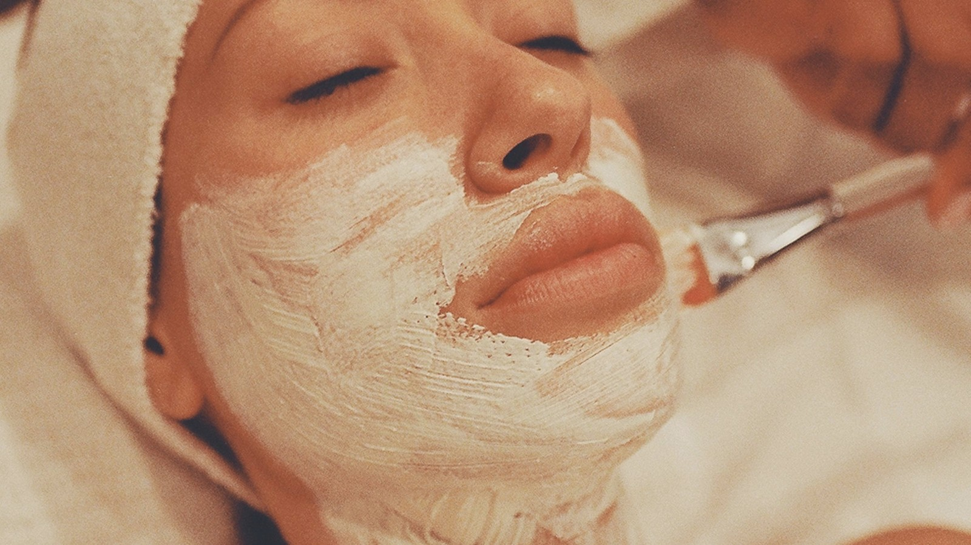
Photo: Dave Garcia / Pexels

AT A GLANCE
Persistent redness may relate to visible vessels, rosacea, irritation, heat, inflammation or other causes.
Laser and light treatments can reduce selected visible vessels and background redness but do not remove every trigger.
A calm skin barrier and gentle routine support comfort and treatment tolerance.
Sun protection and trigger awareness remain important after a procedure.
Eye symptoms, painful inflammation, sudden redness or uncertain diagnosis need medical assessment.

Redness is a clue, not a complete answer
A little redness after exercise, heat or strong emotion is normal. What deserves a closer look is redness that stays, returns very easily, forms visible vessels or appears together with burning and inflamed bumps.
Calling all of these patterns “sensitive skin” can delay a more useful assessment. Sensitivity describes how the skin feels and reacts; it does not identify why the redness is present.
Visible vessels and background redness
Small facial vessels may become more noticeable around the nose, cheeks and chin. Genetics, sun exposure, chronic flushing and inflammatory conditions can all contribute. Some vessels remain visible even when the skin feels calm.
Vascular laser and light technologies work by directing energy towards colour within the blood vessel. The intention is to heat the selected vessel while limiting unnecessary injury to surrounding skin. The exact technology and settings depend on vessel size, depth, colour and the patient’s skin characteristics.
Rosacea changes the conversation
Rosacea is a chronic condition that can involve flushing, persistent redness, visible vessels, bumps, burning and sometimes eye symptoms. Aesthetic treatment may help selected vascular features, but it does not replace medical diagnosis or management of active inflammatory disease.
A patient with suspected rosacea may benefit from coordinated care: medical treatment where needed, a gentle routine, trigger awareness and carefully timed laser or light procedures for persistent vessels or redness.
Why the barrier matters even when vessels are the target
A compromised barrier can make the face sting, burn and react strongly to products or procedures. Moisturising and avoiding unnecessary irritation may improve comfort and support the results of rosacea treatment.
Before vascular treatment, aggressive exfoliation, uncontrolled dermatitis or a recent product reaction may need to settle. Treating calm skin is generally more predictable than treating skin already in a cycle of irritation.
What laser and light treatment may improve
Appropriate vascular technology may reduce selected visible vessels and diffuse redness. Some vessels respond quickly, while others require repeated sessions. Background redness may soften gradually rather than disappear completely.
Results vary because redness may have several components. A procedure can treat a visible vessel, but it cannot prevent every future flush, remove genetic tendency or eliminate a chronic inflammatory condition.

“Vascular treatment can reduce what is visible, but lasting care also pays attention to inflammation, barrier health, triggers and the diagnosis beneath the redness.”

What the treatment experience may involve
During treatment, patients may feel warmth or brief snapping sensations. Cooling may be used to improve comfort and protect the surface. Afterwards, the skin can appear pink, warm or mildly swollen. Some treated vessels darken temporarily before fading.
The expected reaction depends on the target and settings, so aftercare should be based on the actual procedure rather than generic internet advice.
Why sun exposure changes risk
Recent tanning can increase the amount of pigment competing for light energy in the skin. This can affect safety and may lead to postponement. Sun protection is also important after treatment because treated skin can be more vulnerable and continued exposure contributes to vascular and pigment changes.
Planning around holidays, outdoor work and intense summer exposure is part of responsible treatment selection.
Triggers are individual, not moral failures
Commonly reported redness triggers include:
• Heat and sun — including hot environments and sudden temperature changes.
• Alcohol, spicy food and hot drinks — although individual tolerance varies.
• Stress and strong emotion — which can intensify flushing.
• Exercise — particularly when the skin is already warm or irritated.
• Products and procedures — when they disrupt the barrier or provoke inflammation.
• Your own repeated pattern — which matters more than any universal list of forbidden triggers.
A simple diary can be more useful than a long universal trigger list.
When redness should be medically assessed
Sudden one-sided redness, severe pain, facial swelling, fever, eye pain, light sensitivity, visual changes, widespread rash or signs of infection require medical attention. Persistent redness with inflammatory bumps, recurrent flushing or eye symptoms should also be evaluated for rosacea or another condition.
Aesthetic care is most effective when it works within a clear diagnosis rather than trying to treat uncertainty with energy.
What a natural-looking result means to me
Success may mean fewer visible vessels, a softer red background, less dependence on heavy coverage and greater comfort with the skin. It does not require a completely colourless face. Healthy skin has circulation, variation and movement.
The result I look for is not a completely colourless face. It is skin that appears calmer, more even and still completely natural.

Questions patients often ask
01 Can laser remove all facial redness?
It can reduce selected vessels and diffuse redness, but it cannot eliminate every trigger or cure all underlying conditions.
02 Is persistent redness always rosacea?
No. Irritation, dermatitis, sun damage, visible vessels and other conditions can also cause redness. Medical diagnosis may be needed.
03 How many sessions are usually required?
The number depends on vessel type, extent, technology, settings and individual response. A series may be recommended.
04 Will the vessels come back?
Successfully treated vessels may fade, but new vessels can develop over time because the underlying tendency and triggers may continue.
05 Does vascular treatment hurt?
Most people describe brief heat or snapping sensations. Comfort varies with the area, settings and cooling used.
06 Can I have treatment if I am tanned?
Recent tanning can increase risk and may require postponement. Be honest about sun exposure during assessment.
07 What should I avoid after treatment?
Aftercare varies, but may include avoiding heat, friction, intense exercise, irritating products and unprotected sun for a period.
08 Can skincare alone remove visible vessels?
Skincare can support comfort and barrier health but generally cannot remove established visible vessels.
09 When should redness be assessed by a dermatologist?
Seek medical review for persistent inflammatory redness, eye symptoms, severe discomfort, uncertain diagnosis or inadequate response to gentle care.
10 Can redness and pigmentation be treated together?
Sometimes, but the plan must consider both targets and the risk of irritation. Staging treatments may be safer.
  Franciele Sofiati  Biomédica · Esteticista · Cosmetologista  CRBM 6277 · Londrina, Paraná | ABOUT THE AUTHOR  Care, clarity and realistic expectations.  With redness, I want to understand what is vascular, what is inflammatory and what may need medical assessment before choosing a device. I write these articles in the same way I speak to patients in the clinic: clearly, carefully and without promising more than a treatment can deliver.  Look beneath the redness. Personalised consultations are available in Londrina.

06 · ACNE SCARS · TEXTURE
Not Every Acne Scar Is the Same: Why Texture Requires a Layered Treatment Plan
Acne scars can look like one concern in the mirror, but up close they are often a mixture of shapes, depths and colours. That is why I never like to promise that one device or one session will treat every scar in the same way.
By Franciele Sofiati · Biomédica · Esteticista · Cosmetologista · CRBM 6277
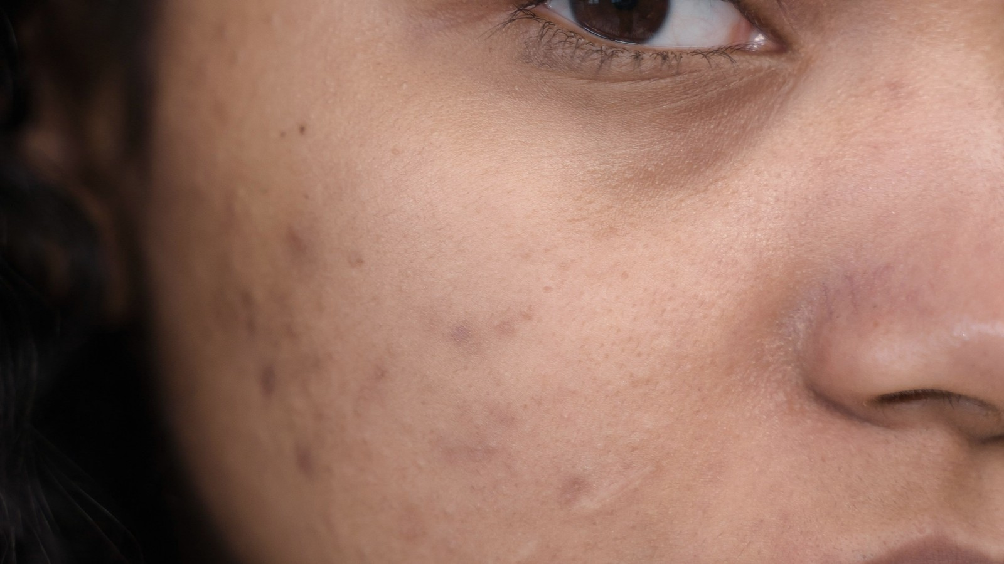
Photo: Ron Lach / Pexels

AT A GLANCE
Acne marks and acne scars are not the same: colour may fade while structural depressions usually persist.
Ice-pick, rolling and boxcar scars have different shapes and may require different methods.
Active acne should be controlled before intensive scar treatment whenever possible.
Combination plans are common because one face can contain several scar types.
The realistic aim is meaningful softening, not guaranteed complete removal.

The difference between a mark and a scar
After acne settles, the skin may be left with colour, texture or both. I always separate these changes during assessment, because a flat red or brown mark is not treated in the same way as a depression, a tethered scar or a raised scar.
This distinction matters because a treatment aimed at pigment will not necessarily lift a depression, while a resurfacing treatment may not be the first choice for colour alone.
Why acne scars form
Deep inflammation can damage the supporting structures of the skin. During healing, the body may produce too little collagen, creating a depressed scar, or too much, creating a raised scar. Picking and squeezing can increase inflammation and injury, but scarring can also occur despite careful behaviour, particularly with severe acne.
Early medical control of inflammatory acne is therefore part of scar prevention. Treating old scars while new deep lesions continue to form is rarely the most coherent sequence.
Ice-pick scars: narrow but deep
Ice-pick scars appear as small, narrow openings that extend deeply into the skin. Their surface size can make them look minor, but their depth may limit the effect of broad resurfacing alone. They often require a technique that specifically addresses the narrow tract.
This is a good example of why a device should not be selected before scar mapping. A treatment that improves the surrounding texture may still leave the deepest ice-pick scars relatively visible.
Boxcar scars: defined edges and variable depth
Boxcar scars are round or oval depressions with more defined edges. Shallow boxcar scars may respond to resurfacing, while deeper scars can need a more targeted approach. Their location and the thickness of surrounding skin influence what is possible.
A patient may describe all depressions as enlarged pores, but the treatment plan changes when the edges and depth reveal a true scar.
Rolling scars: movement beneath the surface
Rolling scars create a wave-like or uneven surface and are often linked to fibrous attachments pulling the skin downward. Resurfacing the top alone may produce limited change if the tethering underneath remains.
Treatment may therefore need to address both the attachment and the surface texture. This is one reason combination plans are common in scar care.

“Acne scar treatment is less about finding the strongest device and more about matching each scar’s shape, depth and attachment to the right method.”

Why one treatment rarely solves every scar
A single face may contain several different treatment targets at once:
• Ice-pick scars — small openings that extend deeply.
• Boxcar scars — depressions with more defined edges.
• Rolling scars — wave-like texture linked to tethering beneath the surface.
• Colour changes — redness or pigmentation left after acne.
• Active acne — which often needs control before scar treatment becomes the priority.
Combination does not mean performing everything in one session. It often means sequencing methods so the skin can heal and each stage has a clear purpose.
Where fractional CO2 laser may fit
Fractional CO2 resurfacing creates controlled microscopic treatment zones while leaving intervening skin to support healing. It can improve selected atrophic scars and overall texture by remodelling collagen. Evidence supports its role, but settings, scar type, skin tone and recovery capacity matter.
It is not a universal first step. Deep narrow scars, significant tethering, active acne, recent tanning or high risk of post-inflammatory pigmentation may change the plan.
The role of patience and photography
Collagen remodelling continues after the visible recovery period. Judging the final result too early can lead to unnecessary additional treatment. Standardised photographs help because daily mirror inspection is influenced by lighting, fatigue and expectation.
Improvement may appear as softer edges, shallower depressions and a smoother transition between scars and surrounding skin rather than complete disappearance.
Skin tone and pigmentation risk
Any procedure that creates inflammation can lead to temporary or persistent pigment changes, particularly in skin that develops post-inflammatory hyperpigmentation easily. Preparation, conservative settings, sun avoidance and aftercare are essential.
The risk does not automatically exclude treatment, but it should influence method, intensity and timing.
The emotional side of scar treatment
Acne scars can affect confidence long after active acne has resolved. A consultation should allow the patient to explain which scars matter most and what change would feel meaningful. Treatment should not intensify shame or promise a flawless surface.
My goal is informed improvement: a plan that respects the skin, the person living in it and the real limits of each method.

Questions patients often ask
01 Can acne scars disappear completely?
Some scars can improve substantially, but complete removal cannot be guaranteed. The usual goal is to make scars softer and less noticeable.
02 Are dark acne marks the same as scars?
No. Flat red or brown marks are colour changes, while depressed or raised scars involve structural change.
03 Why must active acne be controlled first?
Ongoing inflammation can create new scars and complicate healing. Medical acne management may be the priority.
04 Which treatment is best for acne scars?
There is no single best treatment. Scar type, depth, skin tone, active acne and recovery tolerance determine the plan.
05 Does fractional CO2 laser work for every scar?
It can help selected atrophic scars and texture, but deep ice-pick scars or tethered rolling scars may need additional techniques.
06 How many sessions will I need?
The number varies with severity, treatment intensity and response. A staged plan is common.
07 Can scar treatment cause pigmentation?
Yes. Post-inflammatory hyperpigmentation is a recognised risk, especially in pigment-prone skin, so preparation and aftercare matter.
08 How long do results take to develop?
Surface recovery occurs first, while collagen remodelling and visible improvement continue over weeks to months.
09 Can I treat scars while taking acne medication?
Some medications affect timing and healing. Tell the professional and prescribing physician about all current and recent treatment.
10 When should acne be managed by a dermatologist?
Medical care is important for painful nodules, cysts, widespread inflammation, scarring acne or acne that is not responding to appropriate skincare.
  Franciele Sofiati  Biomédica · Esteticista · Cosmetologista  CRBM 6277 · Londrina, Paraná | ABOUT THE AUTHOR  Care, clarity and realistic expectations.  Scar treatment is personal. I map the texture first, explain the limits clearly and build the plan in stages rather than promising a perfect surface. I write these articles in the same way I speak to patients in the clinic: clearly, carefully and without promising more than a treatment can deliver.  Map the scars before choosing the method. Personalised consultations are available in Londrina.

07 · CO₂ LASER · RESURFACING & AFTERCARE
Fractional CO₂ Laser Without the Hype: Preparation, Recovery and the Results That Take Time
Fractional CO₂ laser can be an excellent treatment, but it deserves an honest conversation. The preparation, the visible recovery and the months of gradual remodelling matter just as much as the appointment itself.
By Franciele Sofiati · Biomédica · Esteticista · Cosmetologista · CRBM 6277
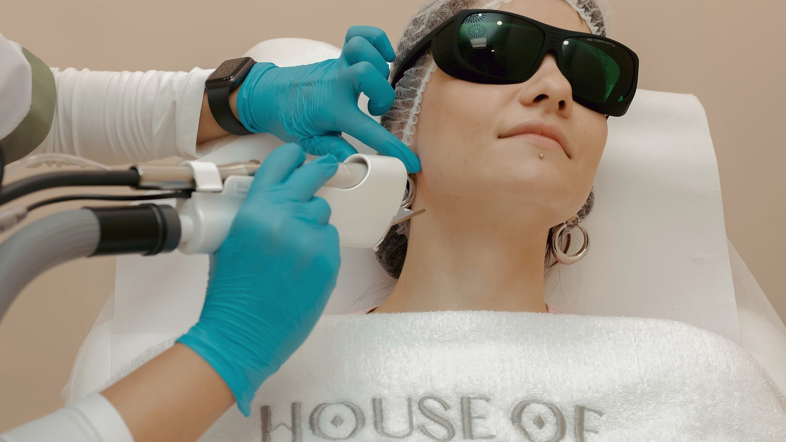
Photo: Khuram Naseem / Pexels

AT A GLANCE
Fractional CO₂ laser is an ablative resurfacing treatment that creates microscopic treatment columns in the skin.
It may improve selected acne scars, texture, fine lines and signs of photodamage, but it is not suitable for everyone.
Visible recovery can include redness, swelling, warmth, crusting or peeling.
Collagen remodelling continues after the surface has healed, so final results are not immediate.
Sun exposure, infection risk, pigment tendency, medications and aftercare capacity all influence safety.

What ‘fractional’ changes
Fractional CO₂ laser creates tiny controlled treatment columns while leaving areas of skin between them to support healing. It is a powerful form of resurfacing, which is exactly why I take candidacy, preparation and aftercare so seriously.
Fractional does not mean superficial or risk-free. It remains a significant procedure whose intensity can be adjusted. The same device can produce very different experiences depending on settings, passes, density and treatment area.
What the treatment may improve
Fractional CO₂ laser is commonly considered for atrophic acne scars, uneven texture, selected fine lines, photodamage and some scars. It can blend scar edges and encourage collagen remodelling. The strongest evidence is not a promise that every concern will respond equally.
Deep narrow scars, significant tethering, active melasma, uncontrolled acne or primarily vascular redness may require another method or a combination plan.
Candidate selection matters more than enthusiasm
A consultation should consider skin tone, tendency to develop post-inflammatory pigmentation, active skin conditions, recent tanning, history of cold sores, scarring tendency, medications, immune status and previous procedures. The patient’s ability to complete aftercare and tolerate visible recovery is equally important.
A technically possible treatment is not automatically the most appropriate treatment for a particular month, season or life schedule.
Preparation is part of the procedure
Preparation may include a few practical changes before fractional CO₂ laser:
• Simplify irritating skincare — so the barrier is calm before treatment.
• Strengthen sun protection — and disclose any recent tanning or sunburn.
• Review products and medications — without stopping prescriptions unless the prescriber advises it.
• Discuss a history of cold sores — because medical antiviral prevention may be needed.
• Follow the clinic’s timing instructions — so the skin reaches the appointment in the safest condition possible.
Arriving with sunburn, active infection or an inflamed barrier can increase risk and lead to postponement.
What the appointment can feel like
Topical anaesthesia and cooling may be used, but sensation varies. Patients often describe heat, prickling or a strong sunburn-like feeling during and immediately after treatment. The treated area may look red and swollen.
Comfort should be monitored throughout. Increasing intensity simply to create a dramatic reaction is not a meaningful measure of quality.

“The visible procedure lasts one appointment. The real treatment includes preparation before it and disciplined healing long after the laser is switched off.”

The visible recovery period
During the first days, the skin may be warm, swollen, red, dry or covered with fine crusting. Peeling and a rough texture can follow. The exact pattern depends on treatment intensity and individual healing. Picking or removing crusts prematurely can increase the risk of infection, prolonged redness and pigmentation.
Aftercare usually focuses on gentle cleansing, prescribed or recommended protective products, avoiding friction and strict light protection. Only the clinician who performed the procedure can give the correct instructions for that treatment.
Downtime is not the same as healing time
A patient may feel ready to return to normal activities once the most visible peeling settles, but biological healing continues. Redness can persist, sensitivity may fluctuate and collagen remodelling develops over weeks to months.
This distinction is important when planning another procedure. Skin that looks closed on the surface may not be ready for additional intensity.
Pigmentation and prolonged redness
Temporary darkening or post-inflammatory hyperpigmentation can occur, particularly in pigment-prone skin or after sun exposure. Prolonged redness is also possible. Conservative parameters, preparation and aftercare reduce risk but do not eliminate it.
Unexpected worsening, blisters, increasing pain, pus, spreading redness or fever should be reported promptly because they may indicate a complication.
Why one session may not be the whole plan
A more intensive session may produce greater change but also more recovery and risk. Several lower-intensity sessions may suit another patient better. Scar type and objective matter more than the idea that one dramatic session is always superior.
The plan may also include other treatments before or after resurfacing, particularly when scars have different depths or attachments.
The result should still look like skin
The most realistic result is smoother transition, softened scars, refined texture and a fresher surface—not poreless, filtered perfection. Natural skin retains movement, follicles and variation.
Fractional CO₂ laser can be a powerful tool when the objective is clear and the recovery is respected. I would always rather recommend a more suitable treatment than use an aggressive technology simply because it is available.

Questions patients often ask
01 Is fractional CO2 laser suitable for every skin tone?
It can be used in different skin tones, but pigment risk varies and requires careful assessment, conservative settings and aftercare.
02 How much downtime should I expect?
Downtime depends on intensity and individual healing. Redness, swelling, roughness, crusting and peeling can remain visible for several days or longer.
03 Does the treatment hurt?
Topical anaesthesia and cooling can reduce discomfort, but heat and stinging are expected to some degree.
04 Can fractional CO2 laser remove acne scars completely?
It can improve selected scars and texture, but complete removal is not guaranteed and combination treatment may be needed.
05 When will I see the final result?
Early surface improvement appears after healing, while collagen remodelling continues for weeks to months.
06 Can I wear makeup during recovery?
Makeup should only be resumed when the treated skin has healed enough and the treating professional confirms it is appropriate.
07 Why is sun avoidance so important?
Recently treated skin is vulnerable, and ultraviolet exposure can increase inflammation and pigmentation risk.
08 Can I pick the peeling skin?
No. Pulling crusts or flakes can injure healing skin and increase the risk of infection, marks and scarring.
09 What symptoms require urgent contact?
Increasing pain, pus, fever, blisters, spreading redness, unusual swelling or rapidly worsening symptoms need prompt professional or medical review.
10 How do I know whether CO2 laser or another treatment is better?
A scar and skin assessment should identify the target, risk profile, recovery tolerance and whether resurfacing addresses the main problem.
  Franciele Sofiati  Biomédica · Esteticista · Cosmetologista  CRBM 6277 · Londrina, Paraná | ABOUT THE AUTHOR  Care, clarity and realistic expectations.  Fractional CO₂ laser can be valuable, but the recovery is part of the treatment. Preparation and aftercare deserve the same attention as the procedure itself. I write these articles in the same way I speak to patients in the clinic: clearly, carefully and without promising more than a treatment can deliver.  Plan the recovery before planning the laser. Personalised consultations are available in Londrina.

08 · LASER HAIR REMOVAL · BODY CARE
Laser Hair Removal Is a Process, Not a Single Appointment
One of the first things I explain about laser hair removal is that the laser is working with the hair cycle. The result is built appointment by appointment, because not every follicle is ready to respond on the same day.
By Franciele Sofiati · Biomédica · Esteticista · Cosmetologista · CRBM 6277

Photo: Gustavo Fring / Pexels

AT A GLANCE
Laser hair removal targets pigment in the hair and is most effective on appropriately selected darker hairs.
A series is needed because hairs pass through different growth phases.
Results are better described as long-term or permanent hair reduction, with maintenance sometimes needed.
Hormonal areas can be less predictable than many body areas.
Recent tanning, certain medications, active infection and inappropriate settings can increase risk.

Why one session cannot treat every hair
Hair does not grow all at once. Each follicle follows its own cycle, and the laser works best when a pigmented hair is in the right growth phase. This is why one appointment can never reach every responsive follicle.
This is why repeated sessions are not a sales invention. They are an attempt to meet different groups of follicles as they enter a treatable phase.
How the laser finds the target
The technology emits light at a wavelength chosen to be absorbed by pigment in the hair. That energy is converted into heat, which can damage the structures responsible for regrowth while cooling and technique help protect the skin.
The contrast between hair pigment and skin pigment influences treatment. Dark, coarse hair often responds more readily than very light, grey, white or red hair, which may contain too little of the target pigment.
Reduction is a more honest word than disappearance
Many people experience substantial and lasting reduction, with remaining hairs becoming finer or growing more slowly. However, the phrase permanent hair removal can create unrealistic expectations. Hormonal changes, age, medication and individual biology can activate new growth.
Maintenance sessions may therefore be needed, especially on the female face or in areas influenced by hormones. A successful result can still be highly valuable even when occasional regrowth occurs.
Why the face behaves differently
Facial hair in women may be influenced by androgens and other hormonal factors. New coarse hairs can appear even after previously treated follicles have responded. Sudden or increasing facial hair, irregular menstrual cycles, acne or other signs of hormonal change may justify medical investigation.
Laser can treat the visible hair, but it does not diagnose or correct the endocrine cause.
Preparation protects the skin and the target
Before laser hair removal, preparation usually focuses on protecting both the skin and the target hair:
• Do not wax, thread or pluck — because these methods remove the structure the laser needs to target.
• Shave only as instructed — according to the area and clinic guidance.
• Avoid recent tanning and sunburn — which increase competing pigment in the skin.
• Disclose medication and skin conditions — including photosensitising substances and recent isotretinoin use.
• Never stop prescribed medication independently — changes should only be made with the prescriber.
All medications, recent isotretinoin use, photosensitising substances and skin conditions should be discussed. Medication should never be stopped without the prescriber’s guidance.

“Laser hair removal works with the hair cycle, not against the calendar. The result develops by treating different groups of follicles over time.”

What treatment feels like
Sensation varies by area, hair density and device. Many patients describe brief heat, snapping or pinching. Integrated cooling and larger treatment tips can improve comfort and efficiency. Dense coarse hair may feel stronger during early sessions and less intense as reduction develops.
Pain is not proof of effectiveness. Settings should be based on the target and skin response, not on the belief that a treatment must be unbearable to work.
The skin immediately afterwards
Temporary redness and small raised areas around follicles can occur. The skin may feel warm or sensitive. These expected reactions usually settle, but aftercare should minimise heat, friction, irritating products and unprotected sun for the period advised.
Blistering, significant burns, severe pain or unusual colour change are not routine and should be reported promptly.
Why treatment intervals change by area
Hair cycles differ across the face and body. Appointments are spaced to improve the chance of treating new growing hairs rather than repeatedly treating the same resting phase. The interval may change as the series progresses and regrowth slows.
Attending too frequently does not necessarily accelerate results and may expose the skin without adding benefit.
Skin tone and device selection
Advances in laser technology allow a wider range of skin tones to be treated, but experience, wavelength, pulse duration, cooling and settings remain essential. A patch test may be appropriate in selected situations.
A history of pigmentation after irritation should be discussed because it may influence preparation and follow-up.
What a good result looks like
Progress is often visible as slower regrowth, patchier distribution, finer hairs and less need for shaving. Photographs and consistent observation are more useful than expecting a perfectly hairless surface after a fixed number of sessions.
The best laser plan gives the hair cycle enough time, protects the skin and changes when the response tells us it should. I do not believe in following a rigid package while ignoring what the body is actually doing.

Questions patients often ask
01 How many laser hair removal sessions will I need?
Many people need six or more sessions, but the exact number depends on the area, hair, hormones, device and response.
02 Is laser hair removal permanent?
It can provide long-term or permanent reduction in many areas, but maintenance and some regrowth are possible.
03 Why does facial hair sometimes return?
Hormonal areas can develop new growth over time, even when previously treated follicles responded.
04 Can blonde, grey or white hair be treated?
These hairs may contain too little pigment for conventional laser targeting and often respond poorly.
05 Should I wax before treatment?
No. Waxing, threading and plucking remove the target. Follow the clinic’s shaving instructions instead.
06 Can I have treatment after tanning?
Recent tanning or sunburn can increase risk and may require postponement.
07 Does laser hair removal hurt?
Most people feel brief heat or snapping. Sensation varies by area and hair density, and cooling can improve comfort.
08 What is normal after a session?
Mild redness, warmth and temporary swelling around follicles can occur. Severe pain, blistering or burns are not routine.
09 Can laser cause darker or lighter patches?
Pigment changes are possible, especially with recent tanning, unsuitable settings or pigment-prone skin.
10 When should excess hair be medically investigated?
Sudden or increasing facial or body hair, especially with menstrual changes, acne or other hormonal symptoms, should be discussed with a physician.
  Franciele Sofiati  Biomédica · Esteticista · Cosmetologista  CRBM 6277 · Londrina, Paraná | ABOUT THE AUTHOR  Care, clarity and realistic expectations.  Laser hair removal works gradually. I plan it around the hair cycle, the skin and the factors that can influence regrowth. I write these articles in the same way I speak to patients in the clinic: clearly, carefully and without promising more than a treatment can deliver.  Plan around your hair, skin and hormones. Personalised consultations are available in Londrina.

09 · COLLAGEN · ULTRASOUND & RADIOFREQUENCY
Collagen Takes Time: Understanding Ultrasound and Radiofrequency Without Expecting a Facelift
With collagen-stimulating treatments, I prefer to talk about gradual support and refinement rather than dramatic lifting. The most natural results appear slowly and should still look like you.
By Franciele Sofiati · Biomédica · Esteticista · Cosmetologista · CRBM 6277
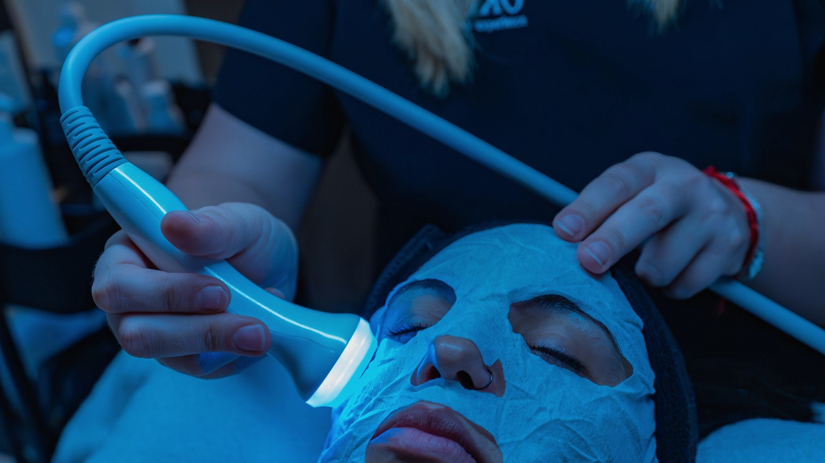
Photo: Emilio Sánchez Hernández / Pexels

AT A GLANCE
Microfocused ultrasound and radiofrequency deliver energy at different depths to create controlled heating and stimulate tissue response.
They are generally best suited to mild or moderate laxity and gradual refinement.
Results develop over weeks to months and vary with age, tissue quality, anatomy and treatment parameters.
They do not remove excess skin or reproduce surgical lifting.
Correct depth, energy and anatomical knowledge are essential for safety.

Why collagen has become a marketing word
The word collagen appears everywhere in aesthetic care, but what matters to me is not the promise on a label. It is the practical question: what degree of change can this treatment realistically create in this face, at this stage of life?
Energy-based devices do not pour new collagen into the skin. They create controlled thermal effects intended to trigger contraction and remodelling. The response belongs to the patient’s biology and develops over time.
How microfocused ultrasound works
Microfocused ultrasound concentrates acoustic energy at selected tissue depths while leaving the surface largely intact. Depending on the device and cartridge, energy can be delivered to deeper structural levels or more superficial skin layers. The resulting thermal points are intended to stimulate contraction and a healing response.
This depth selectivity is one of ultrasound’s advantages, but it also means anatomical planning matters. More lines or higher energy are not automatically better.
How radiofrequency differs
Radiofrequency uses electrical energy to generate heat through tissue resistance. Technologies vary: monopolar, bipolar, multipolar and microneedle radiofrequency do not behave identically. Depth, temperature control and energy delivery influence whether the main objective is skin tightening, texture or another target.
Because the category is broad, the name radiofrequency alone does not explain the expected result. The specific device, protocol and tissue being treated are essential.
Who tends to be a realistic candidate
A realistic candidate is usually someone whose concern and expectations match what the technology can provide:
• Mild to moderate laxity — rather than severe excess skin.
• Early softening of the jawline — or a gradual loss of firmness.
• Textural change — where controlled energy may support skin quality.
• A preference for gradual improvement — rather than a surgical degree of lifting.
• Suitable facial anatomy — including skin thickness, volume distribution and previous procedures.
Age alone does not decide suitability. Skin thickness, fat distribution, bone structure, previous procedures and the direction of change all matter.
Why results are gradual
Some immediate firmness may reflect temporary contraction or swelling, but collagen remodelling develops over weeks and months. Studies of microfocused ultrasound commonly assess improvement around three and six months rather than the next morning.
This timeline should shape photography and follow-up. Judging too early can lead to unnecessary retreatment or disappointment.

“Collagen-stimulating treatments are strongest when they are asked to refine, support and gradually improve—not when they are expected to imitate surgery.”

Subtle does not mean ineffective
A subtle result can be valuable when it improves definition without changing expression or identity. The jawline may look slightly clearer, the lower face more supported or the skin more resilient. These changes can be difficult to capture in inconsistent photographs but meaningful in movement and natural light.
The objective should be agreed in advance. A patient seeking dramatic lifting may be better served by a surgical consultation than by repeated non-surgical procedures.
The importance of preserving facial volume
Heat-based treatments can affect tissue beyond collagen depending on depth and parameters. In a naturally lean or volume-depleted face, indiscriminate treatment may not suit the aesthetic objective. The plan should distinguish laxity from volume loss and avoid treating every shadow as loose skin.
Anatomical assessment is therefore more important than following a standard pattern on every face.
Comfort and immediate recovery
Patients may feel heat, pressure, prickling or brief deeper sensations. Mild redness, tenderness or swelling can occur. Some protocols involve little visible downtime, but lack of downtime does not mean lack of biological effect.
Persistent numbness, weakness, severe pain, burns or unexpected tissue changes require prompt assessment.
Combining technologies thoughtfully
Ultrasound and radiofrequency may be used at different stages because they target tissue differently. Combination should not become accumulation. Each procedure needs a defined purpose, suitable interval and understanding of the total energy delivered.
A coherent plan might prioritise deeper support first and surface texture later, or choose only one modality because it already addresses the main concern.
Maintenance without chasing every change
Ageing continues after treatment. Maintenance may be discussed, but it should respond to observed change rather than anxiety about losing the result. Daily sun protection, sleep, nutrition, smoking avoidance and a tolerable skincare routine remain part of skin quality.
I see these technologies as one part of healthy-ageing care, not as a permanent battle against expression, movement or time.

Questions patients often ask
01 What is the difference between ultrasound and radiofrequency?
They use different forms of energy and can target different depths. Suitability depends on the device, tissue and objective.
02 When will I see results?
Improvement usually develops gradually over weeks to months as tissue remodelling occurs.
03 Can Ultraformer replace a facelift?
No. Microfocused ultrasound may improve mild to moderate laxity but cannot remove significant excess skin or reproduce surgical lifting.
04 Is one session enough?
Some protocols use one session while others use a series. The plan depends on the area, device and response.
05 Does treatment reduce facial fat?
Some radiofrequency and ultrasound parameters can affect deeper tissue. This is why depth and patient selection must be carefully planned.
06 Is the treatment painful?
Sensation varies and may include heat, pressure or brief deeper discomfort. The protocol should remain tolerable and safe.
07 How long do results last?
Duration varies because ageing continues. Maintenance may be considered according to the observed response rather than a universal calendar.
08 Can ultrasound and radiofrequency be combined?
Yes in selected plans, but each treatment should have a clear purpose and appropriate interval.
09 Who may not be a good candidate?
People with certain implants, active infection, unsuitable medical conditions, unrealistic expectations or anatomy that does not match the treatment goal may need another approach.
10 What symptoms after treatment are not normal?
Severe or increasing pain, burns, persistent weakness, marked numbness or unexpected tissue changes require prompt professional or medical evaluation.
  Franciele Sofiati  Biomédica · Esteticista · Cosmetologista  CRBM 6277 · Londrina, Paraná | ABOUT THE AUTHOR  Care, clarity and realistic expectations.  Collagen-stimulating treatments should refine and support the face, not ask technology to imitate a surgical result. I write these articles in the same way I speak to patients in the clinic: clearly, carefully and without promising more than a treatment can deliver.  Choose the depth that matches the concern. Personalised consultations are available in Londrina.

10 · SCALP · HAIR THINNING
Hair Thinning Needs a Cause Before It Needs a Procedure
Hair thinning can be deeply personal, and I understand the wish to begin treatment quickly. Even so, the most responsible first step is to understand what is changing and whether a medical investigation needs to come before a procedure.
By Franciele Sofiati · Biomédica · Esteticista · Cosmetologista · CRBM 6277
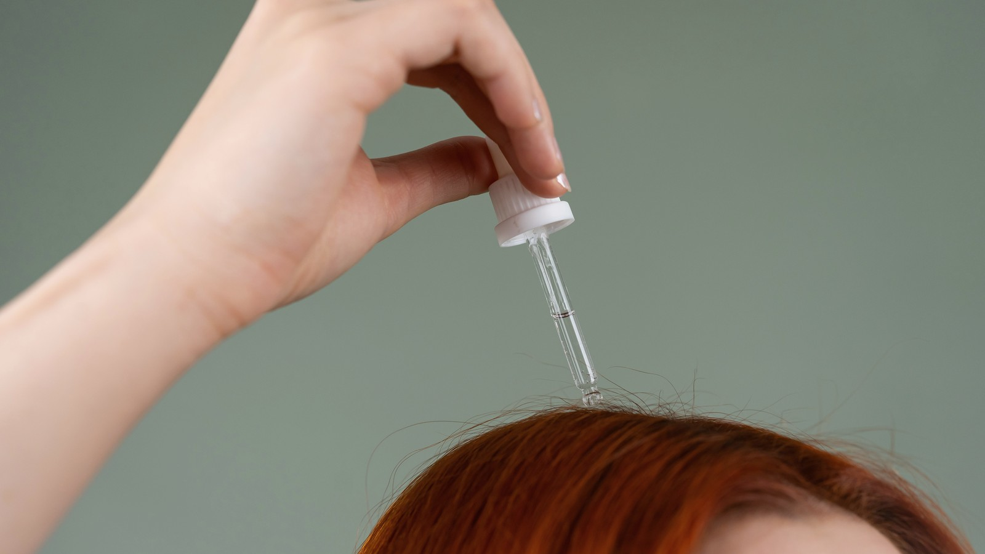
Photo: The Full On Monet / Pexels

AT A GLANCE
Hair shedding, breakage and reduced density are different problems and can occur together.
Causes may include genetics, hormones, illness, nutritional deficiency, medication, inflammation, stress or hair practices.
Scalp microneedling or microinfusion may support selected medically diagnosed patterns, often as an adjunct rather than a replacement for established care.
Progress must be measured over months because hair growth is slow.
Sudden, patchy, painful, scarring or inflammatory hair loss requires medical evaluation.

The difference between shedding, thinning and breakage
When someone says, “My hair is falling,” I begin by clarifying what they are actually seeing. Increased shedding, gradual thinning and breakage can happen together, but they are different processes and they do not lead to the same treatment plan.
The treatment changes depending on which process is dominant. A scalp procedure cannot repair a broken hair shaft, and a cosmetic strengthening routine cannot correct an untreated medical cause of shedding.
Why the timeline matters
Hair changes often follow events with a delay. Significant illness, surgery, childbirth, rapid weight change, intense stress or medication changes can trigger shedding weeks or months later. Patterned thinning develops more gradually and may be noticed as a smaller ponytail or wider central part.
Building a timeline helps connect the visible change to possible triggers and determines whether observation, investigation or treatment is appropriate.
Common causes need different care
Several common causes of hair change require very different forms of care:
• Androgenetic alopecia — gradual follicle miniaturisation linked to genetic and hormonal susceptibility.
• Telogen effluvium — increased shedding after a physical or emotional trigger.
• Alopecia areata — smooth patches caused by an autoimmune process.
• Inflammatory, fungal or scarring conditions — which need specific medical treatment.
• Nutritional or endocrine factors — which may contribute and sometimes require investigation.
Because these conditions can look similar to an untrained eye, persistent hair loss should not be managed indefinitely with cosmetic procedures alone.
Where scalp microneedling and microinfusion may fit
Microneedling creates controlled microchannels and has been studied mainly as an adjunct to established treatment for androgenetic alopecia. Systematic reviews suggest that combination approaches may improve hair density or diameter compared with topical treatment alone, but protocols vary and the evidence does not support using one technique as a universal cure.
Microinfusion methods can deliver selected substances into superficial scalp layers, but the product, indication, professional scope and medical diagnosis must be appropriate. More delivery is not automatically more effective or safer.
Why diagnosis cannot be replaced by a camera
Scalp imaging can document density, shaft variation, redness and scaling, but it does not replace a complete medical assessment when disease is suspected. Blood tests may be relevant for selected patients, and a dermatologist may use dermoscopy, examination or biopsy depending on the pattern.
Technology can support observation. It should not create false certainty.

“Hair treatment becomes more useful when the question changes from ‘Which procedure grows hair?’ to ‘Why is this hair changing, and what part of that cause can we responsibly address?’”

What a realistic treatment timeline looks like
Hair grows slowly. Early treatment may first reduce shedding before visible density improves. Photographs should be taken with the same parting, angle, lighting and hair condition. Comparing wet hair with dry hair or changing the camera distance can create misleading impressions.
Most meaningful assessments occur over months, not days. A plan that promises dramatic regrowth in a few weeks should be viewed cautiously.
The role of the scalp environment
Inflammation, heavy scale, folliculitis and uncontrolled dermatitis can affect comfort and may interfere with procedures. Gentle cleansing and appropriate scalp care can support treatment, but persistent itching, pain, pustules or thick scale should be medically assessed.
Oils and occlusive products are not universally helpful. In some conditions, they can increase build-up or irritation.
Hair practices are part of the consultation
Tight hairstyles, extensions, repeated bleaching, high heat and friction can contribute to breakage or traction-related loss. Early traction may improve when tension stops, but prolonged traction can become permanent.
A useful plan therefore asks not only what products are used, but how the hair is tied, dried, coloured and handled every day.
When medical treatment comes first
Sudden widespread shedding, smooth patches, loss of eyebrows, scalp pain, burning, pustules, scarring, shiny areas without follicular openings or symptoms of hormonal or systemic illness require medical evaluation. Early diagnosis is particularly important in scarring alopecia because destroyed follicles may not regrow.
Aesthetic scalp care can complement treatment after the condition is understood, but it should not delay investigation.
A plan needs evidence, not only hope
Hair concerns make people vulnerable to persuasive claims. The safest approach explains what is known, what remains uncertain, which treatment is supporting medical care and what result would count as meaningful.
A good plan may include referral, laboratory investigation, prescribed medication, procedural support, changes in hair practice and careful photography. Its strength comes from coordination—not from presenting one procedure as the answer to every form of hair loss.

Questions patients often ask
01 Is all hair loss caused by stress?
No. Stress can contribute to shedding, but genetic, hormonal, nutritional, inflammatory, autoimmune and medication-related causes are also possible.
02 Can microneedling regrow hair by itself?
Evidence is strongest for selected combination treatment in androgenetic alopecia. It is not a universal standalone cure.
03 How long before I see improvement?
Hair growth is slow. Meaningful assessment usually requires several months of consistent treatment and standardised photographs.
04 Does shedding mean the follicles are dead?
No. Increased shedding can occur while follicles remain capable of growth. The cause determines the prognosis.
05 Can vitamins stop hair loss?
Supplements help only when a relevant deficiency or medical indication exists. Unnecessary supplementation can be ineffective or harmful.
06 Should I oil my scalp?
Not automatically. Oils may suit some hair routines but can worsen build-up or irritation in certain scalp conditions.
07 What is the difference between hair thinning and breakage?
Thinning reduces density at the scalp; breakage shortens or weakens the hair shaft. Both can occur together.
08 Can tight hairstyles cause permanent hair loss?
Yes. Prolonged traction can damage follicles, so early changes should be taken seriously.
09 When should I see a dermatologist urgently?
Seek prompt assessment for painful, inflamed, scarring or patchy loss, pustules, rapid progression, eyebrow loss or shiny areas without follicles.
10 What should I bring to a hair consultation?
Bring a medication and supplement list, relevant medical history, recent blood tests if available, previous treatment details and photographs showing the timeline.
  Franciele Sofiati  Biomédica · Esteticista · Cosmetologista  CRBM 6277 · Londrina, Paraná | ABOUT THE AUTHOR  Care, clarity and realistic expectations.  Hair concerns deserve investigation before enthusiasm. I want to understand the pattern and the cause before deciding whether a procedure has a useful role. I write these articles in the same way I speak to patients in the clinic: clearly, carefully and without promising more than a treatment can deliver.  Start with the pattern and the history. Personalised consultations are available in Londrina.
Franciele Sofiati

