
Project
Analysis & Visualization of Electric and Hybrid Vehicle
Adoption in Washington State
Group 1: B.E.A.N.N.S. Team

Submitted By

Mr. | Suppakorn | Pojsomphong | 6588077
Mr. | Ratchabhol | Songserm | 6588097
Mr. | Thannatorn | Thongsuk | 6588109
Miss | Nuttida | Wiphaalongkot | 6588144
Miss | Ananya | Sangtanchai | 6588191
Mr. | Natchanon | Sinsub | 6588202

A Report Submitted in Partial Fulfillment of
the Requirements for
ITCS495 Special Topics in Databases and Intelligent Systems
Faculty of Information and Communication Technology
Semester 1/2025
Table of Content
1. Business Domain 1
2. Target Users 2
Target User 1: Policy Makers & Regulators (e.g., Washington State Department of Licensing, Department of Energy) 2
Background: 2
Example Scenarios: 2
Objectives & Scope: 2
Target User 2: Electric Utilities & Charging Network Operators 3
Background: 3
Example Scenarios: 3
Objectives & Scope: 3
Target User 3: OEMs & Dealerships 4
Background: 4
Example Scenarios: 4
Objectives & Scope: 4
3. Objectives 5
Example Research Questions 5
4. Data Description 6
Dataset Overview 6
Data Characteristics 6
Data Quality Assessment 7
Key Fields in the Original Dataset 8
5. Data Preparation (Alteryx) 9
5.1 Overview 9
5.2 Initial Data Ingestion and Profiling 9
5.3 Data Cleansing and Standardization 9
5.4 Feature Engineering and Data Enrichment 10
5.5 Final Scoping and Output 12
5.6 Final Output and Data Schema 12
5.7 Data Quality Results 13
6. Visualization (Power BI) 15
6.1 Objectives 15
6.2 Methodology and Technical Setup 15
6.2.1 Core DAX Measures 15
Market Composition & Policy Metrics 16
Market Share & Ranking Metrics 17
Growth & Trend Analysis Metrics 20
6.3 Dashboard 1: Policy Makers & Regulators 22
Purpose 22
Relevant Project Goals Addressed 22
Dashboard Visuals and Data Analysis 22
6.4 Dashboard 2: Electric Utilities & Charging Operators 25
Purpose 25
Relevant Project Goals Addressed 25
Dashboard Visuals and Data Analysis 26
6.5 Dashboard 3: OEMs & Dealerships 28
Purpose 28
Relevant Project Goals: 28
Dashboard Visuals and Data Analysis: 29
6.6 Project Fulfillment and Technical Summary 31
6.6.1 Fulfillment of Power BI Project Criteria 31
6.6.2 Summary of Visuals Used 31
7. Analysis & Insights (Per User Group Template) 33
Dashboard 1 – Policy Makers & Regulators 33
Dashboard 2 – Electric Utilities & Charging Operators 35
Dashboard 3 – OEMs & Dealerships 37
References 39

1. Business Domain
The business domain of this project lies at the intersection of the automotive industry, energy and utilities, and public policy. The increasing adoption of Electric Vehicles (EVs) and Plug-in Hybrid Electric Vehicles (PHEVs) is reshaping global transportation, shifting the market away from fossil fuel dependence and toward cleaner, more sustainable alternatives. In Washington State, this transition is particularly significant because of strong government incentives, such as the Clean Alternative Fuel Vehicle (CAFV) program, ambitious climate goals, and a growing consumer demand for environmentally friendly transportation. At the same time, utilities face the challenge of preparing for rising electricity demand and ensuring grid stability, while automotive manufacturers and dealerships must understand consumer behavior and competitive positioning to refine their product strategies.
Analyzing EV registration data provides value across multiple stakeholders in this ecosystem. For policy makers and regulators, it offers evidence to evaluate the effectiveness of incentive programs, identify adoption hotspots, and allocate resources for charging infrastructure. For electric utilities and charging operators, it supports load forecasting, infrastructure planning, and prioritization of fast-charging deployment. For original equipment manufacturers (OEMs) and dealerships, the data enables benchmarking of market share, assessment of product-market fit, and anticipation of technology shifts between BEVs and PHEVs.
Within this context, the project belongs to the broader business domain of the EV ecosystem, encompassing market analysis, infrastructure planning, and policy evaluation. By combining data preparation and visualization, the study aims to generate actionable insights that not only describe the current state of EV adoption in Washington but also inform future strategies across government and industry sectors.

2. Target Users
Our project focuses on three primary stakeholder groups that benefit directly from analyzing the Washington State Electric & Hybrid Vehicle dataset. Each group has unique needs, and the dataset provides actionable insights to support their objectives.

Target User 1: Policy Makers & Regulators (e.g., Washington State Department of Licensing, Department of Energy)

Background:
Policy makers and regulators are responsible for creating the policy and financial framework to accelerate the transition to clean transportation and meet state-mandated climate goals. They view data not for commercial profit, but as a tool for evidence-based policy-making, ensuring that public funds are used effectively and transparently. Therefore, they need to monitor EV and PHEV adoption trends to guide environmental policies, evaluate incentive programs such as CAFV, and plan charging infrastructure.

Example Scenarios:
- Identifying which cities have the highest or lowest EV adoption.
  - To ensure equitable access to clean transportation and to identify underserved communities that may require targeted outreach or funding.
- Evaluating whether CAFV eligibility correlates with higher registration volumes.
  - To measure the return on investment (ROI) of public funds and determine if tax incentives are an effective and efficient tool for driving consumer behavior.
- Tracking the long-term shift from PHEVs to BEVs.
  - To understand if the market is moving towards zero-emission vehicles (BEVs) at a pace consistent with long-term climate targets, and whether additional policies are needed to encourage this shift.

Objectives & Scope:
- Use data to design and refine EV incentive policies.
  - To create data-driven policies that are both effective in stimulating adoption and fiscally responsible.
- Allocate funding for charging stations and grid expansion in high-demand areas.
  - To make strategic and equitable investments in public infrastructure, prioritizing areas with the greatest need or highest potential impact.
- Measure progress towards clean energy and emission reduction goals.
  - To ensure accountability and transparency by tracking progress against legislated environmental targets and reporting to the public.

Target User 2: Electric Utilities & Charging Network Operators

Background:
Utilities and charging providers must prepare for rising EV penetration, which impacts electricity demand and grid stability. Understanding geographic EV density helps them plan investment in infrastructure and optimize service delivery.

Example Scenarios:
- Estimating how many EVs are connected to each utility provider (e.g., Seattle City Light vs Puget Sound Energy).
  - To create accurate load forecasts at a local level and identify which substations or distribution networks are at the highest risk of overload.
- Predicting charging demand peaks in urban vs rural areas.
  - To design targeted demand response programs or time-of-use rates that encourage off-peak charging and reduce stress on the grid.
- Determining where to install additional fast-charging stations.
  - To guide capital investment toward locations that will serve the most customers, alleviate range anxiety, and support transportation corridors.

Objectives & Scope:
- Support load forecasting and grid stability.
  - To move from reactive to proactive grid management, anticipating future demand instead of responding to problems as they arise.
- Guide investment decisions for charging infrastructure.
  - To build a robust and reliable charging network that meets current demand and is scalable for future growth.
- Align planning with clean energy transition policies.
  - To ensure that grid upgrades and infrastructure rollouts are synchronized with state policies and can support a fully electrified transportation future.

Target User 3: OEMs & Dealerships

Background:
Automotive manufacturers and dealerships operate in a highly competitive commercial environment. Their primary goals are to increase market share, profitability, and brand loyalty. For them, data serves as competitive intelligence to outperform rivals. In other words, they want to understand brand and model adoption in Washington to benchmark against competitors, refine product strategies, and align with consumer preferences.

Example Scenarios:
- Comparing Tesla’s market share with Nissan, Chevrolet, and Ford.
  - To perform direct competitive benchmarking, understanding which brands are gaining or losing ground and why. This informs everything from marketing spend to product features.
- Identifying which EV models are the most popular across different segments.
  - To understand consumer preferences and identify the 'sweet spot' in the market, ensuring that product development and inventory align with what customers actually want to buy.
- Monitoring the consumer shift from PHEVs toward BEVs.
  - To anticipate future demand and adjust long-term product roadmaps and manufacturing capacity, thereby avoiding investment in declining technologies.

Objectives & Scope:
- Map the competitive EV landscape in Washington.
  - To gain a clear and actionable understanding of the competitive arena, identifying key threats and opportunities.
- Guide marketing and product positioning strategies.
  - To make data-informed decisions on how to price, market, and position their vehicles to stand out from competitors.
- Adjust product roadmaps to better match regional demand.
  - To ensure that future products are highly relevant to the target market, increasing the probability of commercial success.

3. Objectives
The overall objective of this project is to analyze the adoption patterns of electric and hybrid vehicles in Washington State using data-driven methods. By preparing and cleansing the dataset in Alteryx, followed by developing interactive dashboards in Power BI, we aim to provide actionable insights that directly support the needs of our target users.
Specifically, our project addresses the following goals:
- Assess CAFV Incentive Effectiveness
  - Compare registrations of vehicles eligible for Clean Alternative Fuel Vehicle (CAFV) incentives with those that are not.
  - Evaluate whether eligibility influences adoption rates.
- Monitor EV Adoption Trends
  - Track the growth of EV and PHEV registrations over time.
  - Identify key inflection points where adoption accelerated.
- Map Geographic Adoption Hotspots
  - Analyze EV adoption by City, County, and ZIP Code.
  - Identify regions with high or low penetration to inform infrastructure planning.
- Evaluate BEV vs PHEV Market Share
  - Compare the adoption of Battery Electric Vehicles (BEVs) and Plug-in Hybrid Electric Vehicles (PHEVs).
  - Determine whether consumer preferences are shifting toward full EV adoption.
- Identify Market Leaders (Brands & Models)
  - Highlight the top automotive brands and models in terms of adoption.
  - Benchmark OEM competitiveness in the Washington State EV market.
- Explore Pricing and Range Relationships
  - Analyze the relationship between Base MSRP and Electric Range.
  - Identify market gaps (e.g., mid-priced long-range EVs) and segment positioning.
- Analyze Infrastructure Demand by Utility Providers
  - Summarize EV registrations by electric utility providers.
  - Estimate charging demand and identify utilities facing the highest load growth.

Example Research Questions
- Which counties in Washington have the highest EV adoption rates?
- How has the share of BEVs compared to PHEVs evolved from 2010 to 2025?
- Which brands and models dominate the EV market in Washington?
- Are CAFV incentives correlated with higher registration volumes?
- Which electric utility providers will face the greatest charging demand?
- Is there a strong correlation between vehicle price and electric driving range?

4. Data Description

Dataset Overview
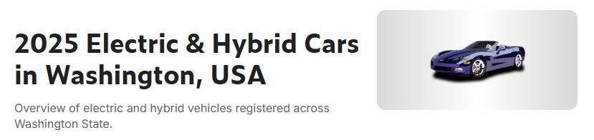
The foundation of this project is the "Electric Vehicle Population Data" dataset, publicly available on Kaggle. This dataset comprises detailed registration records for Battery Electric Vehicles (BEVs) and Plug-in Hybrid Electric Vehicles (PHEVs) across Washington State, with data sourced directly from the state's Department of Licensing.
Each record represents a unique vehicle registration and provides a rich set of attributes covering its technical specifications, geographic location, and policy eligibility.
- Source: Kaggle (Data provided by the Washington State Department of Licensing)
- Link: 2025 Electric and Hybrid Cars in Washington, USA
- Size: Over 200,000 records
- Columns: 17 attributes describing vehicle characteristics, location, and eligibility

Data Characteristics
The dataset provides a comprehensive overview of electric and hybrid vehicle registrations across Washington State. It captures multiple aspects of each registered vehicle from technical specifications to geographic and policy-related information that allows for both quantitative and spatial analyses due to the following key characteristics:.
- Geographic Coverage: The dataset includes vehicle registration data from all cities and counties in Washington State, representing a complete statewide picture of EV adoption. This broad coverage enables regional comparison and identification of geographic trends in electric vehicle usage.
- Temporal Scope: The dataset spans from early EV and PHEV models to vehicles registered up to the 2025 model year, offering insights into the evolution and growth of electric mobility over time.
- Key Analytical Fields: The dataset contains several powerful fields for in-depth analysis:
3.1 Policy Field (CAFV Eligibility): This field indicates whether a vehicle qualifies for the Clean Alternative Fuel Vehicle (CAFV) program, which provides incentives for environmentally friendly vehicles. It allows analysis of policy effectiveness and the relationship between incentives and adoption rates.
3.2 Utility Field: Each vehicle is linked to a specific electricity provider serving its registered location. This connection enables analysis of EV distribution relative to energy infrastructure and grid capacity.
3.3 Geographic Fields: The dataset contains City, County, ZIP Code, and Legislative District information, supporting spatial mapping and regional policy analysis. These fields are crucial for visualizing EV concentration and identifying high-adoption zones.

Data Quality Assessment
While the dataset is comprehensive, an initial assessment revealed several quality considerations that must be addressed during the data preparation stage to ensure the validity of any analytical findings. The key issues and the planned mitigation strategies are outlined below:
- Erroneous Electric Range Values
  - Issue: A significant number of Battery Electric Vehicles (BEVs) are incorrectly listed with an electric range of 0. This is a data artifact, not a true value, likely representing missing or unavailable information for those models.
  - Required Handling: To prevent these erroneous zeros from skewing statistical calculations such as average range, they must be treated as missing values (e.g., converted to Null) during the data cleaning process.
- Incomplete Base MSRP Data
  - Issue: The Base_MSRP (Manufacturer's Suggested Retail Price) column exhibits low data completeness, with a high percentage of missing or zero values, making it unsuitable for direct economic analysis.
  - Required Handling: A robust data enrichment strategy is necessary. This will involve imputing the missing prices based on the vehicle's Make and Model using verified external data from official automaker and market sources.
- Inconsistent Categorical Data
  - Issue: Key categorical fields, particularly City and Electric_Utility, contain spelling variations, inconsistent formatting, and different naming conventions for the same entity (e.g., "City of Seattle - (WA)" vs. "Seattle City Light").
  - Required Handling: These fields require a thorough standardization process to consolidate all variations into a single, uniform format. This step is critical for enabling accurate grouping, aggregation, and spatial analysis.
- Potential for Duplicate Records
  - Issue: The dataset may contain duplicate entries for the same vehicle registration. The provided VIN field was found to be anonymized and is therefore not a reliable key for deduplication.
  - Required Handling: A more reliable unique identifier, such as the DOL_ID (Department of Licensing ID), must be used to identify and remove duplicate records. This ensures that each vehicle is counted only once in the final analysis.

Key Fields in the Original Dataset
Column | Description | Example
VIN data | Vehicle Identification Number (masked) | 5YJSA1E26HF…
Make | Manufacturer / brand of the vehicle | Tesla
Model | Vehicle model name | Model Y
Model Year | Year of manufacture / registration | 2023
Electric Vehicle Type | BEV (Battery Electric Vehicle) or PHEV (Plug-in Hybrid Electric Vehicle) | BEV
Electric Range (miles) | Electric-only driving range; BEVs are coded as 0 miles | 42 (for PHEV)
Base MSRP (USD) | Manufacturer Suggested Retail Price | 52,000
City | City of registration | Seattle
County | County of registration | King
ZIP Code | ZIP code of registration | 98109
Legislative District | Washington State legislative district | 36
Electric Utility | Utility provider for the registered location | Seattle City Light
CAFV Eligibility | Whether the vehicle qualifies for the Clean Alternative Fuel Vehicle program | Eligible / Not Eligible
DOL Vehicle ID | Unique identifier from the Department of Licensing | 1234567

5. Data Preparation (Alteryx)

5.1 Overview
The following sections provide a comprehensive description of the data transformation and enrichment pipeline built in Alteryx. The objective was to convert the raw, publicly-sourced dataset into a high-integrity, analysis-ready format. This involved a multi-stage process of cleaning, feature engineering, data imputation, and filtering to ensure the final data is accurate, relevant, and properly structured for insightful analysis of the electric vehicle market in Washington state.

5.2 Initial Data Ingestion and Profiling
Step 1: Input Data
- Tool: Input Data
- Details: The workflow commences by loading the Electric_Vehicle_Population_Data.csv dataset. A preliminary review of this raw data revealed common issues such as missing values, inconsistent formatting, and extraneous information that necessitated the subsequent cleaning and preparation steps.
Step 2: Auto Field
- Tool: Auto Field
- Details: To preemptively address potential data type mismatches and optimize performance, the Auto Field tool was applied to all columns. This tool intelligently scans the data within each field and assigns the most restrictive, memory-efficient data type possible (e.g., converting a generic string field containing only numbers to a more appropriate integer type). This is a crucial first step for ensuring data integrity in subsequent calculations.

5.3 Data Cleansing and Standardization
Step 1: Data Cleansing
- Tool: Data Cleansing
- Details: A standardized cleaning protocol was applied to rectify inconsistencies:
  - Null Value Handling: Nulls in string-based fields were replaced with empty strings ("") to prevent errors in string manipulation functions. Nulls in numeric fields were replaced with zeros (0) as a baseline.
  - Whitespace Removal: Leading and trailing whitespaces were removed from all relevant fields. This is critical for ensuring the reliability of joins, filters, and conditional logic, as a value like "TESLA " would otherwise not match "TESLA".
Step 2: Attribute Selection
- Tool: Select
- Details: To streamline the dataset and remove irrelevant or unreliable information, two columns were explicitly excluded from the workflow:
  - VIN: The Vehicle Identification Numbers were confirmed to be anonymized placeholders, offering no value for unique vehicle identification.
  - 2020 Census tract: This geographic attribute was not required for the scope of the planned analysis. Removing it reduces the dataset's complexity.
Step 3: Geospatial Data Parsing
- Tool: Text to Columns
- Details: The Vehicle Location column contained geospatial data in a single string, typically formatted as "POINT (Longitude Latitude)". To make this information usable for mapping and spatial analysis, the Text to Columns tool was configured to split this string into separate columns based on the space delimiter, effectively isolating the longitude and latitude values.

5.4 Feature Engineering and Data Enrichment
Step 1: Formula Application
- Tool: Formula
- Details: This was the most intensive stage of data transformation, where new, analytically valuable features were created (feature engineering) and critical missing information was filled in (data imputation).
  - EV_Type_short (Categorical Simplification):
    - Purpose: To create a clean, simple categorical variable from the verbose EV_Type field (e.g., "Battery Electric Vehicle (BEV)").
    - Method: A Regular Expression, REGEX_Replace([EV_Type], ".*\((.*?)\).*", "$1"), was used to extract only the acronym within the parentheses (BEV or PHEV).
  - Range_Miles (Data Quality Correction):
    - Purpose: To address a logical data error where some Battery Electric Vehicles (BEVs) had a listed electric range of 0.
    - Method: An IF statement identified these records and converted the 0 to a Null() value. This correctly represents the data as missing/invalid rather than an actual zero range, preventing it from incorrectly skewing statistical calculations like average range.
  - Vehicle_Age (Feature Engineering):
    - Purpose: To create a more intuitive variable for analysis than ModelYear.
    - Method: A simple calculation, 2025 - [ModelYear], converted the model year into the vehicle's age. This new feature is more directly useful for analyzing trends related to depreciation, technology relevance, and battery longevity.
  - Binary Flags (Feature Engineering):
    - Purpose: To create efficient binary indicators for key attributes.
    - Method: IF statements were used to generate BEV_Flag, PHEV_Flag, and CAFV_Flag. These 1/0 flags are computationally efficient for filtering, counting (e.g., SUM(BEV_Flag)), and are a standard requirement for many predictive modeling algorithms.
  - Base_MSRP (Data Imputation & Enrichment):
    - Purpose: To remedy the sparse and unreliable Base_MSRP field in the original dataset, which was unusable due to a high volume of null and zero values.
    - Method: An extensive, multi-conditional IF/ELSEIF statement was constructed to assign a representative Manufacturer's Suggested Retail Price (MSRP) to each vehicle based on its Model. The price points were meticulously researched from official automaker websites and verified automotive market databases to ensure accuracy. This crucial step transformed a useless column into a powerful feature for economic and market segment analysis.
  - Latitude & Longitude (Final Cleaning):
    - Purpose: To finalize the parsing of coordinate data.
    - Method: The REGEX_Replace function was used to strip any remaining parentheses from the latitude and longitude columns created in Step 3.3, ensuring they are pure numeric values compatible with geospatial tools.
  - Company_Name (Data Standardization):
    - Purpose: To consolidate inconsistent utility company names into standardized categories.
    - Method: An IF statement with the Contains() function was used to group various spellings and sub-designations under a single, official company name, enabling accurate aggregation and analysis of vehicles by utility providers.

5.5 Final Scoping and Output
Step 1: Filtering for Analytical Scope
- Tool: Filter
- Details: To focus the analysis on the most relevant segment of the EV market, a filter was applied with three conditions:
  - [ModelYear] >= 2008 and [ModelYear] < 2025: This scopes the data to the modern era of electric vehicles. The year 2025 was intentionally excluded because the dataset contained too few records for that year. Including this incomplete data could negatively impact the analysis, so the decision was made to remove it.
  - [EV_Type_short] = "BEV" or [EV_Type_short] = "PHEV": This ensures the dataset contains only true electric or plug-in hybrid vehicles.
  - [State] = "WA": This geographically constrains the dataset to Washington state for a focused regional analysis.
Step 2: Deduplication
- Tool: Unique
- Details: To ensure the integrity of the final count and prevent skewed statistics, the Unique tool was used to remove any duplicate records. The DOL_ID (Department of Licensing ID) was used as the unique key, guaranteeing that each vehicle is represented only once in the dataset.

5.6 Final Output and Data Schema
Step 1: Output Data
- Tool: Output Data
- Details: The workflow concludes by saving the fully processed data stream. The final, analysis-ready dataset is written to a comma-separated values file named EV_clean.csv.
Step 2: Resulting Attributes
- Details: The final output file (EV_clean.csv) contains the following 20 attributes, which are a combination of cleaned original fields and newly engineered features:
Attribute | Description
DOL_ID | Unique Department of Licensing ID for each vehicle.
County | The county where the vehicle is registered.
City | The city where the vehicle is registered.
State | The state where the vehicle is registered (filtered to "WA").
ZIP | The 5-digit zip code of the registration address.
Latitude | The clean, numeric latitude coordinate of the vehicle's location.
Longitude | The clean, numeric longitude coordinate of the vehicle's location.
ModelYear | The model year of the vehicle.
Make | The manufacturer of the vehicle (e.g., TESLA, NISSAN).
Model | The specific model of the vehicle (e.g., MODEL Y, LEAF).
EV_Type | The original, descriptive electric vehicle type.
EV_Type_short | [New] A simplified category: "BEV" or "PHEV".
Range_Miles | The electric range of the vehicle in miles (corrected for BEV=0 errors).
Base_MSRP | [Enriched] The imputed Base Manufacturer Suggested Retail Price.
Company_Name | [New] The standardized name of the electric utility provider.
Electric_Utility | The original, uncleaned electric utility provider string.
Vehicle_Age | [New] The calculated age of the vehicle as of 2025.
BEV_Flag | [New] A binary flag (1 if BEV, 0 otherwise).
PHEV_Flag | [New] A binary flag (1 if PHEV, 0 otherwise).
CAFV_Flag | [New] A binary flag for Clean Alternative Fuel Vehicle eligibility.

5.7 Data Quality Results
The execution of this Alteryx workflow resulted in significant improvements to the quality, integrity, and analytical value of the dataset. The key outcomes are summarized below:
- Row Count: The initial dataset was filtered and cleaned, retaining approximately 200,000 records that are directly relevant to the analytical scope.
- Column Count: The dataset was refined to 20 focused attributes, with two irrelevant columns removed and six new, high-value columns engineered.
- Duplicate Removal: Data integrity was enforced by removing all duplicate vehicle entries. The use of DOL_ID as a unique identifier ensures each vehicle is represented only once.
- Standardization: Consistency was imposed on key categorical fields. The Data Cleansing tool unified formatting for fields like City and County by removing whitespace, while the Formula tool consolidated variations in Electric_Utility names into a standardized Company_Name field.
- Missing Value Treatment: A systematic approach was applied to null values. Critical missing data in the Base_MSRP column was intelligently imputed, and logical errors (e.g., BEV range of 0) were corrected to Null() to ensure statistical accuracy.
- Data Accuracy & Relevance: The final dataset is of significantly higher quality, with corrected values, enriched information, and a tight focus on the specific vehicle types, model years, and geography pertinent to the analysis.

6. Visualization (Power BI)

6.1 Objectives
Following the successful preparation of the data, the project transitions to the visualization phase. The primary objective is to transform the clean, enriched dataset into a series of interactive dashboards using Microsoft Power BI. The strategy focuses on developing targeted dashboards for distinct stakeholder groups, moving away from a one-size-fits-all approach. This ensures that the insights presented are clear, relevant, and directly aligned with the specific objectives of each audience.

6.2 Methodology and Technical Setup
The visualizations are built upon a solid technical foundation, using the prepared data as a single source of truth and developing a robust analytical layer to power the report.
- Data Source (Fact Table): The EV_clean.csv dataset, which is the final, curated output from the Alteryx data preparation workflow, serves as the central fact table in the Power BI data model.
- DAX Measure Development: To power the visualizations, a comprehensive suite of measures was developed using Data Analysis Expressions (DAX). Each measure is purpose-built to answer one of the guiding analytical questions, transforming raw data into meaningful metrics. The core DAX measures created for this project are detailed in the following sub-section, Core DAX Measures.

6.2.1 Core DAX Measures
The following section details the 15 core measures created to serve as the analytical engine for the dashboards.
Foundational & Market Size Metrics
These are the fundamental calculations that quantify the overall market and form the basis for many other measures.
1. Total EVs
- Purpose: This foundational measure calculates the total count of all registered electric vehicles in the dataset.
- DAX Formula:

Total EVs = COUNTROWS('EV_clean')
2. Total BEVs
- Purpose: This measure filters the total vehicle count to include only Battery Electric Vehicles (BEVs).
- DAX Formula:
Total BEVs = CALCULATE([Total EVs], 'EV_clean'[EV_Type] = "BEV")
3. Total PHEVs
- Purpose: This measure segments the total vehicle count to include only Plug-in Hybrid Electric Vehicles (PHEVs).
- DAX Formula:
Total PHEVs = CALCULATE([Total EVs], 'EV_clean'[EV_Type] = "PHEV")

Market Composition & Policy Metrics
These measures analyze the proportional breakdown of the market and evaluate the impact of specific policy initiatives.
4. % BEV
- Purpose: Calculates the proportion of BEVs relative to the total number of electric vehicles.
- DAX Formula:
% BEV = DIVIDE([Total BEVs],[Total EVs])
5. % PHEV
- Purpose: Calculates the proportion of PHEVs relative to the total number of electric vehicles.
- DAX Formula:
% PHEV = DIVIDE([Total PHEVs],[Total EVs])

6. CAFV Eligible Count
- Purpose: This measure counts the number of vehicles that qualify for the Clean Alternative Fuel Vehicle (CAFV) incentive.
- DAX Formula:
CAFV Eligible Count = CALCULATE(
[Total EVs],
'EV_clean'[CAFV_Flag] = 1
)
7. CAFV Eligible %
- Purpose: This KPI calculates the proportion of the entire EV fleet that is eligible for the CAFV incentive.
- DAX Formula:
CAFV Eligible % = DIVIDE([CAFV Eligible Count],[Total EVs])

Market Share & Ranking Metrics
These measures are used to identify market leaders and understand competitive dynamics.
8. EV Share by Utility
- Purpose: This measure calculates the market share of EVs for a selected utility compared to the total number of EVs across all utilities.
- DAX Formula:
EV Share by Utility =
-- Use IF to switch calculation based on the slicer status for CompanyName
IF(
-- Check if a value is selected in the 'CompanyName' column slicer
ISFILTERED(EV_Clean[CompanyName]),
-- --- Case 1: A value is selected in the slicer ---
DIVIDE(
COUNTROWS(EV_Clean),
CALCULATE(
COUNTROWS(EV_Clean),
ALL(EV_Clean[CompanyName])
),
0
),
-- --- Case 2: No value is selected in the slicer ---
VAR UtilityCounts =
SUMMARIZE(
ALL(EV_Clean),
EV_Clean[CompanyName],
"CountPerUtility", COUNTROWS(EV_Clean)
)
VAR MaxCount =
MAXX(UtilityCounts, [CountPerUtility])
VAR TotalCount =
CALCULATE(
COUNTROWS(EV_Clean),
ALL(EV_Clean)
)
RETURN
DIVIDE(
MaxCount,
TotalCount,
0
)
)
9. MarketShare%
- Purpose: This calculates the market share for a specific vehicle manufacturer (Make) relative to all other manufacturers.
- DAX Formula:
MarketShare of Top Make % =
-- Use IF to switch calculation based on the slicer status
IF(
-- Check if a value is selected in the 'Make' column slicer
ISFILTERED(EV_Clean[Make]),
-- --- Case 1: A value is selected in the slicer ---
DIVIDE(
COUNTROWS(EV_Clean),
CALCULATE(
COUNTROWS(EV_Clean),
ALL(EV_Clean[Make])
),
0
),
-- --- Case 2: No value is selected in the slicer ---
VAR MakeCounts =
SUMMARIZE(
ALL(EV_Clean),
EV_Clean[Make],
"CountPerMake", COUNTROWS(EV_Clean)
)
VAR MaxCount =
MAXX(MakeCounts, [CountPerMake])
VAR TotalCount =
CALCULATE(
COUNTROWS(EV_Clean),
ALL(EV_Clean)
)
RETURN
DIVIDE(
MaxCount,
TotalCount,
0
)
)
10. Top Make
- Purpose: This dynamic measure identifies the name of the top-selling vehicle manufacturer based on the number of registrations.
- DAX Formula:
Top Make = VAR TopMakeTable =
TOPN(
1,
SUMMARIZE(EV_Clean, EV_Clean[Make], "Count", COUNTROWS(EV_Clean)),
[Count],
DESC
)
RETURN
MAXX(TopMakeTable, EV_Clean[Make])
11. Top Model
- Purpose: Similar to "Top Make," this measure identifies the single most popular vehicle model by registration count.
- DAX Formula:
Top Model =
VAR TopModelTable =
TOPN(
1,
SUMMARIZE(EV_Clean, EV_Clean[Model], "Count", COUNTROWS(EV_Clean)),
[Count],
DESC
)
RETURN
MAXX(TopModelTable, EV_Clean[Model])
12. Top Utility (by Total EVs)
- Purpose: This measure finds the name of the electric utility provider that serves the highest number of EVs.
- DAX Formula:
Top Utility (by Total EVs) =
CALCULATE(
VALUES('EV_clean'[Electric_Utility]),
TOPN(
1,
ALL('EV_clean'[Electric_Utility]),
[Total EVs],
DESC
)
)

Growth & Trend Analysis Metrics
These advanced measures are designed to analyze market dynamics over time.
13. Annual Growth Rate
- Purpose: This measure calculates the year-over-year growth rate of EV registrations by comparing the current year's total to the previous year's.
- DAX Formula:
Annual Growth Rate =
VAR PrevYear =
CALCULATE(
[Total EVs],
FILTER(
ALL(EV_clean),
EV_clean[ModelYear] = MAX(EV_clean[ModelYear]) - 1
)
)
RETURN
DIVIDE([Total EVs] - PrevYear, PrevYear)
14. Top Growth ZIP (by Latest Year)
- Purpose: This measure identifies the ZIP code with the highest number of new EV registrations in the most recent year of data.
- DAX Formula:
Top Growth ZIP (by Latest Year) =
VAR _LatestYear = CALCULATE(MAX('EV_clean'[ModelYear]), ALL('EV_clean'))
VAR _TopZIP =
TOPN(
1,
VALUES('EV_clean'[ZIP]),
CALCULATE(
[Total EVs]
),
DESC
)
RETURN
_TopZIP
15. AAGR %
- Purpose: The Average Annual Growth Rate calculates the average year-over-year growth across multiple years, providing a more stable measure of the long-term growth trend.
- DAX Formula:

AAGR % =
VAR YearsWithAGR =
FILTER (
SUMMARIZE (
ALLSELECTED ( EV_clean[ModelYear] ),
EV_clean[ModelYear],
"AGR",
VAR Y = EV_clean[ModelYear]
VAR Cur = CALCULATE ( [Total EVs], EV_clean[ModelYear] = Y )
VAR Prev= CALCULATE ( [Total EVs], EV_clean[ModelYear] = Y - 1 )
RETURN IF ( Prev > 0, DIVIDE ( Cur - Prev, Prev ) )
),
NOT ISBLANK ( [AGR] )
)
RETURN
IF ( COUNTROWS ( YearsWithAGR ) > 0,
AVERAGEX ( YearsWithAGR, [AGR] ),
BLANK ()
)

6.3 Dashboard 1: Policy Makers & Regulators
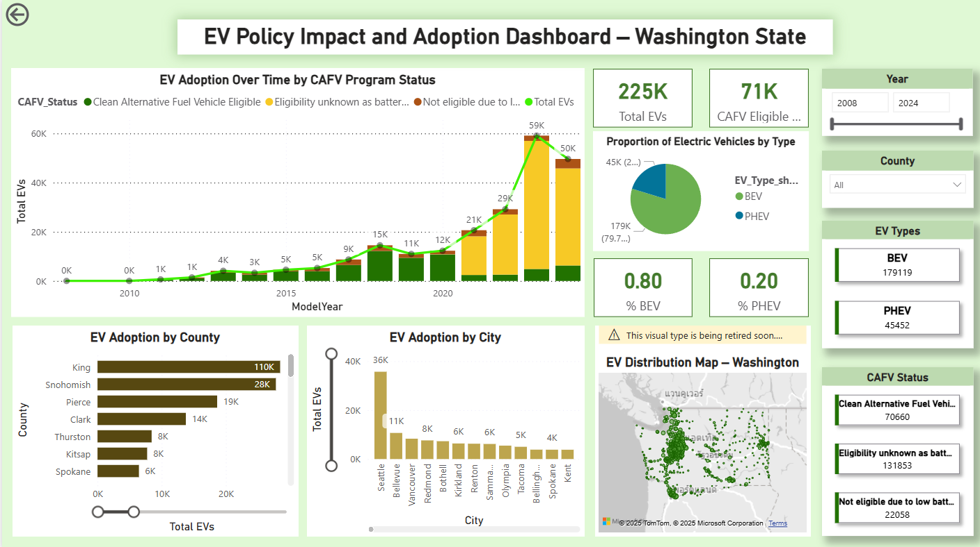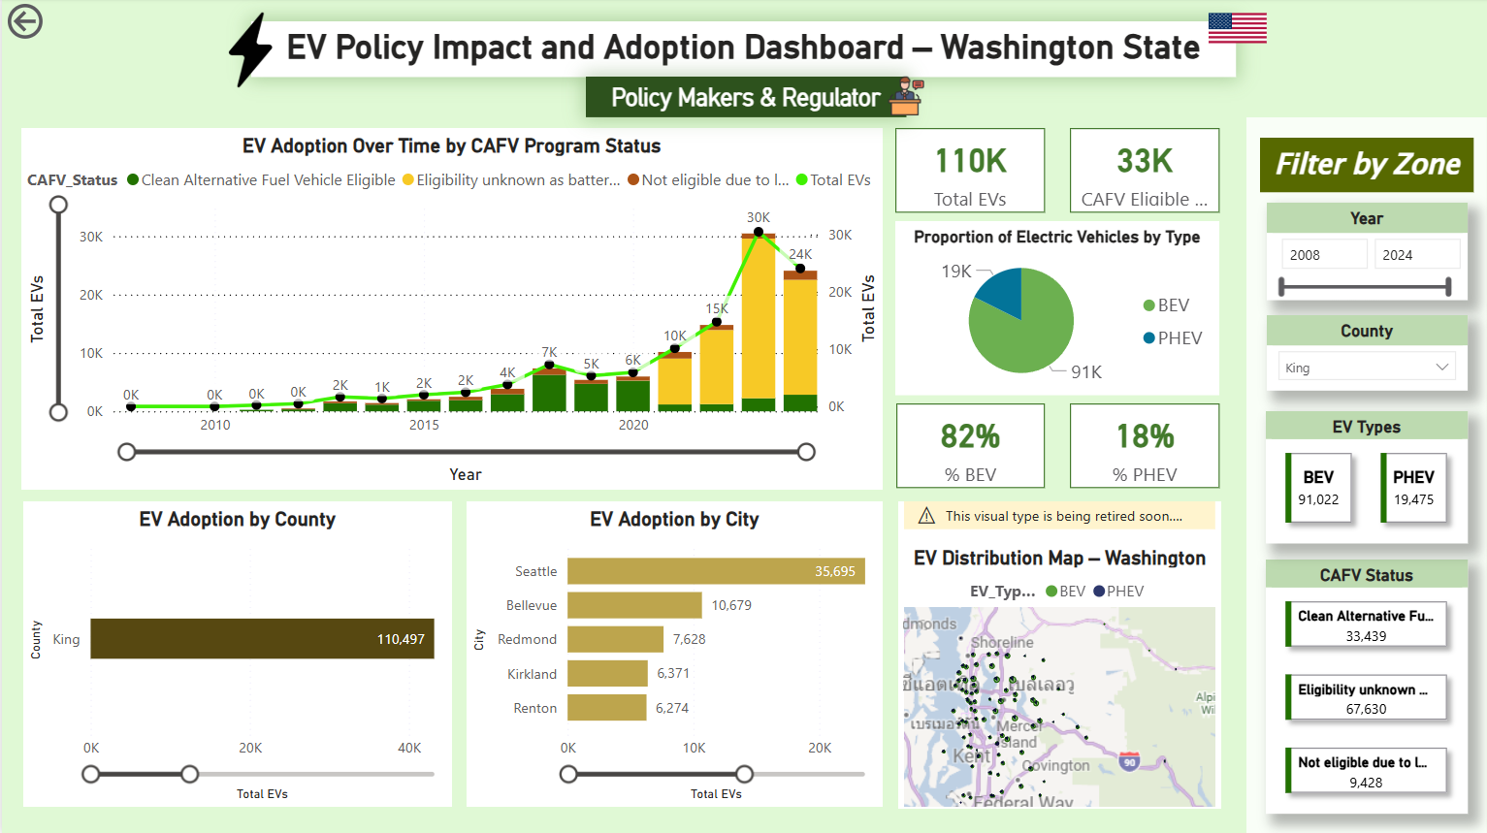

Purpose
This dashboard is designed to help policy makers and regulators (e.g., Washington State DOL, Department of Energy) evaluate the effectiveness of incentive programs (CAFV), monitor regional adoption differences, and plan for infrastructure investments.
- By tracking adoption trends over time, they can measure the impact of policies.
- By visualizing CAFV eligibility, they can verify if incentives drive adoption.
- By mapping geographic hotspots, they can identify regions with low EV penetration and design targeted support programs.

Relevant Project Goals Addressed
- (1.) Assess CAFV Incentive Effectiveness: To directly evaluate the performance and impact of the CAFV incentive program.
- (2.) Monitor EV Adoption Trends: To track and measure the impact of various policies over time.
- (3.) Map Geographic Adoption Hotspots: To identify regions that require targeted support and infrastructure planning.

Dashboard Visuals and Data Analysis
The dashboard is composed of several interactive visuals, each designed to provide specific insights into policy impact and vehicle adoption patterns.
1. Key Performance Indicators (KPIs)
- Purpose: To provide an immediate, high-level summary of the current EV landscape.
- Visuals & Data Used:
  - Total EVs (225K): A Card visual displaying the [Total EV Registrations] measure.
  - CAFV Eligible (71K): A Card visual displaying a DAX measure that counts vehicles where [CAFV_Status] is "Clean Alternative Fuel Vehicle Eligible."
  - % BEV (80%) and % PHEV (20%): Two Card visuals showing the percentage breakdown of vehicle types, calculated using measures that divide [BEV Count] and [PHEV Count] by [Total EV Registrations].
2. EV Adoption Over Time by CAFV Program Status
- Purpose: To visualize the growth of the EV market year-over-year and see how the volume of CAFV-eligible vehicles has trended in parallel.
- Visual & Data Used: A Stacked Column Chart combined with a Line Chart.
  - X-Axis: ModelYear field.
  - Y-Axis (Columns): [Total EV Registrations] measure.
  - Legend (Stacking): CAFV_Status field, which breaks down each year's bar into "Eligible," "Not eligible," and "Eligibility unknown."
  - Y-Axis (Line): [Total EV Registrations] measure, showing the overall growth trend line.
3. Proportion of Electric Vehicles by Type
- Purpose: To show the current market composition between Battery Electric Vehicles (BEVs) and Plug-in Hybrid Electric Vehicles (PHEVs).
- Visual & Data Used: A Donut Chart.
  - Categories: EV_Type_short field ("BEV", "PHEV").
  - Values: [Total EV Registrations] measure.
4. EV Adoption by County & City
- Purpose: To identify the top counties and cities with the highest number of EV registrations, highlighting key administrative areas for policy focus.
- Visuals & Data Used: Two separate Horizontal Bar Charts.
  - Y-Axis: County field for the first chart, City field for the second.
  - X-Axis: [Total EV Registrations] measure for both charts.
5. EV Distribution Map – Washington
- Purpose: To provide a spatial view of where EVs are concentrated across the state, helping to identify both high-adoption hotspots and underserved areas.
- Visual & Data Used: A Map visual (Bubble Map).
  - Location: Latitude and Longitude fields.
  - Bubble Size: [Total EV Registrations] measure.
  - Legend: EV_Type_short field, color-coding the bubbles for BEV and PHEV.
6. Interactive Filters (Slicers)
- Purpose: To allow users to dynamically filter the entire dashboard to explore specific segments of the data.
- Visuals & Data Used: A series of Slicers for the following fields:
  - ModelYear (as a slider)
  - County (as a dropdown)
  - EV_Type_short (as buttons)
  - CAFV_Status (as buttons)

6.4 Dashboard 2: Electric Utilities & Charging Operators
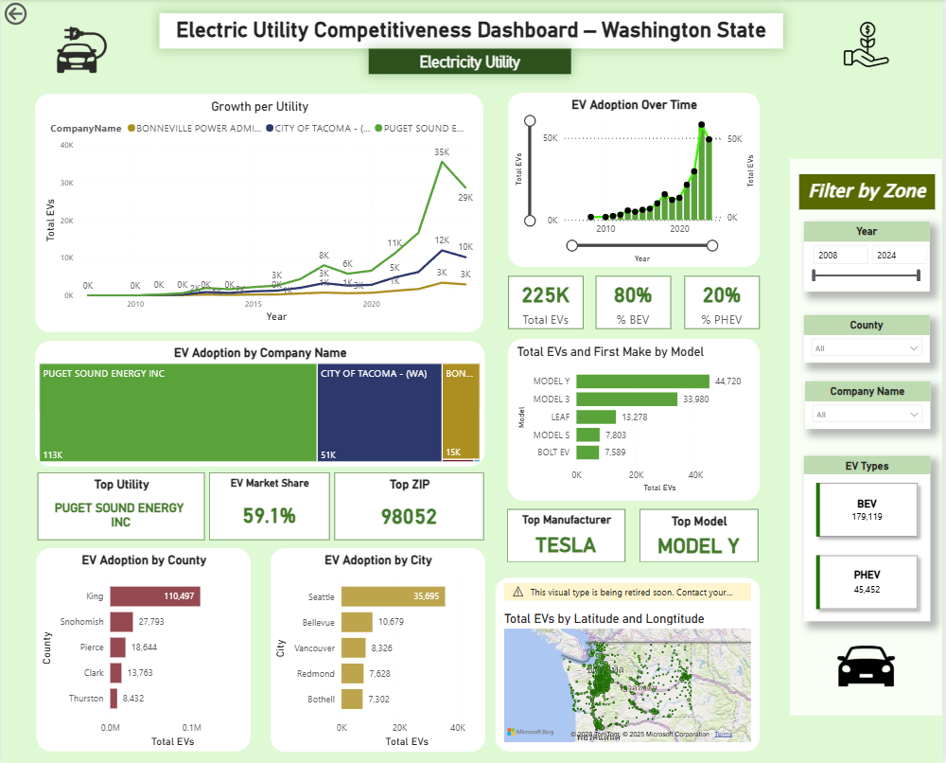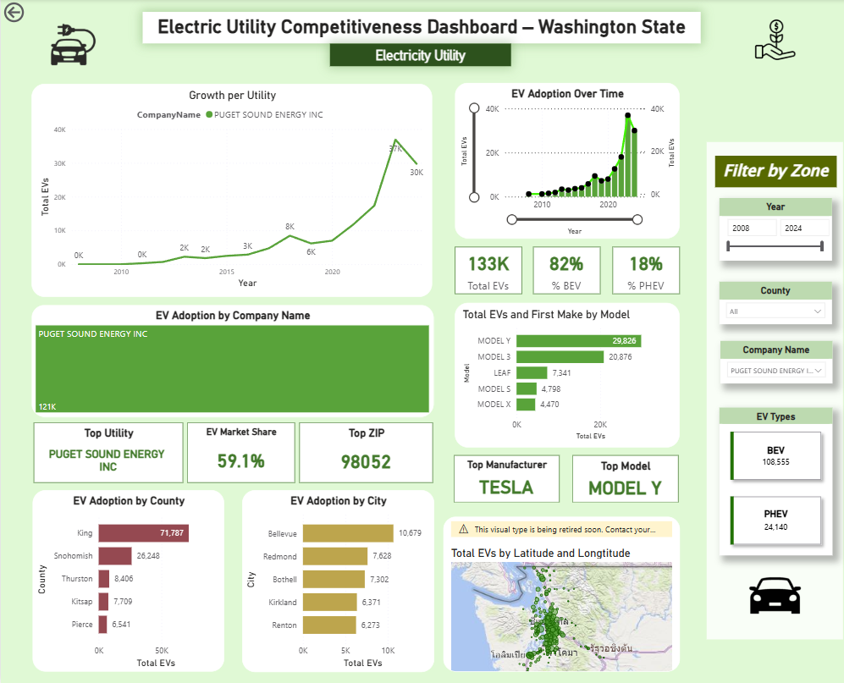

Purpose
This dashboard is specifically designed to support electric utility companies and charging network operators in strategic decision-making related to grid management, load forecasting, and infrastructure planning.
- By visualizing the total number of EVs within their service area, they can accurately estimate current and future charging demand growth.
- By mapping EV density by county, city, and ZIP code, they can identify the most critical locations for deploying new charging infrastructure or upgrading the grid.
- By tracking the BEV vs. PHEV distribution, they can anticipate different charging behaviors (e.g., higher demand for DC fast charging for BEVs vs. Level 2 charging for PHEVs).
- By analyzing growth trends, they can proactively prepare for peak load stress in specific, high-growth areas.

Relevant Project Goals Addressed
- (3.) Map Geographic Adoption Hotspots: To pinpoint optimal locations for the deployment of new charging stations.
- (4.) Evaluate BEV vs PHEV Market Share: To understand the different charging behaviors and patterns associated with BEVs versus PHEVs.
- (6.) Analyze Infrastructure Demand by Utility Providers: To forecast energy demand and plan for grid upgrades, which is the core task for utility providers.

Dashboard Visuals and Data Analysis
The dashboard provides a 360-degree view of the EV market from the perspective of a specific utility provider, selected using the slicer on the right.
1. High-Level KPIs & Trends
- Purpose: To provide an at-a-glance summary of EV adoption over time and the overall market composition.
- Visuals & Data Used:
  - EV Adoption Over Time: A Line Chart showing the growth trend using ModelYear on the x-axis and the [Total EVs] measure on the y-axis.
  - Growth per Utility: A Line Chart that breaks down the growth trend by Electric_Utility (on the legend), allowing for direct comparison between providers.
  - Summary Cards: A set of Card visuals displaying the overall [Total EVs], [% BEV], and [% PHEV] for the selected utility.
2. Utility-Specific Performance
- Purpose: To detail the performance and market characteristics for the selected utility provider.
- Visuals & Data Used:
  - EV Adoption by Company Name: A Bar Chart that visualizes the [Total EVs] for the single utility selected in the slicer.
  - Performance Cards: Three Card visuals displaying the [Top Utility] name, the [EV Market Share] percentage for that utility, and the [Top ZIP] code with the most EVs within their territory.
3. Consumer Vehicle Preferences
- Purpose: To show which specific vehicles are most popular within the selected utility's service area.
- Visuals & Data Used:
  - Total EVs and First Make by Model: A Horizontal Bar Chart displaying the most popular vehicles, using Model on the y-axis and [Total EVs] on the x-axis.
  - Top Manufacturer & Model Cards: Two Card visuals that dynamically display the names of the [Top Make] and [Top Model] based on the filters applied.
4. Geographic Distribution Analysis
- Purpose: To break down EV adoption by county and city, and to visualize the precise geographic density of vehicles.
- Visuals & Data Used:
  - EV Adoption by County & City: Two Horizontal Bar Charts using County and City on the y-axis, respectively, and [Total EVs] on the x-axis.
  - Total EVs by Latitude and Longitude: A Map visual using the Latitude and Longitude fields for location and the [Total EVs] measure to determine the size/density of points on the map.
5. Interactive Filters (Slicers)
- Purpose: To give utility analysts the ability to drill down into the data.
- Visuals & Data Used: A series of Slicers for the following fields:
  - ModelYear (slider)
  - Company Name (dropdown to select the specific utility)
  - EV Types (buttons for BEV/PHEV)

6.5 Dashboard 3: OEMs & Dealerships
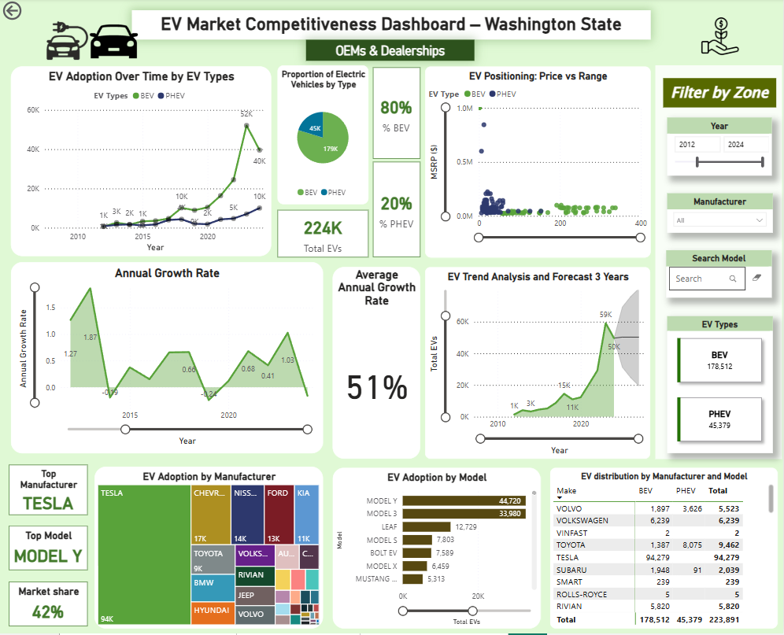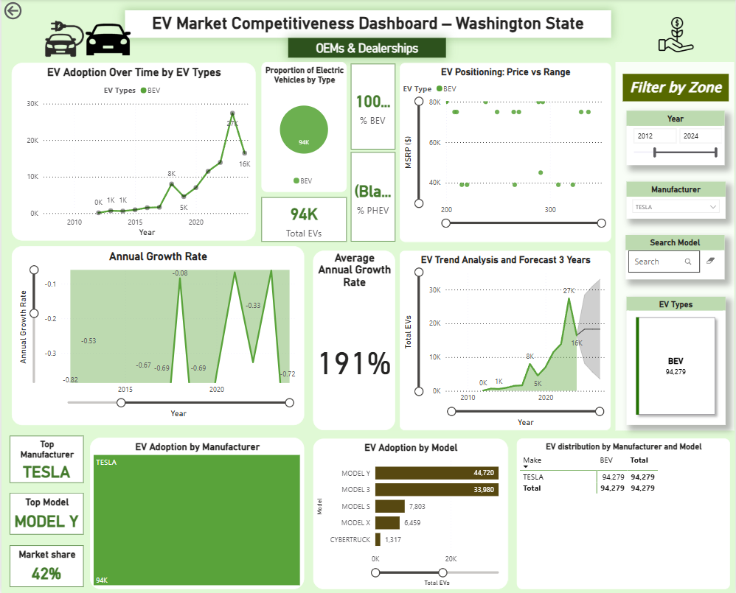

Purpose
This dashboard is designed to provide automotive manufacturers (OEMs) and dealerships with actionable insights for evaluating market competitiveness, monitoring consumer trends, and refining product strategies in the electric vehicle (EV) sector.
By visualizing brand performance, model popularity, and technological transitions between BEVs and PHEVs, this dashboard helps stakeholders make data-driven decisions in areas such as pricing, marketing, and product development.
- By ranking top-performing brands and models, OEMs can benchmark competitiveness and market share.
- By analyzing BEV vs. PHEV adoption trends, they can identify technology shifts and align future investments.
- By visualizing price–range relationships, they can position vehicles to match consumer expectations and segment demands.

Relevant Project Goals:
- (4.) Evaluate BEV vs PHEV Market Share: To track shifting consumer preferences and identify key technology trends.
- (5.) Identify Market Leaders (Brands & Models): To benchmark performance against competitors and measure market share.
- (7.) Explore Pricing and Range Relationships: To correctly position products in the market and identify new segment opportunities.

Dashboard Visuals and Data Analysis:
This dashboard provides a comprehensive market overview, allowing manufacturers to analyze their position and identify opportunities.
1. Market Overview & Composition
- Purpose: To provide a high-level view of the market's growth, size, and the split between BEV and PHEV technologies.
- Visuals & Data Used:
  - EV Adoption Over Time by EV Types: A Line Chart using ModelYear on the x-axis, [Total EVs] on the y-axis, and EV_Type_short as the legend to show separate trend lines for BEVs and PHEVs.
  - Proportion of Electric Vehicles by Type: A Donut Chart showing the market split, using EV_Type_short for the categories and [Total EVs] for the values. It is supplemented with Card visuals for [Total EVs], [% BEV], and [% PHEV].
2. Market Growth Analysis
- Purpose: To analyze the speed and stability of market growth over time.
- Visuals & Data Used:
  - Annual Growth Rate: An Area Chart using ModelYear on the x-axis and the [Annual Growth Rate] measure on the y-axis to visualize the year-over-year percentage change.
  - Average Annual Growth Rate: A Card visual displaying the [AAGR %] measure to show the smoothed, long-term growth trend.
  - EV Trend Analysis and Forecast 3 Years: An Area Chart showing historical adoption ([Total EVs] by ModelYear) combined with a 3-year forecast to help with strategic planning.
3. Competitive Landscape & Performance
- Purpose: To allow for detailed analysis of brand and model performance within the market.
- Visuals & Data Used:
  - EV Adoption by Manufacturer: A Treemap that visualizes market share, using the Make field for categories and [Total EVs] to determine the size of each block.
  - EV Adoption by Model: A Horizontal Bar Chart ranking individual models, with Model on the y-axis and [Total EVs] on the x-axis.
  - Top Manufacturer / Top Model / Market Share: A set of Card visuals that dynamically display the [Top Make], [Top Model], and [MarketShare%] measures.
  - EV distribution by Manufacturer and Model: A Matrix visual with Make as rows, EV_Type_short as columns, and [Total EVs] as the values to provide a detailed breakdown.
4. Product Positioning Analysis
- Purpose: To help manufacturers understand the current market landscape in terms of vehicle price and range, allowing them to identify gaps and opportunities.
- Visual & Data Used:
  - EV Positioning: Price vs Range: A Scatter Plot with the Electric Range field on the x-axis and the [Average MSRP] measure on the y-axis. The EV_Type_short field is used as a legend to color-code the points, providing a clear view of where different models are positioned.
5. Interactive Filters (Slicers)
- Purpose: To enable deep-dive analysis by allowing users to filter by year, manufacturer, and specific model.
- Visuals & Data Used: The dashboard includes several slicers:
  - Standard slicers are used for ModelYear (slider) and Make (dropdown).
  - For searching specific car models, a custom visual from AppSource named "Text filter" is implemented. This allows users to perform a direct text search for a model name.
  - Button slicers are used for EV_Type_short.

6.6 Project Fulfillment and Technical Summary
This section provides a summary of the technical components and visuals used in the Power BI report, confirming that all specified project requirements have been successfully met.

6.6.1 Fulfillment of Power BI Project Criteria
The development of the three stakeholder-specific dashboards adheres to all technical criteria outlined in the project brief:
- Data Import: The report is exclusively powered by the EV_clean.csv file, which was the final output from the Alteryx data preparation workflow, ensuring a direct and clean data pipeline.
- Dashboard Pages: The project delivers three distinct dashboard pages, exceeding the minimum requirement of two. Each page is tailored to a specific stakeholder: Policy Makers, Electric Utilities, and OEMs/Dealerships.
- Visuals Quantity and Variety: The project utilizes a total of over 30 visuals across the three dashboards. This includes 10 unique visual types, surpassing the minimum requirement of 12 total visuals with at least 5 unique types.
- DAX Measures: A total of 15 new DAX measures were created to drive the analysis, including calculations for market share, growth rates, and market leaders. This significantly exceeds the minimum requirement of one new measure.
- Custom Visual: The project incorporates a custom visual from AppSource. The "Text filter" visual was used on the OEM & Dealerships dashboard to provide an intuitive search functionality for specific vehicle models, satisfying the requirement for one custom visual.

6.6.2 Summary of Visuals Used
To meet the analytical needs of each dashboard, a wide variety of visual types were implemented. The list below inventories the unique visuals deployed across the project:
- Card: Used extensively across all dashboards to display key performance indicators (KPIs) such as Total EVs, Average Annual Growth Rate, and market share percentages.
- Line Chart: Used to display EV adoption trends over time, showing growth patterns for the total market and for specific segments (e.g., by EV type, by utility).
- Bar Chart (Stacked & Horizontal): Implemented to compare quantities across different categories, such as EV adoption by county, city, and vehicle model. The stacked column variant was used to show market growth broken down by CAFV status.
- Donut Chart: Used to show the proportional breakdown of the market between BEV and PHEV vehicle types.
- Map: The bubble map visual was used to plot the geographic density of EV registrations by latitude and longitude, identifying regional hotspots.
- Area Chart: Implemented to visualize the annual growth rate over time, emphasizing the magnitude of change from year to year.
- Treemap: Used on the OEM dashboard to display market share by manufacturer in a compact and visually effective format.
- Scatter Plot: Used to analyze the relationship between vehicle price (MSRP) and electric range, helping to identify product positioning opportunities.
- Matrix: Implemented to show a detailed cross-tabular breakdown of EV distribution by both manufacturer and vehicle type (BEV vs. PHEV).
- Custom Visual - Text filter: This AppSource visual was used to provide a powerful and user-friendly search box for filtering by vehicle model.

7. Analysis & Insights (Per User Group Template)

Dashboard 1 – Policy Makers & Regulators

The EV Policy Impact and Adoption Dashboard for Washington State reveals clear trends in electric vehicle growth and policy outcomes over time. EV adoption began gradually in the early 2010s but accelerated significantly after 2018, especially following stronger state-level incentives and the expansion of clean transportation programs. By 2024, the total number of registered EVs exceeded 225,000, indicating sustained growth momentum across the state.
Among these vehicles, around 71,000 (31%) are classified as Clean Alternative Fuel Vehicle (CAFV) eligible, confirming that the policy incentives have played a crucial role in stimulating adoption. The strong representation of CAFV-eligible vehicles suggests that financial incentives and infrastructure initiatives are effectively influencing consumer decisions toward cleaner energy vehicles.
In terms of EV types, Battery Electric Vehicles (BEVs) make up about 80% of all registered EVs, while Plug-in Hybrid Electric Vehicles (PHEVs) account for the remaining 20%. This highlights a growing consumer preference for fully electric options, likely due to improvements in range, affordability, and charging accessibility.
From a regional perspective, King County dominates adoption with over 110,000 EVs, followed by Snohomish (28,000) and Pierce (19,000) counties. This pattern reflects high population density, economic capacity and concentrated infrastructure investments along the Puget Sound corridor, a continuous urban stretch from Everett through Bellevue, Seattle, and Tacoma city, which covers King, Pierce, and Snohomish counties. In contrast, adoption remains limited in rural and inland regions such as Thurston, Kitsap, Yakima and Spokane counties, indicating the potential areas for targeted charging infrastructure and public outreach programs.
The geographic visualization further highlights this urban–rural divide, with dense EV clusters along major highways, particularly Interstate 5 (I-5), which runs north–south through Seattle, Tacoma, and Olympia, and Interstate 90 (I-90), which connects Seattle to Spokane across the state. These routes serve as the backbone of EV concentration and long-distance travel. Meanwhile, eastern Washington remains comparatively underrepresented which underscore the need for regional charging initiatives to ensure equitable EV accessibility across the state.
Overall, the dashboard underscores that Washington’s policy framework has been effective in driving EV growth, but continued efforts are needed to expand equitable adoption across regions in order to ensure that the state’s clean energy transition benefits all communities.

Dashboard 2 – Electric Utilities & Charging Operators

The EV Grid Impact Infrastructure Planning Dashboard delivers strategic insights for electric utility providers and charging network operators seeking to manage load growth, enhance grid stability, and optimize charging infrastructure deployment in Washington State’s rapidly expanding electric vehicle (EV) market. The data reveals that EV adoption is not evenly distributed across the state, but rather heavily concentrated within the service territories of a few major utilities, resulting in localized challenges and opportunities for proactive energy management.
Puget Sound Energy (PSE) emerges as the state’s leading providers, collectively serving over 59% of Washington’s registered EVs. This dominance underscores its central role in supporting the clean transportation transition and highlights the disproportionate responsibility they bear in addressing rising electricity demand. The dashboard emphasizes that these utilities must implement data-driven, localized strategies to ensure the reliability and resilience of their distribution networks as EV adoption continues to accelerate.
From a fleet composition perspective, the data shows that Battery Electric Vehicles (BEVs) constitute approximately 80% of all registered EVs, while Plug-in Hybrid Electric Vehicles (PHEVs) represent the remaining 20%. This BEV-dominant trend signals an important shift in grid dependency. Unlike PHEVs, which supplement their energy needs with internal combustion engines, BEVs draw their full energy from the electrical grid, typically through higher-capacity fast-charging infrastructure. As BEV adoption continues to grow, utilities face increasing pressure to anticipate longer and more concentrated peak loads, making localized load forecasting and dynamic demand management essential to maintain operational stability and prevent grid congestion.
Geographically, EV ownership is densely concentrated within the Puget Sound corridor, particularly across King, Snohomish, and Pierce Counties. For example, within Puget Sound Energy’s territory alone, over 60,000 EVs are registered in King County, followed by Snohomish and Pierce County at 25,000 and 19,000 respectively. This regional clustering enables utilities to pinpoint specific substations and distribution feeders that are most likely to experience capacity strain. The dashboard therefore supports a targeted, evidence-based approach to grid reinforcement and modernization, allowing investments to be prioritized where they will yield the greatest operational and customer impact.
Spatial analysis also links EV density with major transportation corridors, providing a foundation for strategic charging infrastructure deployment. High adoption clusters are found along Interstate 5(I-5), the state’s principal north-south route and Interstate 90 (I-90), the primary east-west corridor. For charging providers, these insights confirm the need to concentrate DC Fast Charging (DCFC) investments in these regions to accommodate both daily commuters and long-distance travelers. By aligning station placement with traffic patterns and EV density, providers can enhance network accessibility, utilization rates, and long-term return on investment.

Dashboard 3 – OEMs & Dealerships

The EV Market Competitiveness Dashboard for Washington State provides valuable insights for automotive manufacturers (OEMs) and dealerships seeking to increase market share, profitability, and brand loyalty within the rapidly expanding EV landscape. The data highlights strong adoption momentum, with over 225,000 registered electric vehicles as of 2024. Battery Electric Vehicles (BEVs) dominate the market, accounting for approximately 80% of total EVs, while Plug-in Hybrid Electric Vehicles (PHEVs) represent the remaining 20%. This shift reflects growing consumer confidence in range, performance, and charging accessibility, alongside the gradual decline of hybrid reliance.
Tesla remains the dominant manufacturer, holding a commanding 42% market share with over 94,000 registered vehicles statewide. Its success is primarily driven by the Model Y and Model 3, which together account for the majority of BEV ownership. This performance highlights Tesla’s strong ecosystem, innovation, and consumer trust reinforcing its leadership in both market presence and brand influence. Other key players such as Chevrolet, Nissan, Ford, and Kia hold smaller shares but demonstrate steady engagement in the EV market, reflecting their strategic transition toward electrification and increasing competition across price tiers.
From a pricing and product positioning perspective, the dashboard shows a clear separation between BEVs and PHEVs. BEVs generally offer greater driving range across multiple price points, indicating that consumers increasingly value long-distance capability and zero-emission driving. In contrast, PHEVs cluster at lower price levels but deliver limited range, signaling that this segment may continue to decline as BEV technology becomes more accessible and affordable. For manufacturers, these insights serve as a key indicator to shift product roadmaps and marketing strategies toward fully electric offerings.
Brand and model benchmarking further reveals emerging competitiveness among non-Tesla brands. Models like the Chevrolet Bolt, Nissan Leaf, and Ford Mustang Mach-E show consistent adoption growth, suggesting potential for expansion with targeted pricing and infrastructure support. Meanwhile, Rivian is gaining traction in the premium and adventure EV segments, highlighting opportunities for product differentiation and niche positioning. Asian brands such as Hyundai and Kia also show upward momentum, indicating growing consumer confidence and market diversification within Washington’s EV ecosystem.
Overall, the dashboard illustrates that Washington’s EV market has entered a mature and highly competitive phase, led by Tesla’s dominance and supported by an expanding mix of established and emerging automakers. For OEMs and dealerships, these insights emphasize the need to accelerate BEV innovation, refine pricing strategies, and expand infrastructure partnerships to meet regional demand. Aligning product portfolios with local preferences and consumer behavior will be critical for sustaining competitiveness and capturing growth opportunities in the state’s accelerating transition toward sustainable electric mobility.

References
[1] Fatima, Saman. 2024. "2025 Electric & Hybrid Cars in Washington, USA." Kaggle. https://www.kaggle.com/datasets/samanfatima7/2025-electric-and-hybrid-cars-in-washington-usa.
[2] Washington State Department of Commerce – Strengthening Communities and Growing Washington's Economy https://www.commerce.wa.gov/
[3] Alternative Fuels Data Center: The go-to resource for advanced transportation fuels and technologies https://afdc.energy.gov/
[4] View and Report Outages - City Light seattle.gov

