**First Task (API Tests through POSTMAN)**

1. Navigate to <https://www.postman.com/> and create a new account using Sign Up
2. Once you get redirected to the home page, click on Import File from the home page

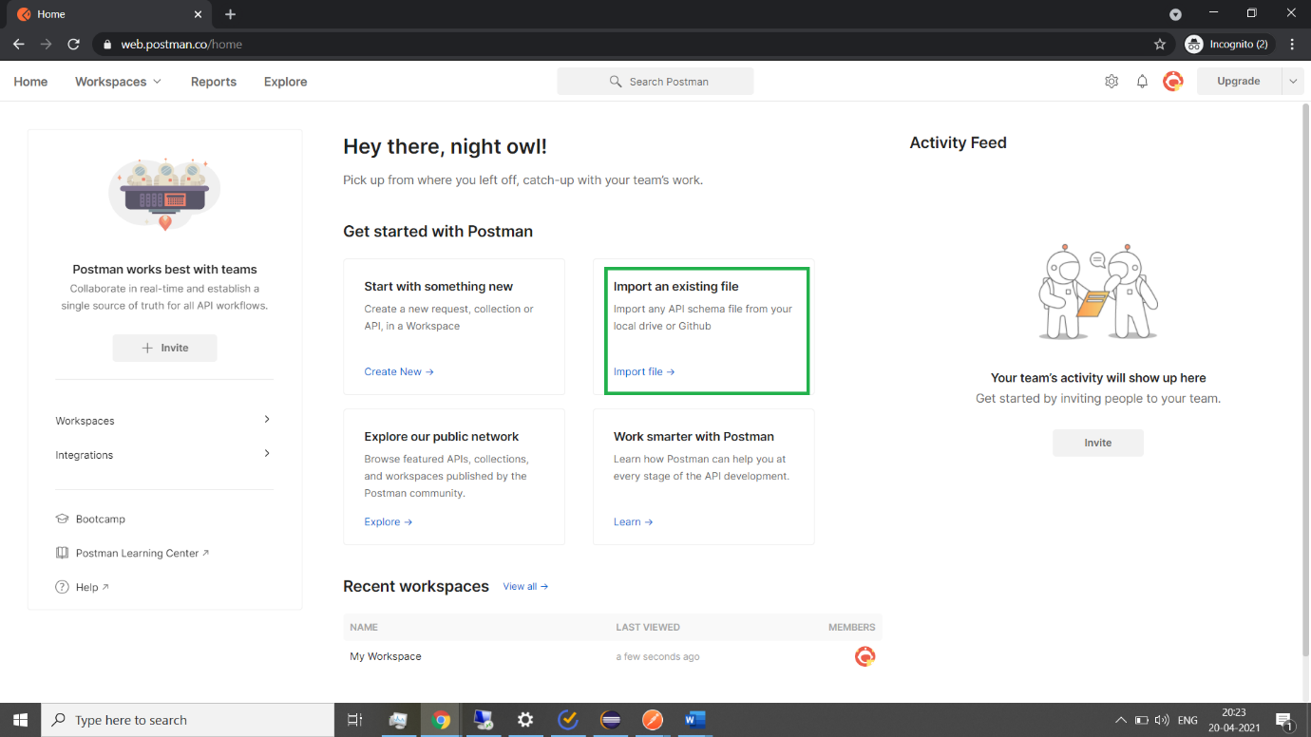

1. Choose the link option and paste the following link and click on Import <https://www.postman.com/collections/33d04b047f06f7c2bfd9>
2. Once it is imported, click on the three dots displayed next to the file click on Run Collection

You can see the results and the tests attached to each API

**Second Task (UI Automation)**

1. Download Eclipse
2. Create a Java Project
3. Add the libraries that I have attached as a zip file, by right clicking on your project name, navigating to Build Path>>Configure Build Path
4. Under the project, Create a package and Add the class file to the package (Or you can create a class under the package and copy paste the code that I have given).
5. I have used Chrome latest version (Chrome 90), so please update chrome to the latest version as I will be sharing the libraries for the latest version of chrome
6. Also, ensure to update your chrome driver path and chrome browser path as in the code or you can update the code with the path as in your machine.