# **FBDOX - DOCUMENT AUTOMATION - WEB SERVICES INTEGRATION/UI FIXES**

## VERIFICATION GUIDE

## 

## Stripe Integration

Register for stripe account and navigate to https://dashboard.stripe.com/account/apikeys to find your stripe API keys. Set them in `server/config/environment/shared.js` file under `stripe` key.

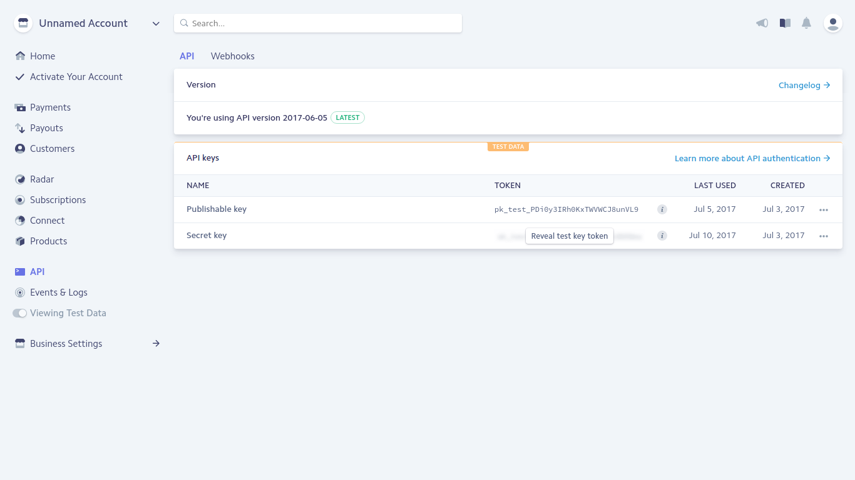

Navigate to <https://dashboard.stripe.com/account/relay/settings> to set the tax rate on orders. You can set a percentage for all orders or use a 3rd party provider to determine the tax rate based on customer data.

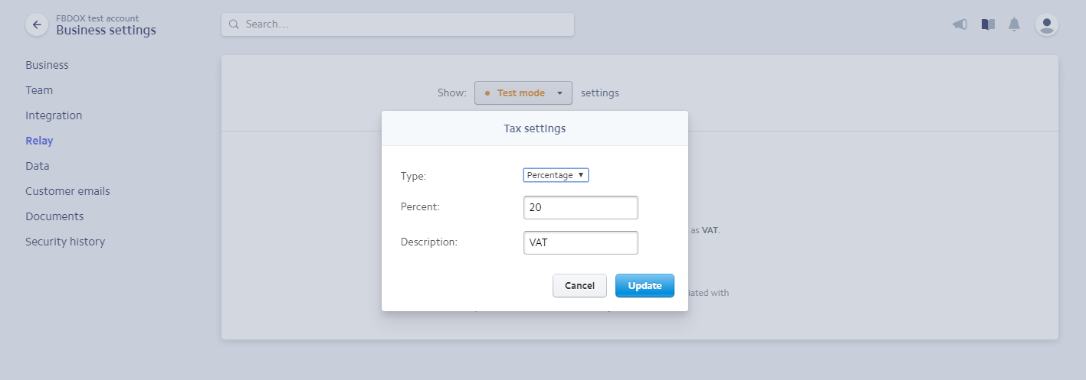

**Setup webhook**

To test stripe webhooks one need to setup webhook as shown below.

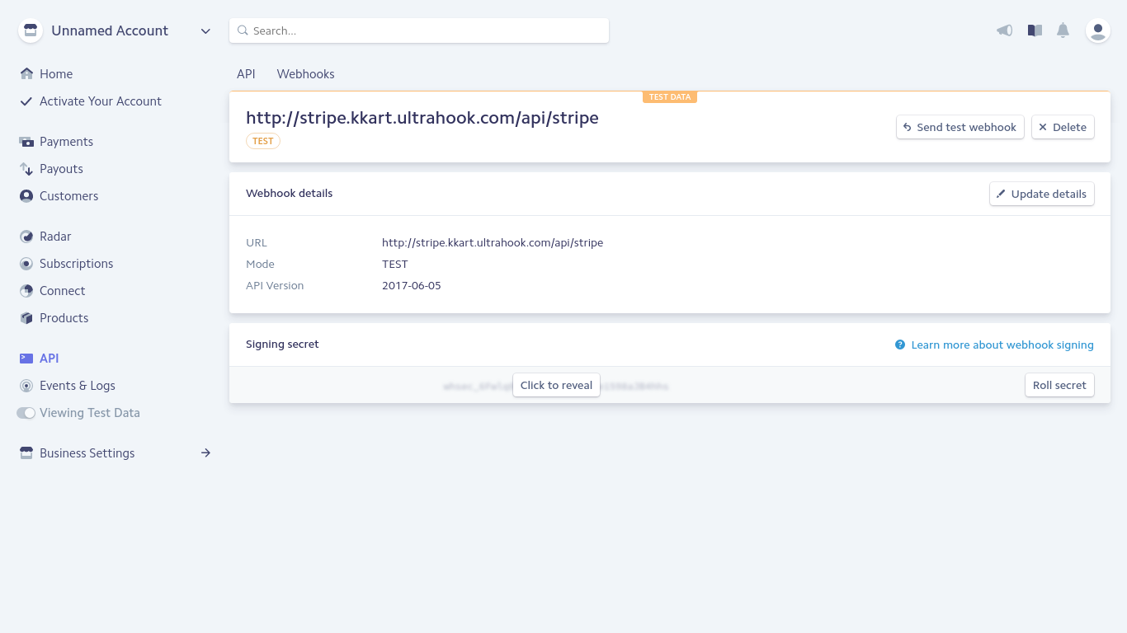

Here I am using ultrahook to be able to test webhooks locally. You should check:

<http://www.ultrahook.com/>

and setup to be able to verify webhooks.

**Verify subscription plans are created**

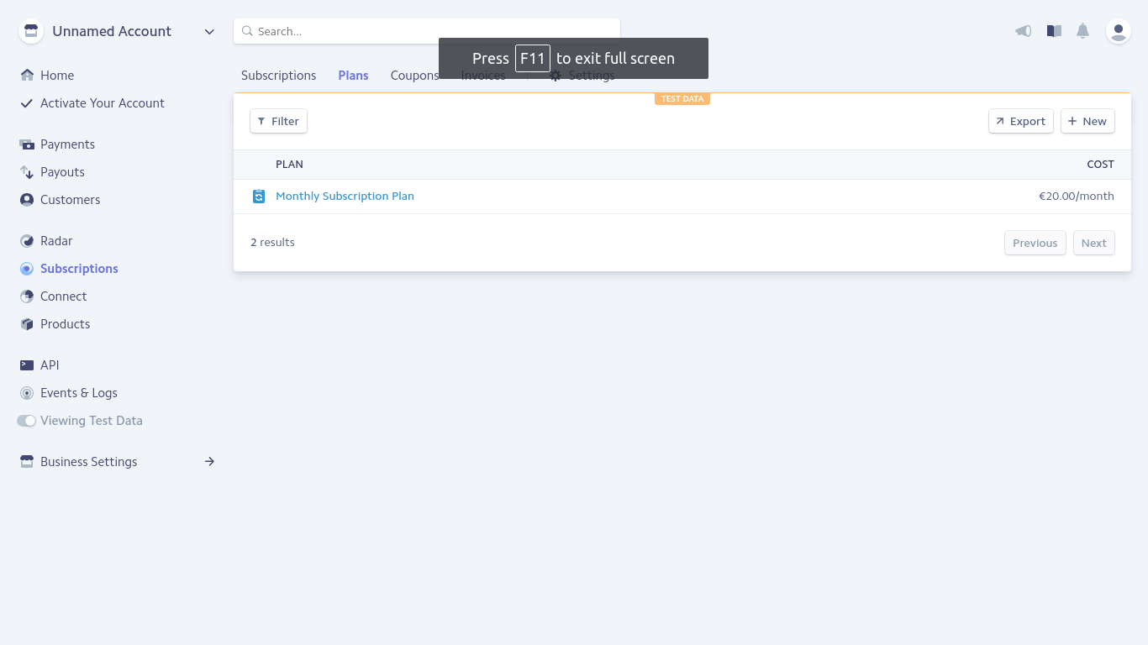

**Verify products are created/deleted initially or when one changes them in admin**

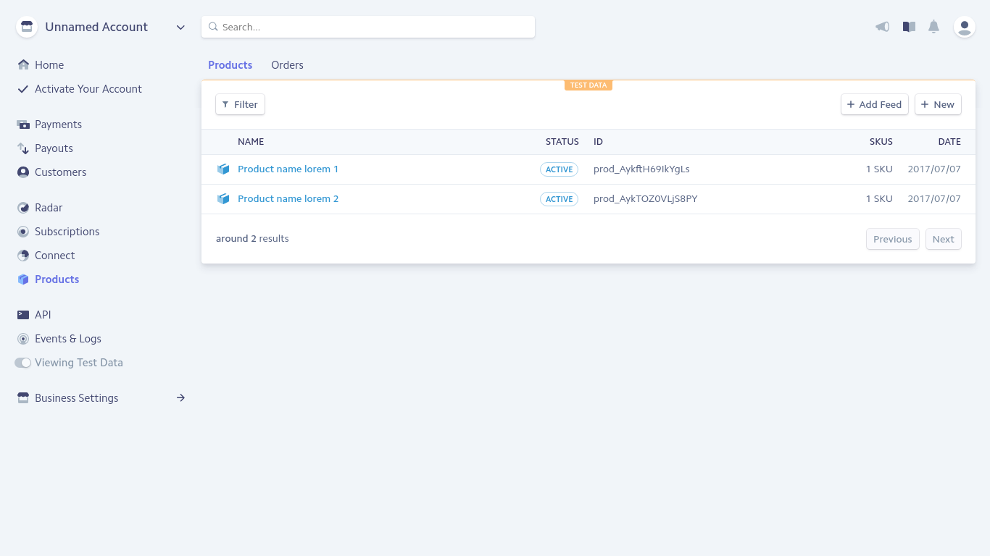

**Verify coupons**

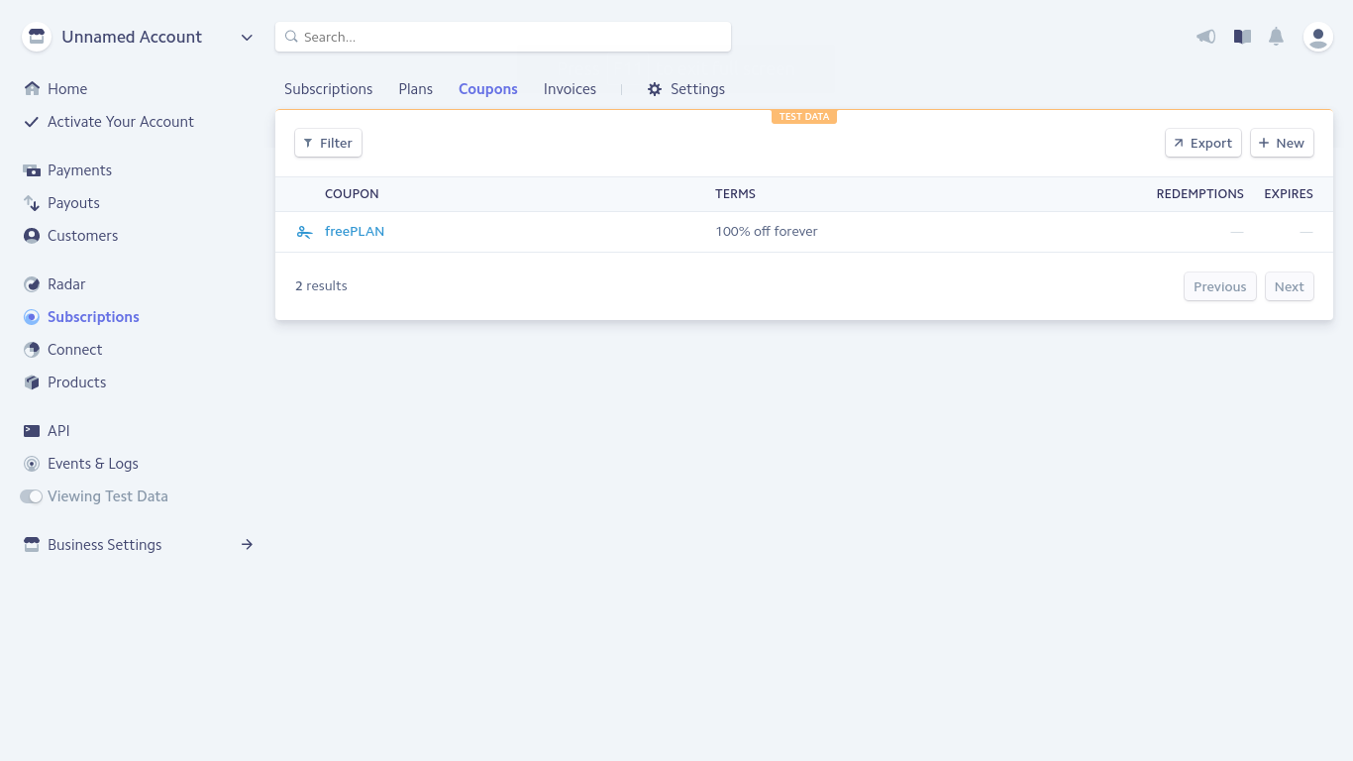

**Verify discounts are applied and working**

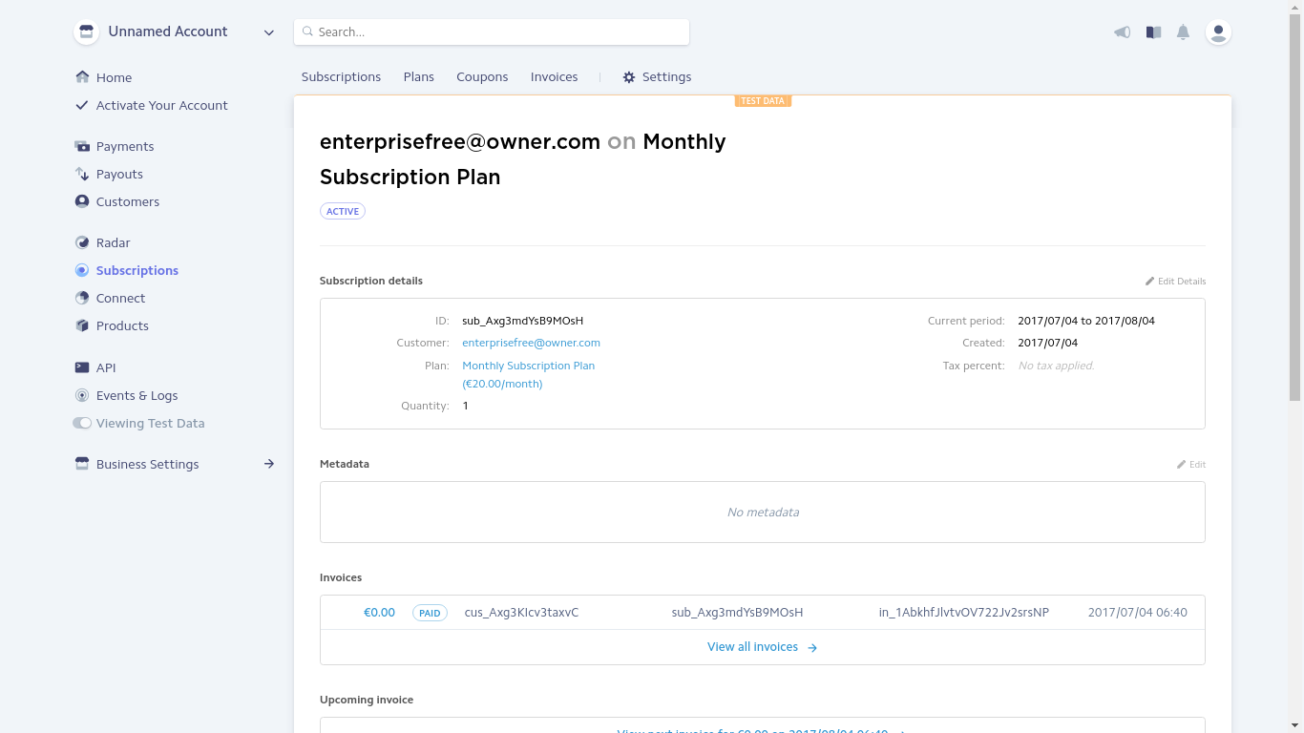

change user discount and see them updted in stripe.

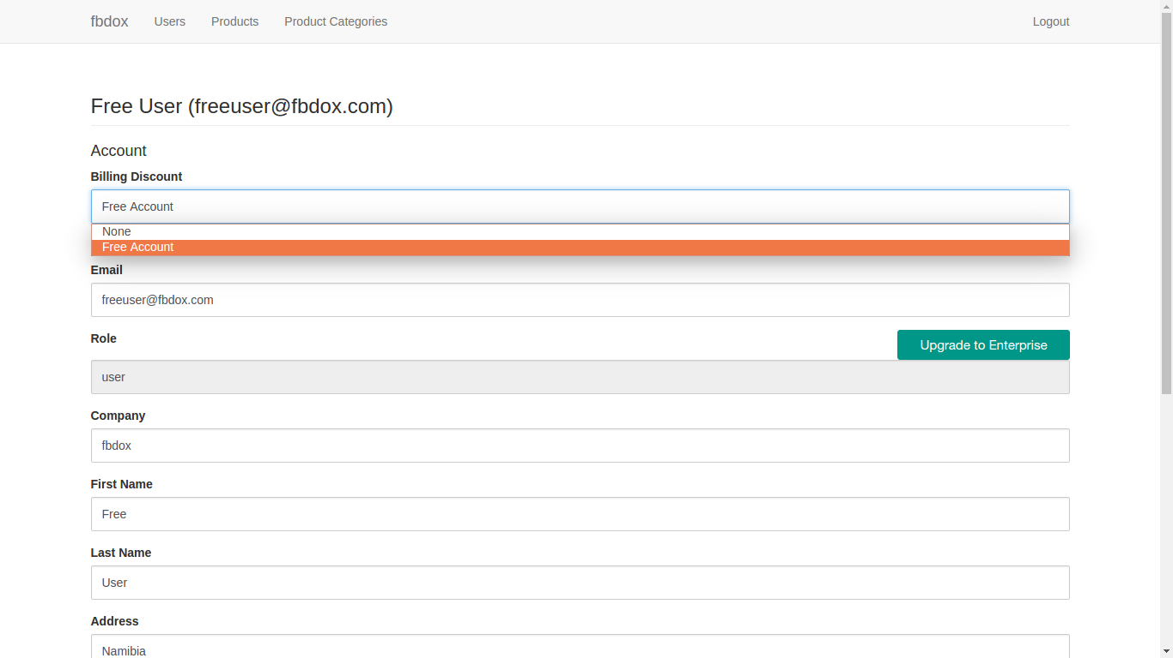

**Verify placing single orders for products**

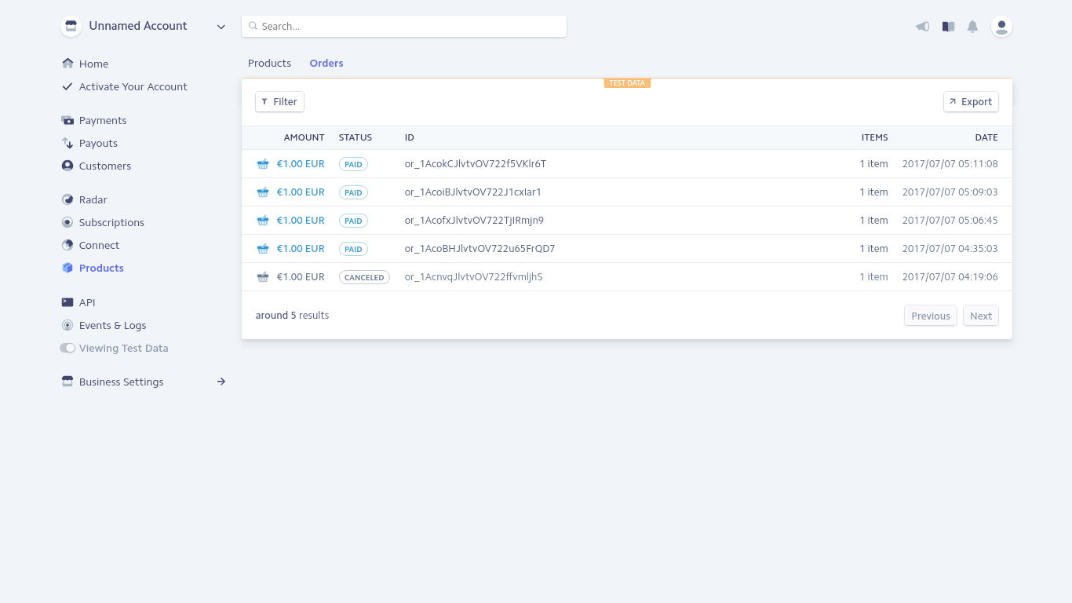

those should be place via the POST /api/products/:id/orders API

## Document Generation

To verify one need to update some product with the provided test files.

