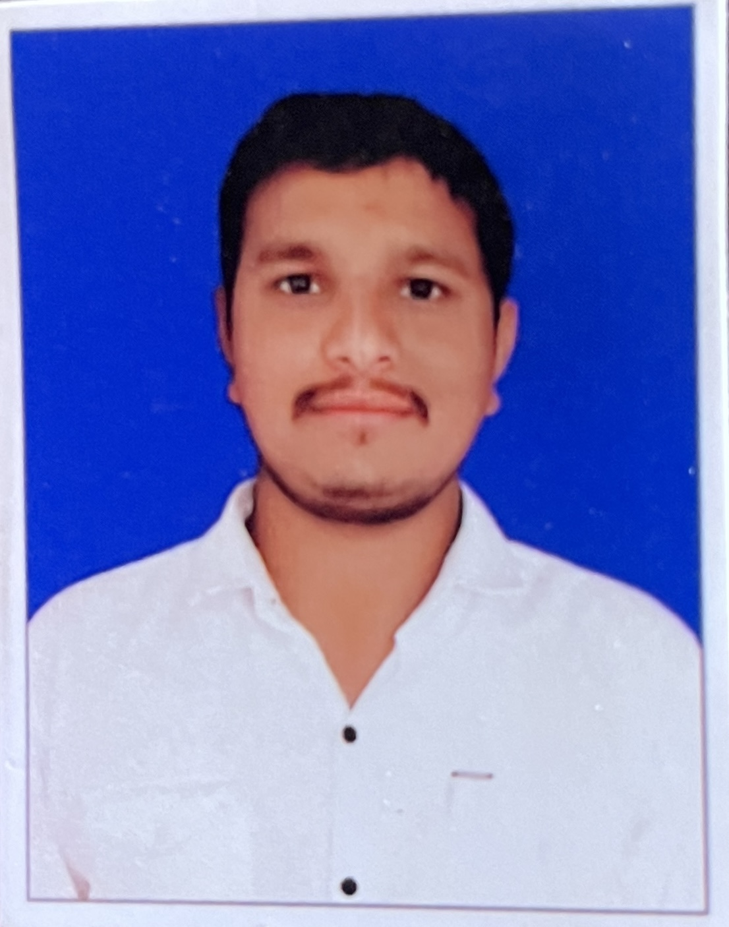 |  | MECHANICAL ENGINEERING
Profile  NAME:- ZALA JOGAJI SHIVSANG  GENDER:- MALE  DOB:-11/07/2001  LANGUAGE:- HINDI,ENGLISH,GUJRATI  Contact  PHONE:  9723720984  EMAIL:  ZALAJOGAJI@GMAIL.COM  Hobbies  READING  PLAYING  TRAVELING  GAMING |  | EDUCATION  PIONEER SCHOOL,PATAN  MARCH 2016  STD:-10  64.5%  M.L.I.D.S,BHANDU  2016 - 2019  6.26 CGPA  WORK EXPERIENCE  SAGAR POLYFILM PVT LTD, MANDALI(QUALITY INSPECTOR)  1 AUG 2025 TO PRESENT  MEASURING,QUALITY CHECKUNG  NYK AUTOLOGISTICS PVT LTD,BECHRAJI (QUALITY INSPECTOR)  1JAN 2023 –31JULY 2025  QUALITY ASSURANCE,VEHICLE ALL PARTS CHECK AND MEASURE BY QUALITY TOOL ,USING 7 QC TOOL,5S,KAIZEN,RESPONSIBLE TEAMWORK.  SUZUKI MOTOR GUJRATPVT LTD,BECHRAJI (VEHICLE INSPECTION)  20JULY 2020–4 FEB 2021  VEHICLE INSPECTION OPERATUION,QUALITY ISSUE RESOLVING,  VEHICLE MEASURMENT GAP IN VERNIER CALIPER.  HONDA MOTORCYCLE PVT LTD,VITHLAPUR (LINE MAN)  (1 JULY 2019 TO 2021)–(MAR 2021 TO DEC 2022)  QUALITY  PARTS UNLOADING  REWORK PART  MAIN PANEL CANTROL  SKILLS
- PROBLEM SOLVING
- SAFETY FIRST QUALITY MUST
- LEADERSHIP
- TRAINING & DEVLOPMENT
- HIGHER PRODUCTION

