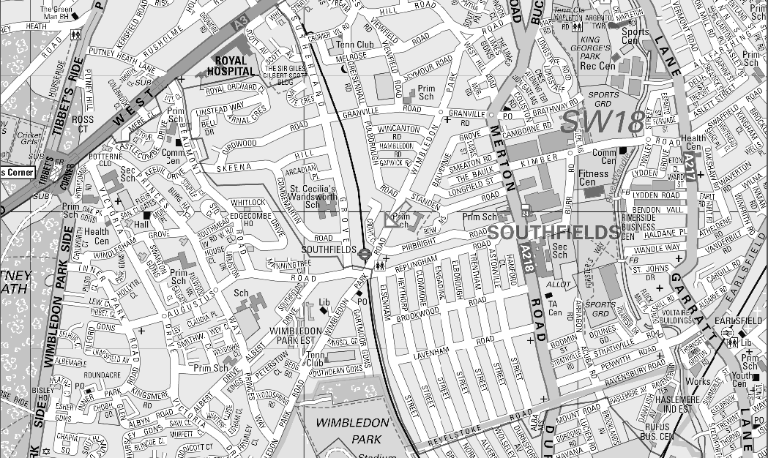

|  |  |  |  |  |
| --- | --- | --- | --- | --- |
| Astonville St | Trentham St | Elborough St | Engadine St | Clonmore st |
| Heythorp St | Elseham St | Replingham rd | Revelstoke rd | Merton Rd |