

Research Topic: A Systematic Review on the Role of Wearable Technology on Type 1 and Type 2 Diabetes in UK Adults

Programme: MSc Public Health and Social Care in Practice
Module name: Practice- Based Research
Module code: LCHS7008
Student name: Harsh Dineshbhai Solanki
Student ID: 2432128
Lecturer: Diola Bijlhout
Table of Contents

1. Introduction and Literature-Based Background to the Study 3
2. Prevalence of the Problem in Health and Social Care 3
3. Research Rationale 4
4. Research Question 4
4.1 Proposed Research Question 4
4.2 Aim 5
4.3 Objectives 5
5. Research Methodology: Secondary Qualitative 5
5.1 Research Philosophy 5
5.2 Research Approach 5
5.3 Research Design 6
5.4 Data Collection Techniques 7
5.5 Analytical Techniques and Procedures 9
6. Ethical Considerations 9
7. Implications of Research 9
8. Conclusion 9
9. Gantt Chart 10
Reference list 11

1. Introduction and Literature-Based Background to the Study
Diabetes is a chronic metabolic disorder which influences the body to regulate the levels of glucose in the blood and needs constant monitoring and self-care (Goyal, Jialal and Singhal, 2023). Both Type 1 and Type 2 diabetes demand that individuals take special care in controlling blood glucose using medication, lifestyle adjustments, and regular check-ups (Sawyer et al., 2022). The severe issues that are associated with type 1 and type 2 diabetes involve damaged nerves, damaged kidney and also heart problems. Accordingly, the care provided to the patients involves effective management of diabetes so that effective health outcomes can be achieved, and also the cost associated with high-quality healthcare can be addressed.
Digital health technologies have become significant in aiding in the management of chronic diseases in the past few years (Wannheden et al., 2022). Wearable technologies enable people to track physiological information in real-time (Lazarou and Exarchos, 2024). The investment within the digital health market is considered to go through an enhancement from 22.5% to 38.4% share in the global context (Grand View Research, 2023). The wearable devices are considered to provide real-time information associated to the physical activity and the level of glucose intake by a patient. It also involves making informed choices regarding the practices of treatment and behavioural aspects.
In the UK, the role of digital innovation in enhancing long-term condition management is being increasingly realised by the healthcare systems (Brown et al., 2023). Diabetes care strategies are embracing wearable technologies to help patients in self-management, increase patient engagement, and better clinical monitoring (Alzghaibi, 2025). In turn, the study of the role of wearable technologies in monitoring diabetes is relevant to learning how digital health solutions can help to improve the outcomes of adults living with diabetes in the UK.

2. Prevalence of the Problem in Health and Social Care
Diabetes is a major health issue in the UK, and it poses a heavy burden on the health and social care services (Latoo et al., 2026). Adults with diabetes have steadily risen in recent years with the changing demographics, lifestyle choices, and the rise in obesity rates (Rajput et al., 2022). In England, by the year 2021, about 7.8% of the population belonging to the age group 16 have been diagnosed with type two diabetes (Gov.UK, 2025). Type 2 diabetes comprises most of the diabetes cases, impacting almost 90% of the population in the UK, with Type 1 diabetes, though not very prevalent, necessitating intensive lifelong management (Diabetes UK, 2024). Both types of diabetes have been on the rise and have posed a significant strain on healthcare resources in the National Health Service.
People with diabetes need continuous medical attention, frequent blood glucose level monitoring and constant lifestyle management (Ajjan et al., 2024). Lack of proper glycaemic control can result in complications that include cardiovascular disease, kidney disease, neuropathy and loss of sight (Zakir et al., 2023). These complications have the potential to lead to hospitalisation, permanent disability, and poorer quality of life for sufferers of the condition.
In terms of healthcare, the process of diabetes management is costly in terms of financial and clinical resources (Zhu et al., 2024). The treatment of diabetes and its associated complications takes a significant percentage of healthcare spending (Prathyusha et al., 2025). Therefore, more interest is shown in new methods that can enhance the management of the disease and decrease the burden on health systems in the long run. Monitoring devices and software that can be worn have thus become a significant field of research and policy.

3. Research Rationale
One of the significant and increasing communal health threats is diabetes. As of 2021, in England, 7.8% of the adults aged sixteen years and over were diagnosed with Type 2 diabetes (Gov.UK, 2025). Type 2 diabetes is found in approximately 90 per cent of the cases of diabetes in the UK (Diabetes UK, 2024). Type 1 diabetes is a disease that requires insulin and its daily management (Tatovic et al., 2023). Glycaemic poor control leads to risks of blindness and kidney disease (Kropp et al., 2023). Cardiovascular complications also pose increased mortality and hospitalisation (Longo et al., 2022). The NHS spends a lot of money every year on the treatment of diabetes (Prathyusha et al., 2025). Hence, diabetes management is now of the utmost importance in the country.
It is a pressing issue since the prevalence on an annual basis is rising. New diagnoses are sparing no time owing to obesity rates and the ageing population. Wearable computing has become available with 24-hour glucose and activity sensors (Keshet et al., 2023). The devices enhance quicker decision-making and more robust self-control behaviours. Investment in digital health increased to 38.4% share (Grand View Research, 2023). However, there is not much evidence regarding the disease and its outcomes, specifically in the UK adult group. There is also a limitation in adopting this device on a national level, specifically due to policy gaps and lack of access towards healthcare due to inequalities. Accordingly, the present research will keep a focus on the evaluation of relevant information so that evidence can lead to appropriate strategies and solutions.

4. Research Question

4.1 Proposed Research Question
What is the role of wearable technology in the management of Type 1 and Type 2 diabetes among adults in the UK?

4.2 Aim
The aim is to critically evaluate the role of wearable technology in the management of Type 1 and Type 2 diabetes among adults in the UK.

4.3 Objectives
- To analyse recent trends in Prevalence & incidence of type 1 & 2 diabetes in adults in the UK.
- To assess evidence from existing research regarding the role of wearable technology in managing type 1 and type 2 diabetes in adults
- To examine current UK public health policies and strategies to identify strengths, weaknesses & gaps to inform wearable technology and future evidence-based practice

5. Research Methodology: Secondary Qualitative

5.1 Research Philosophy
Research philosophy is the system of beliefs and assumptions about the nature of knowledge and the way it can be produced by research (Baruwa and Shutaleva, 2022). It informs on the way reality is perceived and how information is to be perceived in research. The research philosophy embraced in this research will be the interpretivist research philosophy. The interpretivism approach in the context of healthcare research can enable this study to understand the effects of technologies, policies, and practices on patient care and disease management.
The philosophy of interpretivism is appropriate in this study since the research aims to explain the currently available data on the use of wearable technologies in the management of diabetes instead of testing a strictly quantifiable correlation between factors. Through a review of literature and healthcare reports, the research will seek to comprehend the role of wearable devices in patient self-management, glycaemic monitoring and healthcare delivery in the UK. On the other hand, other philosophical stances, such as positivism, were discarded. Positivism usually dwells on quantifiable and measurable data that are obtained through statistical analysis or experiments (Khanday et al., 2024). Although positivist methods work well in clinical trials or experimental studies aimed at evaluating the efficacy of medical devices, they do not apply well to a literature-based study. The current study will not involve creating numerical data and instead focuses on analysing existing evidence on the subject of qualitative and policy implications of this topic, which is why interpretivism will be a more appropriate philosophical framework.

5.2 Research Approach
The research approach is defined as the procedure to create knowledge and come up with conclusions based on the data gathered (Ghanad, 2023). This research will take an inductive approach to research design, where the insights and patterns will be formulated through the analysis of available secondary qualitative data. The research will not begin with a set of predetermined theories but will consider the available literature about wearable devices and diabetes management to establish the new emerging themes and relationships. This method is suitable because it gives the opportunity to be flexible in the interpretation of various results of healthcare reports, policy documents, and academic studies. It helps to create new ways of thinking about the role of wearable devices in self-management and clinical outcomes. Thus, an inductive approach promotes the level of understanding and allows developing theories based on the facts on the ground.

5.3 Research Design
Research design is the general approach that will be launched to answer the research questions and fulfil the study objectives (Ernst and Cochran, 2025). It offers a systematic model that directs the data gathering and analysis. In this study, an explanatory research design is used. Exploratory research will be used to examine relationships between variables and explain how or why certain phenomena occur. The exploratory design will enable the study to explore issues related to the implementation of wearable technology, including access, affordability, digital literacy, and integration with the healthcare system. On the other hand, descriptive research design will not be implicated in the study as it is primarily concerned with describing traits or patterns without necessarily analysing the relationships among variables (Slater and Hasson, 2024). As the proposed study is supposed to examine the effects and consequences of wearable technologies instead of explaining them, an explanatory research design is deemed to be more suitable.
Research choices are defined as the approach of methodology to collecting and analysing data (Saunders, Lewis and Thornhill, 2019). This study will use a mono-method qualitative choice using secondary data. The mono-method choice ensures that any research endeavour can focus on one single type of data rather than combining multiple. In this study, qualitative research of secondary data sources will be employed to explore the research problem. Secondary data is the information that is already compiled and published by other researchers, institutions or organisations (Cheong et al., 2023). The secondary data will be derived in this research through the academic journal articles, governmental reports and policy documents on healthcare and industry publications on wearable technologies and diabetes management. To begin with, using it enables the study to review a large body of evidence on various researches, giving a greater insight into the research subject (Cheong et al., 2023). Second, it allows one to access substantial amounts of data that would be hard to gather using primary research with scarce resources. Thus, it is expected that using this choice can help this research meet its desired outcome within the limited available time.

5.4 Data Collection Techniques
Inclusion-Exclusion Criteria
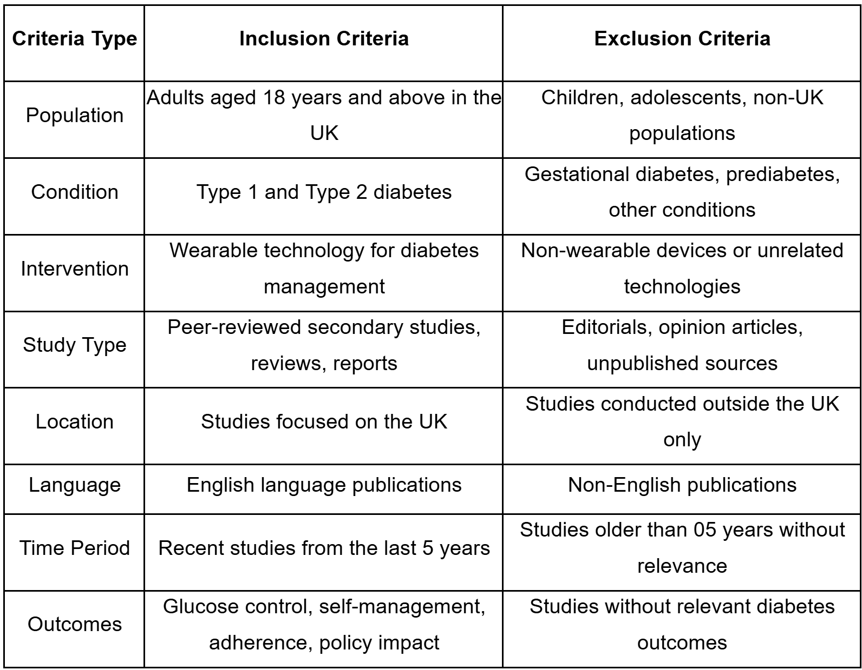
Table 1: Inclusion and Exclusion Criteria
(Source: Author)
Boolean and search operator
In searching for information from relevant databases, different strategies and Boolean operators will be used. Certain examples of relevant keywords that will be used for searching information include:
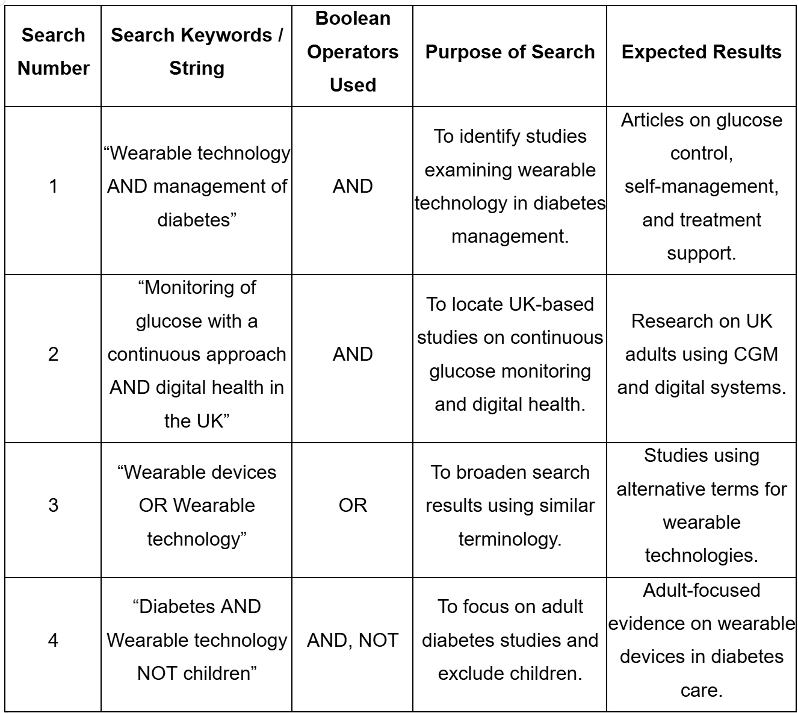
Table 2: Boolean and search operators
(Source: Author)
PRISMA
The relevant studies are selected in accordance with the PRISMA (Preferred Reporting Items to Systematic Reviews and Meta-Analyses) framework. PRISMA process consists of various steps, such as identification, screening, eligibility evaluation and inclusion of relevant studies (Rethlefsen and Page, 2022). Firstly, database searches are conducted to identify a great number of articles. Doubles will be eliminated, and the rest of the studies will be filtered on titles and abstracts. The content of the selected articles is subsequently analysed to ascertain their suitability for the inclusion criteria. Lastly, the most appropriate studies are incorporated to be analysed.
The study will also make use of Critical Appraisal Skills Programme (CASP). This is popular instrument to evaluate the quality, validity and relevance of qualitative and quantitative research studies (CASP, 2024). The methodology is considered to provide a guided checklist that contributes to the assessment of ethical consideration methodology and credibility of the research windings. The application of this method will further assist in valuation of the credibility of the sources with the critical approach so that only comprehensive and high quality information can be used as evidence for the research. This will further assist increasing the validity and rigor of the results by the research.

5.5 Analytical Techniques and Procedures
Thematic data analysis will be performed to analyse the data related to the research topic. As per thematic data analysis, themes and patterns can be effectively identified throughout contextual data, and relevant information can be effectively gathered by the researcher (Naeem et al., 2023). Braun and Clarke's 6-step thematic framework will be applied, through which different themes will be formed. These things will be further evaluated for the identification of patterns and trends associated with health care outcomes associated with diabetes and wearable technology. The review will concentrate on the main topics of glycaemic control, patient engagement, and wearable devices efficacy. Outcomes comparison will help identify the emerging trends and relationships to understand better how wearable technology can affect the management of diabetes and overall healthcare outcomes.

6. Ethical Considerations
The ethical consideration within this research will involve ensuring academic integrity. In this aspect, all the qualitative data that will be gathered will be cited accurately so that plagiarism can be avoided. The ethical guidelines provided by the University of Wales Trinity Saint David (UWTSD) ethical committee will be followed in maintaining ethical integrity. Also, the Data Protection Act 2018 will also be followed so that the research can adhere towards ethical compliance. As per Article 5 of the Data Protection Act 2018, all information is required to be processed fairly and lawfully and also in a transparent manner associated with the data subject (GDPR, 2018). Furthermore, the present research will only use publications that are credible, respecting the rights of intellectual property.

7. Implications of Research
This study will reinforce hypotheses relating to technology and self-management. It will illuminate the use of wearables in diabetes behaviour models. The results would be useful in future research on digital health adoption. With improved patient monitoring systems, healthcare practice will be enhanced. Evidence will be utilised in the planning of personalised treatments by clinicians. NHS services will also determine effective strategies of implementation of wearables. There will be a reduction in access gaps and disparities. There will be better self-management support among adults with diabetes.

8. Conclusion
It can be concluded that the present research will evaluate how type 1 and type 2 diabetes can be effectively treated by wearable devices, specifically among UK adults. Through reviewing the literature on the subject, healthcare reports and policy documents, the study indicates the promise of wearable technologies in aiding continuous monitoring, glycaemic control, and patient self-management. The study also takes into account issues concerning access and application in the healthcare systems. In general, the results help to better understand how digital health technologies can help to achieve better management of diabetes and healthcare delivery.

9. Gantt Chart
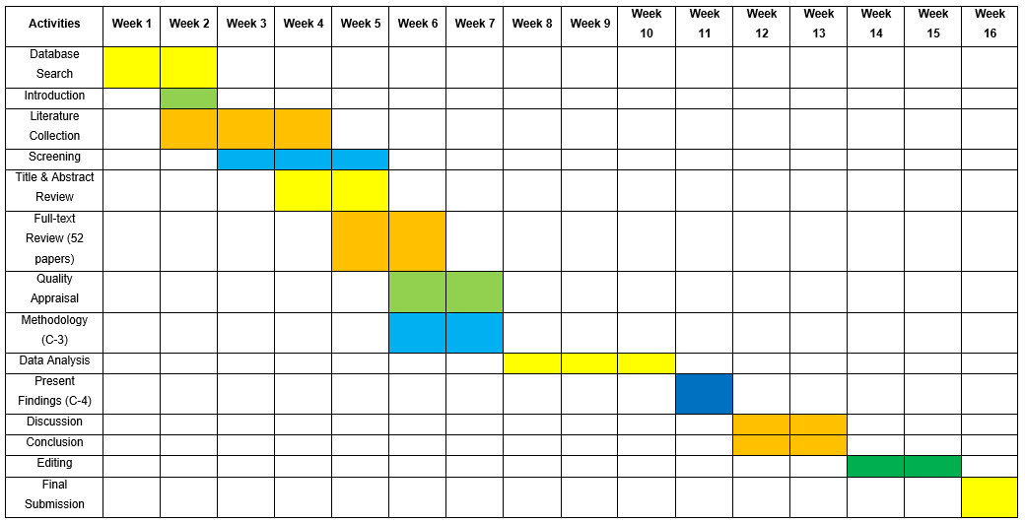
Table 3: Gantt Chart
(Source: Author)

Reference list
Ajjan, R.A., Battelino, T., Cos, X., Del Prato, S., Philips, J.C., Meyer, L., Seufert, J. and Seidu, S. (2024) ‘Continuous glucose monitoring for the routine care of type 2 diabetes mellitus’, Nature Reviews Endocrinology, 20(7), pp. 426-440. Available at: https://doi.org/10.1038/s41574-024-00973-1
Alzghaibi, H. (2025) ‘Perspectives of people with diabetes on AI-integrated wearable devices: perceived benefits, barriers, and opportunities for self-management’, Frontiers in Medicine, 12. Available at: https://doi.org/10.3389/fmed.2025.1563003
Baruwa, I.B. and Shutaleva, A. (2022) ‘Nature of knowledge in philosophy’, Journal of Education, Society and Behavioural Science, 35(10), pp. 47–59. Available at: https://doi.org/10.9734/jesbs/2022/v35i1030463
Baumeister, S., Kocher, T., Papapanou, P.N., Holtfreter, B. and Demmer, R.T. (2026) ‘Cross‐sectional studies: strengths, limitations, and methodological considerations’, Journal of Periodontal Research. Available at: https://doi.org/10.1111/jre.70063
Brown, M.R., Knight, M., Peters, C.J., Maleki, S., Motavalli, A. and Nedjat-Shokouhi, B. (2023) ‘Digital outpatient health solutions as a vehicle to improve healthcare sustainability—a United Kingdom focused policy and practice perspective’, Frontiers in Digital Health, 5, pp. 1242896. Available at: https://doi.org/10.3389/fdgth.2023.1242896
CASP (2024). Critical Appraisal Checklists. Available at: https://casp-uk.net/casp-tools-checklists/ (Accessed: 20 April 2026).
Cheong, H., Lyons, A., Houghton, R. and Majumdar, A. (2023) ‘Secondary qualitative research methodology using online data within the context of social sciences’, International Journal of Qualitative Methods, 22(1), pp. 1–19. Available at: https://doi.org/10.1177/16094069231180160
Diabetes UK (2024) How many people in the UK have diabetes? Available at: https://www.diabetes.org.uk/about-us/about-the-charity/our-strategy/statistics (Accessed: 11 April 2026).
Ernst, M.E. and Cochran, G.L. (2025) ‘Research and scholarly methods: research ideas, questions, and aims’, Journal of the American College of Clinical Pharmacy. Available at: https://doi.org/10.1002/jac5.70095
GDPR (2018) Article 5 GDPR – Principles relating to processing of personal data. Available at: https://gdpr-info.eu/art-5-gdpr/ (Accessed: 11 April 2026).
Ghanad, A. (2023) ‘An overview of quantitative research methods’, International Journal of Multidisciplinary Research and Analysis, 6(8). Available at: https://doi.org/10.47191/ijmra/v6-i8-52
Gov.UK (2025) ‘Diabetes profile: statistical commentary, March 2025’, GOV.UK. Available at: https://www.gov.uk/government/statistics/diabetes-profile-update-march-2025/diabetes-profile-statistical-commentary-march-2025 (Accessed: 11 April 2026).
Goyal, R., Jialal, I. and Singhal, M. (2023) Type 2 diabetes. Available at: https://www.ncbi.nlm.nih.gov/books/NBK513253/ (Accessed: 11 April 2026).
Grand View Research (2023). Digital Health Market (2025 - 2030). Available at: https://www.grandviewresearch.com/industry-analysis/digital-health-market (Accessed: 13 April 2026).
Keshet, A., Reicher, L., Bar, N. and Segal, E. (2023) ‘Wearable and digital devices to monitor and treat metabolic diseases’, Nature metabolism, 5(4), pp. 563-571. Available at: https://doi.org/10.1038/s42255-023-00778-y
Khanday, S.A., Vali, K.M., Junaid, M. and Ahmad, M. (2024) ‘Understanding positivism: a qualitative exploration of its principles and relevance today’, European Journal of Theoretical and Applied Sciences, 12(6), pp. 531–543. Available at: https://doi.org/10.14738/aivp.126.17986
Kropp, M., Golubnitschaja, O., Mazurakova, A., Koklesova, L., Sargheini, N., Vo, T.T.K.S., de Clerck, E., Polivka Jr, J., Potuznik, P., Polivka, J. and Stetkarova, I., (2023) ‘Diabetic retinopathy as the leading cause of blindness and early predictor of cascading complications—risks and mitigation’, Epma Journal, 14(1), pp. 21-42. Available at: https://doi.org/10.1007/s13167-023-00314-8
Latoo, J., Khan, Y.S., Latoo, A., Alabdulla, M., Jan, F., Masoodi, N., Sura, D., Islam, S. and Wadoo, O. (2026) ‘The psychological burden of diabetes: common mental health disorders, their impact on disease outcomes and strategies for intervention’, Journal of Diabetes & Metabolic Disorders, 25(1), pp. 105. Available at: https://doi.org/10.1007/s40200-026-01915-6
Lazarou, E. and Exarchos, T.P. (2024) ‘Predicting stress levels using physiological data: real-time stress prediction models utilizing wearable devices’, AIMS Neuroscience, 11(2), pp. 76–102. Available at: https://doi.org/10.3934/neuroscience.2024006
Naeem, M., Ozuem, W., Howell, K. and Ranfagni, S. (2023) ‘A step-by-step process of thematic analysis to develop a conceptual model in qualitative research’, International Journal of Qualitative Methods, 22(1), pp. 1–18. Available at: https://doi.org/10.1177/16094069231205789
Prathyusha, L., Agrawal, R., Singh, G., Kumar, S. and Agarwal, T. (2025) ‘Out-of-pocket expenditure on treatment of diabetes mellitus and its complications among residents of slum areas of Agra city—A community-based study’, Indian Journal of Community Medicine, 50(2), pp. 373–378. Available at: https://doi.org/10.4103/ijcm.ijcm_392_23
Rajput, S.A., Ashraff, S. and Siddiqui, M. (2022) ‘Diet and management of type II diabetes mellitus in the United Kingdom: a narrative review’, Diabetology, 3(1), pp. 72-78. Available at: https://doi.org/10.3390/diabetology3010006
Rethlefsen, M.L. and Page, M.J. (2022) ‘PRISMA 2020 and PRISMA-S: common questions on tracking records and the flow diagram’, Journal of the Medical Library Association: JMLA, 110(2), pp. 253. Available at: https://doi.org/10.5195/jmla.2022.1449
Saunders, M., Lewis, P. and Thornhill, A. (2019) Research methods for business students. 8th edn. Harlow: Pearson.
Sawyer, B., Hilliard, E., Hackney, K.J. and Stastny, S. (2022) ‘Barriers and strategies for type 1 diabetes management among emerging adults: a qualitative study’, Clinical Medicine Insights: Endocrinology and Diabetes, 15. Available at: https://doi.org/10.1177/11795514221098389
Slater, P. and Hasson, F. (2024) ‘Quantitative research designs, hierarchy of evidence and validity’, Journal of Psychiatric and Mental Health Nursing, 32(3), pp. 656–660. Available at: https://doi.org/10.1111/jpm.13135
Tatovic, D., Narendran, P. and Dayan, C.M. (2023) ‘A perspective on treating type 1 diabetes mellitus before insulin is needed’, Nature Reviews Endocrinology, 19(6), pp. 361-370. Available at: https://doi.org/10.1038/s41574-023-00816-5
Wannheden, C., Åberg-Wennerholm, M., Dahlberg, M., Revenäs, Å., Tolf, S., Eftimovska, E. and Brommels, M. (2022) ‘Digital health technologies enabling partnerships in chronic care management: scoping review’, Journal of medical Internet research, 24(8), pp. e38980. Available at: https://doi.org/10.2196/38980
Zakir, M., Ahuja, N., Surksha, M.A., Sachdev, R., Kalariya, Y., Nasir, M., Kashif, M., Shahzeen, F., Tayyab, A., Khan, M.S.M., Junejo, M., Kumar, F.M., Varrassi, G., Kumar, S., Khatri, M. and Mohamad, T. (2023) ‘Cardiovascular complications of diabetes: from microvascular to macrovascular pathways’, Cureus, 15(9). Available at: https://doi.org/10.7759/cureus.45835
Zhu, J., Zhou, Y. and Wang, G. (2024) ‘Cost-effectiveness of pharmacist care in diabetes management: a systematic review’, Diabetes Therapy, 15(1), pp. 61-76. Available at: https://doi.org/10.1007/s13300-023-01505-2

