Academic year / Semester: 2024/25 Semester 1
Module code and title: 3GK012 – Preparing for Success at University

Module Leader: Alex Robottom
Assignment type: Essay

Personal Development Planning (PDP): Reflection on Academic, Personal and Career Development at University

Table of Contents
1. Reflection 1: Myself as an undergraduate 3
2. Reflection 2: Learning in the university context 4
3. Reflection 3: My Academic Skills Development 5
4. Aims and Ambitions 6
5. My Academic Success Plan 8
References 10

1. Reflection 1: Myself as an undergraduate
An undergraduate degree provides both knowledge and hands-on skills, career opportunities, personal development, networking, and greater job ability across many occupations (Malhotra, Iyer and Dave, 2022). I am a present undergraduate learner of the University of Wolverhampton and hence view myself as a disciplined learner who has been acclimatising to academic learning following years of harsh working conditions in a strictly organised factory environment. This reflection is part of my Personal Development Planning process and is done during the initial four weeks of the semester.
I have chosen to attend university due to my desire to improve my career opportunities in the long term and get a promotion to new working statuses such as operations, logistics or managerial. The ABP Wessex, where I worked as a Factory Production Worker, has given me valuable practical skills such as the use of discipline, working together as a team, and being responsible. Practical skills like discipline, teamwork and responsibility make people reliable, collaborate in and out of work and perform better (Obodozie and Nwabufo, 2025). However, I understand that modern labour mobility requires skills, intellectual abilities, and communication, and a university education can be a good source of these qualities.
I would especially like to succeed in my studies at university and in myself. My initial educational goal is to graduate with good grades through increasing my studying skills, perfecting the craft of academic writing and learning to become confident in my learning techniques. This leads to increased levels of quality confidence in communicating ideas and an increase in time management, and is ultimately productive, organised and enhances academic and career achievements (Patzak, Zhang and Vytasek, 2025). Personally, I would like to be better organised and more confident in the way I express ideas and better control time management. The other thing I intend to do is be more autonomic in how I approach the process of learning, problem solving and decision making. My motivation is based on the desire to live a more prosperous and safe future. In the UK, the share of the youth population who had attained higher education at the age of 19 stood at 40% (BBC News, 2013). My personal development makes it easier to combat challenges, balance with the game of university, and show my academic ability. This sense of challenge is what motivates me to be focused and determined.
There are several strengths which I contribute towards my studies. My strongest attribute is that I have a strong work ethic that was formed because of the industrial experience. I have completed 8–10-hour shifts under production, strict health and safety measures and achieved performance expectations at ABP Wessex. These strengths facilitate successful teamwork, perseverance, and performance in rigorous academic and teamwork settings (Francis et al., 2024). Moreover, I will deal with this through support services, workshops, and tutor feedback regularly. Nonetheless, I can be challenged by independent study and writing academic papers, particularly by essay structure, referencing, and critical analysis. I shall employ support services as a guide, workshops to acquire skills, and tutor evaluation to enhance writing, structure, and critical analysis.

2. Reflection 2: Learning in the university context
The shift to university learning has involved a form of transition from a more structured factory environment to a more independent academic environment (Dost and Mazzoli Smith, 2023). The factory work with well-defined responsibilities is something I will need to adapt to in my studies at the university. Throughout the first semester, I came up with my own learning strategies such as time management, concentration on lectures and independent research. According to the recent data, the UK higher education system enrolled more than 2.9 million students (GOV UK, 2026). Thus, this highlights the significance of independent and self-managed learning capabilities.
Among the key strategies that I am planning to implement is the accomplishment of independent study following work shifts, regardless of time consideration. Yet, I enjoy learning at night, although exhaustion diminishes attention and deteriorates the quality of learning. In lectures, I make handwritten notes and broadly review important points using my own words instead of copying the information on the slides. Consistent revision enhances long-term retention over cramming, and so regular study is an effective study method (Theobald, 2024). Moreover, I plan to revise the notes in 24 to 48 hours to enhance retention, although I occasionally reread passively.
My discipline in factory work makes me consistent, organised and successful in my studies. Planning also enhances time management, promotes consistency, and helps to deliver academic tasks on time (Galaviz, 2025). Furthermore, I am accustomed to working on a schedule, and this aspect helps me to meet the deadline and continue studying consistently. Nevertheless, less effective ones are passive strategies like re-reading, which do not have a measurable effect on my quality of understanding and critical thinking. This has demonstrated to me that being consistent is not all that matters, and the quality of learning strategies is also vital.
In the classroom, I am more likely to be a passive observer in the discussion of a seminar because I lack the necessary confidence to engage in it. I listen to lectures carefully and make extensive notes, but I tend to feel insecure during discussions. Consequently, I do not necessarily participate fully in the learning process. The issue is nationally evident with around 872, 000 UK youth experiencing education and employment hardships and 12.2% of the population out of education, employment and training (Office for National Statistics, 2024). I understand that being more active would contribute to achieving better communication skills and understanding the subject more thoroughly.
The most demanding aspect of independent education and job balance is more challenging since long working hours will lead to exhaustion that reduces concentration and productivity. This is also a time management issue as it influences the schedule and organisation of study and work assignments. Considering my present learning process, I realise that I need to use more proactive methods that include the ability to summarise main points, ask questions, and organise the learning sessions well. I will also be attending academic skills workshops and seeking tutor help to enhance my comprehension. These measures will assist me in becoming a better critical thinker and an independent learner.

3. Reflection 3: My Academic Skills Development
The most important skills to get efficient independent learning are academic writing, reference writing, critical thinking, time management, and research, which are all academic skills in higher education (Hilario et al., 2025). Citation can ensure a proper recognition of credited sources, whereas critical thinking allows one to assess and not characterise (Panjaitan, Novelyn and Angreni, 2024). In addition, time management helps to meet deadlines, and research skills allow acquiring reliable information (Hilario et al., 2025). The combination of these skills leads to a sense of self-directed learning and improves academic performance.
My work experience and transition into university have enabled me to acquire some important academic and transferable skills. Time management is one of the most drastic, and it was influenced by longer periods of working at ABP Wessex and balancing it with studying. I must admit that having 8–10-hour shifts combined with academic commitments has also necessitated proper planning, prioritisation and maximising of the limited time that I have. A study of 10,000 UK undergraduates revealed that 56% of studies accompanied by an average of 14.5 hours per week (The Guardian, 2024). This has assisted me in scheduling my study and completing deadlines regularly. I have gained discipline and reliability when I am placed under stringent health, safety, and performance standards. These qualities can be applied to school work, where they lead to delivery on time and structured study habits. (Ghimire, Dahal and Rai, 2023). I improved teamwork, communication, and problem-solving as part of the collaboration with the use of factory work. The experience also contributes to my effectiveness in making a positive contribution to group work in the university.
I have developed several strengths, and a few of my major academic strengths require improvement, particularly in critical analysis, academic writing and independent analysis. One of the areas is academic writing and how to arrange essays properly and maintain an academic tone (Britton, 2025). I sometimes struggle to organise my thinking logically and develop logical and convincing arguments. The second issue is a reference concern, and how this should be done consistently in the proper form of the Harvard formatting, to have academic integrity.
Moreover, my critical analysis skills will have to be enhanced, as at times, I tend to be more descriptive than evaluative, questioning, or constructing my own arguments. This is more generalised, where 38% of the first-year students expressed that they did not feel ready to study at the university level (Office for National Statistics, 2021). As a result, this restricts the level, quality and academic effectiveness of the writing.
For example, my previous work experience, ABP Wessex, indicates that my job was primarily centred on operational and practical work as opposed to scholarly or analytical work. I was routinely exposed to using machinery, processing raw materials, and delivering towards production goals, which entailed accuracy, discipline, and attention to detail, but not formal writing or critical analysis. I was also a strict health and safety observer, and I was able to prepare goods to be dispatched in an efficient manner. These duties created robust practical ability, without working with argument structure, source referencing or logical thinking (Ricco, 2025). This clarifies why I am presently exhibiting problems with my academic activities.
The future strategies of improving my academic skills will entail attending academic writing workshops and utilising the services provided by the university regularly. The learning and practising of essay writing regularly will enable its structure and clarity, and the use of Harvard referencing on a regular basis. The weaknesses will be identified, and the continuous improvement of the academic performance and critical thinking skills will be supported with the help of tutor feedback.

4. Aims and Ambitions
Short-term (this academic year)
My primary short-term goal is to get effectively adjusted to the learning process at the university through building successful studying skills and becoming more self-sufficient in accomplishing my educational tasks. I will also enhance my academic writing skills, especially in essay structure, the use of formal language, and proper referencing. Academic writing proficiency enhances clarity, critical thinking, structure, communication, and performance of the entire academic activities (Li, Noordin and Yang, 2026). My overall goal is to have a 2: 1 average grade in each module by the close of this academic year. To address this, I will attend academic skills workshops, daily practice in writing, maintain a structured schedule to study, and continually apply tutor feedback to improve my work. Also, I am planning to have a short course in skills or online vocation, like a Microsoft Excel Data Analysis or Level 2 Certificate in Logistics and Supply Chain, to further enhance my academic level and employability by May 2026. This will not only help me to grow academically but also improve my hands-on skills in my future job.
During the degree (next 3–4 years)
In the next three to four years, I would like to acquire profound knowledge in operations and logistics with a high overall degree classification. Another objective of mine is to gain confidence in presentations and essential employability skills, such as communication, leadership skills, and problem-solving, by May 2027. Effective confidence enhances communication and needed employability skills, promotes teamwork, flexibility, and work performance (Wang, 2024). In this regard, I will be an active learner who attends seminars, practices presentations, and works with a group of people to enhance collaboration and communication skills. I will also pursue internships or part-time jobs involving operations or logistics to get practical experience and be able to put the theory into practice in practice. These measures will ensure that I graduate as a well-rounded graduate, not only in knowledge but also in skills.
Career Ambitions
In the long term, my professional objective is to graduate to new operations, logistics, or management roles, and this will be achieved by the year 2029. I wish to leave my current factory job and a supervisory or managerial job, to which I will be able to take on more responsibility and be involved in the decision-making processes. To achieve it, I will make sure that I am excelling in my academics, gaining work experience in the relevant field, practising professional skills and developing contacts in the industry to support my career promotion.
My objective after graduation is to have a stable, well-paid position with a chance of growth in my career. My future goals of attaining financial independence and career growth in the chosen sphere are pursuing graduate positions and gaining experience in the industry. I have ambitious goals inspired by the goals to get a better future, feel more stable, and advance in my career. The shift into a professional occupation is a factor that encourages me to be focused, enhance my competence, and achieve long-term personal and professional success.

5. My Academic Success Plan
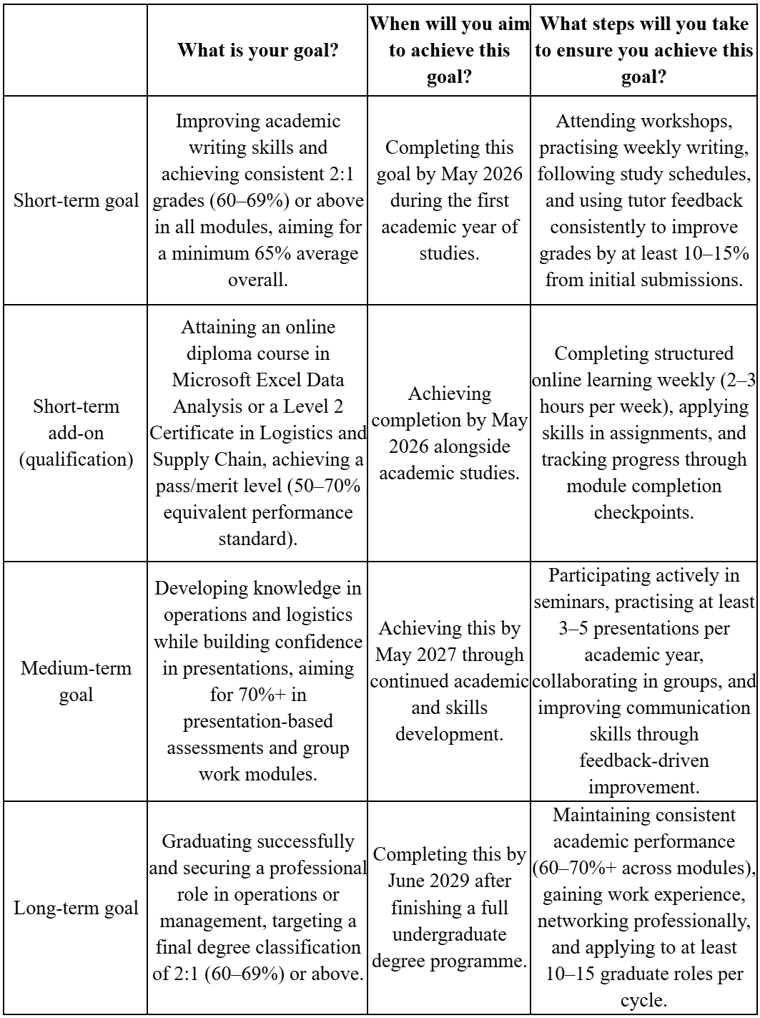

Table 1: Personal Development Plan
(Source: Author)
My Academic Success Plan is grounded on three clear objectives, which address my academic progress, employability competencies and long-term professional growth, with schedules and activities. Such a gradual strategy will help me develop, maintain my steady growth and enable me to successfully reach my academic and professional objectives.
Short-term Goal (by May 2026)
The short-term objective is to gain better academic writing skills and to attain a regular grade of 2:1 across all modules throughout the first academic year by the end of May 2026. To accomplish this, I will take academic skills workshops, write weekly, use the structured study schedules and continuously give feedback to the tutors so that the latter could help me to get better. I will also constantly employ tutor feedback to refine my skills in writing, referencing and critical thinking. Besides this, I will acquire an online diploma course, sitting either Microsoft Excel Data Analysis or a Level 2 Certificate in Logistics and Supply Chain, which will further augment my academic capability and my practical employability aptitude. This will aid my academic growth as well as my employability levels and will boost my confidence and performance, as well as equip me better to pursue the opportunities offered in the field of professional and further educational excellence.
Medium-term Goal (by May 2027)
The medium-term objective that I have is to advance my knowledge in both operations and logistics and gain confidence in the realm of presentations. I am determined to attain this by May 2027 via advancement in my field of study and competencies. To support this, I will engage in seminars, practice of presenting and teamwork with other students. I will also emphasise the enhancement of my skills in communication and confidence in conveying ideas. These activities will allow me to apply the achievements of academic knowledge more effectively and prepare me to occupy future professional positions.
Long-term Goal (by June 2029)
My future objective is to successfully complete my education and obtain a professional job in operations or management. I hope to accomplish this by June 2029 after I have achieved my undergraduate degree programme. To achieve this, I shall continue to achieve good academic grades, attain experience, build connections and apply continuously to graduate opportunities. This will help me build a robust career base, move on to management, and enhance my professional growth and stability in the long-run.

References
BBC News (2013) Record numbers of students enter university. Available at: https://www.bbc.com/news/education-25432377 (Accessed: 30 April 2026).
Britton, C. (2025) ‘Academic writing: Key components, structure, and avoiding plagiarism’, Journal of Perioperative Practice, 35(5). Available at: https://doi.org/10.1177/17504589241310405
Dost, G. and Mazzoli Smith, L. (2023) ‘Understanding Higher Education Students’ Sense of belonging: a Qualitative meta-ethnographic Analysis’, Journal of Further and Higher Education, 47(6), pp.1–28. Available at: https://doi.org/10.1080/0309877x.2023.2191176
Francis, N., Pritchard, C., Prytherch, Z. and Rutherford, S. (2024) ‘Making teamwork work: enhancing teamwork and assessment in higher education', FEBS Open Bio, 15(1). Available at: https://doi.org/10.1002/2211-5463.13936
Galaviz, G.O. (2025) ‘Impact of Time Management on Academic Performance’, Journal of Information Systems Engineering and Management, 10(21s), pp.46–65. Available at: https://doi.org/10.52783/jisem.v10i21s.3289
Ghimire, B., Dahal, R. and Rai, B. (2023) ‘The Attitude of Flexible Work Arrangement on Academics’ Job Satisfaction: The Emerging Market Case’, Journal of System and Management Sciences, 13(2), pp.370–383. Available at: https://doi.org/10.33168/JSMS.2023.0226
GOV UK (2026) Higher education student enrolments UK: 2024 to 2025. Available at: https://www.gov.uk/government/statistics/higher-education-student-enrolments-uk-2024-to-2025 (Accessed: 1 May 2026).
Hilario, Giovanni, E., Ubaldina, E. and Carcausto-Calla, W. (2025) ‘Critical Thinking in Academic Writing at the University: A Scoping Review’, Journal of Educational and Social Research, 15(4), pp.240–240. Available at: https://doi.org/10.36941/jesr-2025-0135
Li, S., Noordin, N. and Yang, T. (2026) ‘Critical Thinking as a Bridge Between Reading, Reflection, and Academic Writing: A Mixed-Methods Study of International Doctoral Candidates’, Sage Open, 16(1). Available at: https://doi.org/10.1177/21582440261415778
Malhotra, N., Iyer, V.M. and Dave, K. (2022) ‘Employability of graduates and postgraduates in respect to retail industry: a study of selected states of North India', Industrial and Commercial Training, 54(3), pp.442–459. Available at: https://doi.org/10.1108/ict-12-2021-0087
Obodozie, N.M. and Nwabufo, I.J. (2025) ‘Promoting collaboration in the modern workplace: A path to productivity and resilience', World Journal of Advanced Research and Reviews, 25(2), pp.524–533. Available at: https://doi.org/10.30574/wjarr.2025.25.2.0343
Office for National Statistics (2021) Coronavirus and first year higher education students, England - Office for National Statistics. Available at: https://www.ons.gov.uk/peoplepopulationandcommunity/healthandsocialcare/healthandwellbeing/bulletins/coronavirusandfirstyearhighereducationstudentsengland/4octoberto11october2021 (Accessed: 1 May 2026).
Office for National Statistics (2024) Young people not in education, employment or training (NEET), UK. Available at: https://www.ons.gov.uk/employmentandlabourmarket/peoplenotinwork/unemployment/bulletins/youngpeoplenotineducationemploymentortrainingneet/august2024 (Accessed: 1 May 2026).
Panjaitan, A.O., Novelyn, S. and Angreni, F. (2024) ‘The Impact of Proper Citation on Academic Integrity and Scholarship’, Asian Journal of Advanced Research and Reports, 18(10), pp.192–201. Available at: https://doi.org/10.9734/ajarr/2024/v18i10766
Patzak, A., Zhang, X. and Vytasek, J. (2025) ‘Boosting productivity and wellbeing through time management: evidence-based strategies for higher education and workforce development', Frontiers in Education, 10. Available at: https://doi.org/10.3389/feduc.2025.1623228
Ricco, R. (2025) ‘Argumentative Reasoning: Development, Training, and Relevance to Academic Outcomes’, Behavioral Sciences, 15(12), p.1700. Available at: https://doi.org/10.3390/bs15121700
The Guardian (2024) More than half of UK students working long hours in paid jobs. Available at: https://www.theguardian.com/education/article/2024/jun/13/more-than-half-of-uk-students-working-long-hours-in-paid-jobs (Accessed: 1 May 2026).
Theobald, M. (2024) ‘Study longer or study effectively? Better study strategies can compensate for less study time and predict goal achievement and lower negative affect’, British Journal of Educational Psychology. Available at: https://doi.org/10.1111/bjep.12725
Wang, H. (2024) ‘The Impact of Communication Skills on Work Performance in Team Collaboration’, Advances in Economics Management and Political Sciences, 121(1), pp.99–106. Available at: https://doi.org/10.54254/2754-1169/121/20242359

