Week 1
Given an array of nonnegative integers, design a linear algorithm and implement it using a program to find whether given key element is present in the array or not. Also, find total number of comparisons for each input case. (Time Complexity = O(n), where n is the size of input)
#include <iostream>
using namespace std;
// Linear search function with comparison count (without inbuilt functions)
pair<bool, int> linearSearch(int arr[], int size, int key) {
int comparisons = 0;
for (int i = 0; i < size; ++i) {
comparisons++;
if (arr[i] == key) {
return make_pair(true, comparisons); // Key found, return true and comparison count
}
}
return make_pair(false, comparisons); // Key not found, return false and comparison count
}

int main() {
int size;
cout << "Enter the size of the array: ";
cin >> size;

int arr[size]; // Using a fixed-size array (C-style)
cout << "Enter the array elements: ";
for (int i = 0; i < size; ++i) {
cin >> arr[i];
}

int key;
cout << "Enter the key to search: ";
cin >> key;

pair<bool, int> result = linearSearch(arr, size, key);

if (result.first) {
cout << "Present " << result.second << endl;
} else {
cout << "Not Present " << result.second << endl;
}

return 0;
}

OUTPUT:-
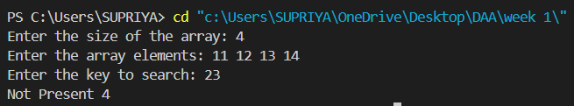

2. Given an already sorted array of positive integers, design an algorithm and implement it using a program to find whether given key element is present in the array or not. Also, find total number of comparisons for each input case. (Time Complexity = O(logn), where n is the size of input).

#include <iostream>

using namespace std;

pair<bool, int> binarySearch(int arr[], int size, int key) {
int comparisons = 0;
int low = 0;
int high = size - 1;

while (low <= high) {
comparisons++;

int mid = low + (high - low) / 2;

if (arr[mid] == key) {
return make_pair(true, comparisons);
} else if (arr[mid] < key) {
low = mid + 1;
} else {
high = mid - 1;
}
}

return make_pair(false, comparisons);
}

int main() {
int size;
cout << "Enter the size of the sorted array: ";
cin >> size;

int arr[size];
cout << "Enter the sorted array elements: ";
for (int i = 0; i < size; ++i) {
cin >> arr[i];
}

int key;
cout << "Enter the key to search: ";
cin >> key;

pair<bool, int> result = binarySearch(arr, size, key);

if (result.first) {
cout << "Present " << result.second << endl;
} else {
cout << "Not Present " << result.second << endl;
}

return 0;
}
OUTPUT:-
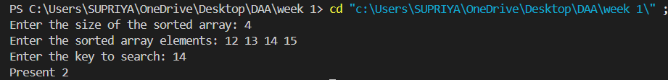

3. Given an already sorted array of positive integers, design an algorithm and implement it using a program to find whether a given key element is present in the sorted array or not. For an array arr[n], search at the indexes arr[0], arr[2], arr[4],. ,arr[2k] and so on. Once the interval (arr[2k] < key < arr[ 2k+1] ) is found, perform a linear search operation from the index 2k to find the element key. (Complexity < O(n), where n is the number of elements need to be scanned for searching): Jump Search

#include <iostream>
#include <cmath>
using namespace std;
pair<bool, int> jumpSearch(int arr[], int size, int key) {
int comparisons = 0;
int jump = sqrt(size);
int prev = 0;
while (arr[min(jump, size) - 1] < key) {
comparisons++;
prev = jump;
jump += sqrt(size);
if (prev >= size) {
return make_pair(false, comparisons);
}
}

for (int i = prev; i < min(jump, size); ++i) {
comparisons++;
if (arr[i] == key) {
return make_pair(true, comparisons);
}
}

return make_pair(false, comparisons);
}

int main() {
int size;
cout << "Enter the size of the sorted array: ";
cin >> size;

int arr[size];
cout << "Enter the sorted array elements: ";
for (int i = 0; i < size; ++i) {
cin >> arr[i];
}
int key;
cout << "Enter the key to search: ";
cin >> key;

pair<bool, int> result = jumpSearch(arr, size, key);

if (result.first) {
cout << "Present " << result.second << endl;
} else {
cout << "Not Present " << result.second << endl;
}
return 0;
}

OUTPUT:-
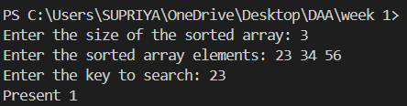
WEEK 2
1. Given a sorted array of positive integers containing few duplicate elements, design an algorithm and implement it using a program to find whether the given key element is present in the array or not. If present, then also find the number of copies of given key. (Time Complexity = O(log n))
#include <iostream>
#include <vector>

using namespace std;

int findFirstOccurrence(const vector<int>& arr, int key) {
int low = 0, high = arr.size() - 1, result = -1;
while (low <= high) {
int mid = low + (high - low) / 2;
if (arr[mid] == key) {
result = mid;
high = mid - 1;
} else if (arr[mid] < key) {
low = mid + 1;
} else {
high = mid - 1;
}
}
return result;
}

int findLastOccurrence(const vector<int>& arr, int key) {
int low = 0, high = arr.size() - 1, result = -1;
while (low <= high) {
int mid = low + (high - low) / 2;
if (arr[mid] == key) {
result = mid;
low = mid + 1;
} else if (arr[mid] < key) {
low = mid + 1;
} else {
high = mid - 1;
}
}
return result;
}

int main() {
int t;
cin >> t;
while (t--) {
int n;
cin >> n;
vector<int> arr(n);
for (int i = 0; i < n; ++i) {
cin >> arr[i];
}
int key;
cin >> key;
int first = findFirstOccurrence(arr, key);
int last = findLastOccurrence(arr, key);
if (first == -1) {
cout << "Key not present" << endl;
} else {
cout << key << " - " << (last - first + 1) << endl;
}
}
return 0;
}

OUTPUT:-
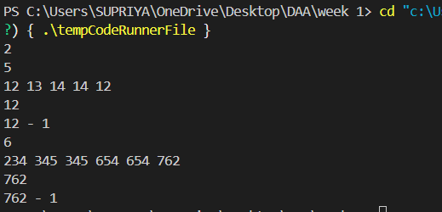

2. Given a sorted array of positive integers, design an algorithm and implement it using a program to find three indices i, j, k such that arr[i] + arr[j] = arr[k].
#include <iostream>
#include <vector>
#include <algorithm>

using namespace std;

// Function to find three indices i, j, k such that arr[i] + arr[j] = arr[k]
void findIndices(const vector<int>& arr) {
int n = arr.size();
bool found = false; // Flag to check if a sequence is found

// Iterate through the array to find potential k
for (int k = n - 1; k >= 0; --k) {
// Use two pointers i and j to find if arr[i] + arr[j] = arr[k]
int i = 0, j = k - 1;
while (i < j) {
if (arr[i] + arr[j] == arr[k]) {
cout << i + 1 << ", " << j + 1 << ", " << k + 1 << endl; // Print indices (1-based)
found = true;
return; // Return after finding the first sequence
} else if (arr[i] + arr[j] < arr[k]) {
i++; // Increment i if the sum is less than arr[k]
} else {
j--; // Decrement j if the sum is greater than arr[k]
}
}
}

// If no sequence is found
if (!found) {
cout << "No sequence found." << endl;
}
}

int main() {
int t;
cin >> t; // Read the number of test cases

while (t--) {
int n;
cin >> n; // Read the size of the array

vector<int> arr(n);
for (int i = 0; i < n; ++i) {
cin >> arr[i]; // Read the array elements
}

findIndices(arr); // Call the function to find indices
}

return 0;
}
OUTPUT:- 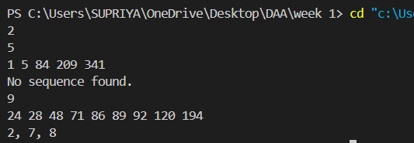
3. Given an array of nonnegative integers, design an algorithm and a program to count the number of pairs of integers such that their difference is equal to a given key, K.
#include <iostream>
#include <vector>

using namespace std;

// Function to swap two integers
void swap(int& a, int& b) {
int temp = a;
a = b;
b = temp;
}

// Function to perform bubble sort
void bubbleSort(vector<int>& arr) {
int n = arr.size();
for (int i = 0; i < n - 1; ++i) {
for (int j = 0; j < n - i - 1; ++j) {
if (arr[j] > arr[j + 1]) {
swap(arr[j], arr[j + 1]);
}
}
}
}

// Function to count pairs with a given difference K
int countPairsWithDifference(vector<int>& arr, int k) {
int count = 0;
int n = arr.size();

// Sort the array using bubble sort
bubbleSort(arr);

// Use two pointers to find pairs
int i = 0, j = 1;

while (j < n) {
int diff = arr[j] - arr[i];

if (diff == k) {
count++;
i++;
j++;
} else if (diff < k) {
j++;
} else {
i++;
}

// Avoid checking the same element twice for the difference
if (i == j) {
j++;
}
}

return count;
}

int main() {
int t;
cin >> t; // Read the number of test cases

while (t--) {
int n;
cin >> n; // Read the size of the array

vector<int> arr(n);
for (int i = 0; i < n; ++i) {
cin >> arr[i];
}

int k;
cin >> k; // Read the key difference

int result = countPairsWithDifference(arr, k);
cout << result << endl; // Output the result
}

return 0;
}
OUTPUT:-
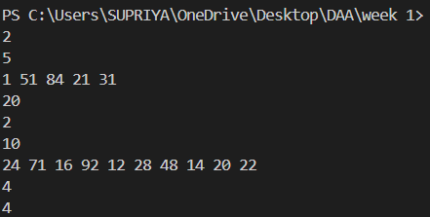

WEEK 3
Given an unsorted array of integers, design an algorithm and a program to sort the array using insertion sort. Your program should be able to find number of comparisons and shifts ( shifts - total number of times the array elements are shifted from their place) required for sorting the array.
#include <iostream>
#include <vector>

using namespace std;

void insertionSort(vector<int>& arr, int& comparisons, int& shifts) {
int n = arr.size();
for (int i = 1; i < n; ++i) {
int key = arr[i];
int j = i - 1;

while (j >= 0 && arr[j] > key) {
comparisons++;
arr[j + 1] = arr[j];
shifts++;
j = j - 1;
}
if(j>=0)
{
comparisons++;
}
arr[j + 1] = key;
if(i != j+1)
shifts++;
}
}

int main() {
int t;
cin >> t;

while (t--) {
int n;
cin >> n;

vector<int> arr(n);
for (int i = 0; i < n; ++i) {
cin >> arr[i];
}

int comparisons = 0;
int shifts = 0;

insertionSort(arr, comparisons, shifts);

for (int i = 0; i < n; ++i) {
cout << arr[i] << (i == n - 1 ? "" : " ");
}
cout << endl;
cout << "comparisons = " << comparisons << endl;
cout << "shifts = " << shifts << endl;
}

return 0;
}

OUTPUT:-
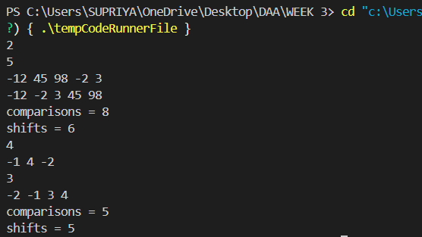

2. . Given an unsorted array of integers, design an algorithm and implement a program to sort this array using selection sort. Your program should also find number of comparisons and number of swaps required.
#include <iostream>
#include <vector>

using namespace std;

void selectionSort(vector<int>& arr, int& comparisons, int& swaps) {
int n = arr.size();
for (int i = 0; i < n - 1; ++i) {
int minIndex = i;
for (int j = i + 1; j < n; ++j) {
comparisons++;
if (arr[j] < arr[minIndex]) {
minIndex = j;
}
}
if (minIndex != i) {
swap(arr[i], arr[minIndex]);
swaps++;
}
}
}

int main() {
int t;
cin >> t;

while (t--) {
int n;
cin >> n;

vector<int> arr(n);
for (int i = 0; i < n; ++i) {
cin >> arr[i];
}

int comparisons = 0;
int swaps = 0;

selectionSort(arr, comparisons, swaps);

for (int i = 0; i < n; ++i) {
cout << arr[i] << (i == n - 1 ? "" : " ");
}
cout << endl;
cout << "comparisons = " << comparisons << endl;
cout << "swaps = " << swaps << endl;
}

return 0;
}

OUTPUT:-
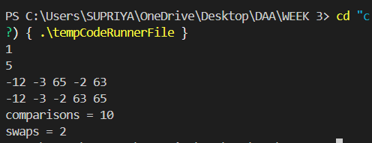
3. Given an unsorted array of positive integers, design an algorithm and implement it using a program to find whether there are any duplicate elements in the array or not. (use sorting) (Time Complexity = O(n log n))
#include <iostream>
#include <vector>

using namespace std;

// Function to swap two integers
void swap(int& a, int& b) {
int temp = a;
a = b;
b = temp;
}

// Function to perform quicksort
void quickSort(vector<int>& arr, int low, int high) {
if (low < high) {
int pivot = arr[high];
int i = low - 1;

for (int j = low; j < high; ++j) {
if (arr[j] <= pivot) {
i++;
swap(arr[i], arr[j]);
}
}
swap(arr[i + 1], arr[high]);
int partitionIndex = i + 1;

quickSort(arr, low, partitionIndex - 1);
quickSort(arr, partitionIndex + 1, high);
}
}

string findDuplicates(vector<int>& arr) {
int n = arr.size();

// Sort the array using quicksort
quickSort(arr, 0, n - 1);

// Check for adjacent duplicates
for (int i = 0; i < n - 1; ++i) {
if (arr[i] == arr[i + 1]) {
return "YES"; // Duplicates found
}
}

return "NO"; // No duplicates found
}

int main() {
int t;
cin >> t;

while (t--) {
int n;
cin >> n;

vector<int> arr(n);
for (int i = 0; i < n; ++i) {
cin >> arr[i];
}

cout << findDuplicates(arr) << endl;
}

return 0;
}

OUTPUT:-
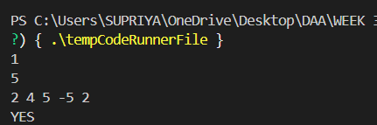

WEEK 4:
1. Given an unsorted array of integers, design an algorithm and implement it using a program to sort an array of elements by dividing the array into two subarrays and combining these subarrays after sorting each one of them. Your program should also find number of comparisons and inversions during sorting the array.
#include <iostream>
#include <vector>

using namespace std;

// Function to merge two sorted subarrays and count comparisons and inversions
pair<long long, long long> merge(vector<int>& arr, int left, int mid, int right) {
int n1 = mid - left + 1;
int n2 = right - mid;

vector<int> L(n1);
vector<int> R(n2);

for (int i = 0; i < n1; i++)
L[i] = arr[left + i];
for (int j = 0; j < n2; j++)
R[j] = arr[mid + 1 + j];

int i = 0, j = 0, k = left;
long long comparisons = 0, inversions = 0;

while (i < n1 && j < n2) {
comparisons++; // Increment comparisons

if (L[i] <= R[j]) {
arr[k] = L[i];
i++;
} else {
arr[k] = R[j];
inversions += n1 - i; // Increment inversions
j++;
}
k++;
}

while (i < n1) {
arr[k] = L[i];
i++;
k++;
}

while (j < n2) {
arr[k] = R[j];
j++;
k++;
}

return {comparisons, inversions};
}

// Function to perform merge sort and count comparisons and inversions
pair<long long, long long> mergeSort(vector<int>& arr, int left, int right) {
if (left < right) {
int mid = left + (right - left) / 2;

pair<long long, long long> leftResult = mergeSort(arr, left, mid);
pair<long long, long long> rightResult = mergeSort(arr, mid + 1, right);
pair<long long, long long> mergeResult = merge(arr, left, mid, right);

return {leftResult.first + rightResult.first + mergeResult.first,
leftResult.second + rightResult.second + mergeResult.second};
}
return {0, 0};
}

int main() {
int t;
cin >> t;

while (t--) {
int n;
cin >> n;

vector<int> arr(n);
for (int i = 0; i < n; i++)
cin >> arr[i];

pair<long long, long long> result = mergeSort(arr, 0, n - 1);

for (int i = 0; i < n; i++)
cout << arr[i] << (i == n - 1 ? "" : " ");
cout << endl;

cout << "comparisons = " << result.first << endl;
cout << "inversions = " << result.second << endl;
}

return 0;
}

OUTPUT:-
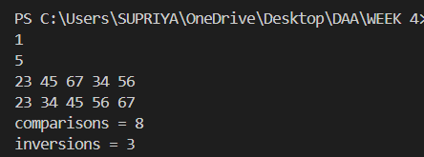

2. Given an unsorted array of integers, design an algorithm and implement it using a program to sort an array of elements by partitioning the array into two subarrays based on a pivot element such that one of the sub array holds values smaller than the pivot element while another sub array holds values greater than the pivot element. Pivot element should be selected randomly from the array. Your program should also find number of comparisons and swaps required for sorting the array.
#include <iostream>
#include <vector>

using namespace std;

pair<int, int> partition(vector<int>& arr, int low, int high, long long& comparisons, long long& swaps) {
int pivotIndex = low + rand() % (high - low + 1);
swap(arr[pivotIndex], arr[high]);
swaps++;
int pivot = arr[high];
int i = low - 1;
for (int j = low; j < high; j++) {
comparisons++;
if (arr[j] <= pivot) {
i++;
swap(arr[i], arr[j]);
swaps++;
}
}
swap(arr[i + 1], arr[high]);
swaps++;
return {i + 1, swaps};
}

pair<long long, long long> quickSort(vector<int>& arr, int low, int high, long long& comparisons, long long& swaps) {
if (low < high) {
pair<int, int> partitionResult = partition(arr, low, high, comparisons, swaps);
int pivotIndex = partitionResult.first;
swaps = partitionResult.second;
quickSort(arr, low, pivotIndex - 1, comparisons, swaps);
quickSort(arr, pivotIndex + 1, high, comparisons, swaps);
}
return {comparisons, swaps};
}

int main() {
int t;
cin >> t;
while (t--) {
int n;
cin >> n;
vector<int> arr(n);
for (int i = 0; i < n; i++)
cin >> arr[i];
long long comparisons = 0, swaps = 0;
pair<long long, long long> result = quickSort(arr, 0, n - 1, comparisons, swaps);
for (int i = 0; i < n; i++)
cout << arr[i] << (i == n - 1 ? "" : " ");
cout << endl;
cout << "comparisons = " << result.first << endl;
cout << "swaps = " << result.second << endl;
}
return 0;
}

OUTPUT:-
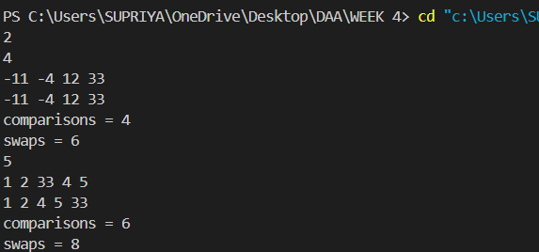

3. Given an unsorted array of integers, design an algorithm and implement it using a program to find Kth smallest or largest element in the array. (Worst case Time Complexity = O(n))
#include <iostream>
#include <vector>
#include <algorithm>
#include <random>

using namespace std;

// Function to partition the array around a pivot
int partition(vector<int>& arr, int low, int high) {
int pivot = arr[high];
int i = low - 1;
for (int j = low; j < high; j++) {
if (arr[j] <= pivot) {
i++;
swap(arr[i], arr[j]);
}
}
swap(arr[i + 1], arr[high]);
return i + 1;
}

// Function to find the Kth smallest element using QuickSelect
int quickSelect(vector<int>& arr, int low, int high, int k) {
if (k > 0 && k <= high - low + 1) {
int pivotIndex = partition(arr, low, high);

if (pivotIndex - low == k - 1) {
return arr[pivotIndex];
} else if (pivotIndex - low > k - 1) {
return quickSelect(arr, low, pivotIndex - 1, k);
} else {
return quickSelect(arr, pivotIndex + 1, high, k - (pivotIndex - low + 1));
}
}
return -1; // Indicates that K is out of bounds
}

int main() {
int t;
cin >> t;

while (t--) {
int n;
cin >> n;

vector<int> arr(n);
for (int i = 0; i < n; i++) {
cin >> arr[i];
}

int k;
cin >> k;

int result = quickSelect(arr, 0, n - 1, k);

if (result != -1) {
cout << result << endl;
} else {
cout << "not present" << endl;
}
}

return 0;
}

OUTPUT:-
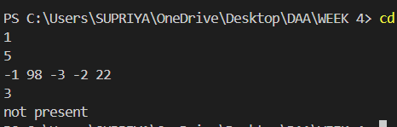

WEEK 5
- Given an unsorted array of alphabets containing duplicate elements. Design an algorithm and implement it using a program to find which alphabet has maximum number of occurrences and print it. (Time Complexity = O(n)) (Hint: Use counting sort)
- #include <iostream>
- #include <vector>

- using namespace std;

- pair<char, int> findMaxOccurrences(const vector<char>& arr) {
- vector<int> count(26, 0);

- for (char c : arr) {
- count[c - 'a']++;
- }

- int maxCount = 0;
- char maxChar = ' ';

- for (int i = 0; i < 26; ++i) {
- if (count[i] > maxCount) {
- maxCount = count[i];
- maxChar = 'a' + i;
- }
- }

- if (maxCount == 1) {
- return {'\0', -1};
- } else {
- return {maxChar, maxCount};
- }
- }

- int main() {
- int t;
- cin >> t;

- while (t--) {
- int n;
- cin >> n;

- vector<char> arr(n);
- for (int i = 0; i < n; ++i) {
- cin >> arr[i];
- }

- pair<char, int> result = findMaxOccurrences(arr);

- if (result.second == -1) {
- cout << "No Duplicates Present" << endl;
- } else {
- cout << result.first << " - " << result.second << endl;
- }
- }

- return 0;
- }

OUTPUT:-
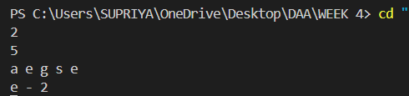

2. Given an unsorted array of integers, design an algorithm and implement it using a program to find whether two elements exist such that their sum is equal to the given key element. (Time Complexity = O(n log n))
#include <iostream>
#include <vector>

using namespace std;

// Function to perform a simple insertion sort
void insertionSort(vector<int>& arr) {
int n = arr.size();
for (int i = 1; i < n; ++i) {
int key = arr[i];
int j = i - 1;
while (j >= 0 && arr[j] > key) {
arr[j + 1] = arr[j];
j = j - 1;
}
arr[j + 1] = key;
}
}

pair<int, int> findSumPair(vector<int>& arr, int key) {
// 1. Sort the input array using insertion sort.
insertionSort(arr); // This takes O(n^2) in worst case, but required by the prompt

// 2. Initialize two pointers, 'left' and 'right'.
int left = 0;
int right = arr.size() - 1;

// 3. Iterate through the sorted array using the two pointers.
while (left < right) {
// 4. Calculate the sum of the elements at the 'left' and 'right' pointers.
int sum = arr[left] + arr[right];

// 5. Check if the sum is equal to the key.
if (sum == key) {
// 6. If the sum is equal to the key, return the pair of elements.
return {arr[left], arr[right]};
} else if (sum < key) {
// 7. If the sum is less than the key, move the 'left' pointer to the right.
left++;
} else {
// 8. If the sum is greater than the key, move the 'right' pointer to the left.
right--;
}
}

// 9. If no pair is found, return a pair with both elements as -1 to indicate no such elements exist.
return {-1, -1};
}

int main() {
int t;
cin >> t;

while (t--) {
int n;
cin >> n;

vector<int> arr(n);
for (int i = 0; i < n; ++i) {
cin >> arr[i];
}

int key;
cin >> key;

pair<int, int> result = findSumPair(arr, key);

if (result.first == -1 && result.second == -1) {
cout << "No Such Element Exist" << endl;
} else {
cout << result.first << " " << result.second << endl;
}
}

return 0;
}

Output:-
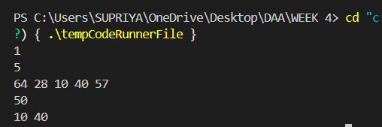

3. You have been given two sorted integer arrays of size m and n. Design an algorithm and implement it using a program to find list of elements which are common to both. (Time Complexity = O(m+n))
#include <iostream>
#include <vector>

using namespace std;

vector<int> findCommonElements(const vector<int>& arr1, const vector<int>& arr2) {
// 1. Initialize an empty vector to store the common elements.
vector<int> commonElements;

// 2. Initialize two pointers, 'i' and 'j', to traverse the two arrays.
int i = 0;
int j = 0;

// 3. Iterate through both arrays using the pointers.
while (i < arr1.size() && j < arr2.size()) {
// 4. If the elements at the current pointers are equal, it's a common element.
if (arr1[i] == arr2[j]) {
// 5. Add the common element to the 'commonElements' vector.
commonElements.push_back(arr1[i]);
// 6. Move both pointers to the next elements.
i++;
j++;
}
// 7. If the element in 'arr1' is smaller, move its pointer to the next element.
else if (arr1[i] < arr2[j]) {
i++;
}
// 8. If the element in 'arr2' is smaller, move its pointer to the next element.
else {
j++;
}
}

// 9. Return the vector containing the common elements.
return commonElements;
}

int main() {
int m;
cin >> m;

vector<int> arr1(m);
for (int i = 0; i < m; ++i) {
cin >> arr1[i];
}

int n;
cin >> n;

vector<int> arr2(n);
for (int i = 0; i < n; ++i) {
cin >> arr2[i];
}

vector<int> result = findCommonElements(arr1, arr2);

// 10. Print the common elements.
for (int element : result) {
cout << element << " ";
}
cout << endl;

return 0;
}

Output:-
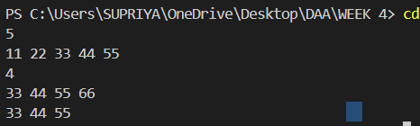

WEEK 6
1.Given a (directed/undirected) graph, design an algorithm and implement it using a program to find if a path exists between two given vertices or not. (Hint: use DFS)
NAME: - SUPRIYA RAWAT
SECTION: - I2
ROLL NO.: - 117

#include <iostream>
#include <vector>
using namespace std;
// Function to perform Depth-First Search (DFS)
bool dfs(const vector<vector<int>>& graph, int startVertex, int endVertex, vector<bool>& visited) {
visited[startVertex] = true;

if (startVertex == endVertex) {
return true;
}

for (size_t i = 0; i < graph.size(); i++) {
if (graph[startVertex][i] && !visited[i]) {
if (dfs(graph, i, endVertex, visited)) {
return true;
}
}
}

return false;
}

int main() {
int numVertices;
cout << "Enter the number of vertices: ";
cin >> numVertices;

vector<vector<int>> graph(numVertices, vector<int>(numVertices));
cout << "Enter the adjacency matrix:\n";
for (int i = 0; i < numVertices; i++) {
for (int j = 0; j < numVertices; j++) {
cin >> graph[i][j];
}
}

int startVertex, endVertex;
cout << "Enter the start vertex and end vertex: ";
cin >> startVertex >> endVertex;

vector<bool> visited(numVertices, false); // Initialize all vertices as not visited

if (dfs(graph, startVertex - 1, endVertex - 1, visited)) {
cout << "Yes Path Exists\n";
} else {
cout << "No Such Path Exists\n";
}

return 0;
}

OUTPUT:-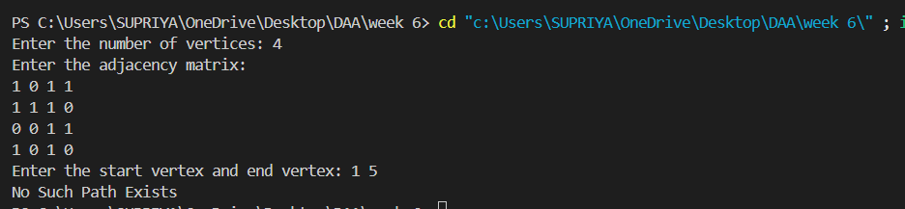

2.Given a graph, design an algorithm and implement it using a program to find if a graph is bipartite or not. (Hint: use BFS)
NAME: - SUPRIYA RAWAT
SECTION: - I2
ROLL NO.: - 117

#include <iostream>
#include <vector>
#include <queue>

using namespace std;

// Function to perform Breadth-First Search (BFS) for bipartite check
bool isBipartite(const vector<vector<int>>& graph) {
int numVertices = graph.size();
vector<int> color(numVertices, -1); // -1: not colored, 0: color 1, 1: color 2

for (int startVertex = 0; startVertex < numVertices; startVertex++) {
if (color[startVertex] == -1) { // If not colored, start BFS
queue<int> q;
q.push(startVertex);
color[startVertex] = 0; // Assign color 0 to the start vertex

while (!q.empty()) {
int u = q.front();
q.pop();
for (int v = 0; v < numVertices; v++) {
if (graph[u][v]) { // If there is an edge
if (color[v] == -1) { // If not colored, assign opposite color
color[v] = 1 - color[u];
q.push(v);
} else if (color[v] == color[u]) { // If same color, not bipartite
return false;
}
}
}
}
}
}
return true; // All components are bipartite
}

int main() {
int numVertices;
cout << "Enter the number of vertices: ";
cin >> numVertices;

vector<vector<int>> graph(numVertices, vector<int>(numVertices));
cout << "Enter the adjacency matrix:\n";
for (int i = 0; i < numVertices; i++) {
for (int j = 0; j < numVertices; j++) {
cin >> graph[i][j];
}
}

if (isBipartite(graph)) {
cout << "Yes Bipartite\n";
} else {
cout << "Not Bipartite\n";
}

return 0;
}

OUTPUT :-
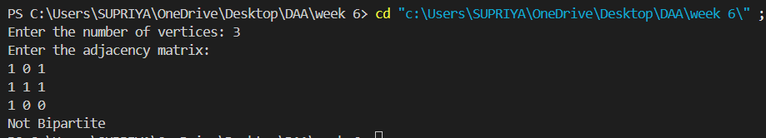

3.Given a directed graph, design an algorithm and implement it using a program to find whether cycle exists in the graph or not.
NAME: - SUPRIYA RAWAT
SECTION: - I2
ROLL NO.: - 117

#include <iostream>
#include <vector>
using namespace std;

bool isCyclicUtil(const vector<vector<int>>& graph, int v, vector<bool>& visited, vector<bool>& recursionStack) {
if (!visited[v]) {
visited[v] = true;
recursionStack[v] = true;
for (size_t i = 0; i < graph.size(); i++) {
if (graph[v][i]) {
if (!visited[i]) {
if (isCyclicUtil(graph, i, visited, recursionStack)) {
return true;
}
} else if (recursionStack[i]) {
return true;
}
}
}
}
recursionStack[v] = false;
return false;
}
bool isCyclic(const vector<vector<int>>& graph) {
int numVertices = graph.size();
vector<bool> visited(numVertices, false);
vector<bool> recursionStack(numVertices, false);

for (int i = 0; i < numVertices; i++) {
if (isCyclicUtil(graph, i, visited, recursionStack)) {
return true;
}
}
return false;
}

int main() {
int numVertices;
cout << "Enter the number of vertices: ";
cin >> numVertices;

vector<vector<int>> graph(numVertices, vector<int>(numVertices));
cout << "Enter the adjacency matrix:\n";
for (int i = 0; i < numVertices; i++) {
for (int j = 0; j < numVertices; j++) {
cin >> graph[i][j];
}
}
if (isCyclic(graph)) {
cout << "Yes Cycle Exists\n";
} else {
cout << "No Cycle Exists\n";
}
return 0;
}
OUTPUT:-

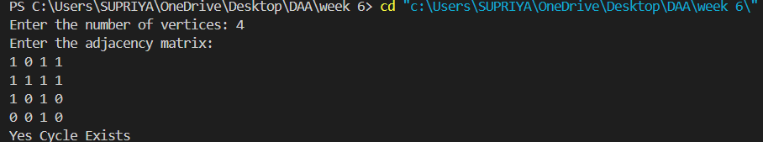
WEEK 7

1.Given an unsorted array of alphabets containing duplicate elements. Design an algorithm and implement it using a program to find which alphabet has maximum number of occurrences and print it. (Time Complexity = O(n)) (Hint: Use counting sort)

NAME: - SUPRIYA RAWAT
SECTION: - I2
ROLL NO.: - 117

#include <iostream>
#include <vector>

using namespace std;

pair<char, int> findMaxOccurrences(const vector<char>& arr) {
vector<int> count(26, 0);

for (char c : arr) {
count[c - 'a']++;
}

int maxCount = 0;
char maxChar = ' ';

for (int i = 0; i < 26; ++i) {
if (count[i] > maxCount) {
maxCount = count[i];
maxChar = 'a' + i;
}
}

if (maxCount == 1) {
return {'\0', -1};
} else {
return {maxChar, maxCount};
}
}

int main() {
int t;
cin >> t;

while (t--) {
int n;
cin >> n;

vector<char> arr(n);
for (int i = 0; i < n; ++i) {
cin >> arr[i];
}

pair<char, int> result = findMaxOccurrences(arr);

if (result.second == -1) {
cout << "No Duplicates Present" << endl;
} else {
cout << result.first << " - " << result.second << endl;
}
}

return 0;
}

OUTPUT:-


2. Given an unsorted array of integers, design an algorithm and implement it using a program to find whether two elements exist such that their sum is equal to the given key element. (Time Complexity = O(n log n))
NAME: - SUPRIYA RAWAT
SECTION: - I2
ROLL NO.: - 117

#include <iostream>
#include <vector>

using namespace std;

// Function to perform a simple insertion sort
void insertionSort(vector<int>& arr) {
int n = arr.size();
for (int i = 1; i < n; ++i) {
int key = arr[i];
int j = i - 1;
while (j >= 0 && arr[j] > key) {
arr[j + 1] = arr[j];
j = j - 1;
}
arr[j + 1] = key;
}
}

pair<int, int> findSumPair(vector<int>& arr, int key) {
// 1. Sort the input array using insertion sort.
insertionSort(arr); // This takes O(n^2) in worst case, but required by the prompt

// 2. Initialize two pointers, 'left' and 'right'.
int left = 0;
int right = arr.size() - 1;

// 3. Iterate through the sorted array using the two pointers.
while (left < right) {
// 4. Calculate the sum of the elements at the 'left' and 'right' pointers.
int sum = arr[left] + arr[right];

// 5. Check if the sum is equal to the key.
if (sum == key) {
// 6. If the sum is equal to the key, return the pair of elements.
return {arr[left], arr[right]};
} else if (sum < key) {
// 7. If the sum is less than the key, move the 'left' pointer to the right.
left++;
} else {
// 8. If the sum is greater than the key, move the 'right' pointer to the left.
right--;
}
}

// 9. If no pair is found, return a pair with both elements as -1 to indicate no such elements exist.
return {-1, -1};
}

int main() {
int t;
cin >> t;

while (t--) {
int n;
cin >> n;

vector<int> arr(n);
for (int i = 0; i < n; ++i) {
cin >> arr[i];
}

int key;
cin >> key;

pair<int, int> result = findSumPair(arr, key);

if (result.first == -1 && result.second == -1) {
cout << "No Such Element Exist" << endl;
} else {
cout << result.first << " " << result.second << endl;
}
}

return 0;
}

Output:-


3. You have been given two sorted integer arrays of size m and n. Design an algorithm and implement it using a program to find list of elements which are common to both. (Time Complexity = O(m+n))
NAME: - SUPRIYA RAWAT
SECTION: - I2
ROLL NO.: - 117

#include <iostream>
#include <vector>

using namespace std;

vector<int> findCommonElements(const vector<int>& arr1, const vector<int>& arr2) {
// 1. Initialize an empty vector to store the common elements.
vector<int> commonElements;

// 2. Initialize two pointers, 'i' and 'j', to traverse the two arrays.
int i = 0;
int j = 0;

// 3. Iterate through both arrays using the pointers.
while (i < arr1.size() && j < arr2.size()) {
// 4. If the elements at the current pointers are equal, it's a common element.
if (arr1[i] == arr2[j]) {
// 5. Add the common element to the 'commonElements' vector.
commonElements.push_back(arr1[i]);
// 6. Move both pointers to the next elements.
i++;
j++;
}
// 7. If the element in 'arr1' is smaller, move its pointer to the next element.
else if (arr1[i] < arr2[j]) {
i++;
}
// 8. If the element in 'arr2' is smaller, move its pointer to the next element.
else {
j++;
}
}

// 9. Return the vector containing the common elements.
return commonElements;
}

int main() {
int m;
cin >> m;

vector<int> arr1(m);
for (int i = 0; i < m; ++i) {
cin >> arr1[i];
}

int n;
cin >> n;

vector<int> arr2(n);
for (int i = 0; i < n; ++i) {
cin >> arr2[i];
}

vector<int> result = findCommonElements(arr1, arr2);

// 10. Print the common elements.
for (int element : result) {
cout << element << " ";
}
cout << endl;

return 0;
}

Output:-


Week 7
program that implements Dijkstra’s algorithm
NAME: - SUPRIYA RAWAT
SECTION: - I2
ROLL NO.: - 117

#include <iostream>
#include <vector>
#include <queue>
#include <stack>
#include <climits>

using namespace std;

typedef pair<int, int> PII; // (weight, node)

void dijkstra(int V, vector<vector<PII>>& adj, int target) {
vector<int> dist(V, INT_MAX);
vector<int> parent(V, -1);
priority_queue<PII, vector<PII>, greater<PII>> pq;

dist[target] = 0;
pq.push({0, target});

while (!pq.empty()) {
int d = pq.top().first;
int u = pq.top().second;
pq.pop();

for (auto edge : adj[u]) {
int v = edge.first;
int weight = edge.second;

if (dist[u] + weight < dist[v]) {
dist[v] = dist[u] + weight;
parent[v] = u;
pq.push({dist[v], v});
}
}
}

for (int i = 0; i < V; i++) {
if (i == target) continue;

cout << "Friend at node " << i << ":\n";
cout << "Shortest Distance = " << dist[i] << "\nPath = ";

stack<int> path;
int node = i;
while (node != -1) {
path.push(node);
node = parent[node];
}

while (!path.empty()) {
cout << path.top();
path.pop();
if (!path.empty()) cout << " -> ";
}
cout << "\n\n";
}
}

int main() {
int V, E;
cout << "Enter number of nodes: ";
cin >> V;
cout << "Enter number of edges: ";
cin >> E;

vector<vector<PII>> adj(V);
cout << "Enter each edge as: node1 node2 weight\n";
for (int i = 0; i < E; i++) {
int u, v, w;
cin >> u >> v >> w;
adj[u].push_back({v, w});
adj[v].push_back({u, w}); // Undirected graph
}

int akshayHouse;
cout << "Enter the destination node (Akshay's house): ";
cin >> akshayHouse;

dijkstra(V, adj, akshayHouse);

return 0;
}

OUTPUT:-

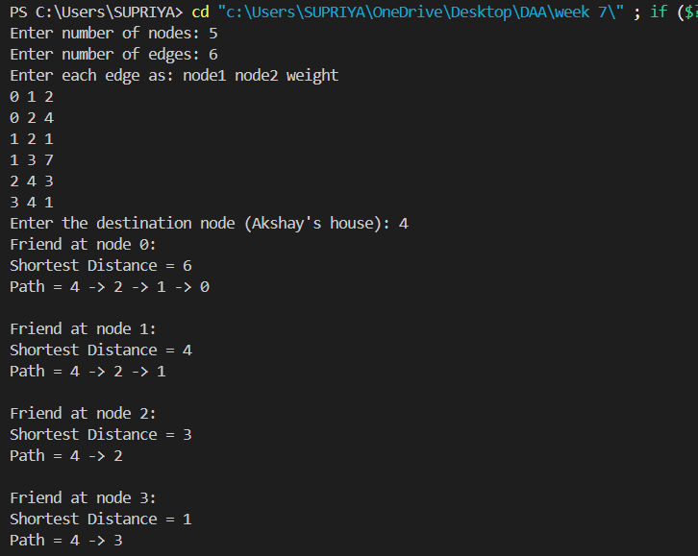

2.Design an algorithm and implement it using a program to solve previous question's problem using Bellman- Ford's shortest path algorithm.

NAME: - SUPRIYA RAWAT
SECTION: - I2
ROLL NO.: - 117

#include <iostream>
#include <vector>
#include <climits>
using namespace std;

struct Edge {
int u, v, weight;
};

// Function to print path from destination to source
void printPath(vector<int>& parent, int v) {
if (v == -1) return;
printPath(parent, parent[v]);
cout << v << " ";
}

int main() {
int V;
cin >> V;
vector<vector<int>> adj(V, vector<int>(V));
vector<Edge> edges;

// Input the adjacency matrix
for (int i = 0; i < V; ++i)
for (int j = 0; j < V; ++j) {
cin >> adj[i][j];
if (adj[i][j] != 0)
edges.push_back({i, j, adj[i][j]});
}

int src;
cin >> src;

vector<int> dist(V, INT_MAX);
vector<int> parent(V, -1);
dist[src] = 0;

// Relax edges (V-1) times
for (int i = 0; i < V - 1; ++i)
for (auto edge : edges)
if (dist[edge.u] != INT_MAX && dist[edge.u] + edge.weight < dist[edge.v]) {
dist[edge.v] = dist[edge.u] + edge.weight;
parent[edge.v] = edge.u;
}

// Print paths and weights
for (int i = 0; i < V; ++i) {
printPath(parent, i);
cout << ": ";
if (dist[i] == INT_MAX)
cout << "INF";
else
cout << dist[i];
cout << endl;
}

return 0;
}

OUTPUT:-
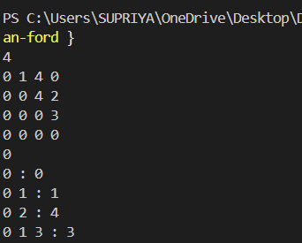

3. program to find the weight of the shortest path from source to destination with exactly k edges on the path.
NAME: - SUPRIYA RAWAT
SECTION: - I2
ROLL NO.: - 117

#include <iostream>
#include <vector>
#include <climits>
using namespace std;

const int INF = INT_MAX;

int shortestPathWithKEdges(vector<vector<int>>& graph, int u, int v, int k, vector<vector<vector<int>>>& dp) {

if (k == 0 && u == v) return 0;
if (k == 0) return INF;

if (dp[u][v][k] != -1) return dp[u][v][k];

int res = INF;
int V = graph.size();

for (int i = 0; i < V; i++) {
if (graph[u][i] != 0) {
int temp = shortestPathWithKEdges(graph, i, v, k - 1, dp);
if (temp != INF)
res = min(res, graph[u][i] + temp);
}
}

return dp[u][v][k] = res;
}

int main() {
int V;
cin >> V;

vector<vector<int>> graph(V, vector<int>(V));

for (int i = 0; i < V; i++)
for (int j = 0; j < V; j++)
cin >> graph[i][j];

int source, destination, k;
cin >> source >> destination >> k;

source--;
destination--;
vector<vector<vector<int>>> dp(V, vector<vector<int>>(V, vector<int>(k + 1, -1)));

int result = shortestPathWithKEdges(graph, source, destination, k, dp);

if (result == INF)
cout << "no path of length k is available" << endl;
else
cout << "Weight of shortest path from (" << source + 1 << "," << destination + 1 << ") with " << k << " edges : " << result << endl;

return 0;
}

OUTPUT:

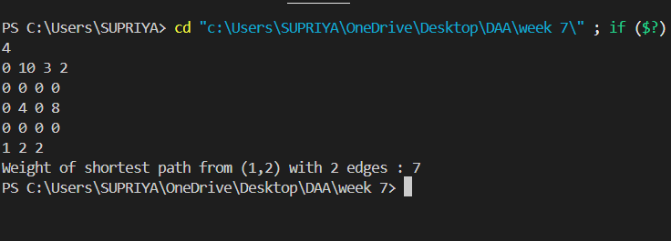

WEEK 8
1.Program of prim’s algorithm.
NAME: - SUPRIYA RAWAT
SECTION: - I2
ROLL NO.: - 117
#include <iostream>
#include <vector>
#include <queue>
#include <utility>
using namespace std;

const int INF = 1e9;

int primMST(vector<vector<pair<int, int>>>& graph, int n) {
vector<int> key(n, INF);
vector<bool> inMST(n, false);
priority_queue<pair<int, int>, vector<pair<int, int>>, greater<pair<int, int>>> pq;

key[0] = 0;
pq.push({0, 0});

int minCost = 0;

while (!pq.empty()) {
int u = pq.top().second;
pq.pop();

if (inMST[u]) continue;
inMST[u] = true;
minCost += key[u];

for (auto& edge : graph[u]) {
int v = edge.first;
int weight = edge.second;
if (!inMST[v] && weight < key[v]) {
key[v] = weight;
pq.push({key[v], v});
}
}
}
return minCost;
}

int main() {
int n, m;
cout << "Enter number of cities and roads: ";
cin >> n >> m;

vector<vector<pair<int, int>>> graph(n);

cout << "Enter roads (city1 city2 cost):\n";
for (int i = 0; i < m; ++i) {
int u, v, w;
cin >> u >> v >> w;
graph[u].push_back({v, w});
graph[v].push_back({u, w});
}

int result = primMST(graph, n);
cout << "Minimum cost to connect all cities: " << result << endl;

return 0;
}
OUTPUT:
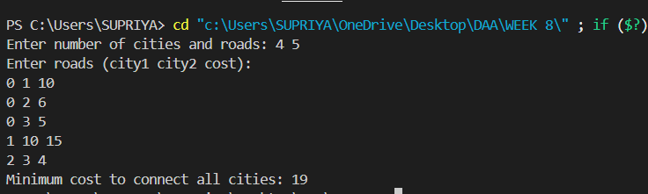

2. previous problem using Kruskal's algorithm.
NAME: - SUPRIYA RAWAT
SECTION: - I2
ROLL NO.: - 117

#include <iostream>
#include <vector>
#include <algorithm>
using namespace std;

struct Edge {
int u, v, weight;
Edge(int u, int v, int weight) : u(u), v(v), weight(weight) {}
};

int find(int parent[], int i) {
if (parent[i] == i) return i;
return parent[i] = find(parent, parent[i]);
}

void unionSets(int parent[], int rank[], int x, int y) {
int rootX = find(parent, x);
int rootY = find(parent, y);

if (rootX != rootY) {

if (rank[rootX] < rank[rootY])
parent[rootX] = rootY;
else if (rank[rootX] > rank[rootY])
parent[rootY] = rootX;
else {
parent[rootY] = rootX;
rank[rootX]++;
}
}
}

int kruskal(int n, vector<Edge>& edges) {

sort(edges.begin(), edges.end(), [](Edge& a, Edge& b) {
return a.weight < b.weight;
});

int parent[n], rank[n];

for (int i = 0; i < n; ++i) {
parent[i] = i;
rank[i] = 0;
}

int mstWeight = 0, edgeCount = 0;

for (auto& edge : edges) {
int u = edge.u, v = edge.v, weight = edge.weight;
if (find(parent, u) != find(parent, v)) {
mstWeight += weight;
unionSets(parent, rank, u, v);
edgeCount++;
}

if (edgeCount == n - 1)
break;
}

return mstWeight;
}

int main() {
int n;
cout << "Enter the number of vertices: ";
cin >> n;

vector<Edge> edges;
cout << "Enter the adjacency matrix (0 for no edge, other values for edge weights):\n";

int adjMatrix[n][n];

for (int i = 0; i < n; ++i) {
for (int j = 0; j < n; ++j) {
cin >> adjMatrix[i][j];
if (adjMatrix[i][j] != 0 && i < j) {
edges.push_back(Edge(i, j, adjMatrix[i][j]));
}
}
}

int result = kruskal(n, edges);
cout << "Minimum Spanning Weight: " << result << endl;

return 0;
}

OUTPUT:
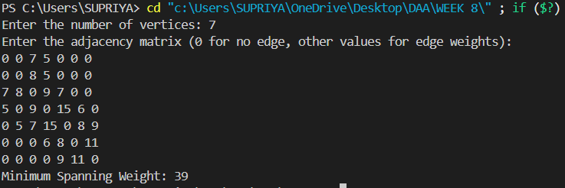

3. program to find the maximum budget required for the project.
NAME: - SUPRIYA RAWAT
SECTION: - I2
ROLL NO.: - 117

#include <iostream>
#include <vector>
#include <queue>
using namespace std;

const int INF = 1e9;

int maxSpanningTree(vector<vector<int>>& graph, int n) {
vector<int> key(n, -INF);
vector<bool> inMST(n, false);
priority_queue<pair<int, int>> pq;

key[0] = 0;
pq.push({0, 0});

int maxCost = 0;

while (!pq.empty()) {
int u = pq.top().second;
pq.pop();

if (inMST[u]) continue;
inMST[u] = true;
maxCost += key[u];

for (int v = 0; v < n; ++v) {
if (graph[u][v] && !inMST[v] && graph[u][v] > key[v]) {
key[v] = graph[u][v];
pq.push({key[v], v});
}
}
}
return maxCost;
}

int main() {
int n;
cin >> n;

vector<vector<int>> graph(n, vector<int>(n));

for (int i = 0; i < n; i++)
for (int j = 0; j < n; j++)
cin >> graph[i][j];

int result = maxSpanningTree(graph, n);
cout << "Maximum Spanning Weight: " << result << endl;

return 0;
}

OUTPUT:
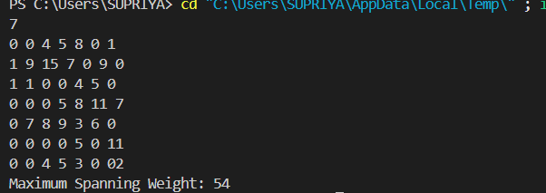

WEEK 9
Q1. program to implement Floyd- Warshall all pair shortest path algorithm.
NAME: - SUPRIYA RAWAT
SECTION: - I2
ROLL NO.: - 117

#include <iostream>
#include <vector>
#include <string>
using namespace std;

#define INF 1000000000 // Large number for infinity

int main() {
int V;
cout << "Enter number of vertices: ";
cin >> V;

vector<vector<int>> dist(V, vector<int>(V));
cout << "Enter the adjacency matrix (use INF for no direct edge):\n";

for (int i = 0; i < V; i++) {
for (int j = 0; j < V; j++) {
string val;
cin >> val;
if (val == "INF")
dist[i][j] = INF;
else
dist[i][j] = stoi(val);
}
}

// Floyd-Warshall Algorithm
for (int k = 0; k < V; k++) {
for (int i = 0; i < V; i++) {
for (int j = 0; j < V; j++) {
if (dist[i][k] < INF && dist[k][j] < INF)
dist[i][j] = min(dist[i][j], dist[i][k] + dist[k][j]);
}
}
}

// Output the shortest distance matrix
cout << "\nShortest Distance Matrix:\n";
for (int i = 0; i < V; i++) {
for (int j = 0; j < V; j++) {
if (dist[i][j] == INF)
cout << "INF ";
else
cout << dist[i][j] << " ";
}
cout << endl;
}

return 0;
}

OUTPUT: 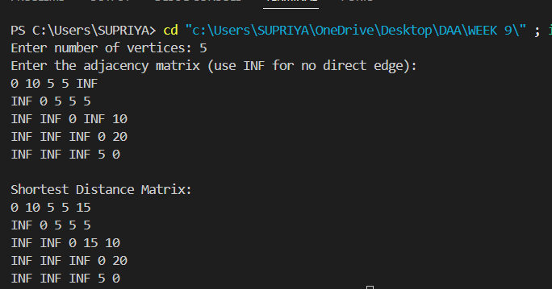

Q2. Design an algorithm and implement it using a program to find the list of the selected items such that the final selected content has weight w and has maximum value.
NAME: - SUPRIYA RAWAT
SECTION: - I2
ROLL NO.: - 117

#include <iostream>
#include <vector>
#include <algorithm>
using namespace std;

struct Item {
int index;
double value, weight;
double ratio;

Item(int i, double v, double w) {
index = i;
value = v;
weight = w;
ratio = v / w;
}
};

// Custom comparator to sort by value/weight ratio
bool cmp(Item a, Item b) {
return a.ratio > b.ratio;
}

int main() {
int n;
cout << "Enter number of items: ";
cin >> n;

vector<double> weights(n), values(n);
cout << "Enter weights:\n";
for (int i = 0; i < n; i++) cin >> weights[i];

cout << "Enter values:\n";
for (int i = 0; i < n; i++) cin >> values[i];

double capacity;
cout << "Enter knapsack capacity: ";
cin >> capacity;

vector<Item> items;
for (int i = 0; i < n; i++) {
items.push_back(Item(i + 1, values[i], weights[i])); // index from 1
}

sort(items.begin(), items.end(), cmp);

double totalValue = 0.0;
vector<pair<int, double>> selectedItems;

for (auto item : items) {
if (capacity == 0) break;

if (item.weight <= capacity) {
// Take full item
totalValue += item.value;
capacity -= item.weight;
selectedItems.push_back({item.index, item.weight});
} else {
// Take fraction
double frac = capacity / item.weight;
totalValue += item.value * frac;
selectedItems.push_back({item.index, capacity});
capacity = 0;
}
}

// Output
cout << "Maximum value : " << totalValue << endl;
cout << "item-weight\n";
for (auto x : selectedItems) {
cout << x.first << "-" << x.second << endl;
}

return 0;
}

OUTPUT: 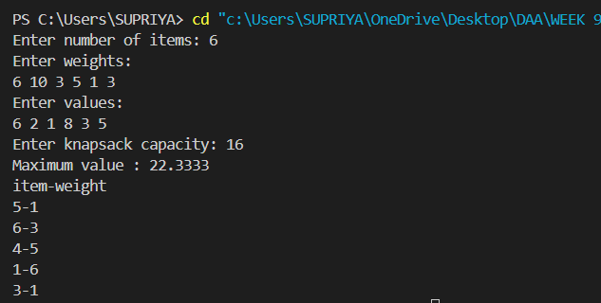

Q3. Given an array of elements. Assume arr[i] represents the size of file i. Write an algorithm and a program to merge all these files into single file with minimum computation. For given two files A and B with sizes m and n, computation cost of merging them is O(m+n). (Hint: use greedy approach)
NAME: - SUPRIYA RAWAT
SECTION: - I2
ROLL NO.: - 117

#include <iostream>
#include <vector>
#include <queue>
using namespace std;

int minMergeCost(vector<int>& files) {
priority_queue<int, vector<int>, greater<int>> minHeap;

for (int file : files) {
minHeap.push(file);
}

int totalCost = 0;

while (minHeap.size() > 1) {
int first = minHeap.top(); minHeap.pop();
int second = minHeap.top(); minHeap.pop();

int merged = first + second;
totalCost += merged;

minHeap.push(merged);
}

return totalCost;
}

int main() {
int n;
cout << "Enter number of files: ";
cin >> n;

vector<int> files(n);
cout << "Enter file sizes:\n";
for (int i = 0; i < n; ++i) {
cin >> files[i];
}

int result = minMergeCost(files);
cout << "Minimum computation cost: " << result << endl;

return 0;
}

OUTPUT:
