1. Write a Java program to take input as a command-line argument. Your name, course, university roll number, and semester. Display the information in the following format:
Name:
University Roll No:
Course:
Semester:

public class CommandLineInput {
public static void main(String[] args) {
if (args.length < 4) {
System.out.println("Please provide Name, University Roll No, Course, and Semester.");
return;
}

String name = args[0];
int rollNo = Integer.parseInt(args[1]); // Convert string to integer
String course = args[2];
int semester = Integer.parseInt(args[3]); // Convert string to integer

System.out.println("Name: " + name);
System.out.println("University Roll No: " + rollNo);
System.out.println("Course: " + course);
System.out.println("Semester: " + semester);
}
}
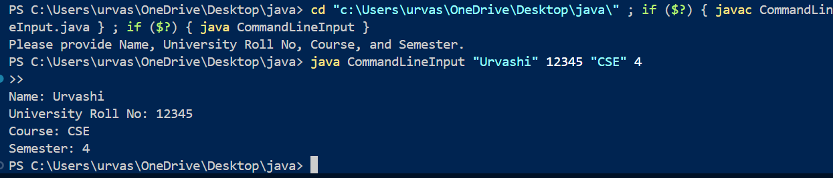

2. Using the switch statement, write a menu-driven program to calculate the maturity amount of a bank deposit.
The user is given two options:
(i) Term Deposit
(ii) Recurring Deposit
- For option (i): Accept Principal (p), rate of interest (r), and time period in years (n).
  - Calculate and output the maturity amount (a) using the formula: a=p(1+r/100)na = p(1 + r / 100)^na=p(1+r/100)n
- For option (ii): Accept monthly installment (p), rate of interest (r), and time period in months (n).
  - Calculate and output the maturity amount (a) using the formula: a=p×n+p×n×(n+1)×r/100×1/12a = p \times n + p \times n \times (n + 1) \times r / 100 \times 1 / 12a=p×n+p×n×(n+1)×r/100×1/12
- If the user enters an incorrect option, an appropriate error message should be displayed.
[ Use Scanner Class to take input ]

import java.util.Scanner;

public class BankDepositCalculator {
public static void main(String[] args) {
Scanner sc = new Scanner(System.in);

System.out.println("Choose Deposit Type:");
System.out.println("1. Term Deposit");
System.out.println("2. Recurring Deposit");
int choice = sc.nextInt();

switch (choice) {
case 1:
// Term Deposit Calculation
System.out.print("Enter Principal (p): ");
double p = sc.nextDouble();
System.out.print("Enter Rate of Interest (r): ");
double r = sc.nextDouble();
System.out.print("Enter Time Period in Years (n): ");
int n = sc.nextInt();

double termAmount = p * Math.pow((1 + r / 100), n);
System.out.println("Maturity Amount: " + termAmount);
break;

case 2:
// Recurring Deposit Calculation
System.out.print("Enter Monthly Installment (p): ");
double monthlyP = sc.nextDouble();
System.out.print("Enter Rate of Interest (r): ");
double monthlyR = sc.nextDouble();
System.out.print("Enter Time Period in Months (n): ");
int months = sc.nextInt();

double recurringAmount = (monthlyP * months) + (monthlyP * months * (months + 1) * monthlyR / 100 * 1 / 12) / 2;
System.out.println("Maturity Amount: " + recurringAmount);
break;

default:
System.out.println("Invalid Option! Please select 1 or 2.");
}

sc.close();
}
}
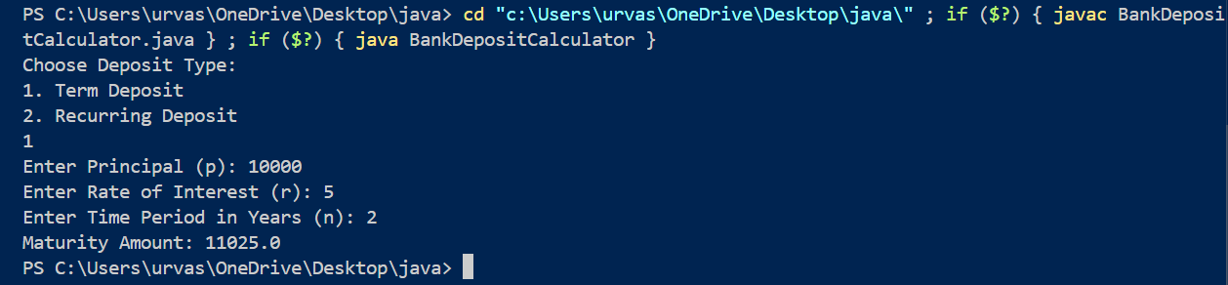

3. Program to find if the given numbers are Friendly Pair or not (Amicable or not). Friendly Pair are two or more numbers with a common abundance.
import java.util.Scanner;

public class FriendlyPair {
static int sumOfDivisors(int num) {
int sum = 0;
for (int i = 1; i <= num / 2; i++) {
if (num % i == 0) {
sum += i;
}
}
return sum;
}

public static void main(String[] args) {
Scanner sc = new Scanner(System.in);

System.out.print("Enter first number: ");
int num1 = sc.nextInt();

System.out.print("Enter second number: ");
int num2 = sc.nextInt();

sc.close();

// Compute sum of divisors
int sum1 = sumOfDivisors(num1);
int sum2 = sumOfDivisors(num2);

// Check friendly pair condition
if (sum1 * num2 == sum2 * num1) {
System.out.println("Friendly Pair");
} else {
System.out.println("Not Friendly Pair");
}
}
}
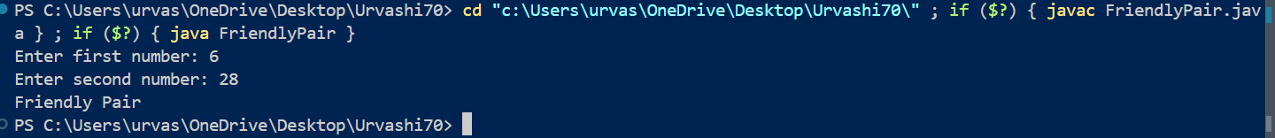

4. Program to replace all 0's with 1 in a given integer. Given an integer as an input, all the 0's in the number have to be replaced with 1.
import java.util.Scanner;

class ReplaceZero {
public static void main(String[] args) {
Scanner sc = new Scanner(System.in);
System.out.println("Enter an integer:");
int num = sc.nextInt();
sc.close();

int result = replaceZeroWithOne(num);
System.out.println("Output: " + result);
}

public static int replaceZeroWithOne(int num) {
if (num == 0) return 1;

int result = 0, place = 1;
while (num > 0) {
int digit = num % 10;
if (digit == 0) digit = 1;
result += digit * place;
place *= 10;
num /= 10;
}
return result;
}
}

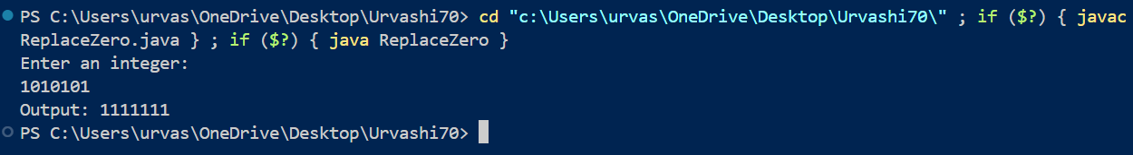

5. Printing an array into Zigzag fashion. Suppose you were given an array of integers, and you are told to sort the integers in a zigzag pattern. In general, in a zigzag pattern, the first integer is less than the second integer, which is greater than the third integer, which is less than the fourth integer, and so on. Hence, the converted array should be in the form of e1 < e2 > e3 < e4 > e5 < e6.
import java.util.*;
public class ZigZagArray {
public static void zigzag(int[] arr) {
int n = arr.length;
boolean flag = true;
for (int i = 0; i < n - 1; i++) {
if (flag) {
if (arr[i] > arr[i + 1]) {
swap(arr, i, i + 1);
}
} else {
if (arr[i] < arr[i + 1]) {
swap(arr, i, i + 1);
}
}
flag = !flag;
}
}

private static void swap(int[] arr, int i, int j) {
int temp = arr[i];
arr[i] = arr[j];
arr[j] = temp;
}

public static void main(String[] args) {
Scanner scanner = new Scanner(System.in);

System.out.print("Enter the number of elements: ");
int n = scanner.nextInt();
int[] arr = new int[n];

System.out.println("Enter the elements:");
for (int i = 0; i < n; i++) {
arr[i] = scanner.nextInt();
}

zigzag(arr);

System.out.println("ZigZag Array: " + Arrays.toString(arr));

scanner.close();
}
}
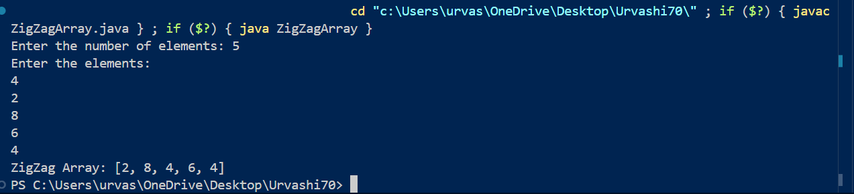

6. Problem: Rearranging Positive and Negative Numbers in an Array
Method:
This approach moves all negative numbers to the beginning and positive numbers to the end, but changes the order of appearance of the elements in the array.
Steps:
- Declare an array and input the array elements.
- Start traversing the array, and if the current element is negative, swap the current element with the first positive element. Continue traversing until all elements have been encountered.
- Print the rearranged array.

import java.util.Scanner;
import java.util.Arrays;

public class RearrangeArray {
public static void rearrange(int[] arr) {
int n = arr.length;
int j = 0;

for (int i = 0; i < n; i++) {
if (arr[i] < 0) {
if (i != j) {
int temp = arr[i];
for (int k = i; k > j; k--) {
arr[k] = arr[k - 1];
}
arr[j] = temp;
}
j++;
}
}
}

public static void main(String[] args) {
Scanner scanner = new Scanner(System.in);

System.out.print("Enter the number of elements: ");
int n = scanner.nextInt();
int[] arr = new int[n];

System.out.println("Enter " + n + " elements:");
for (int i = 0; i < n; i++) {
arr[i] = scanner.nextInt();
}

System.out.println("Original Array: " + Arrays.toString(arr));

rearrange(arr);

System.out.println("Rearranged Array: " + Arrays.toString(arr));

scanner.close();
}
}

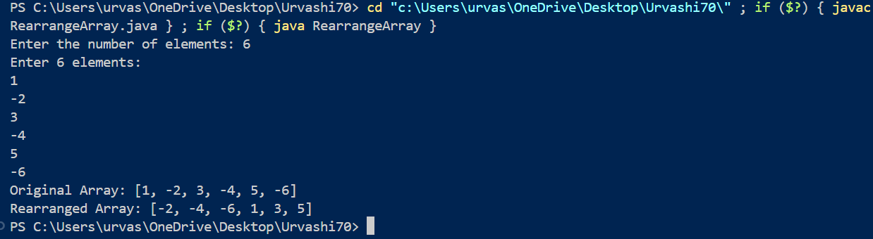

7. Program to find the saddle point coordinates in a given matrix. A saddle point is an element of the matrix, which is the minimum element in its row and maximum element in its column.

import java.util.Scanner;

public class SaddlePoint {
public static void main(String[] args) {
Scanner sc = new Scanner(System.in);

System.out.print("Enter number of rows and columns: ");
int n = sc.nextInt();
int[][] mat = new int[n][n];

System.out.println("Enter the matrix elements:");
for (int i = 0; i < n; i++) {
for (int j = 0; j < n; j++) {
mat[i][j] = sc.nextInt();
}
}
boolean found = false;
for (int i = 0; i < n; i++) {
int minRow = mat[i][0], colIndex = 0;
for (int j = 1; j < n; j++) {
if (mat[i][j] < minRow) {
minRow = mat[i][j];
colIndex = j;
}
}

boolean isSaddle = true;
for (int k = 0; k < n; k++) {
if (mat[k][colIndex] > minRow) {
isSaddle = false;
break;
}
}

if (isSaddle) {
System.out.println("Saddle Point found at (" + i + ", " + colIndex + ") with value: " + minRow);
found = true;
break;
}
}

if (!found) {
System.out.println("No saddle point found.");
}

sc.close();
}
}

