WEEK 14
Q1. Given a number n, write an algorithm and a program to find nth ugly number. Ugly numbers are those numbers whose only prime factors are 2, 3 or 5. The sequence 1, 2, 3, 4, 5, 6, 8, 9, 10, 12, 15, 16, 18, 20, 24,. is sequence of ugly numbers.
NAME: - SUPRIYA RAWAT
SECTION: - I2
ROLL NO.: - 117

#include <iostream>
#include <vector>
#include <algorithm>
using namespace std;

int getUglyNumber(int n) {
vector<int> ugly(n);
ugly[0] = 1;

int i2 = 0, i3 = 0, i5 = 0;
int next2 = 2, next3 = 3, next5 = 5;

for (int i = 1; i < n; ++i) {
int next_ugly = min({next2, next3, next5});
ugly[i] = next_ugly;

if (next_ugly == next2) {
i2++;
next2 = ugly[i2] * 2;
}
if (next_ugly == next3) {
i3++;
next3 = ugly[i3] * 3;
}
if (next_ugly == next5) {
i5++;
next5 = ugly[i5] * 5;
}
}

return ugly[n - 1];
}

int main() {
int T, n;
cin >> T;
while (T--) {
cin >> n;
cout << getUglyNumber(n) << endl;
}
return 0;
}
OUTPUT:-
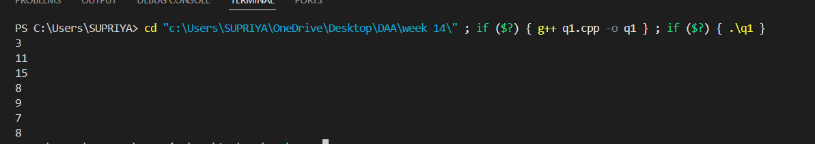

Q2. Given a directed graph, write an algorithm and a program to find mother vertex in a graph. A mother vertex is a vertex v such that there exists a path from v to all other vertices of the graph
NAME: - SUPRIYA RAWAT
SECTION: - I2
ROLL NO.: - 117

#include <iostream>
#include <vector>
#include <stack>
#include <algorithm>

using namespace std;

void DFS(int u, vector<bool>& visited, const vector<vector<int>>& adj) {
stack<int> s;
s.push(u);
visited[u] = true;

while (!s.empty()) {
int current_vertex = s.top();
s.pop();

for (int v : adj[current_vertex]) {
if (!visited[v]) {
visited[v] = true;
s.push(v);
}
}
}
}

int findMotherVertex(int V, const vector<vector<int>>& adj) {
vector<bool> visited(V, false);
int v_last_finished = -1;

for (int i = 0; i < V; ++i) {
if (!visited[i]) {
DFS(i, visited, adj);
v_last_finished = i;
}
}

fill(visited.begin(), visited.end(), false);

DFS(v_last_finished, visited, adj);

for (int i = 0; i < V; ++i) {
if (!visited[i]) {
return -1;
}
}

return v_last_finished;
}

int main() {
int V = 6;
vector<vector<int>> adj(V);
adj[0].push_back(3);
adj[0].push_back(4);
adj[3].push_back(1);
adj[1].push_back(5);
adj[4].push_back(5);
adj[5].push_back(2);
int motherVertex = findMotherVertex(V, adj);
if (motherVertex != -1) {
cout << "The mother vertex is: " << motherVertex << endl;
} else {
cout << "No mother vertex found in the graph." << endl;
}
return 0;
}
OUTPUT:-

