RESULTS REPORT
Model training,
evaluation and findings
What was trained, how it was measured, and what it showed
DM-AHR-ViT · Explainable Vision Transformer for Skin Lesion Classification Using Dermoscopy Images
Research prototype only. Not clinically validated and not intended for diagnosis, triage or patient care.
In one sentence
Across 38 trained models (Original, the 128 px control, DullRazor and the rebuilt diffusion arm Cv2 at eight seeds each; the released checkpoint and our first, failed diffusion run at three) evaluated on a locked test set of 1,502 images, Original scored highest at macro-F1 0.741. Our first diffusion run (0.426) failed because of a training-script defect. After repairing it, retraining and teaching the model with real hair strands, the rebuilt arm Cv2 scored 0.722 ± 0.012, statistically indistinguishable from Original, the 128 px control and classical DullRazor (section 8); only Original over DullRazor is established. DullRazor recovered clean images better than the diffusion arm on synthetic hair and on pasted real strands. The pre-registered check that the rebuilt model removes real hair from photographs was not met, so this study does not show that hair removal helps or hurts classification, and removal on real photographs is supported only by a 12-image visual look and a pasted-strand test.

1. What was trained and how
The first fifteen Vision Transformers (sections 2 to 7) are five input conditions (arms) at three random seeds each; Stage C added three Cv2 runs and Stage E twenty more (section 8). Everything except the arm is identical — same frozen split, same manifests, same architecture, hyperparameters, augmentation and evaluation code — so a difference between arms is attributable to the hair-removal condition alone. Creleased is the authors' released DM-AHR checkpoint run through our pipeline at a 25-step respaced schedule; it was added after the protocol was frozen and is reported as exploratory.
Arm | Input the classifier sees | Macro-F1 (mean ± SD)
A — original | untouched dermoscopy image | 0.750 ± 0.005
B — DullRazor classical | classical hair removal (DullRazor-style) | 0.698 ± 0.009
C — first diffusion run (defective trainer) | diffusion-generated hairless image | 0.426 ± 0.013
A* — 128 px control | original through the same 128 px round-trip | 0.732 ± 0.008
Creleased — released ckpt | released DM-AHR checkpoint, 25-step respaced (exploratory) | 0.713 ± 0.028

Training recipe (identical for every run)
Component | Setting
Backbone | ViT-B/16, ImageNet-1k pretrained, 224 px input, 196 patches
Optimiser | AdamW, lr 3e-5, weight decay 0.05, warm-up 5 epochs then cosine decay
Batch / precision | 32, bf16 autocast, gradient clipping 1.0
Class imbalance | inverse-frequency class weights from the training split only
Early stopping | validation macro-F1, patience 10, max 100 epochs
Seeds | 42, 123, 2026
Test protocol | the locked test set is scored once per frozen checkpoint

Compute environment
All GPU work ran on Modal: NVIDIA A100 80GB PCIe, Python 3.11.12, torch 2.5.1+cu124, CUDA 12.4. A typical training run took about 6.5 minutes (25 epochs to early stopping). Per-run GPU type and wall-clock are logged in artifacts/logs/run_registry.jsonl.
2. Classification results
All metrics are computed on the held-out test set of 1,502 images. Macro-F1 is the primary endpoint because classes are severely imbalanced: nv is two thirds of the data, so plain accuracy rewards ignoring the rare classes.
Arm | Macro-F1 | Accuracy | Balanced acc. | Macro AUC
A — original | 0.750 ± 0.005 | 0.858 ± 0.012 | 0.735 | 0.969
A* — 128 px control | 0.732 ± 0.008 | 0.851 ± 0.006 | 0.726 | 0.969
B — DullRazor classical | 0.698 ± 0.009 | 0.842 ± 0.005 | 0.687 | 0.965
C — first diffusion run (defective trainer) | 0.426 ± 0.013 | 0.685 ± 0.019 | 0.452 | 0.878
Creleased — released ckpt | 0.713 ± 0.028 | 0.848 ± 0.009 | 0.696 | 0.967

Hair-present subset
Arm | Macro-F1 | n
A — original | 0.749 ± 0.002 | 1316
A* — 128 px control | 0.735 ± 0.013 | 1316
B — DullRazor classical | 0.691 ± 0.009 | 1316
C — first diffusion run (defective trainer) | 0.411 ± 0.017 | 1316
Creleased — released ckpt | 0.712 ± 0.029 | 1316

This is the subset where hair removal actually operates — the images it could help. The ordering is unchanged from the full test set.
Per-class test metrics
Class | Arm | Support | F1 | Recall (sensitivity) | Specificity | AUC
akiec | A | 49 | 0.625 | 0.694 | 0.982 | 0.956
 | B | 49 | 0.589 | 0.639 | 0.982 | 0.947
 | C | 49 | 0.286 | 0.408 | 0.952 | 0.911
 | Astar | 49 | 0.556 | 0.673 | 0.974 | 0.961
 | Creleased | 49 | 0.562 | 0.633 | 0.979 | 0.954
bcc | A | 77 | 0.750 | 0.706 | 0.991 | 0.975
 | B | 77 | 0.724 | 0.740 | 0.984 | 0.979
 | C | 77 | 0.315 | 0.290 | 0.971 | 0.881
 | Astar | 77 | 0.747 | 0.719 | 0.989 | 0.982
 | Creleased | 77 | 0.726 | 0.736 | 0.984 | 0.976
bkl | A | 165 | 0.676 | 0.644 | 0.967 | 0.955
 | B | 165 | 0.628 | 0.590 | 0.965 | 0.947
 | C | 165 | 0.356 | 0.461 | 0.863 | 0.791
 | Astar | 165 | 0.677 | 0.630 | 0.971 | 0.949
 | Creleased | 165 | 0.692 | 0.679 | 0.965 | 0.946
df | A | 17 | 0.733 | 0.706 | 0.998 | 0.987
 | B | 17 | 0.591 | 0.529 | 0.997 | 0.978
 | C | 17 | 0.140 | 0.137 | 0.990 | 0.863
 | Astar | 17 | 0.719 | 0.627 | 0.999 | 0.985
 | Creleased | 17 | 0.620 | 0.471 | 1.000 | 0.980
mel | A | 167 | 0.634 | 0.615 | 0.959 | 0.939
 | B | 167 | 0.561 | 0.529 | 0.957 | 0.935
 | C | 167 | 0.400 | 0.373 | 0.939 | 0.820
 | Astar | 167 | 0.613 | 0.611 | 0.952 | 0.925
 | Creleased | 167 | 0.609 | 0.617 | 0.949 | 0.936
nv | A | 1006 | 0.943 | 0.956 | 0.855 | 0.981
 | B | 1006 | 0.942 | 0.958 | 0.844 | 0.980
 | C | 1006 | 0.871 | 0.827 | 0.855 | 0.922
 | Astar | 1006 | 0.943 | 0.949 | 0.872 | 0.982
 | Creleased | 1006 | 0.942 | 0.941 | 0.884 | 0.980
vasc | A | 21 | 0.889 | 0.825 | 1.000 | 0.991
 | B | 21 | 0.853 | 0.825 | 0.998 | 0.991
 | C | 21 | 0.615 | 0.667 | 0.993 | 0.955
 | Astar | 21 | 0.868 | 0.873 | 0.998 | 0.999
 | Creleased | 21 | 0.840 | 0.794 | 0.999 | 0.994

Recall is the proposal's sensitivity. Supports for df (17) and vasc (21) are small, so their per-class numbers are noisy and are not interpreted individually.
3. Hair-removal image quality
Measured on the 186 held-out synthetic pairs — hair composited onto genuinely hair-absent images, so a true hairless reference exists. The unprocessed hairy input is scored as a floor: falling below it means the method made the image worse than doing nothing.
Condition | PSNR (dB) mean ± SD | SSIM mean ± SD
Hairy input (floor) | 22.13 ± 1.90 | 0.520 ± 0.093
Arm B — classical | 35.73 ± 2.11 | 0.918 ± 0.023
Creleased — released ckpt | 27.08 ± 2.63 | 0.703 ± 0.094
Arm C — diffusion | 14.29 ± 1.09 | 0.074 ± 0.006

Why Arm C scores below the untouched input — a training-script defect
An earlier version of this report called the checkpoint undertrained; that diagnosis is retracted. Our training script fed the network t/T as the noise level while the sampler feeds sqrt(alphas_cumprod_prev), and the two run in opposite directions. On 50 validation pairs the released checkpoint prefers the sampler's encoding at every timestep tested (2.9× to 20.5× lower error) and ours prefers t/T (about 10× lower), so more iterations of the old script could not have fixed it. Arm C as reported measures a defective training run and says nothing about DM-AHR as published. The script is now fixed; a retrain on validation pairs still failed full 2,000-step sampling (14.96 dB against a 21.30 dB hairy-input floor, 24 pairs) and was stopped on cost at 56,300 of a planned 100,000 iterations. See reports/oneshot_diagnostic_report.md.

Does any arm remove real hair? Not cleanly
Every image-quality number above is measured on synthetic hair overlays. A separate check on 40 hairy training images with real hair (test set not used; artifacts/diagnosis/real_hair_check.json) found that the released DM-AHR model leaves real hair in place: it changes hair pixels about as much as other pixels (ratio 1.13, against 21.7 for DullRazor), and the strands are visibly intact in the contact sheet. Our DullRazor arm does remove hair, but in all 8 images reviewed it replaced lesion and skin texture with blocky patches, and in one it erased the whole lesion; the likely cause is our frozen detector and inpainting settings. So neither arm cleanly removed real hair, and the classification comparison does not test whether hair removal helps. One control in that check failed (the hair-coverage measure, now void); the conclusion rests on the change ratio, whose control passed. See reports/hair_check_prereg.md.

4. Explainability
For every test image, two saliency methods — Grad-CAM on the patch grid and attention roll-out — were compared against the released HAM10000 lesion mask. The table reports the fraction of the top-20% most salient pixels that fall inside the mask, averaged over seeds, with the two chance baselines for context.
Arm | Grad-CAM overlap | Roll-out overlap | Grad-CAM pointing | Roll-out pointing | Uniform chance | Gaussian chance
A — original | 0.363 | 0.555 | 0.468 | 0.842 | 0.200 | 0.644
A* — 128 px control | 0.404 | 0.577 | 0.536 | 0.858 | 0.200 | 0.644
B — DullRazor classical | 0.388 | 0.586 | 0.494 | 0.876 | 0.200 | 0.644
C — first diffusion run (defective trainer) | 0.412 | 0.337 | 0.617 | 0.242 | 0.200 | 0.644
Creleased — released ckpt | 0.382 | 0.568 | 0.524 | 0.878 | 0.200 | 0.644

Overlap measures spatial alignment with released masks, not clinically correct reasoning. Every arm beats uniform chance, but a centred-Gaussian prior scores 0.644 on overlap and 0.953 on the pointing game, exceeding every arm on both measures. No arm therefore beats a trivial attend-to-the-centre baseline, and these numbers do not establish that any arm localises lesions better than that prior. The masks themselves are single-rater: a dermatologist (Tschandl P) created binary masks for all 10,015 images, network-initialised and then verified, corrected or replaced by hand in FIJI (Tschandl et al., Nature Medicine 2020), so overlap is measured against one tracing, not consensus.
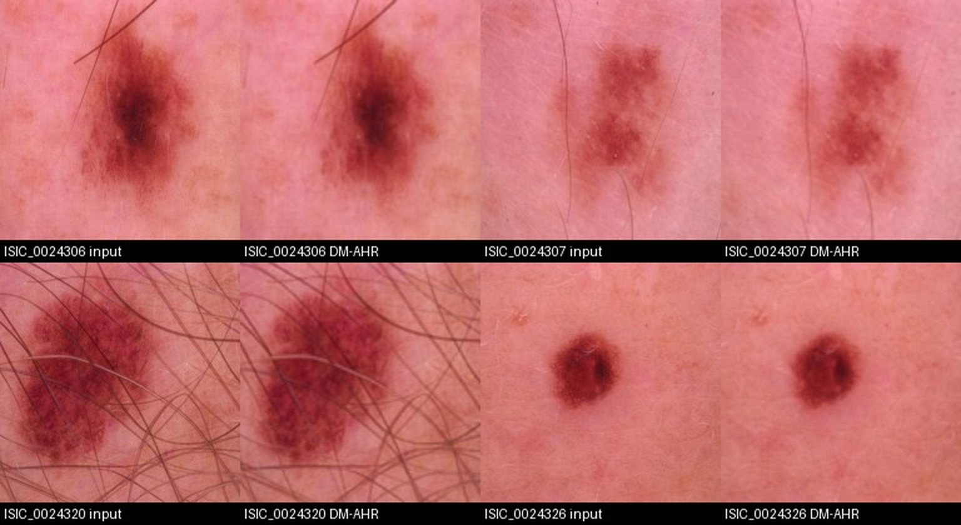
Figure 1 — Arm C diffusion removal, from the preprocessing report, reproduced here because the same failed hair-removal output drives both its quality scores and its classification deficit.
5. Statistical comparisons
Every endpoint is tested twice, as the protocol requires: a lesion-group bootstrap (10,000 replicates, the same resample shared across arms and seeds, percentile 95% CI) and a Wilcoxon signed-rank test on values collapsed to one per lesion group. For the classification endpoint the per-group value is that group's mean per-image correctness, so the Wilcoxon test asks whether the arms differ in per-lesion accuracy — it is not a test of macro-F1 itself, and the column header says so. Holm correction is applied across the three planned comparisons within each endpoint, separately for each test; A–A* is a secondary control in its own family and cannot inflate the planned family. A CI spanning zero is called inconclusive, not 'no difference'.
Endpoint | Comparison | Diff. | 95% CI (bootstrap) | p (Holm) | Wilcoxon p (per-group acc.) | Groups
paired_psnr | B-hairy input | +13.604 | +13.261 to +13.943 | <0.0001 | <0.0001 | 186
paired_psnr | C-B | -21.441 | -21.768 to -21.106 | <0.0001 | <0.0001 | 186
paired_psnr | C-hairy input | -7.838 | -8.088 to -7.592 | <0.0001 | <0.0001 | 186
paired_ssim | B-hairy input | +0.398 | +0.385 to +0.410 | <0.0001 | <0.0001 | 186
paired_ssim | C-B | -0.843 | -0.847 to -0.840 | <0.0001 | <0.0001 | 186
paired_ssim | C-hairy input | -0.446 | -0.459 to -0.433 | <0.0001 | <0.0001 | 186
test_macro_f1 | A-Astar | +0.018 | -0.008 to +0.045 | 0.1668 | 0.0739 | 1437
test_macro_f1 | A-B | +0.052 | +0.019 to +0.087 | 0.0012 | 0.0113 | 1437
test_macro_f1 | A-C | +0.324 | +0.283 to +0.366 | <0.0001 | <0.0001 | 1437
test_macro_f1 | B-C | +0.272 | +0.225 to +0.320 | <0.0001 | <0.0001 | 1437
test_macro_f1 | C-Astar | -0.306 | -0.348 to -0.265 | <0.0001 | <0.0001 | 1437
test_macro_f1 | A-Astar | +0.014 | -0.014 to +0.041 | 0.3218 | 0.0800 | 1251
test_macro_f1 | A-B | +0.058 | +0.022 to +0.095 | 0.0008 | 0.0058 | 1251
test_macro_f1 | A-C | +0.337 | +0.291 to +0.383 | <0.0001 | <0.0001 | 1251
test_macro_f1 | B-C | +0.279 | +0.224 to +0.333 | <0.0001 | <0.0001 | 1251
test_macro_f1 | C-Astar | -0.324 | -0.370 to -0.279 | <0.0001 | <0.0001 | 1251
x1_gradcam_overlap20 | A-B | -0.027 | -0.039 to -0.017 | <0.0001 | <0.0001 | 1437
x1_gradcam_overlap20 | A-C | -0.053 | -0.065 to -0.040 | <0.0001 | <0.0001 | 1437
x1_gradcam_overlap20 | B-C | -0.025 | -0.037 to -0.013 | 0.0002 | <0.0001 | 1437
x1_rollout_overlap20 | A-B | -0.032 | -0.034 to -0.029 | <0.0001 | <0.0001 | 1437
x1_rollout_overlap20 | A-C | +0.217 | +0.208 to +0.226 | <0.0001 | <0.0001 | 1437
x1_rollout_overlap20 | B-C | +0.249 | +0.239 to +0.258 | <0.0001 | <0.0001 | 1437

Exploratory: released-checkpoint arm
These rows are not part of the pre-registered family. Creleased uses the authors' released DM-AHR checkpoint at a 25-step respaced schedule, a deviation from the paper's 2,000 steps, and its classifier was trained on our budget. Holm correction is applied within this exploratory family only.
Endpoint | Comparison | Diff. | 95% CI (bootstrap) | p (Holm) | Cohen's dz | Groups
paired_psnr | Creleased-B | -8.657 | -9.063 to -8.254 | <0.0001 | -3.073 | 186
paired_psnr | Creleased-hairy input | +4.946 | +4.503 to +5.388 | <0.0001 | +1.639 | 186
paired_ssim | Creleased-B | -0.215 | -0.228 to -0.204 | <0.0001 | -2.558 | 186
paired_ssim | Creleased-hairy input | +0.182 | +0.166 to +0.199 | <0.0001 | +1.595 | 186
test_macro_f1 | A-Creleased | +0.038 | +0.005 to +0.071 | 0.0476 | +0.053 | 1437
test_macro_f1 | B-Creleased | -0.015 | -0.049 to +0.019 | 0.4004 | -0.011 | 1437
test_macro_f1 | A-Creleased | +0.037 | +0.002 to +0.073 | 0.0768 | +0.060 | 1251
test_macro_f1 | B-Creleased | -0.021 | -0.057 to +0.016 | 0.2614 | -0.016 | 1251

6. What this says about the three hypotheses
H1 — image quality (diffusion preserves texture better than classical):
- PSNR: B higher than C (C - B = -21.441, 95% CI -21.768 to -21.106). SSIM: B higher than C (C - B = -0.843, 95% CI -0.847 to -0.840). H1 is not supported by these data. Arm C's SSIM is near-constant across all 186 pairs (0.074 ± 0.006, with 186 below 0.15), which is what the inverted noise-level signal in our training script produces. The released checkpoint was then scored through the same adapter (Creleased): it clears the hairy-input floor by 4.95 dB but sits 8.66 dB below classical inpainting, so H1 is now tested for DM-AHR and is not supported.
H2 — classification (diffusion-cleaned images improve the ViT):
- A vs C: A higher than C (A - C = +0.324, 95% CI +0.283 to +0.366). B vs C: B higher than C (B - C = +0.272, 95% CI +0.225 to +0.320). The direction is opposite to the hypothesis and the gap is large. The released checkpoint does not rescue it: A vs Creleased is +0.038 (95% CI +0.005 to +0.071, Holm p=0.048, negligible effect) and B vs Creleased is inconclusive (-0.015, CI -0.049 to +0.019, Holm p=0.400).
- A vs B: A higher than B (A - B = +0.052, 95% CI +0.019 to +0.087). This must not be read as evidence that hair removal hurts classification: the real-hair check shows our frozen DullRazor settings damage lesions, so the gap is confounded with image damage and was not separated from it.
H3 — explainability (attention focuses more on lesions after diffusion):
- Grad-CAM overlap, A vs C: C higher than A (A - C = -0.053, 95% CI -0.065 to -0.040). Attention roll-out, A vs C: A higher than C (A - C = +0.217, 95% CI +0.208 to +0.226). The methods disagree in direction, but H3 is not supported and the measurement is uninformative as specified: a centred-Gaussian prior beats every arm on both overlap (0.644) and pointing (0.953), so no arm demonstrates lesion localisation beyond a centre bias. That is a limitation of the measurement, not a finding about diffusion hair removal, and it must be fixed before H3 can be tested.
Resolution control:
- A vs A*: inconclusive (A - A* 95% CI -0.008 to +0.045). Because this is inconclusive, the 128 px round-trip alone does not explain Arm C's deficit.
7. Limitations
- Arm C is a failed replication, caused by a training-script defect — Our script gave the network an inverted noise-level signal (t/T instead of the sampler's sqrt(alphas_cumprod_prev)), so the model ran 20,000 iterations learning the wrong mapping; it was also sampled at 1,000 steps against 2,000 and upsampled from 128 px to 224. The upstream config's n_iter is 660,000 and the released checkpoint is named I725000_E1083. The fixed script, sampled from pure noise at the budgets tried, did not give usable output; the partial-noise sampler used for Cv2 did. Arm C's results describe that defective run, not the published method. The rebuilt arm Cv2 (section 8) is the fair test of the method.
- Arm B damages lesions on real hair — On 8 real-hair training images reviewed, our frozen DullRazor settings replaced lesion and skin texture with blocky inpainting patches, and in one image erased the lesion (a dark lesion and marker ink were read as hair). The A-versus-B difference is therefore confounded and is not evidence about hair removal in general. Re-tuning the arm on training and validation images would address it; that was not done.
- The released diffusion model leaves real hair — It reproduces synthetic hair removal well, which is what it was trained on, but on 40 real-hair training images it left the hair in place. Creleased is therefore close to 'the original at 128 px' and is not a test of hair removal.
- Creleased is exploratory, not pre-registered — It uses the authors' released checkpoint at a 25-step respaced schedule, a deviation from the paper's 2,000 steps, and the routine that produced those images is not reproducible from committed code. Its classifier was trained on our budget rather than the paper's. The paper states the model was trained on HAM10000 images other than a 700-image test set, so it very probably saw our validation and test images (no labels were used). Its comparisons are reported in their own Holm family and must not be read as pre-registered results.
- Seeds — the intervals in sections 2 to 7 resample ~1,437 lesion groups with the three seeds held fixed, so they leave out training-seed variance, and the three-seed SDs turned out to be misleading (section 8). Section 8 adds eight seeds and a two-level bootstrap for the four arms that matter; even so the design resolves only differences of about 0.04 to 0.05, limited by the test sample.
- Screening unvalidated — the proposal specifies the manually annotated hair masks of Lama et al. (ChimeraNet) as an independent reference for screening quality, and those masks were not obtained. This is a skipped step, not a gap in the data. The threshold was calibrated on synthetic pairs and frozen, which protects the test set but does not validate the detector on real hair. The 89.8% screening prevalence is reported as a limitation.
- Masks are single-rater — the HAM10000 segmentations were created by one dermatologist (Tschandl P), network-initialised and then verified, corrected or replaced by hand in FIJI (Tschandl et al., Nature Medicine 2020). No inter-rater agreement is available, so explanation overlap is measured against one tracing.
- Single corpus — one public dataset; nothing here establishes behaviour on other scanners or populations.
- Licensing unresolved — HAM10000 is CC BY-NC 4.0; the DM-AHR repository's README (CC BY-NC 4.0) and LICENSE (Apache-2.0) contradict each other. Commercial use needs a rights decision.
8. Stage C and Stage E: the rebuilt diffusion arm (Cv2) and the review response
The first diffusion run (arm C) failed because of the training defect described above. The trainer was repaired and the model retrained. A partial-noise sampler (start from the noised input at level 600 of 2,000, 50 strided DDIM steps) replaced sampling from pure noise, and the model was fine-tuned for 20,000 iterations on real hair strands harvested from train-split photos and pasted onto clean train-split photos. The procedure, checkpoint hash, sampler and endpoints were written down before any test-split use of the new model (reports/protocol_addendum_stageC.md); each of the three Cv2 classifiers was evaluated once on the test split. After an independent review, Stage E (reports/prereg_v4_review_response.md) added five seeds for four arms, a corrected statistical analysis that includes training-seed variance, and several validation-only checks.
Classification (eight seeds per arm; test macro-F1, mean ± SD over seeds)
Arm | Full test (n=1,502) | Hair-present (n=1,316)
A — original | 0.741 ± 0.024 | 0.743 ± 0.020
A* — 128 px control | 0.728 ± 0.020 | 0.728 ± 0.022
B — DullRazor classical | 0.693 ± 0.017 | 0.688 ± 0.019
Cv2 — rebuilt diffusion | 0.722 ± 0.012 | 0.719 ± 0.012
Creleased — released ckpt | 0.713 ± 0.028 (3 seeds) | 0.712 ± 0.029 (3 seeds)
C — first diffusion run (defective trainer) | 0.426 ± 0.013 (3 seeds) | 0.411 ± 0.017 (3 seeds)

- A vs B: +0.048 (95% CI +0.012 to +0.085, planned); Holm p 0.008; with seeds held fixed the interval would have been +0.022 to +0.075.
- A vs A* (resolution control): +0.013 (95% CI -0.019 to +0.047, secondary_control); Holm p 0.411; with seeds held fixed the interval would have been -0.008 to +0.035.
- A vs Cv2: +0.019 (95% CI -0.013 to +0.054, exploratory); Holm p 0.498; with seeds held fixed the interval would have been -0.004 to +0.044.
- B vs Cv2: -0.028 (95% CI -0.059 to +0.002, exploratory); Holm p 0.194; with seeds held fixed the interval would have been -0.052 to -0.006.
- Cv2 vs A* (resolution control): -0.006 (95% CI -0.034 to +0.021, exploratory); Holm p 0.671; with seeds held fixed the interval would have been -0.024 to +0.011.
Only the original-over-DullRazor difference is established, and DullRazor damages lesions on real photos, so it says little about hair removal in general. The intervals resample lesion groups and training seeds. The minimum detectable difference is 0.04 to 0.05 (80% power), set mainly by the size of the test sample, so this design cannot resolve a 0.02 difference whatever the seed count. All Cv2 rows are exploratory because Cv2 was designed after the Stage B gate failed. Standardised effect sizes for macro-F1 are not reported because the earlier ones were not interpretable; per-image log-loss shows no established difference either (pooled_seed_analysis.csv).
Image quality on the 186 synthetic test pairs
Input | PSNR (dB) | SSIM
Hairy input | 22.13 | 0.520
B — DullRazor | 35.73 | 0.918
Cv2 — rebuilt diffusion | 29.18 | 0.861
Creleased (its own sampler) | 27.08 | 0.703

Cv2 improves on the hairy input by +7.05 dB (95% CI +6.89 to +7.21) but is -6.55 dB against DullRazor (CI -6.91 to -6.19). The fidelity hypothesis is not supported on these pairs. The synthetic hair is simple dark curves that the detector finds exactly, DullRazor repairs only those pixels, and the diffusion model regenerates the whole 128 px image and loses fine detail. The pairs say nothing about real hair.
Explanation overlap (X1 subset; top 20% attention inside the lesion)
Arm | Grad-CAM overlap | Rollout overlap
A — original | 0.364 | 0.558
A* — 128 px control | 0.406 | 0.580
B — DullRazor classical | 0.391 | 0.589
Cv2 — rebuilt diffusion | 0.410 | 0.604

Against the resolution-matched control A*, Grad-CAM overlap does not differ (+0.004, CI -0.006 to +0.014), so the gain over A comes from the 128 px resolution. Rollout overlap is higher by +0.024 (CI +0.022 to +0.026), a small gain whose interval leaves out seed-to-seed variation; Cv2 exceeds A* in two of three seeds. The A* rows were added to the statistics after the planned rows had been seen. These are three-seed numbers: arm A's Grad-CAM overlap ranges from 0.22 to 0.44 across seeds, and every arm is below the centred-Gaussian baseline of 0.644 for both methods, so no between-arm claim is drawn from them.
Checks added after the independent review (validation data only)
Pasted real strands, 96 validation composites | PSNR (dB) | Strand removal | Lesion pixels changed | Skin pixels changed
Hairy input | 25.59 | 0.000 | 0.0% | 0.0%
B - DullRazor | 40.31 | 0.905 | 5.9% | 1.0%
Cv2 - rebuilt diffusion | 33.86 | 0.787 | 18.3% | 17.8%

Lesion and skin pixels changed are measured only where the hair did not cover them, so any change there is damage. Cv2 minus DullRazor, paired: PSNR -6.45 dB (95% CI -7.34 to -5.62), strand removal -0.118, lesion pixels changed +12.4 points. DullRazor is better on every measure here. The composite targets are the cleanest photos, so this does not show how DullRazor behaves on photos with ink or dense hair.
- Lesion change on real photos — on 52 real validation photos DullRazor changed 25.1% of lesion pixels and Cv2 10.9% (hair crossing the lesion counts as change for both).
- Residual hair — the pre-registered rule for a train/test asymmetry fired, but untrained DullRazor shows the same gap, so the rule is confounded by which photos are harvested. A post-hoc comparison with validation photos meeting the same harvest criterion shows the train photos keep slightly more hair, not less.
- Use of the conditioning image — all four models use the hairy input at noise levels up to 1000; at 1500 the released model still does and the repaired models barely do (error ratio with the input zeroed: 2.6 to 4.2 against 1.1 to 1.45).
What is and is not validated
- Gate not met — the Stage B gate for removing hair from real photographs was not met (inside/outside ratio 1.95 and 1.57 against 2.0; follow-up composite rule 0.14 and 0.15 against 0.20). Stage C ran anyway as a recorded deviation (decision D34).
- What supports removal on photographs — an agent-reviewed look at 12 dense-hair validation photos shows nearly all hair removed with lesion outline and colour kept and fine texture lost; the ground-truth test on pasted real strands removes 77% of strand error at t0=600. This is supporting evidence, not a passed pre-registered test. A blinded human review kit (50 photos) is built and awaits a person's ratings.
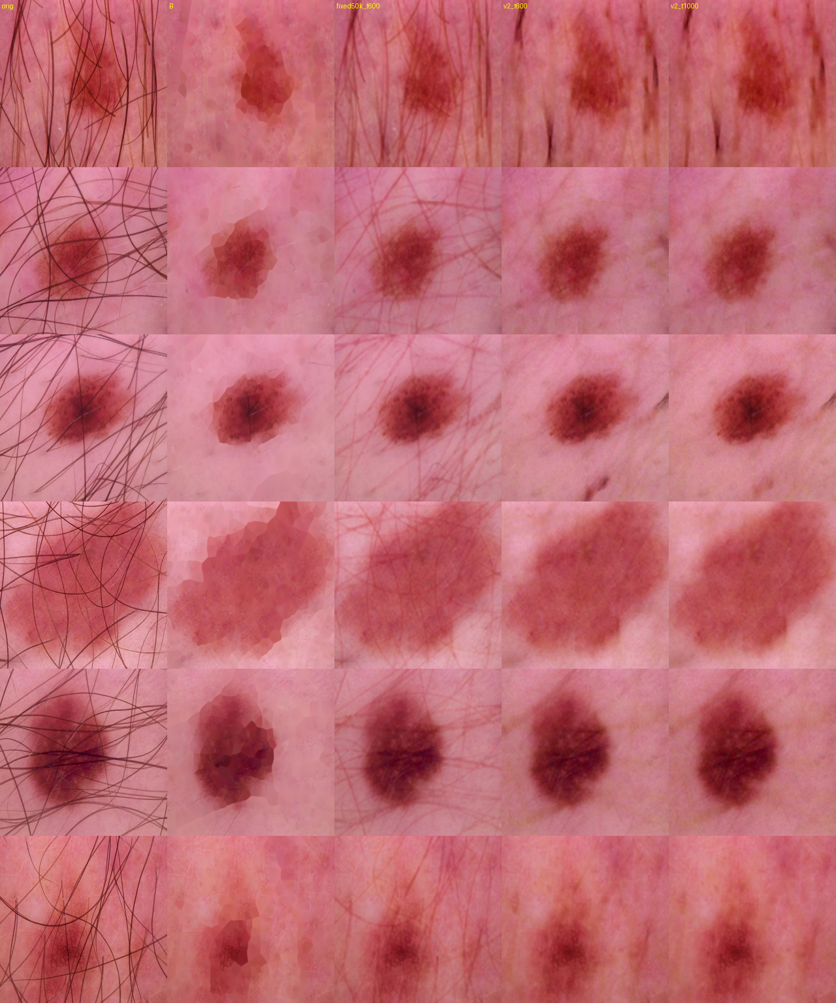
Validation photos with dense hair. Columns: original, DullRazor, first fixed model, rebuilt model at t0=600, rebuilt model at t0=1000 (128 px, agent-reviewed).
9. Reproducibility
- Determinism — Arm A seed 42 re-run from scratch reproduced validation macro-F1 exactly (0.778336 vs 0.778336).
- Portability — the frozen split hash was reproduced byte for byte across two Modal accounts, and the full data-preparation chain was re-run natively with no Modal present, giving the identical hash.
- How to explore — notebooks/01_results_walkthrough.ipynb reads the committed artifacts and explains these tables interactively; notebooks/02 and 03 reproduce the pipeline on Modal or a local GPU.
Every table here is generated from artifacts/logs/: classification_seed_summary.csv, classification_per_class.csv, paired_psnr_ssim_test.csv, xai_localization_*.csv and statistical_comparisons.csv. This document is built by scripts/14_results_report.py and can be regenerated after any rerun.

