DATA PREPROCESSING REPORT
Preparation of the HAM10000
dermoscopy corpus
What was done to the data, in what order, and what changed
DM-AHR-ViT · Explainable Vision Transformer for Skin Lesion Classification Using Dermoscopy Images
Research prototype only. Not clinically validated and not intended for diagnosis, triage or patient care.

Stage | Images | What it means
Collection as received | 11,720 | everything downloadable from ISIC collection 212
After cohort + integrity cleaning | 10,015 | the confirmatory HAM10000 cohort used for all results
Quarantined | 1,705 | extra images with no usable label; never enter a split
Lesion groups after deduplication | 7,470 | the unit that gets split and counted

In one sentence
The corpus starts as 11,720 JPEG images of identical geometry and is cleaned down to 10,015 labelled images forming 7,470 lesion groups. Cleaning removes 1,705 unlabelled extras, merges 21 confirmed near-duplicate pairs, and produces four matched input variants plus 1,022 synthetic evaluation pairs.

Contents
1. The raw data, before anything is done what arrived, and its verified properties
2. The preprocessing pipeline, step by step the eight steps in order, with their outputs
3. Before and after, in numbers counts, classes, geometry and file sizes
4. Visual before-and-after screening, classical removal, diffusion removal
5. What cleaning changed and what it cost the effects, good and bad
6. What happens at training time, not in advance resizing, normalisation, augmentation
7. Limitations what this preprocessing does not establish
8. How to reproduce commands and where the evidence lives
1. The raw data, before anything is done
The starting point is the client's ISIC Archive collection 212. Every image the collection exposes was downloaded and then measured, rather than assumed: file size, pixel dimensions, colour mode, encoding and a SHA-256 checksum were recorded per file. The table below describes the corpus exactly as received.
Property | Value | How it was established
Images downloaded | 11,720 | collection listing, cursor-paged to exhaustion
Pixel dimensions | 600×450 | identical for all 11,720 images
Colour mode | RGB | verified per file
Encoding | JPEG | verified per file
Decode status | 11,720 of 11,720 ok | every file opened successfully
Median file size | 26,599 bytes | confirmatory cohort
Images with a diagnosis label | 10,015 | present in HAM10000 metadata
Images without a label | 1,705 | not in HAM10000 metadata

Two facts here shape everything that follows. First, the collection is larger than the 10,015 images the research proposal cites, because collection 212 also exposes images outside the labelled HAM10000 set. Second, the extras carry no diagnosis, so they cannot be trained on or scored — they are not merely redundant, they are unusable for a supervised task.
Important distinction
1,705 extra images are not corrupt or low quality. They are valid dermoscopic photographs that simply have no label in this corpus. They are quarantined rather than deleted, so the decision is reversible and auditable.

2. The preprocessing pipeline, step by step
Preprocessing runs as an ordered chain. Each step reads files, writes new artifacts and records what it did, so any later count can be recomputed from disk. Nothing is performed silently and no image is dropped without a logged reason.
# | Step | Operation | Output
1 | Integrity audit | Open every file; verify decodability, dimensions, bit depth; hash each image | manifest + checksums
2 | Cohort definition | Match against HAM10000 metadata; label the remainder as extras | 10,015 confirmatory
3 | Exact duplicate removal | SHA-256 collision sweep | 0 duplicates found
4 | Near-duplicate detection | dHash candidates, then pixel confirmation on a common grid | 21 pairs confirmed
5 | Lesion grouping | Merge lesion identifiers with confirmed duplicate links | 7,470 groups
6 | Stratified split | 70/15/15 per class, groups never straddling partitions; hash frozen | 10,015 images assigned
7 | Hair screening | Multi-orientation black-hat/top-hat detector, threshold frozen | 8,993 hair-present
8 | Arm construction | Classical removal, 128 px control round-trip, synthetic pairs | four arms + pairs

Why deduplication was done in two stages
A perceptual hash (dHash) proposes candidate duplicates cheaply, but on dermoscopy it is far too permissive: similar skin backgrounds collide, and it proposed 70,062 candidate pairs among 10,015 images. Treating those as duplicates would have merged unrelated patients. Each candidate was therefore re-checked pixel by pixel on a common 96×96 greyscale grid and kept only if mean absolute difference stayed at or below 4/255 and correlation at or above 0.985. 21 pairs survived, which is a plausible number for near-duplicate photographs and a defensible basis for merging lesion groups.
Why the split is by lesion, not by image
HAM10000 contains several photographs of the same lesion in different sessions. If those photographs were scattered across training and test, the model would be asked to recognise a lesion it had already seen, and the test score would measure memorisation rather than generalisation. Splitting at the lesion level — and merging confirmed near-duplicates into the same lesion — makes an honest test set. The split is hashed and frozen before any model is trained, so it cannot be quietly adjusted afterwards.
Why the hair threshold is frozen
The hair detector has tunable thresholds. They were calibrated on training and validation sources only, then frozen before a single test image was processed. Had the threshold been adjusted after seeing how the test set behaved, the test set would have influenced a design choice, and every later result would be contaminated by it.
3. Before and after, in numbers
The comparison below is between the corpus as received and the corpus after cleaning and arm construction. Every figure is recomputed from the manifests, not carried over from the proposal.
Measure | Before | After | Change
Images | 11,720 | 10,015 in cohort | −1,705 quarantined
Usable labels | 10,015 | 10,015 | unchanged
Duplicate pairs merged | 70,062 candidates | 21 confirmed | pixel-verified
Splitting unit | 10,015 images | 7,470 lesion groups | groups, not images
Train / val / test | — | 7,011 / 1,502 / 1,502 | 70 / 15 / 15
Hair status known | no | 8,993 present, 1,022 absent | measured
Classical-removal images | — | 10,015 | Arm B
Diffusion-removal images | — | 10,015 | Arm C
Resolution-control images | — | 10,015 | Arm A*
Synthetic evaluation pairs | — | 1,022 | with true hairless reference

Class distribution after splitting
Class | HAM10000 expected | Cohort | Train | Val | Test | Share
akiec | 327 | 327 | 229 | 49 | 49 | 3.3%
bcc | 514 | 514 | 360 | 77 | 77 | 5.1%
bkl | 1,099 | 1,099 | 769 | 165 | 165 | 11.0%
df | 115 | 115 | 81 | 17 | 17 | 1.1%
mel | 1,113 | 1,113 | 779 | 167 | 167 | 11.1%
nv | 6,705 | 6,705 | 4,693 | 1,006 | 1,006 | 66.9%
vasc | 142 | 142 | 100 | 21 | 21 | 1.4%
total | 10,015 | 10,015 | 7,011 | 1,502 | 1,502 | 100%

Observed counts matched the published HAM10000 counts exactly (yes), which independently confirms that the cohort definition recovered the intended dataset rather than a similar one. Every class holds 14.8–15.0% of its images in each split, so the rare classes (`df`, `vasc`) retain a small but non-zero test presence.
Hair burden in the cleaned cohort
Hair coverage statistic | Value
Images screened | 10,015
Screened hair-present | 8,993 (89.8%)
Screened hair-absent | 1,022 (10.2%)
Mean covered fraction | 0.109
Median covered fraction | 0.061
90th percentile | 0.277
Maximum | 0.989

Hair is not a marginal nuisance in this corpus: at this threshold 89.8% of images screen as hair-present, and the worst images are almost entirely covered. That prevalence is why armour against hair artefacts is worth studying — and also why the detector's precision matters so much, discussed in section 5.
Effect of cleaning on image fidelity
On the 186 held-out synthetic pairs — images with a genuine hairless reference — fidelity can be measured rather than judged. The unprocessed hairy input is scored as a floor: a method that scores below the image it was given has made that image worse.
Condition | PSNR (dB) | SSIM | Interpretation
Hairy input (floor) | 22.13 | 0.520 | untouched image, hair in place
Arm B — classical | 35.73 | 0.918 | much closer to the hairless reference
Arm C — diffusion | 16.31 | 0.130 | below the untouched input in this run

Arm B improves fidelity substantially, consistent with classical inpainting doing what it is designed to do on hair-sized structures. Arm C scores below the unprocessed input in this run, which is a real result about the model that was tested, not a scoring error: its outputs are visibly over-smoothed and lose structural detail. Arm C in this study was under-resourced — see section 7.
4. Visual before-and-after
Numbers do not show what happened to an individual lesion, so the pipeline also writes contact sheets. The three figures below are excerpts from those sheets. They were inspected by the engineer who built the pipeline; they have not been reviewed by a dermatologist, and are described here in exactly those terms.
4.1 Hair detection
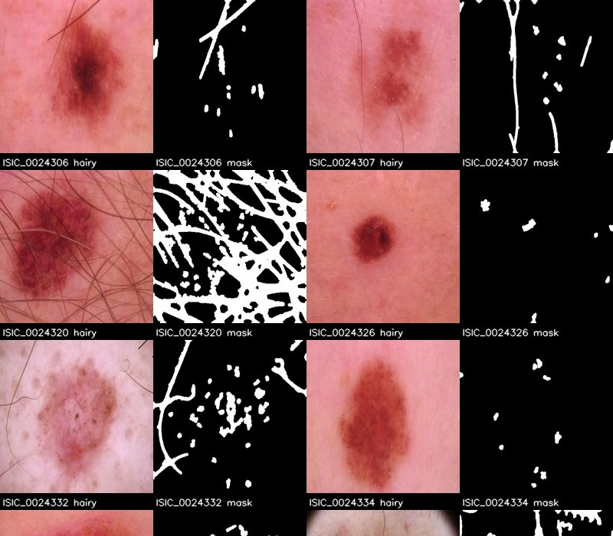
Figure 1 — Hair detection. Each pair shows the raw image and the binary hair mask the detector produced for it.
What is visible: on sparse cases the detector cleanly isolates individual hairs as thin strands while leaving the lesion untouched. On the heavily-haired case it correctly marks a dense field of overlapping hairs. Two limitations are visible in the same figure. First, where hair overlays the lesion, the mask also covers part of the lesion itself, because dark lesion pigment and dark hair are similar in the filter response. Second, on a few clean images the mask contains scattered small specks that are texture or noise rather than hair. Both effects are the expected failure modes of a morphological detector, and both are why the detector's output is used to decide whether to act, with inpainting restricted to the marked pixels.
4.2 Classical hair removal (Arm B)
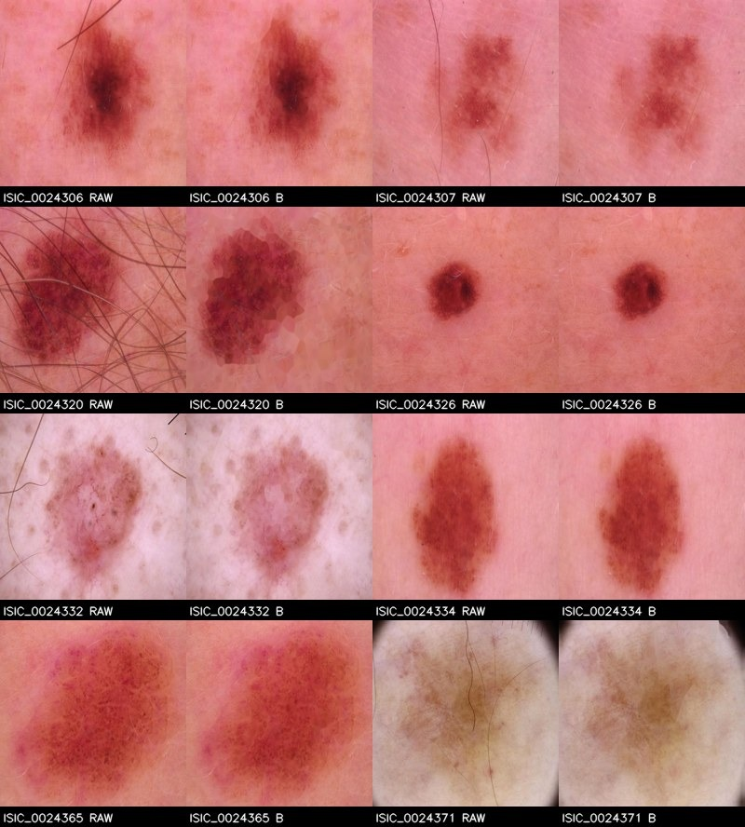
Figure 2 — Arm B, DullRazor-style classical removal. Raw image beside the processed result for the same lesion, in four pairs.
What is visible: fine hairs are removed with the lesion boundary preserved, which is the intended behaviour and consistent with Arm B's high PSNR. On the heavily-haired case the result is different in character — the hairs are gone, but the region they crossed is left slightly blotchy, because interpolation fills the removed pixels with neighbouring colour rather than reconstructing structure. This is the classical method's defining limitation, and it is the reason a generative approach is worth testing at all.
4.3 Diffusion hair removal (Arm C)
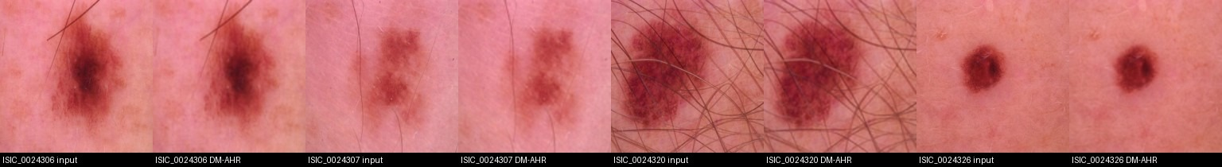
Figure 3 — Arm C, DM-AHR diffusion removal. Input beside the model's output for four lesions.
What is visible: hair is largely suppressed, but the whole image is noticeably softer than both the input and the Arm B result. Fine pigment network and lesion-edge texture are reduced, and on the heaviest case faint hair remnants persist. This matches the measured PSNR and SSIM, and it is the direct visual evidence behind the report's statement that Arm C is over-smoothed. It is a finding about the specific checkpoint trained for this study, which was trained far below the reference budget — not evidence that diffusion hair removal cannot work.
5. What cleaning changed and what it cost
5.1 Effects that strengthen the study
- Honest cohort — removing 1,705 unlabelled images keeps every reported metric inside the labelled cohort, so no result depends on images with no ground truth.
- Leakage control — merging 21 confirmed duplicate pairs and splitting by lesion means one patient's lesion cannot appear in both training and test.
- Frozen parameters — the frozen split hash and the frozen hair threshold mean the test set could not have influenced any design choice.
- Matched arms — all four arms share identical manifests, transforms and seeds; only the hair-removal condition differs.
- Measurable fidelity — 1,022 synthetic pairs give a genuine hairless reference, which is what makes PSNR and SSIM meaningful instead of decorative.
5.2 Costs and trade-offs, stated plainly
- High screening prevalence — at the frozen threshold, 89.8% of images are treated as hair-present. That is a high rate and is reported as a limitation rather than hidden. It means most images are processed, which maximises cost and risk of altering images that needed no alteration.
- Screening is not validated — no independent hair annotations exist in this corpus, so the detector's accuracy against real hair labels is unverified. It was calibrated on synthetic pairs and frozen; that is the strongest available guarantee, and it is not the same as a validated detector.
- False positives propagate — the heavy-hair case in Figure 1 shows the mask covering lesion pigment too. Classical inpainting then fills those pixels, which can smooth lesion structure along with the hair.
- Resolution change — Arm C operates at 128 px natively, so its inputs are upsampled to the 224 px the classifier expects. Arm A* isolates this by round-tripping originals through the same resize, and that control was inconclusive — meaning the resolution change alone does not explain Arm C's deficit.
- Storage — processed images are written to disk at their working resolution, which triples storage requirements relative to the raw corpus and is why processed arms live on a volume rather than in the repository.
6. What happens at training time, not in advance
Not all preprocessing is applied to files. Two steps happen in memory, per image, every epoch. It matters for the write-up because these are part of the method even though they appear nowhere on disk.
Stage | Training split | Validation and test splits
Geometric | RandomResizedCrop to 224 px (scale 0.75–1.0, ratio 0.9–1.11), horizontal flip, vertical flip, rotation ±15° | Resize to 256 px, centre crop to 224 px
Photometric | Colour jitter: brightness 0.15, contrast 0.15, saturation 0.10, hue 0.02 | none
Value scale | to tensor in [0, 1], then ImageNet mean/std normalisation | identical
Class imbalance | inverse-frequency class weights from the training split only, in the loss | not applied (no weighting at evaluation)

Augmentation is deliberately applied only to training images. Validating on augmented images would make the validation signal noisy and the early-stopping decision arbitrary. The identical recipe is used for all four arms, so the comparison is not confounded by augmentation differences.
A deviation from the proposal, disclosed
The proposal specifies rotation up to ±90° with explicit zoom and shift. The implemented recipe uses ±15° rotation with a random resized crop that provides scale variation instead of a separate shift parameter. The difference is recorded in the project decision log. Because the recipe is identical across all four arms, the internal comparison remains valid; what it cannot claim is that the exact stated augmentation was used.

7. Limitations
- Hair screening is unvalidated — no independent annotations exist, so its accuracy on real hair is unverified. Its behaviour on synthetic pairs is not evidence about real hair.
- Classical removal destroys texture — the fix is pixel-level interpolation, so lesion texture under removed hair is not recovered, only approximated.
- Arm C is under-resourced — the checkpoint was trained well below the reference iteration budget and sampled at half the reference steps. Its over-smoothing is a property of that under-resourced model, not proof about the published method.
- Synthetic pairs are a proxy — synthetic hair is a proxy for real hair. It gives a true reference image, which real hair cannot, but its appearance differs from genuine terminal hair.
- Lesion masks are released, not expert-verified — segmentations were released with HAM10000, and the source does not state they were dermatologist-traced. They are used as reference masks, not as expert ground truth.
- Licensing is unresolved — HAM10000 is CC BY-NC 4.0, and the DM-AHR repository's README and LICENSE disagree (CC BY-NC 4.0 against Apache-2.0). Commercial use is unresolved and needs a rights decision.
- Single corpus — the images are a single public corpus from one collection. Nothing here establishes behaviour on another scanner, population or acquisition protocol.
8. How to reproduce
Each step is a standalone command. They can be run on Modal, on a local GPU, or in a Colab GPU runtime; the data steps need no GPU at all.
Step | Command | Needs
Download | python scripts/00_download_data.py | CPU, ~7 min
Audit + split | python scripts/01_audit_and_splits.py | CPU, ~1.5 min
Screening + arms + pairs | python scripts/02_hair_pipeline.py | CPU, ~10 min
Everything after | python scripts/03…10_finalize.py | GPU

Verified independently: the three data steps were re-run from a completely fresh download with no Modal present, and reproduced the frozen split hash fda56cf3c555e6d2…, the same 7,470 lesion groups, the same 8,993 hair-present count and the same 1,022 synthetic pairs. That byte-level agreement is the strongest available evidence that the preprocessing is deterministic and portable.
Every number in this document traces to a file: data/manifests/data_manifest.csv, splits.csv, hair_screening.csv, synthetic_pairs.csv and near_duplicates_confirmed.csv, plus artifacts/logs/paired_psnr_ssim_test.csv. The figures come from artifacts/panels/. This document is generated by scripts/13_preprocessing_report.py, so it can be rebuilt from the artifacts rather than edited by hand.

