Quiz Management

# Vision:

To develop a quiz application for a student which assembles the questions dynamically which is exported to a text file as well to view. We can performs all the CRUD operations based on the user input.

# SRS:

Eclipse-jee-photon, java version:1.8, and H2 database  version :1.4.

# Introduction :

Please find the screenshot to find the project structure.

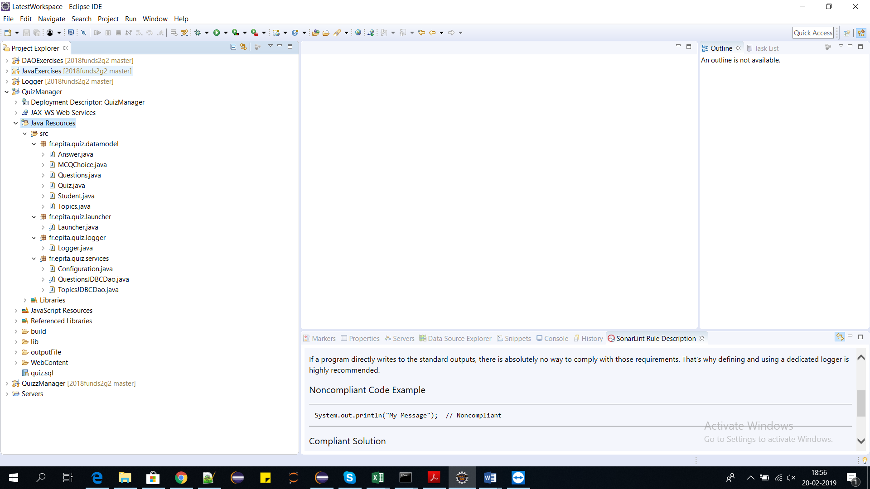

# Database:

Please execute the queries in quiz.sql file in the folder. This uses h2 1.4.196 jar file which is there in the lib folder.

# Classes:

**Datamodel classes** Answer.java, MCQChoice.java, Questions.java, Quiz.java, Student.java, Topics.java

The java code will be provided for you.In this system, the data model (or domain model) is represented as java classes and as database tables.The business logic of the system is carried out by Java objects, while the database provides permanent storage for those objects.



**Logger class** which is Logger.java

Java contains the java logging API. This logging API allows you to configure which message types are written. Individual classes can use this logger to write messages to the configured log files. The java.util.logging package provides the logging capabilities via the Logger class.



**Launcher class** to launch which is Launcher.java

Launcher class consists of the UI and their inputs. The main core logic is written in this class. User inputs is provided through this class.



**Service classes** Configuration.java, QuestionsJDBCDao.java and TopicsJDBCDao.java

A service class provides a way of a client to interact with some functionality in the application. The database connectivity is provided through the below service classes and all the CRUD operations and main methods are in the below classes.

# 

# Parameters :

The parameters used in this project are question, topic name, difficulty which can be updated deleted and insert values. We can list the topics from the database as well as we are exporting the quiz questions to the output files in the outputFile folder.