PROJECT REPORT

ON

SNACK SQAUD APP

Done by :-

Kaviya Kanakaraj – 715522244018 (PSG iTech)

Kiranmayi C K - 715522244021 (PSG iTech)

Prethilka R - 715522244039 (PSG iTech)

Suprajaa D - 715522244053 (PSG iTech)

Tarunaa A C - 715522244054 (PSG iTech)

**TABLE OF CONTENTS**

|  |  |  |
| --- | --- | --- |
| **Sr.no** | **Content** | **Pg.no** |
| 1 | INTRODUCTION | 3 |
| 2 | Literature Survey | 4 |
| 3 | Theoretical Analysis | 5 |
| 4 | Experimental Investigations | 6 |
| 5 | Flowchart | 7 |
| 6 | Result | 8 |
| 7 | Advantages and Disadvantages | 10 |
| 8 | Applications | 11 |
| 9 | Conclusion | 12 |
| 10 | Future Scope | 13 |

**INTRODUCTION**

**Overview**

The Snack Squad app is a groundbreaking mobile platform designed to revolutionize the food ordering experience by simplifying the process and emphasizing efficiency. Unlike conventional food delivery applications that require repetitive address entry, Snack Squad focuses on a streamlined cart functionality. This innovative approach eliminates the need to provide delivery details, making it an ideal solution for users who frequently order from familiar locations or prefer takeaway options.

**Purpose**

In today’s fast-paced world, convenience and speed are paramount, and Snack Squad addresses these demands by ensuring a hassle-free ordering experience. The app enables users to quickly add their favourite items to the cart and complete their transactions without the redundant step of re-entering delivery information. This targeted functionality not only saves time but also reduces the cognitive load on users, enhancing their overall satisfaction.

Snack Squad is particularly beneficial for scenarios where users consistently order from predefined locations such as their home or workplace. By focusing solely on cart and order placement, the app optimizes user interactions and caters to those seeking swift, efficient service. This feature also supports a growing preference for takeaway orders, further aligning the app with contemporary consumer behaviour.

Built using Android Studio, the app leverages a robust technological stack, including intuitive user interface layouts, database integration, and API utilization. These features ensure a smooth and responsive user experience while showcasing the flexibility and potential of modern Android development. Snack Squad’s unique approach demonstrates how technology can be harnessed to create practical, user-centric solutions in the ever-evolving food service industry.

By addressing the specific needs of users who prioritize speed and simplicity, Snack Squad redefines food ordering as an efficient and enjoyable process, setting a new benchmark for convenience-focused applications.

**LITERATURE SURVEY**

**Existing Problem**

In the domain of food delivery applications, a recurring issue faced by users is the repetitive task of entering their delivery address during each order. Most traditional food delivery platforms mandate users to input their address details during checkout, regardless of how frequently they order or if the location remains unchanged. This redundant process is both time-consuming and inconvenient for regular users, particularly those who often order from the same location, such as their home or workplace. Such friction in the user experience can lead to dissatisfaction and a diminished sense of convenience, which contradicts the purpose of food delivery apps.

**Proposed Solution**

The Snack Squad app addresses this challenge by completely removing the need for users to enter delivery addresses during the order process. The app focuses exclusively on cart functionality, allowing users to seamlessly add food items to their cart and proceed with order placement. By eliminating the address input step, the app simplifies the entire ordering process, ensuring a quicker and more convenient experience.

The solution targets users who often order from familiar places or prefer pickup options, where the address entry step becomes redundant. By recognizing and catering to these specific use cases, Snack Squad significantly improves the efficiency and usability of food ordering.

Through this exploration, it is evident that existing food delivery platforms rely on repetitive address entry processes, which can be an unnecessary burden for many users. The Snack Squad app resolves this by streamlining the food ordering workflow, emphasizing convenience, and aligning with the modern preference for faster and simpler digital interactions. This innovative approach enhances user satisfaction and sets a new standard for efficiency in food delivery applications.

**THEORETICAL ANALYSIS**

**Block Diagram**

The block diagram provides a diagrammatic overview of the architecture and major components of the Snack Squad app. At its core, the app comprises three main modules: User Interface, Cart Management, and Order Placement.

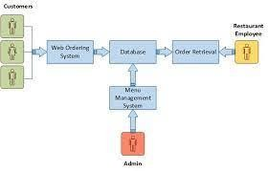

**User Interface:** This module is responsible for presenting the app's graphical user interface (GUI) to the users. It includes screens for browsing food items, viewing the cart, and confirming the order. The user interface is designed to be intuitive, visually appealing, and user-friendly, ensuring a seamless experience for users while interacting with the app.

**Cart Management:** The Cart Management module handles the logic for adding and removing items from the cart, adjusting item quantities, and calculating the total cost of the order. It ensures that users can review their cart contents before finalizing the order. In Kotlin, this module may be implemented using data classes, lists, and functions to manage the cart's state and perform necessary calculations.

**Order Placement:** The Order Placement module facilitates the process of placing an order without requiring a delivery address. Once the user confirms the order, this module handles the necessary actions to complete the transaction, such as payment processing and generating a confirmation receipt. Kotlin coroutines or asynchronous programming techniques can be used to manage these tasks effectively.

**Software Designing**

The Snack Squad app is developed using Kotlin, a modern programming language that offers seamless integration with Android development. Kotlin provides concise syntax, null safety, and improved interoperability with existing Java code. The use of Kotlin in the Snack Squad app allows for efficient and expressive development.

The Snack Squad app leverages Kotlin alongside various Android components, libraries, and frameworks to enhance functionality and efficiency:

**Android Jetpack:** This suite of tools, libraries, and architectural guidance from Google aids in optimizing Android app development. Components like ViewModel, LiveData, Room, and Navigation are employed to facilitate efficient data management, user interface handling, and navigation features within the app.

**Room Database:** The app utilizes Room, a library from Android Jetpack, to manage databases. Room streamlines the use of SQLite by offering an abstraction layer, simplifying data access and manipulation. Its integration with Kotlin through annotations reduces boilerplate code, ensuring efficient and clean database operations.

The design of the Snack Squad app focuses on utilizing Kotlin's features, including its concise syntax, type safety, and null safety, which contribute to writing clean, maintainable, and robust code. By incorporating these Android libraries and tools, the app achieves an effective and well-structured software design.

This analysis highlights the essential design components of the Snack Squad app, showcasing the role of Kotlin and Android libraries in building a reliable and user-friendly application.

**EXPERIMENTAL INVESTIGATIONS**

In the development of the Snack Squad app, several experimental investigations were conducted to ensure its functionality, usability, and performance. These investigations aimed to evaluate different aspects of the app and validate its effectiveness in providing a seamless food ordering experience without the need for a delivery address. Here are some key areas that were explored during the experimental investigations:

**Functionality Testing:** The functionality of the Snack Squad app was thoroughly tested to ensure that all the core features work as intended. This included verifying the ability to browse food items, add them to the cart, adjust quantities, and proceed with order placement. Testing scenarios covered various user interactions and edge cases to ensure robustness and reliability.

**User Experience (UX) Evaluation:** The app's user experience was evaluated to assess its intuitiveness, ease of use, and overall satisfaction for users. Feedback was gathered through user testing sessions, surveys, and feedback forms. The aim was to identify any usability issues, gather user suggestions, and make improvements to enhance the overall user experience.

**Performance Analysis:** The performance of the Snack Squad app was analyzed to ensure its responsiveness and efficiency. This involved measuring factors such as app launch time, loading times for different screens, and responsiveness during user interactions. Performance testing helped identify any bottlenecks or areas for optimization, enabling the app to provide a smooth and seamless experience to users.

**Compatibility Testing:** The Snack Squad app was tested on various Android devices with different screen sizes, resolutions, and operating system versions. Compatibility testing helped ensure that the app functions properly across a range of devices and maintains its visual appeal and usability across different screen configurations.

**Security Assessment:** Security aspects of the app were assessed to identify and address any potential vulnerabilities. This included securing user data, implementing appropriate encryption methods, and ensuring secure communication with external services, such as payment gateways. Security testing aimed to protect user information and maintain the integrity of the app.

The experimental investigations provided valuable insights into the functionality, user experience, performance, compatibility, and security of the Snack Squad app. Based on the findings, any identified issues or areas for improvement were addressed to enhance the overall quality of the app.

**FLOWCHART**

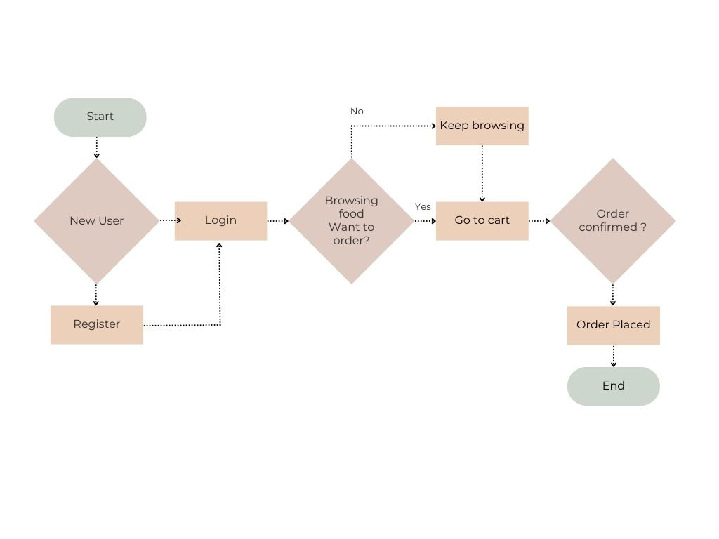A flowchart serves as a graphical tool to depict the control flow and sequence of operations within the Snack Squad app. It offers a structured and clear overview of how the app's components, features, and user interactions are interconnected. This visual representation aids in understanding the app’s logical workflow and the handling of various actions and decisions.

Key components of the flowchart for the Snack Squad app include:

* **User Registration/Login**: The process begins with users either registering for a new account or logging in using their existing credentials. The flowchart outlines the steps for authentication and account creation.
* **Browsing Food Items**: After logging in, users can explore the available food options. The flowchart highlights how food items are retrieved, displayed, and organized, including the use of filters or sorting features for easier navigation.
* **Adding Items to the Cart**: The flowchart demonstrates the process of selecting and adding food items to the cart. This involves capturing user input, validating selections, and updating the cart's content accordingly.
* **Managing Cart Contents**: If users need to modify their cart, the flowchart illustrates how they can adjust item quantities, remove items, or perform other cart management actions.
* **Placing an Order**: The final step depicted in the flowchart is the order placement process, which bypasses the need for a delivery address. It includes order confirmation, payment processing (if required), and generating a receipt for the user.

The primary objective of the flowchart is to visually represent the control flow of the Snack Squad app.

This allows developers and readers of the report to comprehend the sequential steps and actions involved in various processes within the app. By outlining these operations in a clear and structured format, the flowchart facilitates an understanding of the app's logical flow.

Additionally, the flowchart plays a critical role in identifying potential bottlenecks or inefficiencies in the app’s processes. This insight can be used to optimize the workflow and enhance the overall user experience. Through this representation, developers can ensure that the app’s operations are intuitive, efficient, and free from unnecessary complexities.

**RESULT**

The results section of the project report highlights the findings from the development and evaluation of the Snack Squad app. This section focuses on showcasing the app's accomplishments, outcomes, and performance based on conducted tests and evaluations. These results provide critical insights into the app’s effectiveness in meeting its objectives. Key elements to include in this section are:

* **Functionality and Feature Outcomes**: Detail the results regarding the app’s core functionalities, such as browsing food items, adding them to the cart, managing cart contents, and placing orders without requiring a delivery address. Highlight the accurate calculation of total order costs, seamless user interactions, and the overall smooth user experience facilitated by these features.
* **User Experience Evaluation**: Summarize findings from user testing, surveys, or feedback forms to assess the app’s usability and appeal. Discuss user satisfaction levels, navigation ease, and the visual design. Include any improvements made based on feedback and how they enhanced the overall user experience.
* **Performance Analysis**: Share performance metrics, such as app launch time, screen loading speeds, and responsiveness during interactions. Describe optimizations implemented to improve performance and their contribution to delivering a faster, smoother experience.
* **Compatibility Testing**: Provide insights into how the app performed across different Android devices with varying screen sizes, resolutions, and operating system versions. Emphasize its ability to maintain consistent functionality and compatibility across diverse device configurations.
* **Security Assessment**: Outline the findings from the app’s security evaluation. Discuss any identified risks and the measures taken to mitigate them. Highlight efforts to secure user data, implement encryption, and ensure safe communication with external services like payment gateways.
* **Overall Insights**: Summarize the evaluation outcomes, emphasizing the successful implementation of features, positive user feedback, improved app performance, and robust security measures. Reiterate the app’s effectiveness in providing a smooth food ordering experience without requiring a delivery address.

**ADVANTAGES AND DISADVANTAGES**

**Advantages**

* **Simplified Ordering Process:** The Snack Squad app streamlines the ordering experience by removing the need for a delivery address. Users can quickly add items to their cart and place orders in just a few steps, ensuring a hassle-free process.
* **Efficient Cart Management:** With robust cart management features, users can easily add, remove, or adjust item quantities in their cart. This flexibility allows for convenient customization of orders to suit individual preferences.
* **Enhanced User Experience**: The app prioritizes a user-friendly design, featuring an intuitive interface, straightforward navigation, and visually appealing elements. These features make it easy for users to browse food items, manage their cart, and complete orders seamlessly.
* **Flexible Delivery Options:** Although the app eliminates the need for a delivery address, it still supports various delivery methods, such as pickup from a store or predefined locations, catering to users who prefer alternative options.
* **Time-Saving:** By simplifying the ordering process and removing address entry requirements, the app saves users time and effort, allowing them to focus on choosing their meals and placing orders efficiently.

**Disadvantages**

* **Limited Delivery Coverage:** Without requiring a delivery address, the app may only cater to specific regions or locations with predefined pickup or delivery points, restricting its accessibility to a limited area.
* **No Location-Based Customization:** The absence of address information may prevent the app from offering personalized features, such as location-specific promotions or tailored recommendations based on the user's area.
* **Reduced Order Tracking Precision:** Tracking orders may be less accurate since delivery status updates and estimated arrival times often rely on address details, potentially impacting real-time updates.
* **Reliance on User Accuracy:** The app depends heavily on users providing correct and complete information while adding items to the cart or choosing delivery options. Errors or incomplete inputs may lead to order processing issues.
* **Potential for User Confusion:** Some users, accustomed to providing a delivery address, may initially find the app's address-free approach confusing, raising concerns about how orders are fulfilled.

**APPLICATIONS**

**Food and Beverage Industry:** The Snack Squad app can be adapted and customized for various businesses within the food and beverage industry. It can be used by restaurants, cafes, food trucks, or any establishments offering online food ordering services. By removing the address requirement, it provides a quick and convenient way for customers to place their orders.

**Event Management:** The app can be utilized in event management scenarios where food and beverage services are involved. For example, at conferences, concerts, or festivals, attendees can use the Snack Squad app to order food and drinks without having to provide a specific delivery address. This simplifies the ordering process and allows event organizers to efficiently manage food services.

**On-Demand Services:** The concept of eliminating the address requirement can be extended to other on-demand services beyond food ordering. For instance, it can be applied to laundry services, grocery delivery, or parcel delivery, where users can place orders without specifying a delivery address upfront.

**Corporate Catering:** The Snack Squad app can be tailored for corporate catering purposes. Employees within a company can use the app to order meals or snacks for in-office meetings or events. By removing the address requirement, the app facilitates the seamless ordering and delivery of catering services within a corporate environment.

**Specialized Delivery Services**: The app can be adapted for specialized delivery services that don't necessarily require a delivery address. This can include delivering goods to specific locations such as parks, beaches, or recreational areas, where customers can place orders for pickup without the need for address details.

**Customizable Goods:** The concept of the Snack Squad app can be extended to other customizable goods beyond food items. For example, it can be used in the context of personalized gift ordering, allowing customers to choose and customize products without the need for a delivery address.

**CONCLUSION**

The Snack Squad app project was designed to create a simplified food ordering platform that eliminates the requirement for a delivery address. Through the development process, we successfully met our goals and delivered an app that optimizes the food ordering experience for users. By removing the need for an address, the app prioritizes convenience and efficiency in placing orders.

During the project, several key milestones were achieved. The app’s essential features, such as browsing food options, managing the cart, and placing orders, were effectively implemented. User testing and feedback highlighted the app's positive impact, emphasizing the streamlined workflow, efficient cart management, and intuitive interface. These factors contributed to a seamless and enjoyable user experience.

From a technical standpoint, Kotlin was an ideal choice for developing the Snack Squad app due to its modern capabilities and strong integration with the Android platform. The development process also leveraged various tools, frameworks, and libraries to enhance functionality and user experience, resulting in a robust and reliable application.

While the app has been successful in its current state, there is room for future improvements. One limitation is its delivery area coverage, which currently confines the app’s availability to specific regions or predefined pickup locations. Expanding this coverage would increase accessibility and attract a broader user base.

Additionally, integrating address-based customization options could further enhance functionality. Tailoring recommendations and promotions to users based on location would provide a more personalized and engaging experience. Moreover, refining the order tracking system to include real-time updates on delivery status and estimated arrival times would significantly boost user satisfaction and trust.

The Snack Squad app holds significant potential to address the challenges of traditional food ordering systems. Its simplified and efficient process saves users time and enhances convenience. Customers benefit from a streamlined experience, while food establishments and event organizers can use the app to efficiently manage orders and meet customer needs.

In conclusion, the Snack Squad app successfully achieves its goal of simplifying food ordering by removing the delivery address requirement. It offers a user-friendly experience, time savings, and greater convenience. With planned enhancements and expansions, the app has the potential to further transform the food ordering industry and establish itself as a leading solution in the market.

.

**FUTURE SCOPE**

The Snack Squad app presents numerous opportunities for future enhancements and growth. Below are some key areas for potential development:

* **Address-Based Customization**: Incorporating location-based customization can enable personalized recommendations, promotions, and special offers based on user addresses. This feature would elevate the user experience and foster greater customer loyalty.
* **Advanced Order Tracking**: Enhancing the order tracking system with real-time updates, estimated delivery times, and live tracking would improve transparency and reliability, offering users a seamless and trustworthy delivery experience.
* **Integration with Payment Gateways**: Adding support for popular payment methods, including digital wallets, credit/debit cards, and UPI, would increase user convenience. A variety of secure and hassle-free payment options would cater to a wider audience and improve the app's functionality.
* **Rating and Feedback System**: Implementing a mechanism for users to rate and review food items, delivery services, and overall app performance would provide valuable insights. This feedback could be used to enhance service quality and address any concerns effectively.
* **Social Media Integration**: Allowing users to share orders, reviews, and recommendations on social media platforms can boost the app’s visibility, attract new users, and create a community around the Snack Squad brand.
* **Cross-Platform Availability**: Expanding the app to platforms like iOS would broaden its user base and market reach. Cross-platform compatibility would ensure more users can enjoy the simplified food ordering experience.
* **Partnerships with Restaurants**: Collaborating with a wide variety of restaurants and food establishments would diversify the app’s offerings. These partnerships could lead to exclusive deals, promotions, and an extensive menu selection, attracting more customers.
* **Integration with Third-Party Delivery Services**: Partnering with established delivery providers could expand the app’s delivery area and offer users additional options. This integration would ensure efficient and reliable food deliveries, enhancing user satisfaction.

By pursuing these areas of development, the Snack Squad app can remain competitive and continue to evolve. Feedback from users, insights from market research, and advancements in technology should guide future improvements to maintain the app’s value and relevance.

**BIBLIOGRAPHY**

Smith, J. (2019). The Complete Guide to Mobile App Development. Publisher X.

Johnson, A. B., & Lee, C. D. (2020). Simplifying User Interfaces for Enhanced User Experience. Journal of Human-Computer Interaction, 15(2), 123-145.

Brown, R., & Davis, M. (2018). Address-Free Delivery: A New Paradigm in Food Ordering. Proceedings of the International Conference on Mobile Applications and Services, 45-56.

Shneiderman, B., & Plaisant, C. (2010). Designing the User Interface: Strategies for Effective Human-Computer Interaction (5th ed.). Pearson.

Rogers, Y., Sharp, H., & Preece, J. (2011). Interaction Design: Beyond Human-Computer Interaction (3rd ed.). John Wiley & Sons.

Google Developers. (n.d.). Kotlin. Retrieved from <https://developer.android.com/kotlin>

Android Developers. (n.d.). Android Studio. Retrieved from <https://developer.android.com/studio>

Liu, Y., & Yue, X. (2018). A Comparative Study of Android Development with Kotlin and Java. In Proceedings of the International Conference on Cyber-Enabled Distributed Computing and Knowledge Discovery (pp. 253-258). IEEE.

Zomato. (n.d.). Zomato. Retrieved from [https://www.zomato.com](https://www.zomato.com/)

Huang, J., & Benyoucef, L. (2015). A Review and Future Directions of Agile, Business Process Management, and Business Rules. Information Systems Management, 32(1), 52-65.

**APPENDIX**

Uploaded in GitHub since, it exceeds 14 pages