API(Application Programming Interface)

* An API is essentially a set of rules that dictate how two machines talk to each other.
* An API’s defined communication protocol is what enables developers to build, connect, and integrate applications quickly and at scale.
* Some examples include [**Twilio**](https://tray.io/connectors/twilio-integrations) (communications API), [**Stripe**](https://tray.io/connectors/stripe-integrations) (payments API), and [**Sendgrid**](https://tray.io/connectors/sendgrid-integrations) (email API), which offer a “Platform as a Service” (PaaS) model.

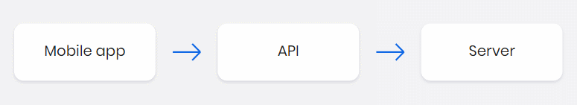

Example: If we order something in Zomato, after restaurant confirming order I will show us map of delivery boy. Zomato requests to API for map and API request to google maps. Then google send acceptance request to API then Zomato can use maps.

Types of API:

* Open API
* Partner API
* Internal API
* Composite API

Open API: This is also known as public API or external API. This type of API can be used by anyone.

Example: Sign in with google.

Partner API: This API are shared externally, but only among those who have a business relationship with company providing the API. Access is limited to authorized clients with official licenses, and thus security measures tend to be stronger with partner APIs than with public api.

Example: shared OTP.

Internal API: This api also called a private api. Internal APIs are only made available for use inside a company and are meant to streamline data transfer between teams system.

Example: Ticket booking.

Composite API: composite APIs combine multiple APIs allowing developers to bundle calls or request and receive one unified response from different servers. If you need data from different application or data source, you would use a composite API.

Example: Shopping Cart.

Type of API Architecture:

* REST
* SOAP
* RPC

REST:

* REST, which stands for Representational State Transfer, is an architectural style for designing networked applications. It is commonly used in the context of web services and APIs (Application Programming Interfaces). RESTful APIs adhere to the principles and constraints defined by REST.

SOAP :

* SOAP, which stands for Simple Object Access Protocol, is a protocol for exchanging structured information in web services and API architectures. Unlike REST, which is an architectural style, SOAP is a specific protocol that defines a set of rules for structuring messages and describes how they should be exchanged over a network.

RPC :

* RPC stands for Remote Procedure Call, and it is a protocol that enables one program to request a service or function from another program on a network as if it were a local procedure or method call. In the context of API architecture, RPC is a method for communication between different systems, allowing them to invoke procedures or methods on a remote server or service.