**Test Plan:**

How to create a test plan:

* There are 6 steps to create.

1. Define the release scope:

* Before any test activity occurs, its important to define the scope of testing for your release.

1. Schedule timeline:

* Specify release deadlines to help you decide your testing time and routine.

1. Test objectives:

* Test objective is a reason or purpose for design and executing a test. These objectives ultimately help guide and define the scope of testing activities.

Defect Density:

* Defect Density = Defect count/size of the release (lines of code)

Test Coverage:

* Test Coverage = (Total number of requirements mapped to test cases / Total number of requirements) x 100.

Defect Detection Efficiency (DDE):

* DDE = The percentage of defects detected during a phase / Total number of defects

Time to Market:

* TTM = The time it takes for your company to go from idea to product launch

1. Determine test deliverables:

* Test deliverables are the products of testing that help track testing progress. Deliverables should meet your projects and client’s needs, be identified early enough to be included in the test plan and be scheduled accordingly.
* Some important deliverables to focus on before, during and after testing:
* Before testing:
* **Test plan document:** The scope, objectives, and approach of the testing endeavour are all outlined in the test plan.
* **Test suite:**Test cases illustrate how to run a test, including input data, expected output, and pass/fail criteria.
* **Test design and environment specifications:** The test environment outlines the hardware and software configurations used for testing.
* During Testing:
* Test Log: The test log records each test cases results including issues and resolutions.
* Defect report: according to severity and priority.
* Test data: to execution precondition and input content required to execute one or more test cases.
* Test summary report lists the number of test run, passed, failed.
* After testing:
* Test Completion report
* User acceptance test report
* Release notes

1. Design the test strategy:

* Test strategy helps to determine test cost, test effort , which feature will be in-scope versus out-of-scope.

1. Plan test environment and test data:

* Test environment includes hardware, software, and network configurations for software testing.

What is test case?

* A Test case are the set of positive and negative executable steps of a test scenario which has a set of pre-conditions, test data, expected results, post-conditions, and actual results.

Difference between test scenario and test case:

* Test scenario gives the idea of what we have to test. Test scenario is like high-level test case.

Who writes Test cases:

* Developers write Unit Tests
* Developers & Testers write Integration Tests
* Testers write Acceptance Tests

Test case templet:

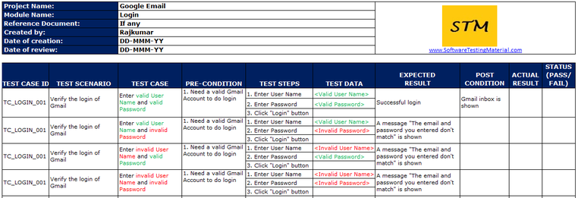

Verification and validation in software testing:

* Verification:
  + focus is on procedure to achieve the results.
  + Mostly a static activity.
  + Activities like requirements review, architecture review, design review, code review.
* Validation:
* Focus is on result things.
* Validation is the dynamic testing.
* Activities like unit test, Integration test, system test, acceptance test.

**Positive Testing and Negative Testing:**

* Positive testing ensures that software performs as it is expected to do. When writing test cases for positive testing valid inputs are provided as inputs.
* Negative testing a software program is evaluated against false or incorrect data. Negative testing is also known as error path testing or failure.

