LINUX BASICS – DEVOPS ASSIGNMENT
Documentation of Linux Command-Line Tasks
GitHub Repository: https://github.com/suprakun/Linux-Basics-Assignment
Objective: Practise essential Linux command-line operations including file and directory management, viewing files, searching, archiving, downloading, permissions, and environment variables.

Task 1 – Creating and Renaming Files/Directories
Requirement: Create a directory named test_dir.
Command: mkdir test_dir
Explanation: mkdir creates the directory test_dir.
Requirement: Inside test_dir, create an empty file called example.txt.
Command: cd test_dir
touch example.txt
Explanation: touch creates the empty file example.txt inside test_dir.
Requirement: Rename example.txt to renamed_example.txt using mv.
Command: mv example.txt renamed_example.txt
Explanation: mv renames the file to renamed_example.txt.
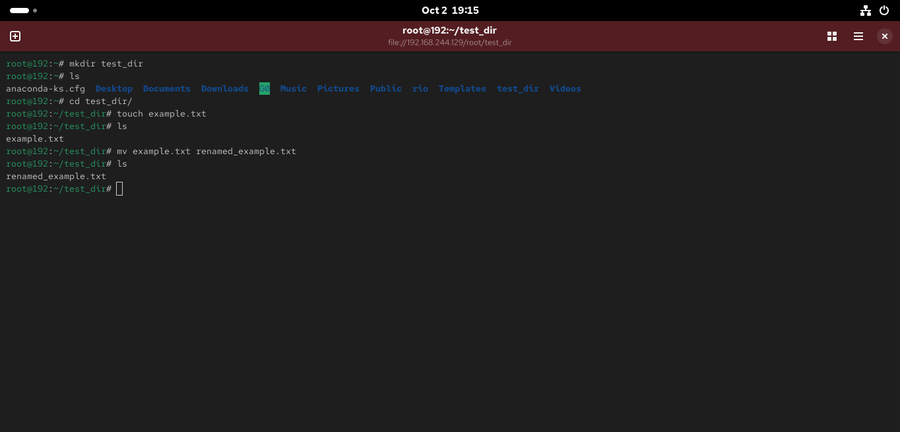
Task 1 terminal screenshot

Task 2 – Viewing File Contents
Requirement: Use cat to display the contents of /etc/passwd.
Command: cat /etc/passwd
Explanation: cat displays the contents of the file.
Requirement: Display only the first 5 lines of /etc/passwd using head.
Command: head -n 5 /etc/passwd
Explanation: head displays the beginning of the file; -n 5 limits the output to five lines.
Requirement: Display only the last 5 lines of /etc/passwd using tail.
Command: tail -n 5 /etc/passwd
Explanation: tail displays the end of the file; -n 5 limits the output to five lines.
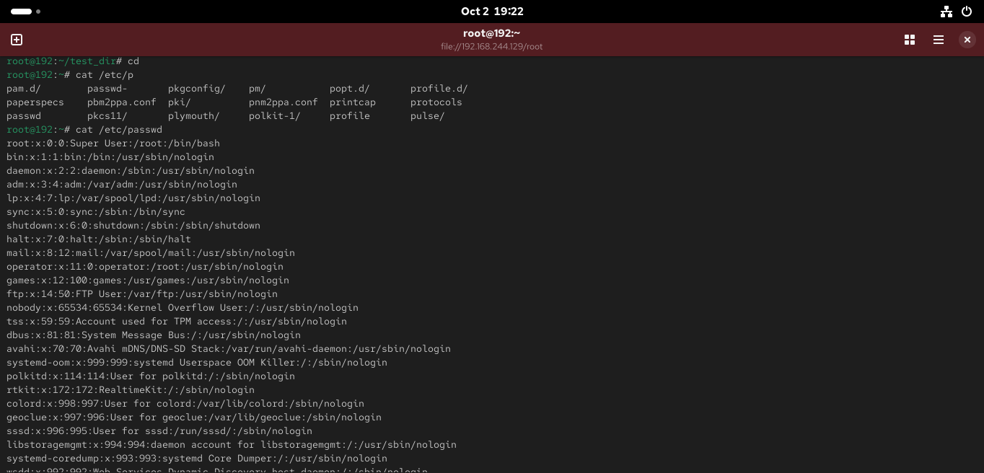
Task 2 terminal screenshot
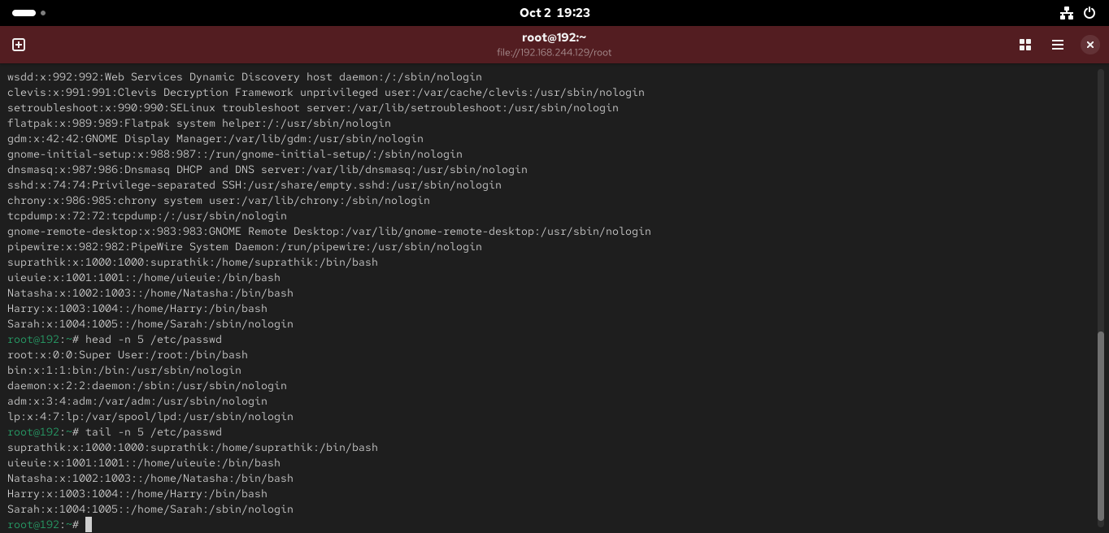
Task 2 terminal screenshot
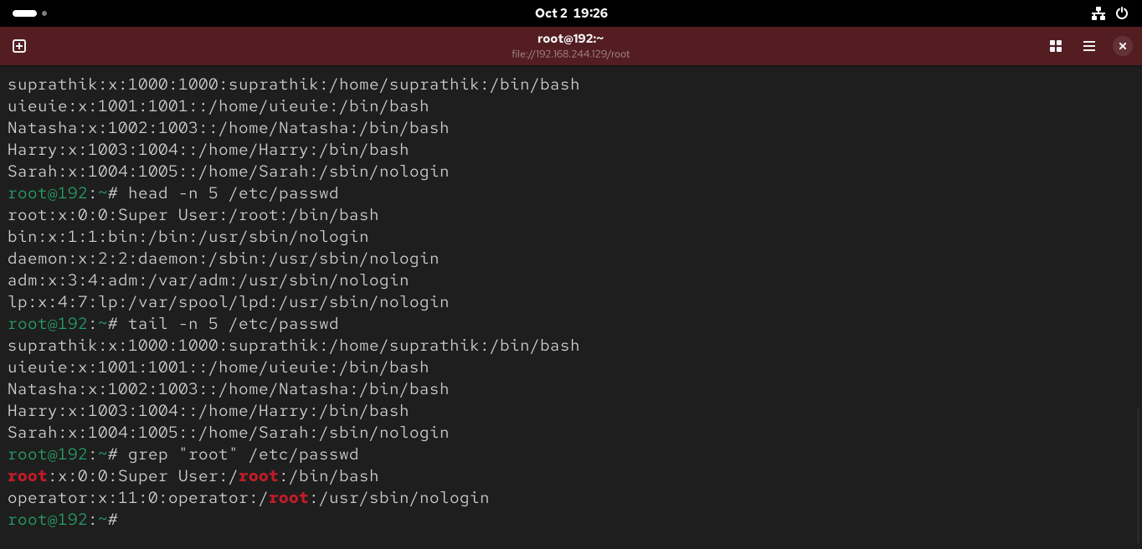
Task 2 terminal screenshot

Task 3 – Searching for Patterns
Requirement: Use grep to find all lines containing the word “root” in /etc/passwd.
Command: grep "root" /etc/passwd
Explanation: grep searches the file for lines containing the specified pattern.
Task 3 terminal screenshot – grep output

Task 4 – Zipping and Unzipping
Requirement: Compress the test_dir directory into test_dir.zip using zip.
Command: zip -r test_dir.zip test_dir
Explanation: zip creates an archive; -r recursively includes the directory contents.
Requirement: Unzip test_dir.zip into a new directory named unzipped_dir.
Command: unzip test_dir.zip -d unzipped_dir
Explanation: unzip extracts the archive; -d specifies the destination directory.
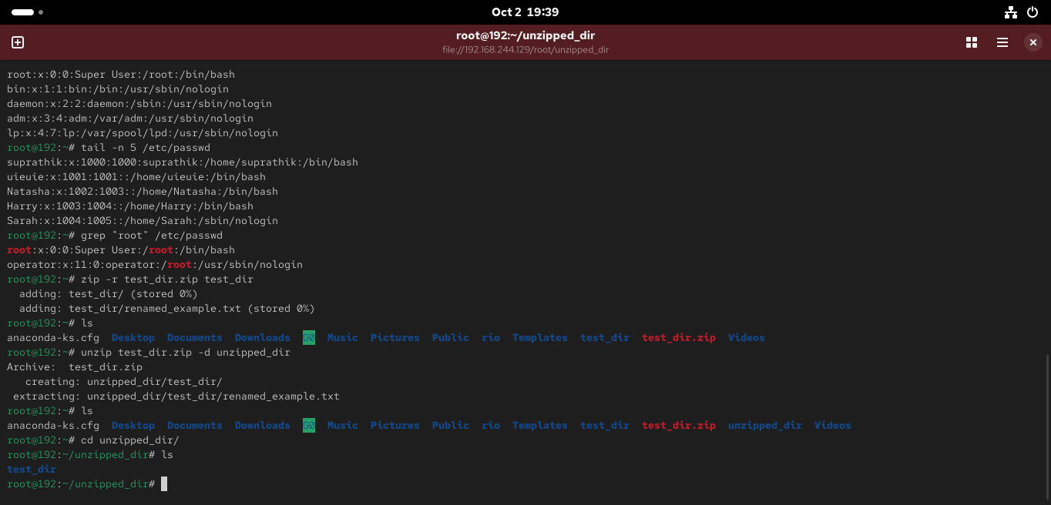
Task 4 terminal screenshot

Task 5 – Downloading Files
Requirement: Use wget to download a file from a URL.
Command: wget <URL>
Explanation: wget downloads a file from a specified URL.
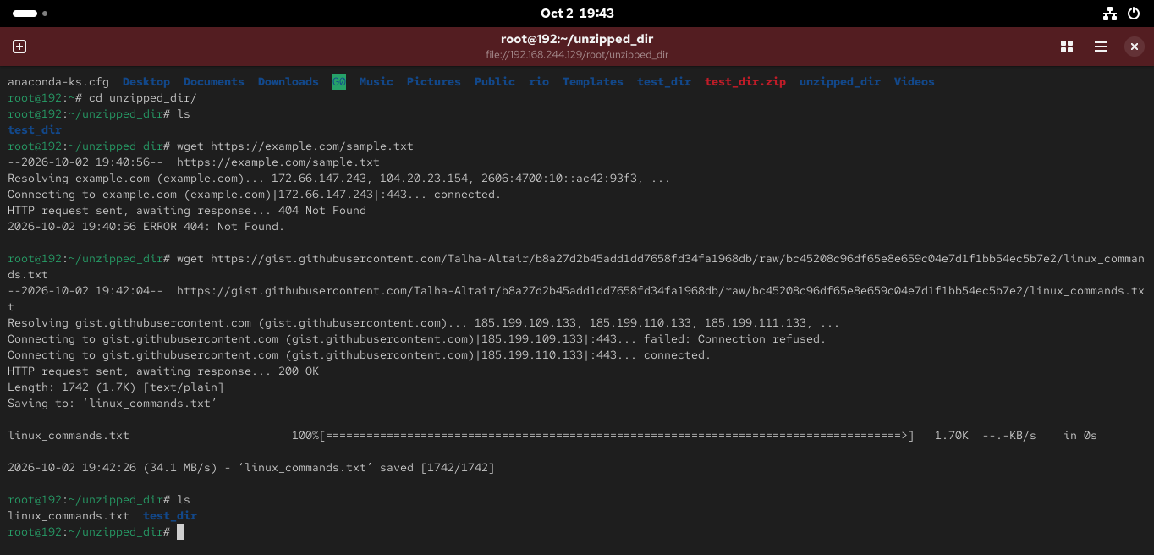
Task 5 terminal screenshot – wget
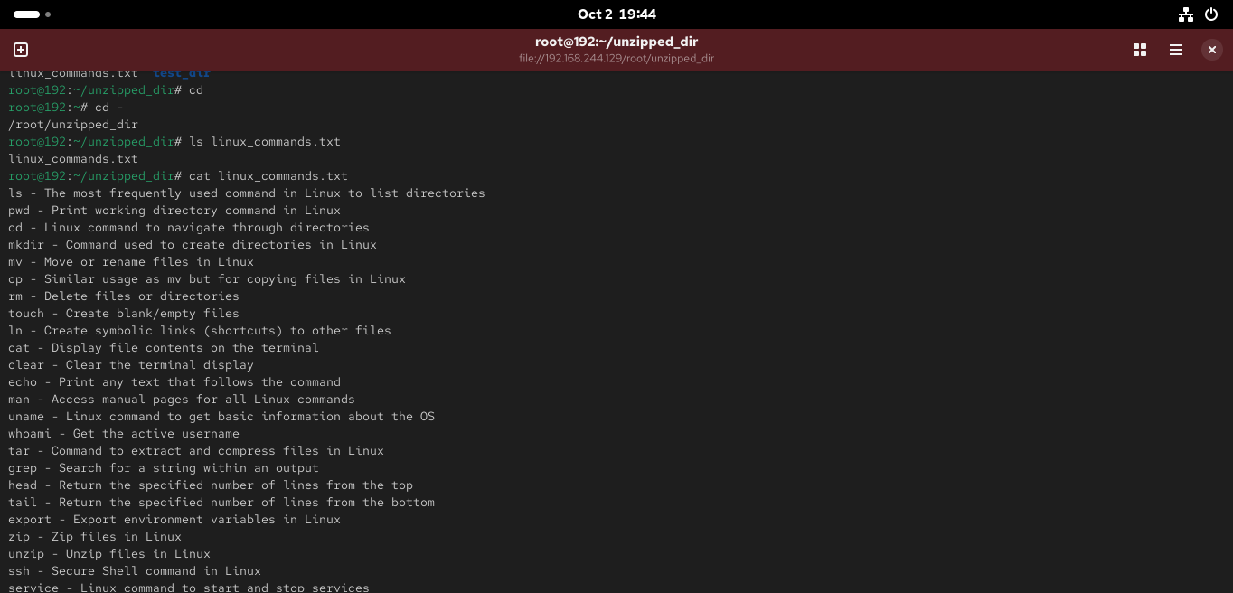
Task 5 additional terminal screenshot

Task 6 – Changing Permissions
Requirement: Create secure.txt and change its permissions to read-only for everyone using chmod.
Commands: touch secure.txt
chmod 444 secure.txt
ls -l secure.txt
Explanation: chmod 444 gives read permission to the owner, group, and others, while removing write and execute permissions.
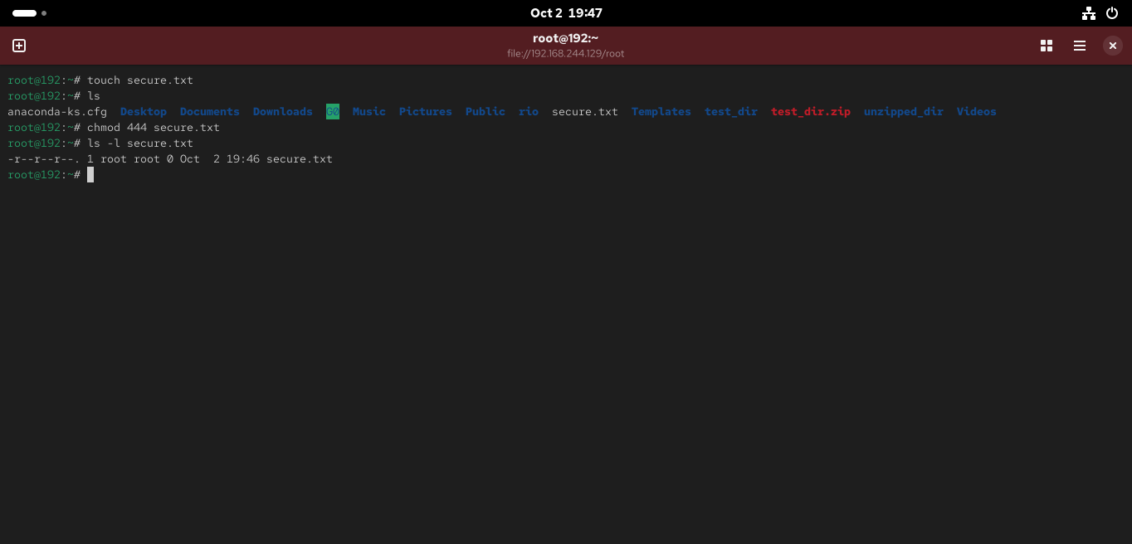
Task 6 terminal screenshot

Task 7 – Working with Environment Variables
Requirement: Use export to set MY_VAR to "Hello, Linux!".
Commands: export MY_VAR="Hello, Linux!"
echo $MY_VAR
Explanation: export sets/exports the environment variable in the current shell, and echo verifies its value.
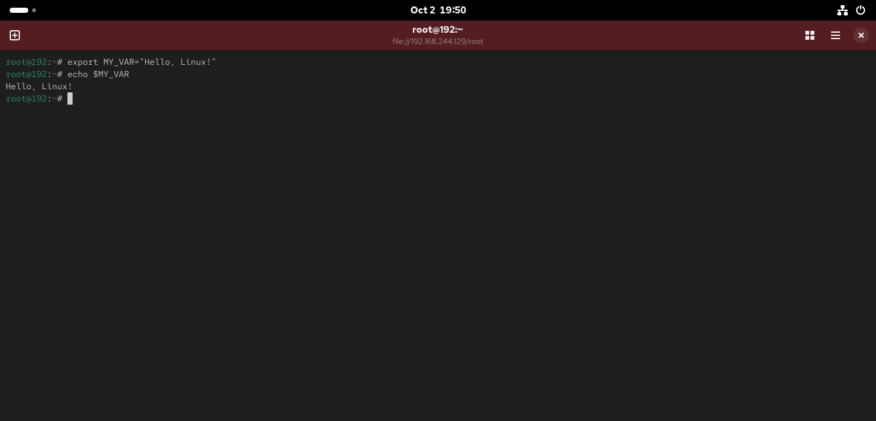
Task 7 terminal screenshot

GitHub Repository
Completed assignment repository: https://github.com/suprakun/Linux-Basics-Assignment

Included Submission Files
- Documentation.docx
- Screenshots/ (all 9 original screenshots)
- test_dir/
- test_dir.zip
- unzipped_dir/
- secure.txt

