PYTHON & BASH
ASSIGNMENT – 2
DEVOPS | Assignment Documentation
Student: Suprathik
GitHub: https://github.com/suprakun/Python-and-Bash-Assignment-2

1. Objective
The objective of this assignment is to practise core Python programming concepts including conditionals, dictionaries, and file handling (reading and writing files).

2. Grade Checker
The program takes a score as input and determines the grade using if / elif / else conditions. The grading ranges are 90+ = A, 80–89 = B, 70–79 = C, 60–69 = D, and below 60 = F.
Source file: 01_grade_checker.py
Test performed: A score of 95 was entered and the program displayed A.
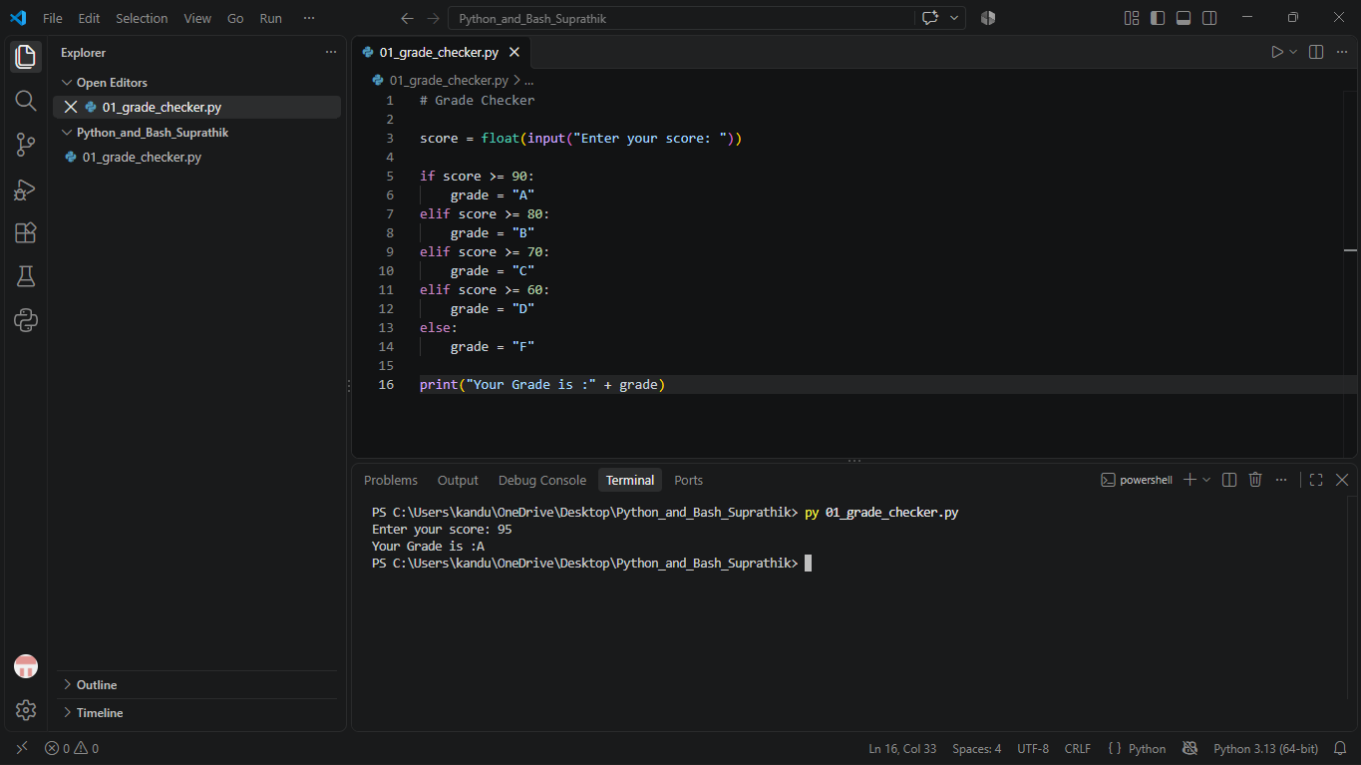
Figure 1: Actual VS Code terminal output for Grade Checker.

3. Student Grades
The program uses a dictionary where student names are keys and grades are values. It allows the user to add a student, update an existing student's grade, print all grades, and exit.
Source file: 02_student_grades.py
Test performed: Ananya was added with grade A, Rahul was updated to A+, and all student grades were displayed.
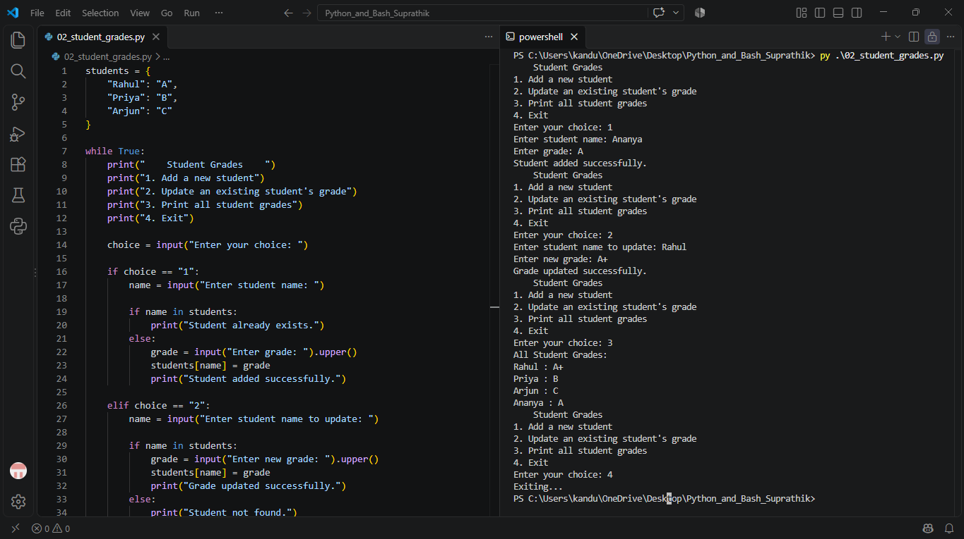
Figure 2: Actual VS Code terminal output for Student Grades.

4. Write to a File
The program creates assignment_notes.txt and writes content to it using open() in write mode and file.write().
Source file: 03_write_file.py
Test performed: The terminal confirmed that the content was written successfully and the text file was created.
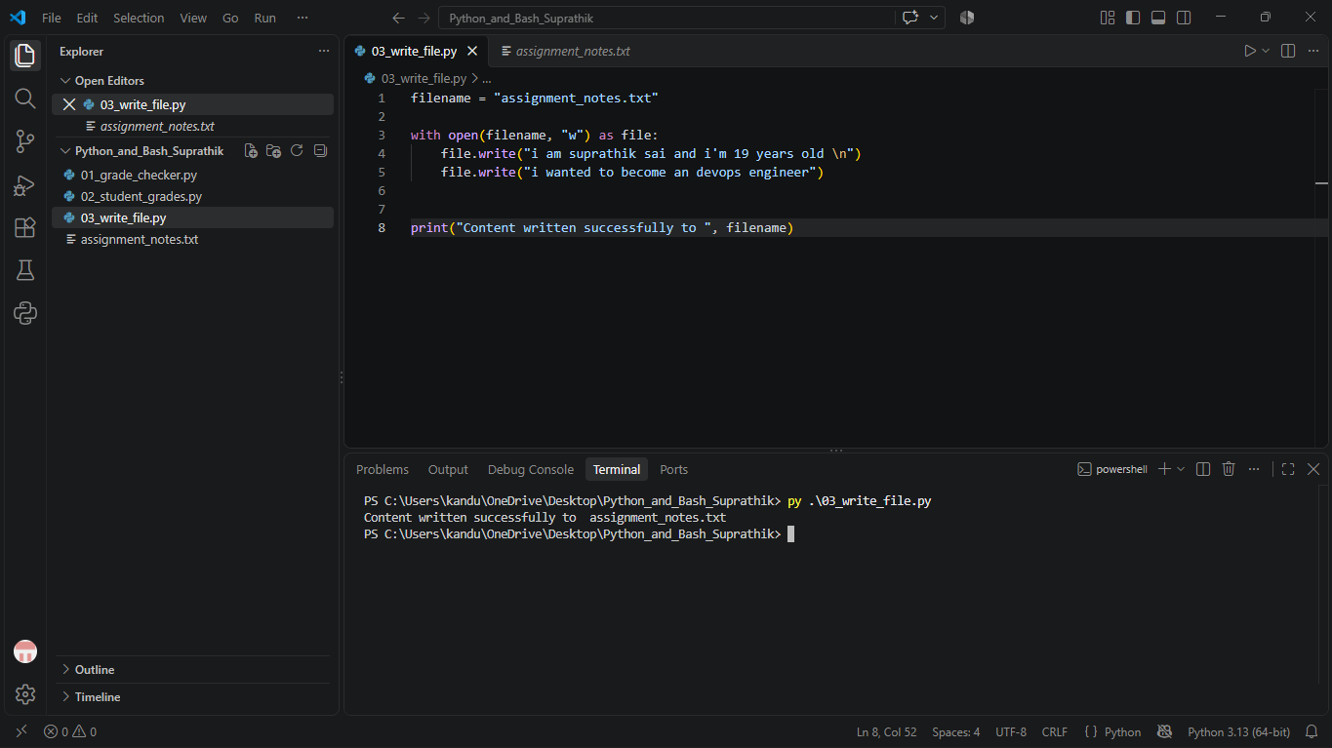
Figure 3: Actual VS Code terminal output for writing the file.

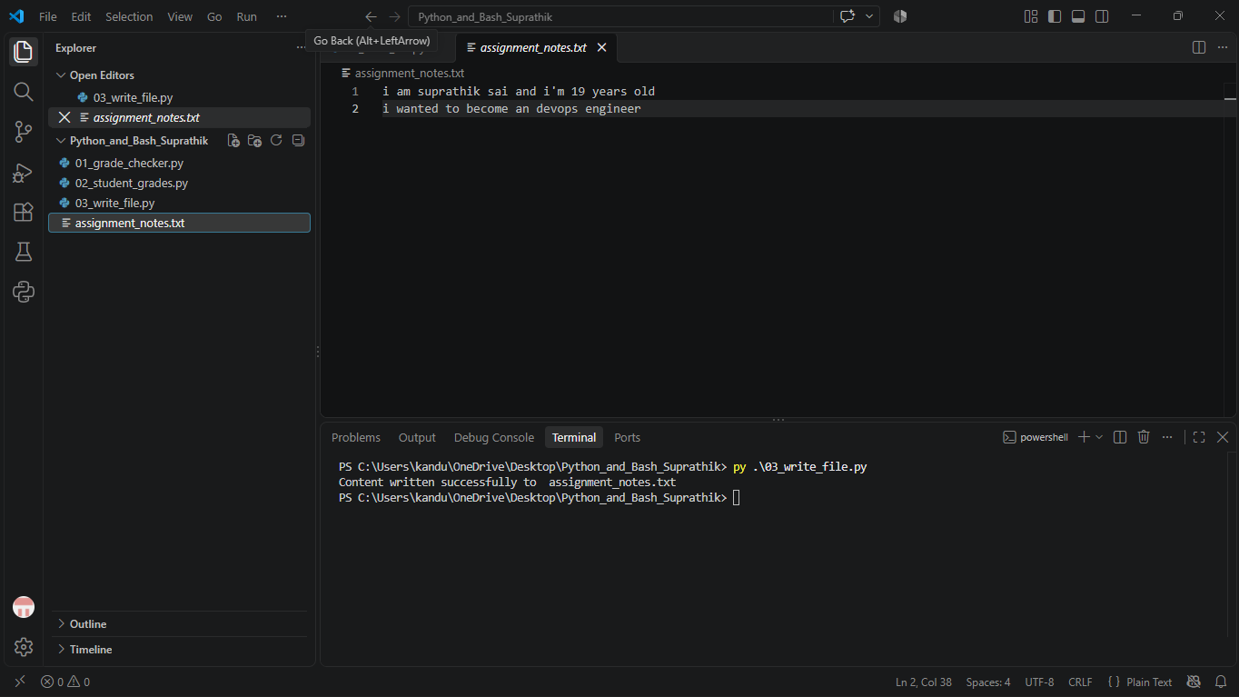
Figure 4: Actual VS Code terminal output of text file.

5. Read from a File
The program opens assignment_notes.txt in read mode and uses file.read() to read and display the stored content.
Source file: 04_read_file.py
Test performed: The terminal displayed the contents stored in assignment_notes.txt.
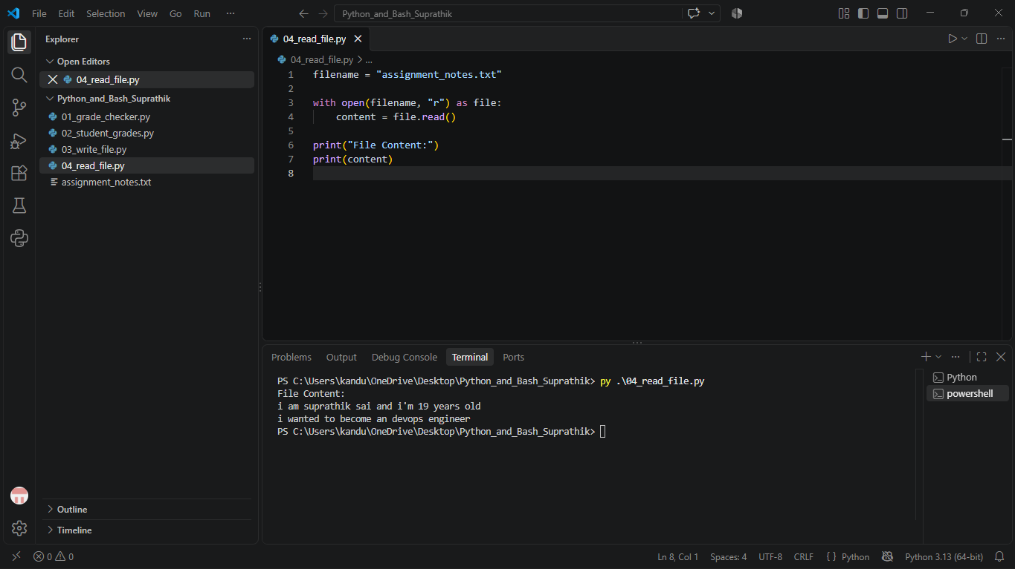
Figure 5: Actual VS Code terminal output for reading the file.

6. GitHub Repository
The source files are available in the public GitHub repository:
https://github.com/suprakun/Python-and-Bash-Assignment-2

7. Project Files
- 01_grade_checker.py
- 02_student_grades.py
- 03_write_file.py
- 04_read_file.py
- assignment_notes.txt
- README.md
- screenshot_task_1.png
- screenshot_task_2.png
- screenshot_task_3.png
- screenshot_task_4.png
- Python_Bash_Assignment_2_Documentation.docx

8. Conclusion
All four tasks were implemented and tested in VS Code. The screenshots in this documentation are the actual screenshots supplied from the student's VS Code executions.

