The energy is computed using the pseudo Wigner-Ville distribution, as described in this file.

Continuous atoms

For a Gaussian function g(t), define a function Wg(t,w) as follows:
(equation 59 and 60, M&Z)

A real gabor atom with parameters and phase is defined as
(equation 54, M&Z)

For this atom, the Wigner-Ville distribution is given by
(equation 58, M&Z)

Periodization for discrete atoms

For discrete signals of length N, the decomposition is done on atoms of length N, and hence the ‘long’ atoms must be periodized. This means that a discrete atom of scale s is constructed by summing the function g and it’s infinite copies shifted by a multiple of N, and then uniformly sampling over N points

(equation 63, M&Z)

Although the discrete version of the wigner-ville distribution was not described in Mallat and Zhang, an obvious strategy is to periodize the spectrum as well. Since the WV distribution is symmetric for real atoms, this amounts to simply flipping and adding the spectra around 0 and N/2, as shown below.

Figure 1 shows the frequency spectrum of an atom of scale = 2 located at center frequency 3/N, where N = 16 (see wignerVilleExample.m). The blue and the red lines correspond to the energy at +c and -c (c=3), and the remaining ones are just copies of these two shifted by multiples of N. The range of interest – 0 to N, is shown in Figure 2.

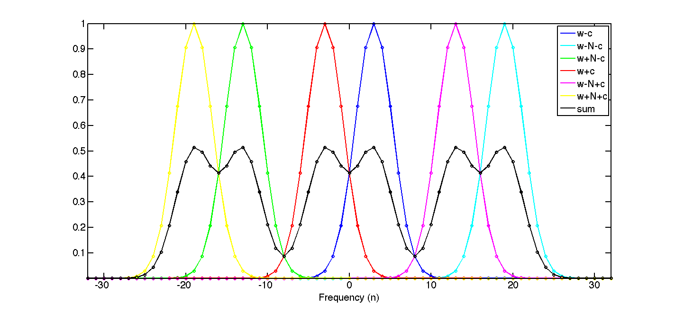
Figure 1

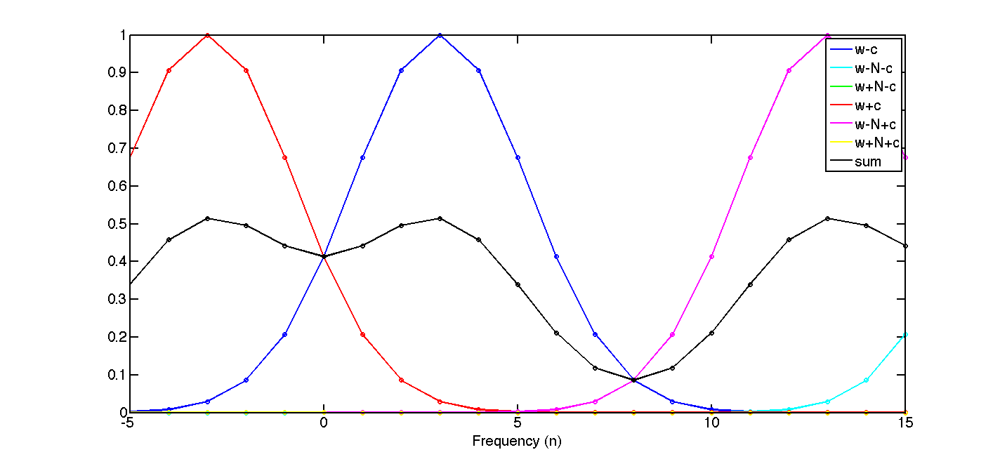
Figure 2

For an atom of scale s, the energy falls off as , such that the value at a distance of N/2 is , which is <10⁻¹⁰ for scale ≥ 4 (oct value greater than 1). Therefore, there is negligible contribution from yellow, green or cyan atoms.

Further, due to the inherent symmetry, the overall WV distribution between 0 and N/2 (black line) can be obtained by mirroring the values of the original blue line outside 0 and N/2 (the red and magenta contributions are mirror images of the blue segment outside the boundaries).

Note the following
- Values need to be computed only for frequency values 0… N/2. The remaining ones are mirror images around N/2.
- Center frequency position (c) should not exceed N/2. If it does, the mirror N-c could be used instead.
- Given an atom of octave oct (scale s = 2^oct) and center position c, energy is less than <10⁻¹⁰ for values outside c ± 2N/s.

Algorithm
For a c code with ‘for’ loops, the mirroring strategy (as described above) can be used. The algorithm for the matlab code is described below.

For atoms with octaves > 2
for w=0,…N/2
If c < 2N/s → Compute (WV(w-c) + WV(w+c))/2 (blue + red traces)
If c > N/2-2N/s → Compute (WV(w-c) + WV(w-N+c))/2 (blue +magenta traces)
Else compute: WV(w-c)/2

For atoms with octave == 2
Compute (WV(w-c) + WV(w+c) + WV(w-N+c))/2 (blue+red+magenta traces)

For atoms with octave == 1
Compute (WV(w-c) + WV(w+c) + WV(w-N+c) + WV(w-N-c) + WV(w+N-c))/2 (all traces except yellow)

Frequency doubling

Note that since the atoms are real, the energy is symmetrically distributed about N/2. For simplicity, we double the energy for values strictly greater than zero and strictly less than N/2, which is equivalent of flipping the energy values beyond N/2. This is done so that the energy between 0 and N/2 add up to unity. In this regard, this algorithm is like computing the energy of the analytic signal.

