**Readme File**

**Name: Supratim Sarkar**

**Topic: Assignment 2 Compiler Designing Lab**

Question:

Implement a lexical analyzer (using any programming language) for the considered tokens/patterns.

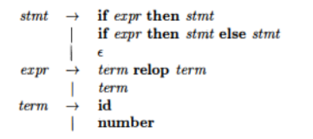

Our code parses the input string of any length be it valid or invalid and returns token class corresponding to these:

* + Keyword
  + Identifier
  + If
  + Then
  + Else
  + Relop

Steps to run the program and get output:

1. The language of the program is C++. So g++ needs to be used: g++ 20CS01073_SupratimSarkar_A2.cpp -o output
2. To execute: ./output
3. Insert the statement inputs in different line and then press enter to get a empty line for which different token sets will be generated.

Example:

Input1: if input<10 then output1=100 else output2>=100

Output1:

(if,)

(id,input)

(relop,<)

(number,10)

(then,)

(id,output1)

(relop,=)

(number,100)

(else,)

(id,output2)

(relop,>=)

(number,100)

Input 2: if x<>10 then y=5 else y>=5

Output2:

(if,)

(id,x)

(relop,<>)

(number,10)

(then,)

(id,y)

(relop,=)

(number,5)

(else,)

(id,y)

(relop,>=)

(number,5)

