INNOVATION LAB Project

DeepFake Video Detection

Supreet Maurya

2201CS70

Objective : Classify a given video as REAL or FAKE

I am using Convolution Neural Network(CNN) and Long Term Short Memory(LSTM) in my neural network and few extra layers to enhance the accuracy.

I am using the FaceForensic++ dataset which has separate REAL and FAKE videos, hence

the dataset needs to be preprocessed before training. I created the json file containing the paths of vides and their label( REAL / FAKE ). The json file contains almost 50% REAL videos and 50% FAKE videos.

Firstly from each video 30 frames were extracted and these frames are passed to CNN to extract the features from each frame.

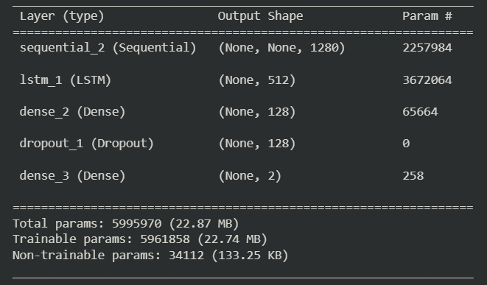

For Frame Extraction i am using the **MobileNetV2** model ( according to the research paper **InceptionV3** was used) as it is light weight and can easily be used in mobile applications and web services. This layer will output the 1280 outputs which will we passed to the pooling layer and the output of this laer is passed to LSTM layer.

For Sequence Processing **LSTM** layer is added with 512 nodes with a dropout of 0.5 to the network and then a fully connected layer of 128 nodes is added with the dropout of 0.5 and activation function as “**relu**” followed by Dense layer with 2 nodes with the activation function as “**softmax**”.

Schematic Diagram of neural network

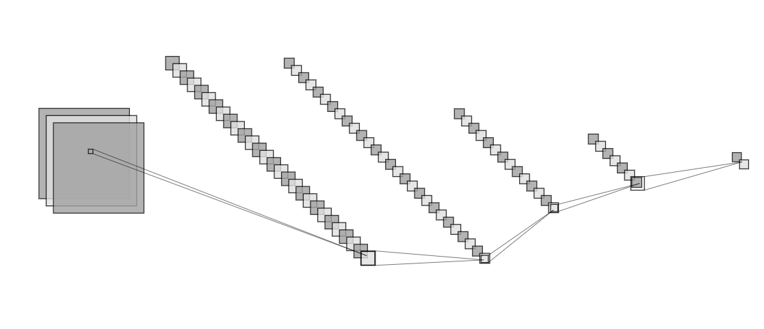

Convolution Pooling LSTM Dense Dense

Architechture of the Solution

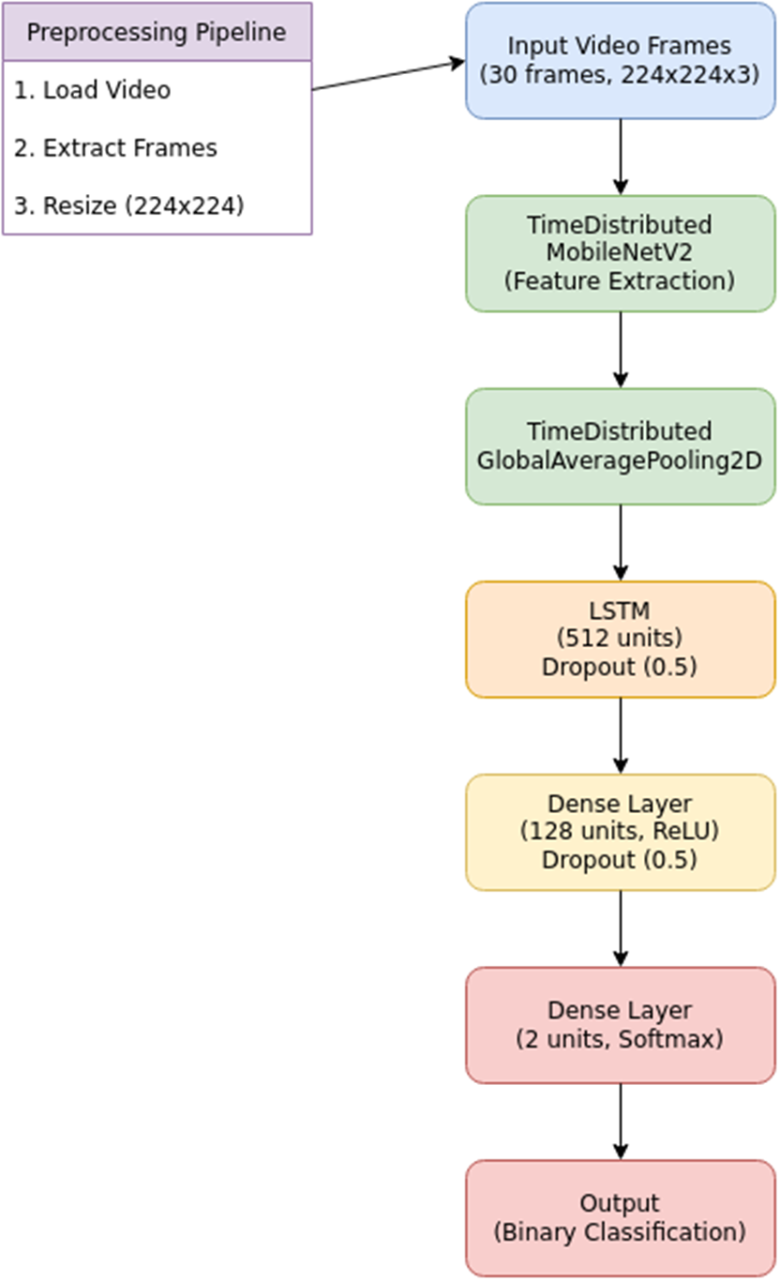

Results

Model was trained with 2000 videos out of which 50 percent were Real and remaining were fake

Model gives 85 percent of accuracy as measured.I tried with different optimizers, increased number of epochs(number of iterations on data) , cross validation and early stopping to reduce the overfitting.