**CIE MANAGEMENT SYSTEM**

**Submitted By:**

**Sanjana M Moodbagil (1BM16IS077)**

**Supreeta Anand Byatnal (1BM16IS090)**

Work done as part of the Self-Study Component for the Undergraduate (UG) Course Database Management Systems (16IS5DCDBM) during the Academic Year 2017-18.

**Course Coordinator**

**Prof. Gururaja H.S.**

**Department of Information Science & Engineering**

**BMS College of Engineering**

**Bangalore-560019**

**ABSTRACT**

CIE management system is a web-based application whose purpose is to automate the existing manual system by the help of computerised equipment and computer software, so that valuable data/information can be stored for a longer period with easy accessing and manipulation of the same.

CIE management system can lead to an error free and reliable management system allowing the organisation to maintain computerised records without redundant entries.

The main aim is to automate CIE time table generation of each semester and the seating arrangements for the test. The project describes how to increase the performance and better the services to clients. It also helps reduce the required time taken and hence obtain fast and accurate results.

**TABLE OF CONTENTS**

1.INTRODUCTION

* AIM AND OBJECTIVE
* PROBLEM STATEMENT

2. SYSTEM ANALYSIS

* SOFTWARE REQUIREMENT SPECIFICATIONS
* SOFTWARE TOOLS USED

3. SYSTEM DESIGN

* ER MODEL
* SCHEMA DESCRIPTION
* TABLES DESCRIPTIONS
* DATA FLOW DIAGRAMS

INTRODUCTION

CIE management system has been developed to override problems prevailing in the practical manual system. It is a simple, easy web-based centralized user interface system that provides a way to manage Internal examinations that happen twice a semester by automating test time table generation and student’s seating arrangement.

**AIM AND OBJECTIVE:**

* We aim at building a web-based application that can be operated by an admin (Department head) and accessed by the students and teachers.
* The main objective is to generate test time table for each sem and student seating arrangement.
* Teachers can view the class they may have to invigilate during a test.
* The application makes the management system more efficient, user friendly and a responsive design.
* It will provide compactness, data accessibility and less effort.

**PROBLEM STATEMENT**

Now that the entire CIE system is centralized, the management of the same become quite hectic. At a time, CIE of 6+ subjects will be going on considering 2nd year to 4th year students. Also, there is no particular seating arrangement that is to be followed during CIE exams.

We are developing a system which makes this management more efficient and organized. It requires the students to enter their USN and correspondingly displays the exam for the day and the information about their seating arrangement.

**SOFTWARE REQUIREMENT SPECIFICATION :**

* We are planning to develop an online CIE Exam management application.
* It’s main objective is to provide a platform for students to view the timetable and their seating arrangement for the particular exam in a day.
* It also acts as a portal for teachers to view the class that they are assigned for invigilation.
* Admin is the once who controls the administration of the portal. He enters the subjects from 2nd semester to 8th semester.
* A timetable is created for the dates entered by the admin and the seats are assigned to the students with a constraint that no two same year students sit next to each other.
* There are many classrooms available to conduct the exam and each classroom has many benches which can accommodate students of different years.
* Students and teachers are the end users who can view the blueprint of seating arrangement, timetable and the classroom allotment for invigilation correspondingly along with the time and date.

**SOFTWARE TOOLS USED:**

Operating System : Windows

Tool used : Visual Studio

**HARDWARE TOOLS USED:**

Processor : Pentium IV 2GHz and Above

RAM : 2GB

Monitor : 15.6” Color Monitor

**SYSTEM DESIGN**

**E-R DIAGRAM :**

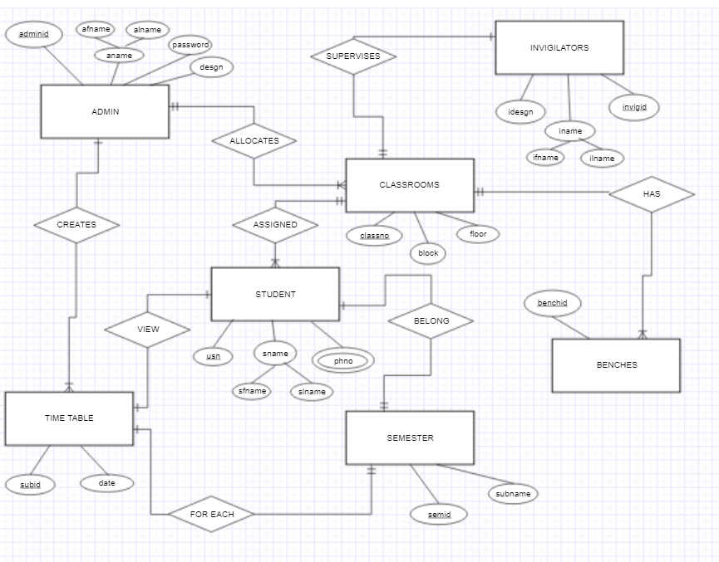

**ER TO RELATIONAL MAPPING :**

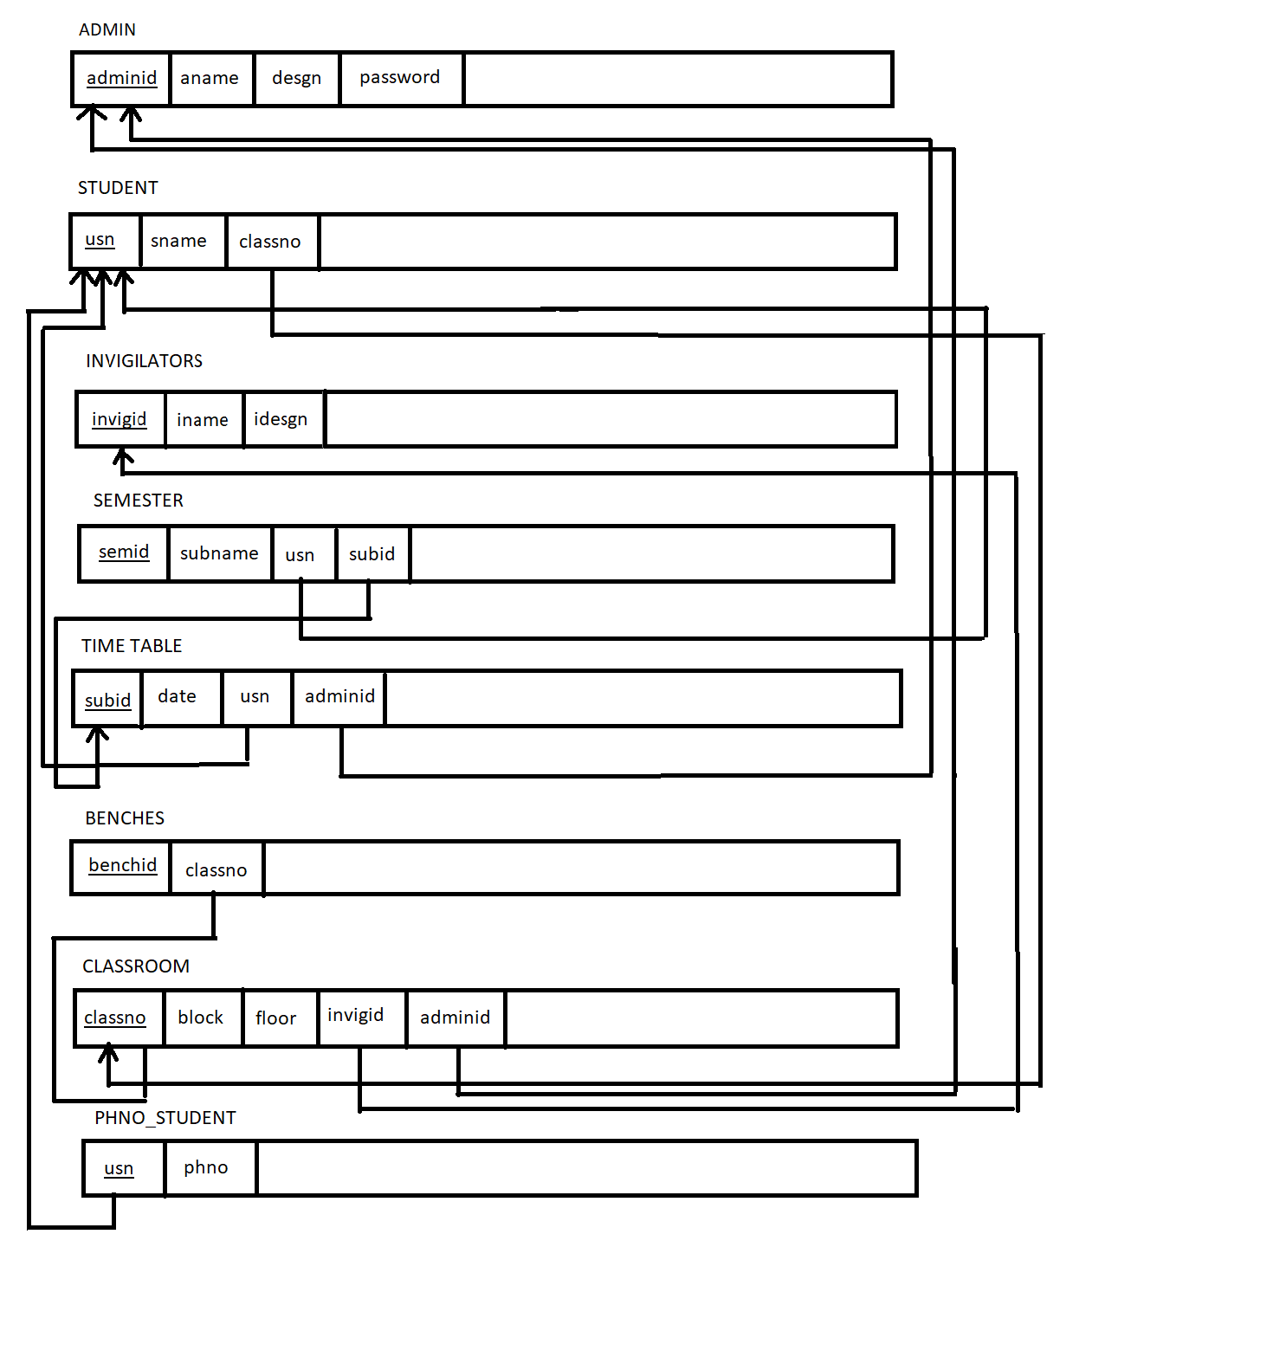

**TABLES DESCRIPTION :**

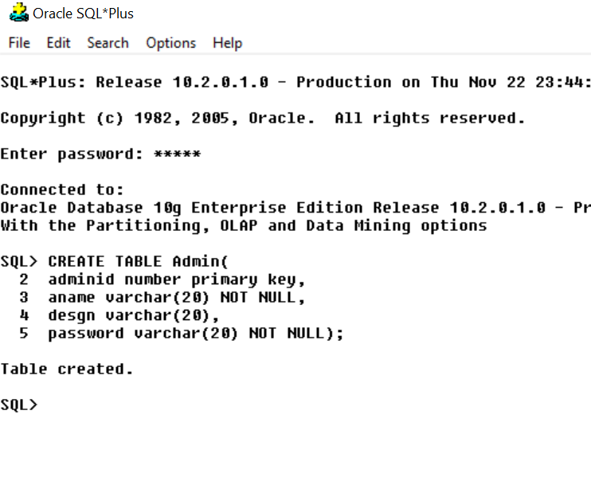

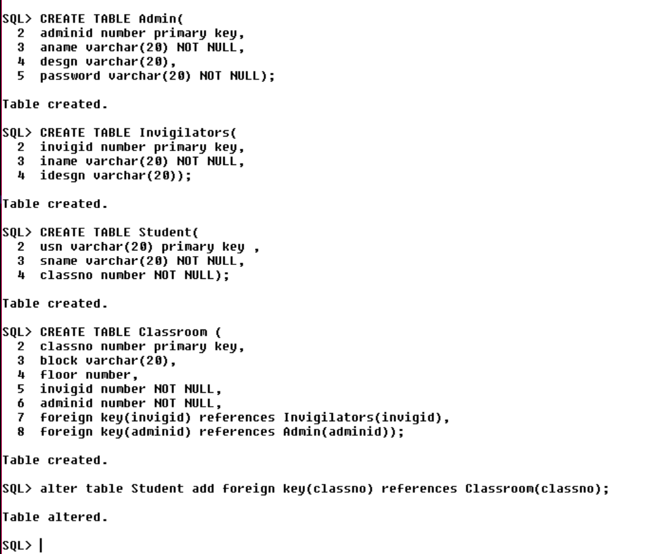

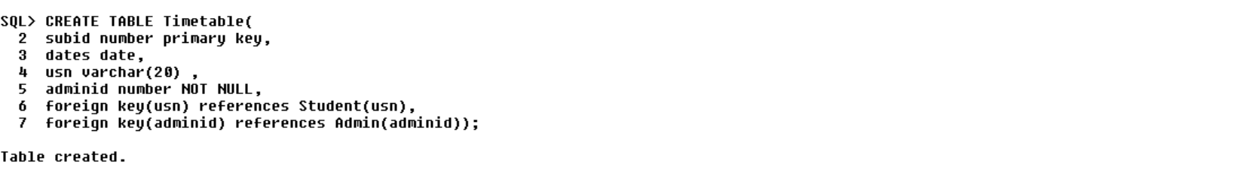

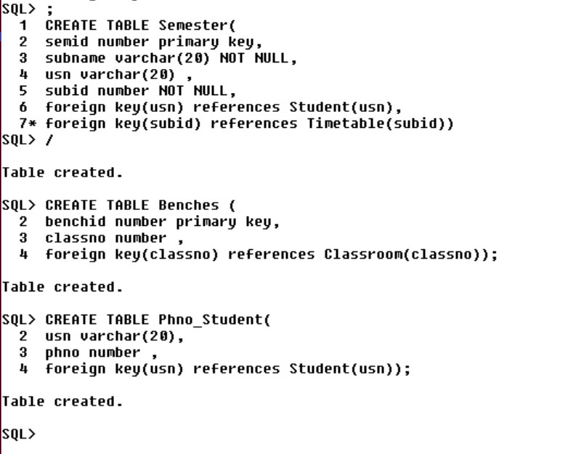

**SCHEMA DESCRIPTION :**

* There are 8 tables : Entities namely – Student, Admin, Invigilators, Classroom, Benches, Timetable, Semester and Phno_Student.
* In Admin table : There are 4 attributes, adminid being the primary key.
* In Student table : There are 3 attributes, usn being the primary key and classno is the foreign key referencing the table Classroom.
* In Classroom table, there are 5 attributes, classno being the primary key ,invigid and adminid being the foreign keys referencing the tables Invigilators and Admin respectively.
* In Invigilators table, there are 3 attributes, invigid being the primary key.
* In Bench table, there are 2 attributes where benchid is the primary key.
* In Semester table , there are 4 attributes where semid is the primary key, usn and subid are the foreign keys referencing Student and Timetable tables.
* In Timetable table, there are 4 attributes. subid is the primary key. usn and adminid are the foreign keys.
* In Phno_Student table, usn is the foreign key referencing Student table. This table is created as phno is a multivalued attribute in Student table.

**DATAFLOW DIAGRAM :**

USERS

INVIGILATOR

ADMIN

LOGIN

LOGIN

Views

CIE Timetable Management

Seating Management

Views

Invigilator Management

Views

LOGOUT