**Webserver and Web client**

**Test case:**

1. Server hosted on burrow.soic.indiana.edu and client on the laptop

Observed time taken for transferring 1 MB files(persistent connection):

Test 1:Time for one 1MB file: Total Time taken is 582859

Test 2:Time for two 1MB file: Total Time taken is 1060052

Test 3:Time for three 1MB file: Total Time taken is 1578384

Test 4:Time for four 1MB file: Total Time taken is 1385622

Test 5:Time for five 1MB file: Total Time taken is 3763950

Test 6:Time for six 1MB file: Total Time taken is 17009207

Test 7:Time for seven 1MB file: Total Time taken is 2219598

Test 8:Time for eight 1MB file: Total Time taken is 2588483

Test 9:Time for nine 1MB file: Total Time taken is 2939745

Test 10:Time for ten 1MB file: Total Time taken is 3825776

All times are in micro seconds

Does the time taken to service multiple requests grow linearly? Why or Why not?

We can see that there is a linear growth in time from Test 1 to 3, but a drop in Test 4, and exponential/abrupt increase in time in Test 5 and 6. Trends from Test 7 to 10 shows some amount of linearity. We can infer that the time to transfer highly varies on the network load/congestion along with server’s load.

**Test case:**

1. Server hosted on localhost and client on the laptop

Observed time taken for transferring 1 MB files(non-persistent connection):

Test 1:Time for one 1MB file: Total Time taken is 9809

Test 2:Time for two 1MB file: Total Time taken is 35124

Test 3:Time for three 1MB file: Total Time taken is 23589

Test 4:Time for four 1MB file: Total Time taken is 31444

Test 5:Time for five 1MB file: Total Time taken is 45382

Test 6:Time for six 1MB file: Total Time taken is 51721

Test 7:Time for seven 1MB file: Total Time taken is 67223

Test 8:Time for eight 1MB file: Total Time taken is 78930

Test 9:Time for nine 1MB file: Total Time taken is 83893

Test 10:Time for ten 1MB file: Total Time taken is 84002

All times are in micro seconds

**Test case:**

1. Server hosted on localhost and client on the laptop

Observed time taken for transferring 1 MB files(persistent connection):

Test 1:Time for one 1MB file: Total Time taken is 19625

Test 2:Time for two 1MB file: Total Time taken is 26963

Test 3:Time for three 1MB file: Total Time taken is 57847

Test 4:Time for four 1MB file: Total Time taken is 62898

Test 5:Time for five 1MB file: Total Time taken is 50166

Test 6:Time for six 1MB file: Total Time taken is 51721

Test 7:Time for seven 1MB file: Total Time taken is 67223

Test 8:Time for eight 1MB file: Total Time taken is 78930

Test 9:Time for nine 1MB file: Total Time taken is 83893

Test 10:Time for ten 1MB file: Total Time taken is 84002

All times are in micro seconds

**UDP based webserver and client: (localhost)**

**Run 1:**

*** Final Request being sent:GET /subtitleFile.txt HTTP/1.1

Host: localhost:8080

Connection: close

server_add::16777343

server_add_port::36895

server_add_family::2

Packet size less than 1000

***Total Length of content from the server:996383

***Total number of packets received from the server:**998**

Total Time taken is 16832

**Run 2:**

149-160-232-238:Debug supreeth$ ./udpWebClient localhost 8080 subtitleFile.txt

Starting the client

Entered processArgumentsAndCreateHttpRequest

Exit processArgumentsAndCreateHttpRequest

*** Final Request being sent:GET /subtitleFile.txt HTTP/1.1

Host: localhost:8080

Connection: close

server_add::16777343

server_add_port::36895

server_add_family::2

Packet size less than 1000

***Total Length of content from the server:941383

***Total number of packets received from the server:**943**

Total Time taken is 19940

I found out of order packets and missing packets also in Run 2. There is no much difference in performance as compared to TCP. The packet drop might have occurred due to multiple successive runs. It might occur when there is network congestion.

**Wireshark attachments:**

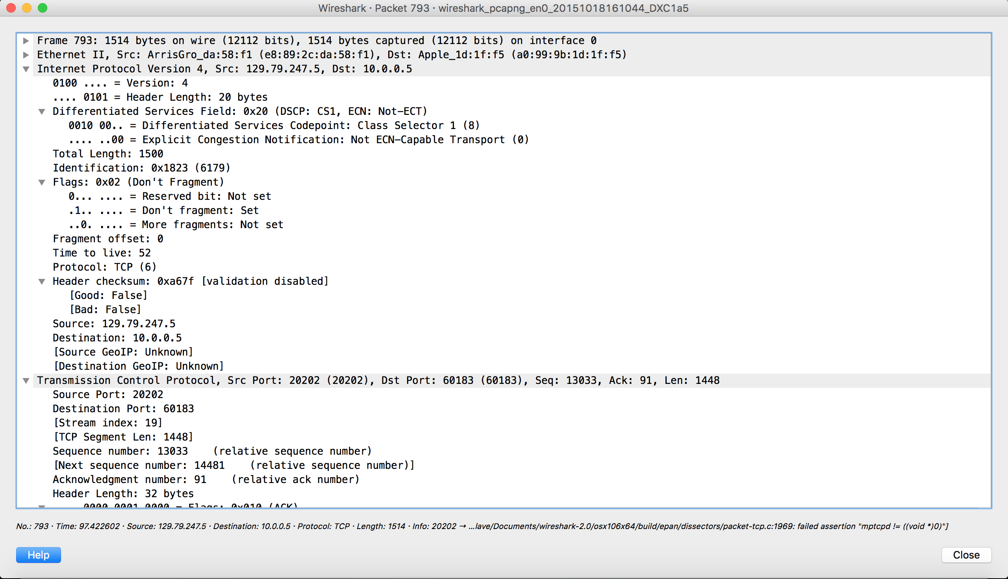

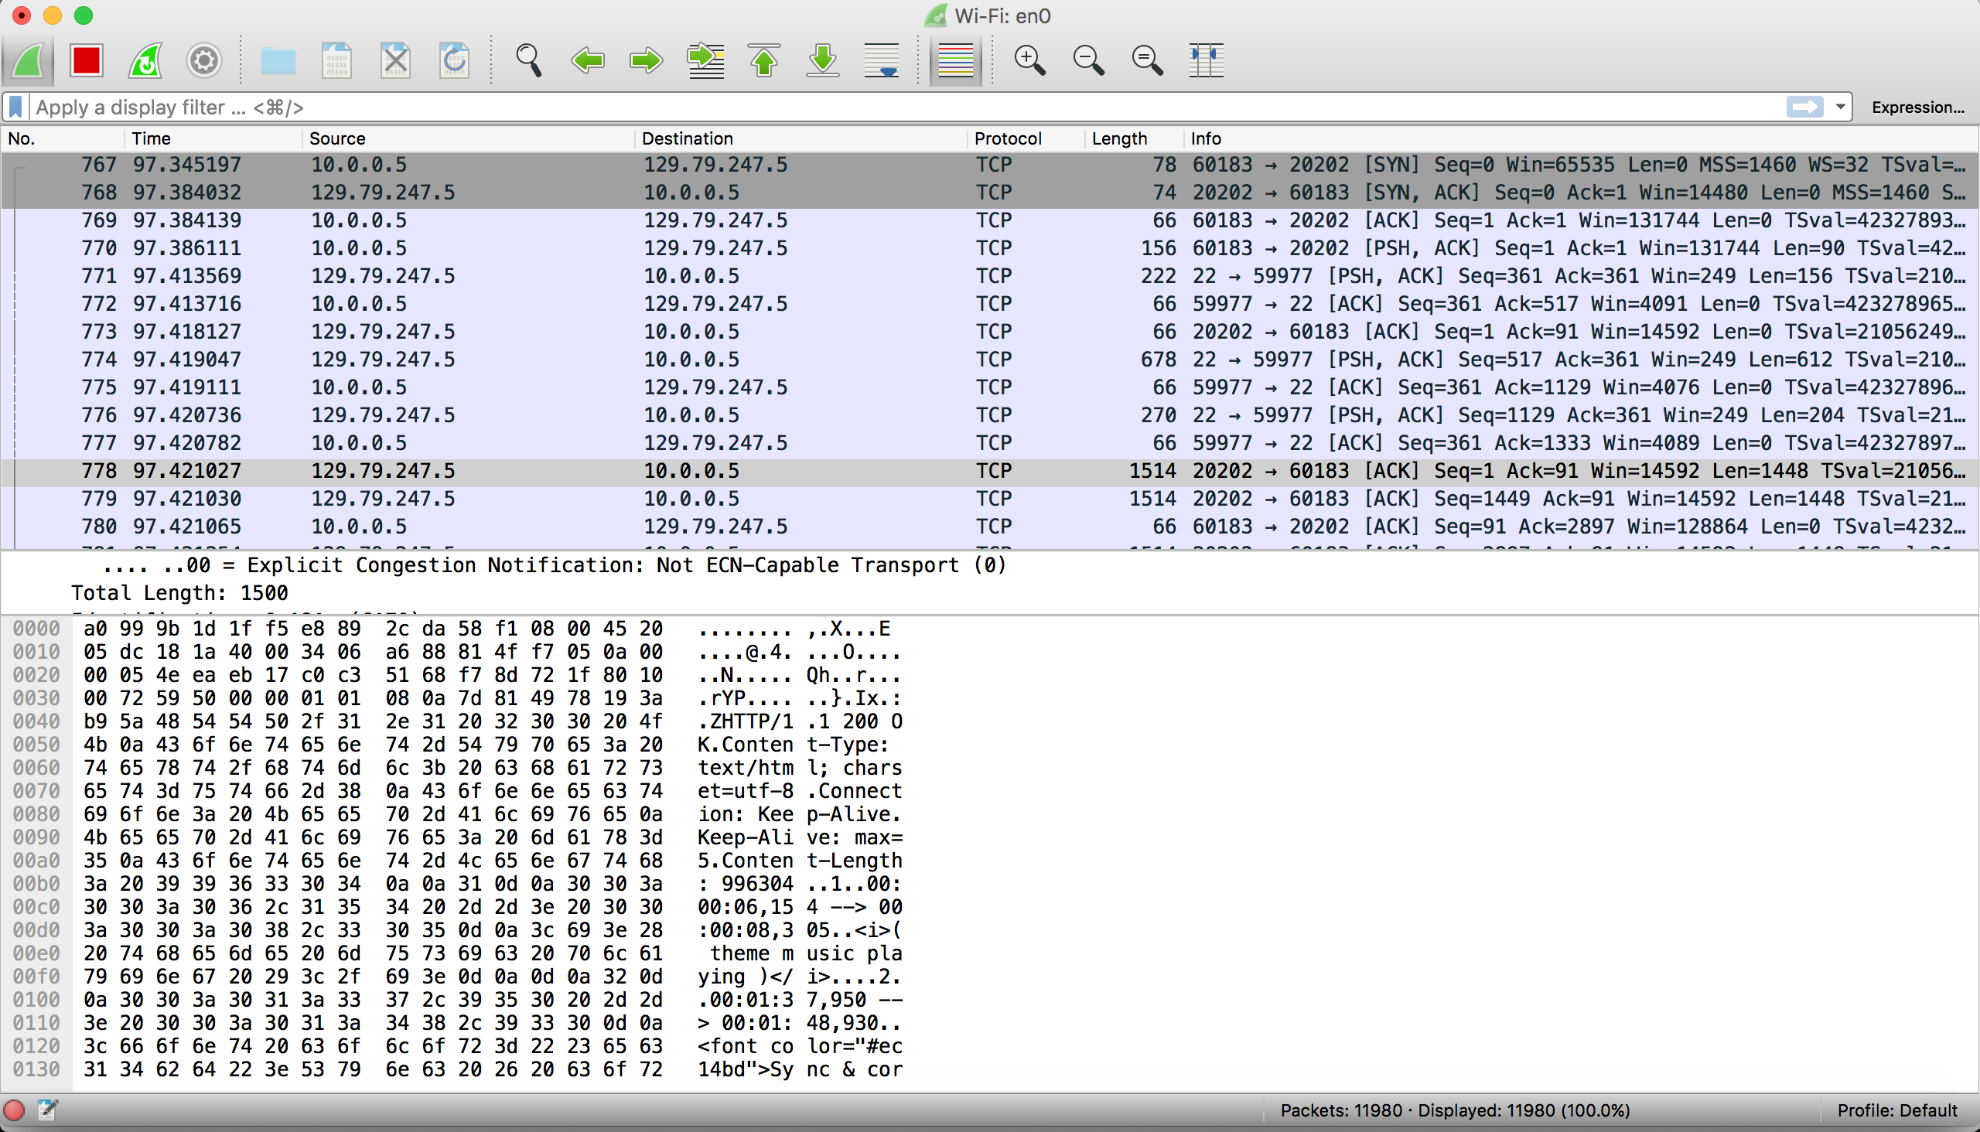

Details on the screenshots:

Server hosted on Burrow: 129.79.247.5

My Client(laptop) IP: 10.0.0.5

1st screenshot shows the IP and TCP header of a packet sent from server to client

2nd screenshot shows the actual packet between them