DAY14

Class Exercise 1

    @PostMapping("/employee")

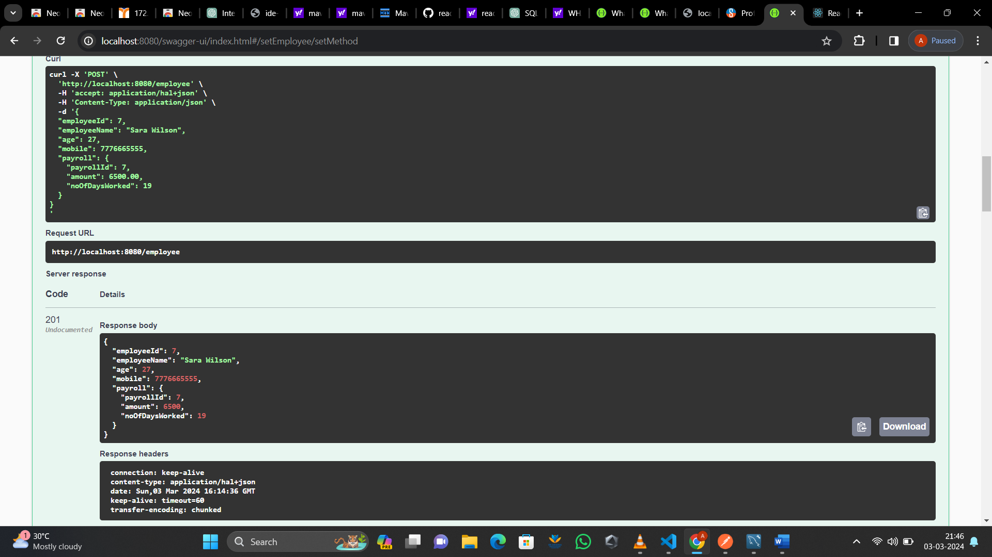

    @GetMapping("/employee")

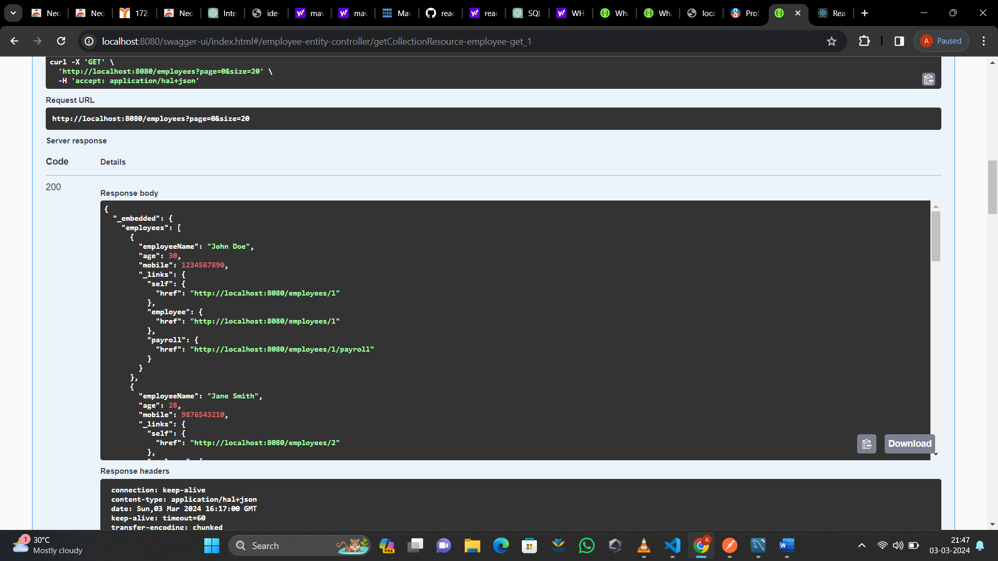

    @GetMapping("/employee/{employeeId}")

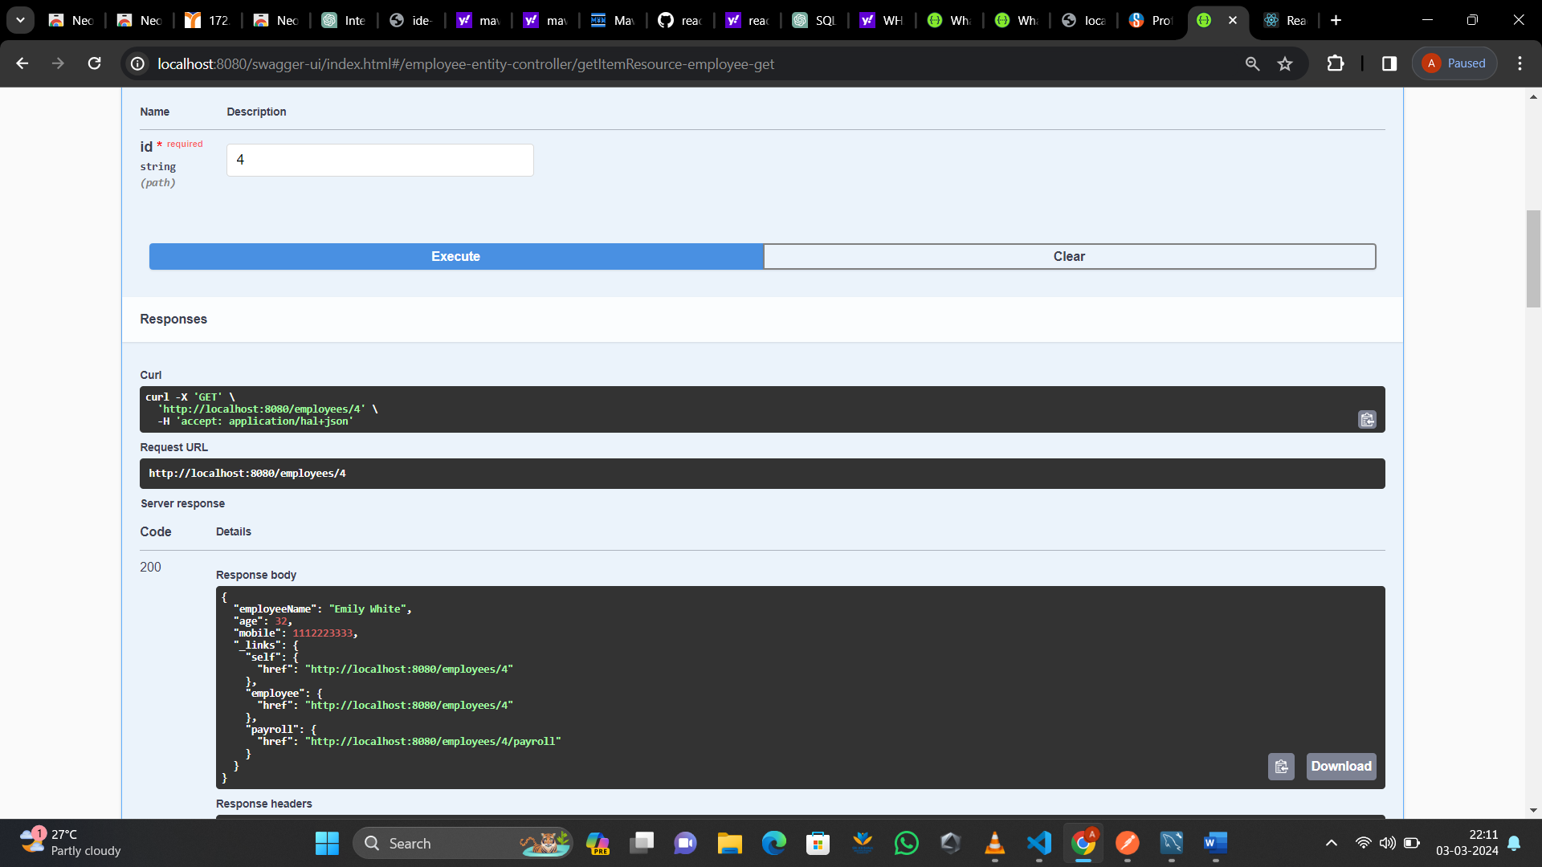

   @PostMapping("/employee/{id}/payroll")

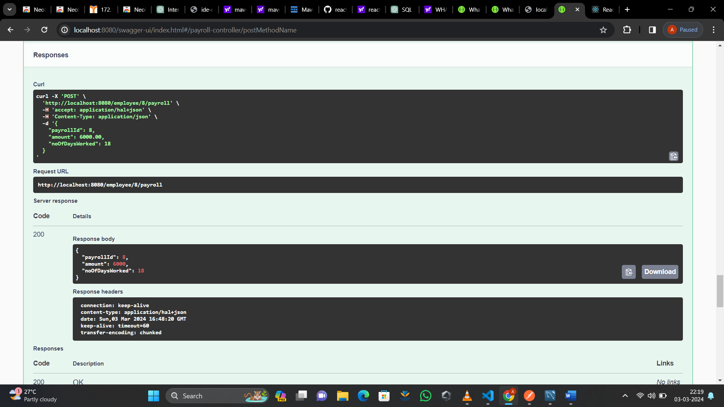

    @GetMapping("/employee/{id}/payroll")

