DAY14

Class Exercise 2

    @PostMapping("/api/book")

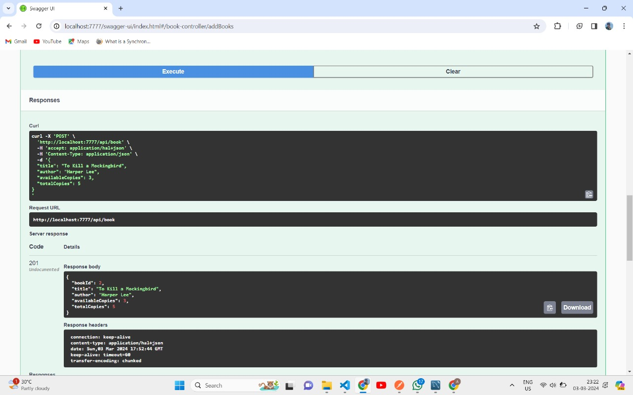

    @GetMapping("/api/book")

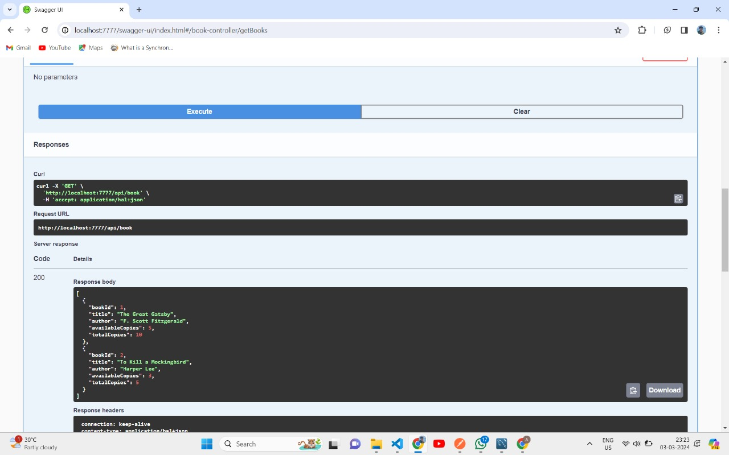

    @GetMapping("/api/book/{bookId}")

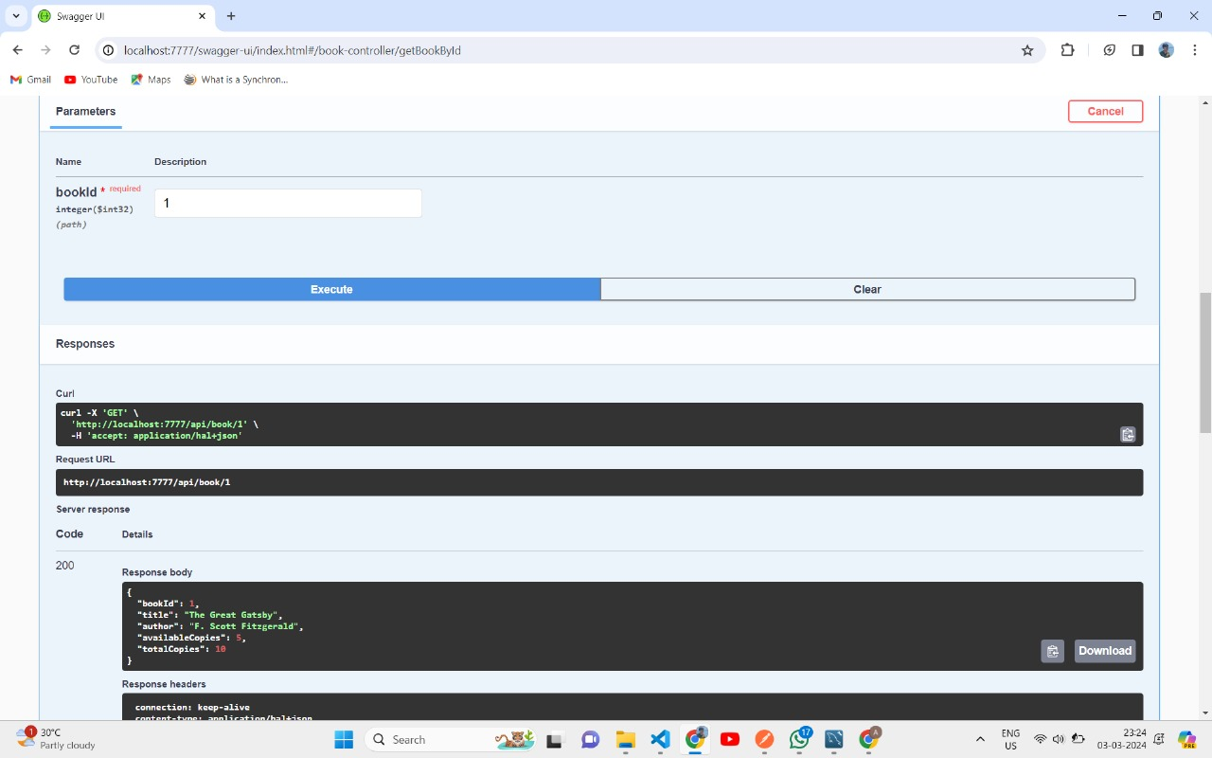

    @PutMapping("/api/book/{bookId}"

