DAY11

Class Exercise 2

    @PostMapping("/student")

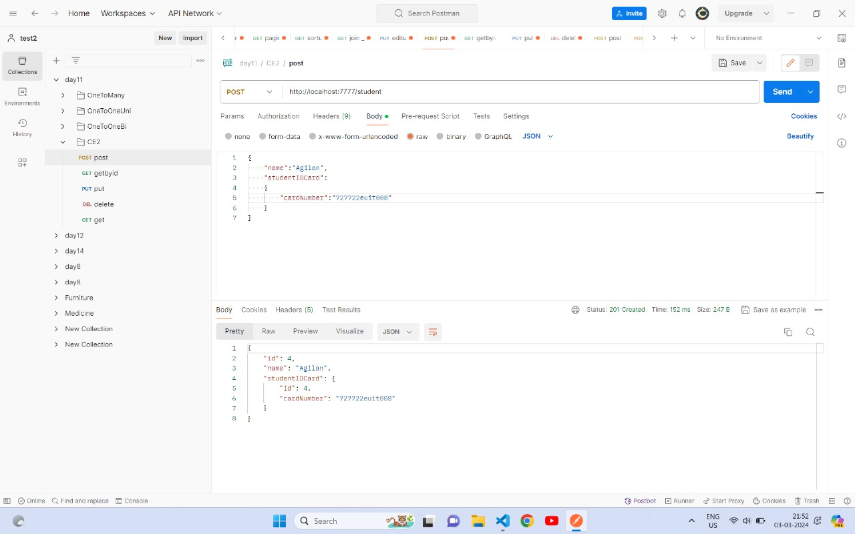

    @GetMapping("/student")

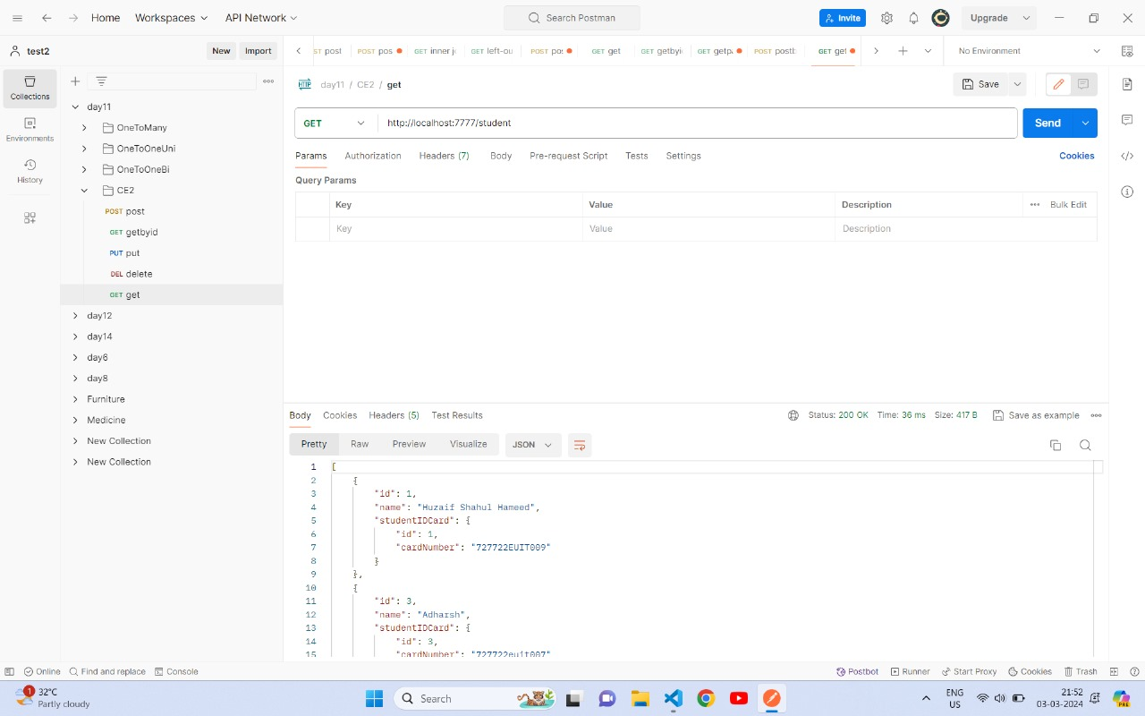

    @GetMapping("/student/{id}")

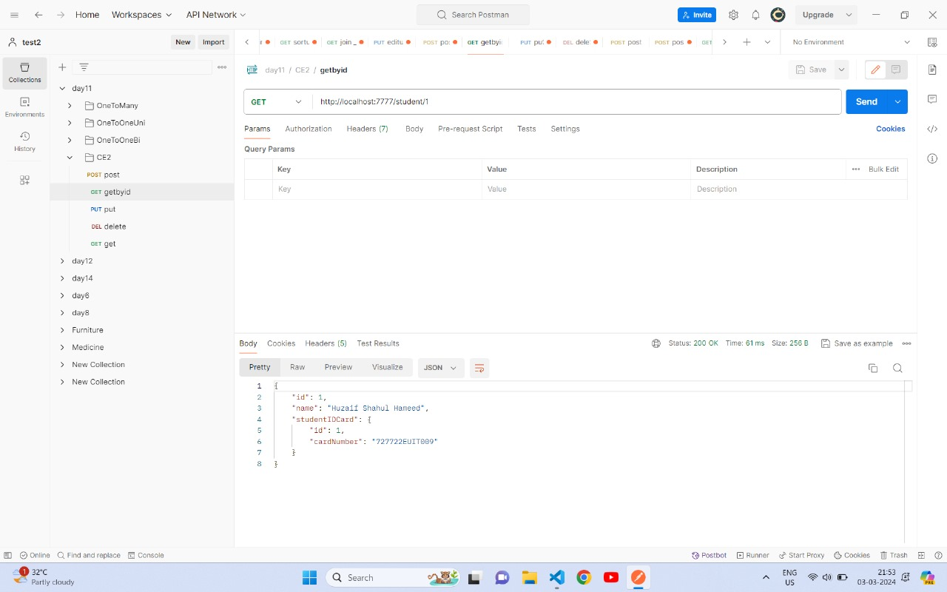

    @PutMapping("/student/{id}")

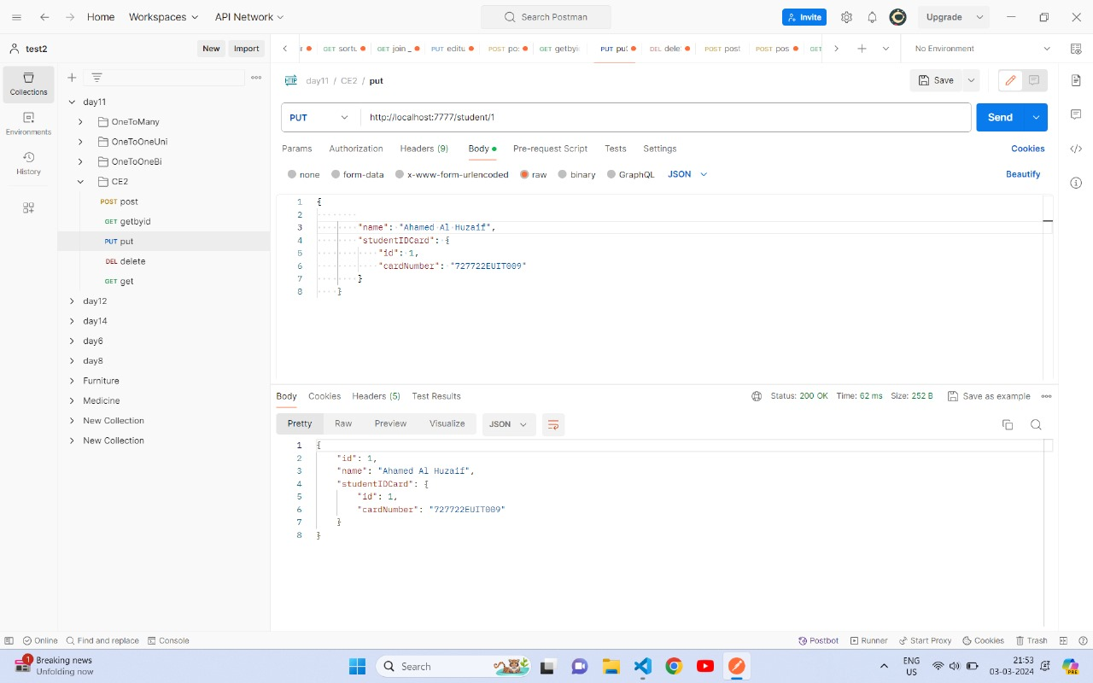

    @DeleteMapping("/student/{id}")

