**First Page:**

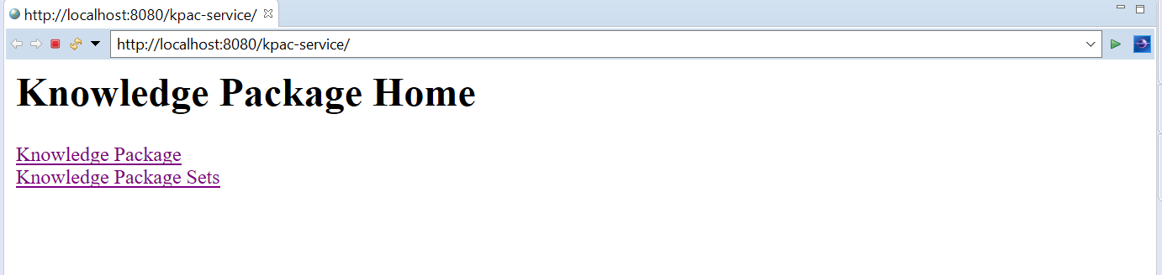

**Onclick of Knowledge Package:**

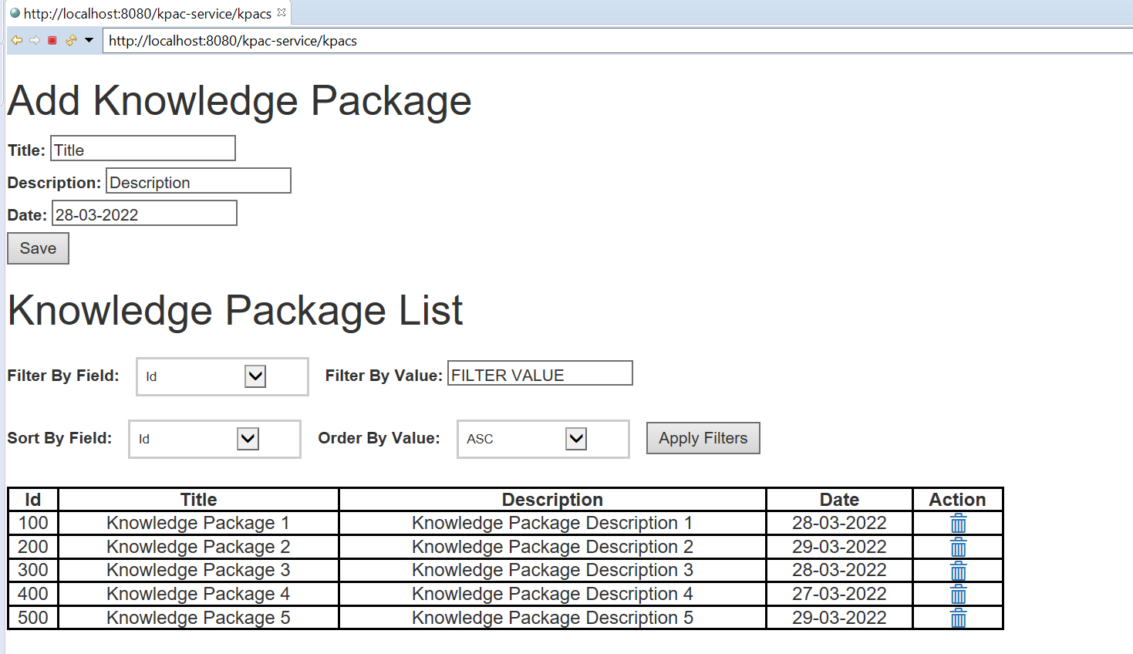

**Adding New Knowledge Package:**

On click on save (from above page):

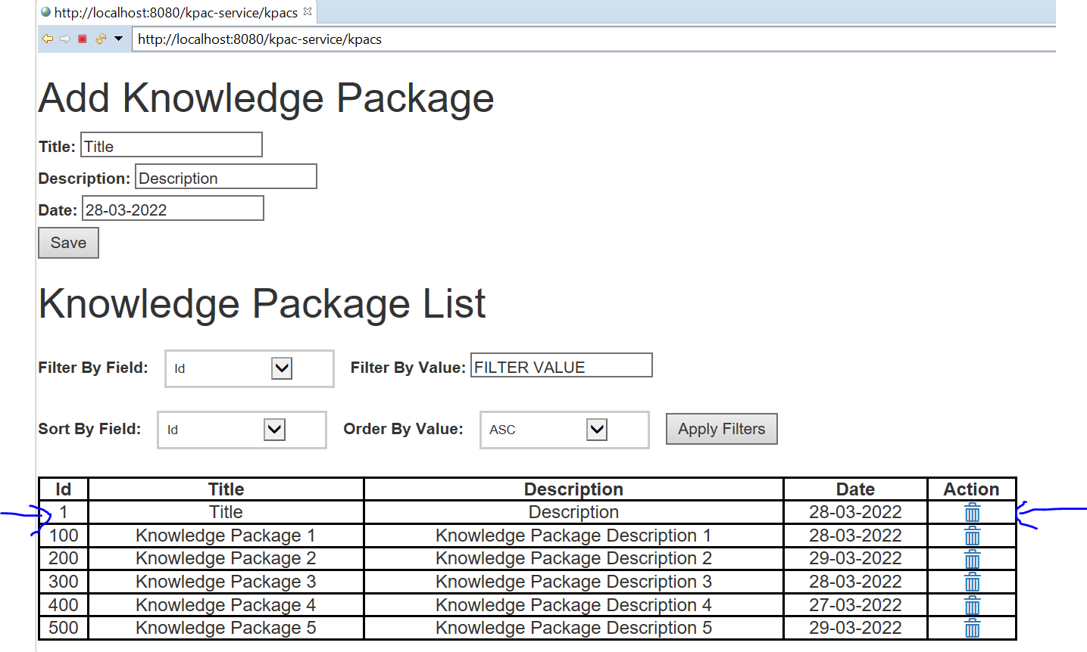

**Apply Filter:**

Example on Date: 28-03-2022 with sort on Tittle field in asc

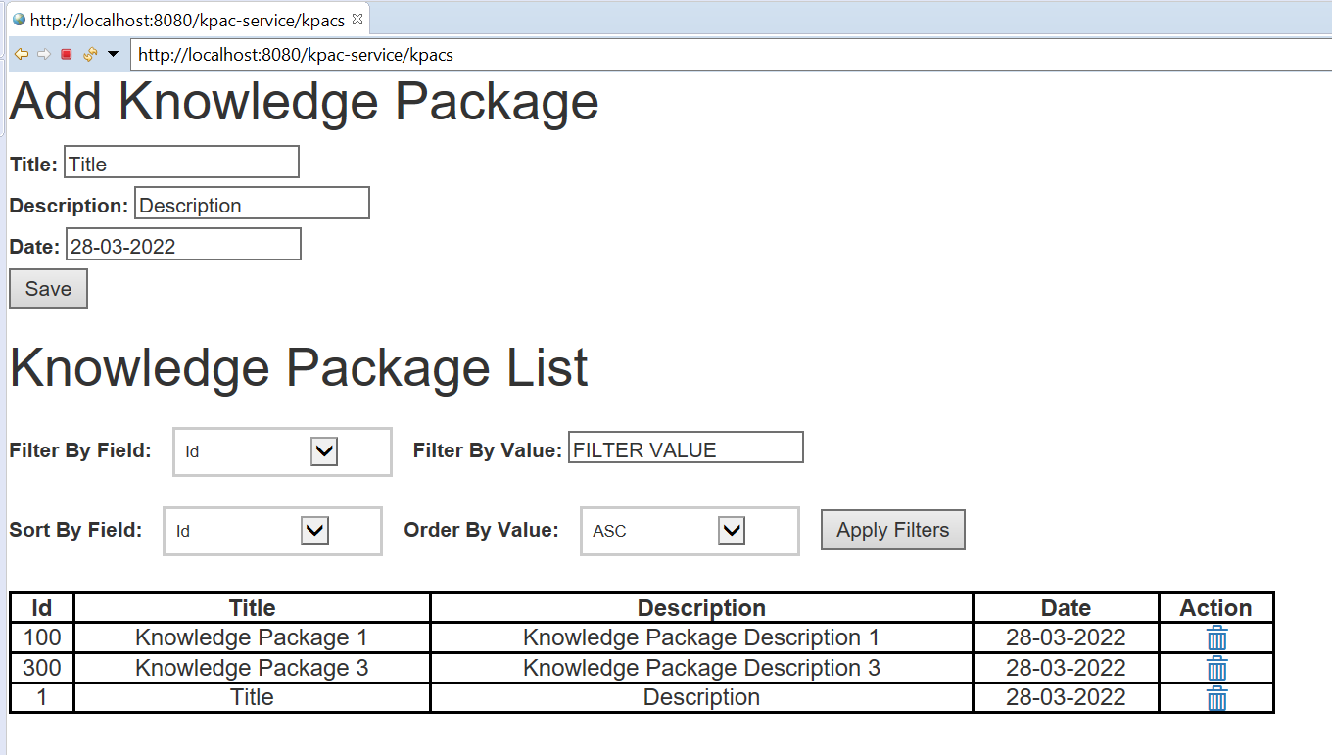

Example on Date: 28-03-2022 with sort on Tittle field in desc

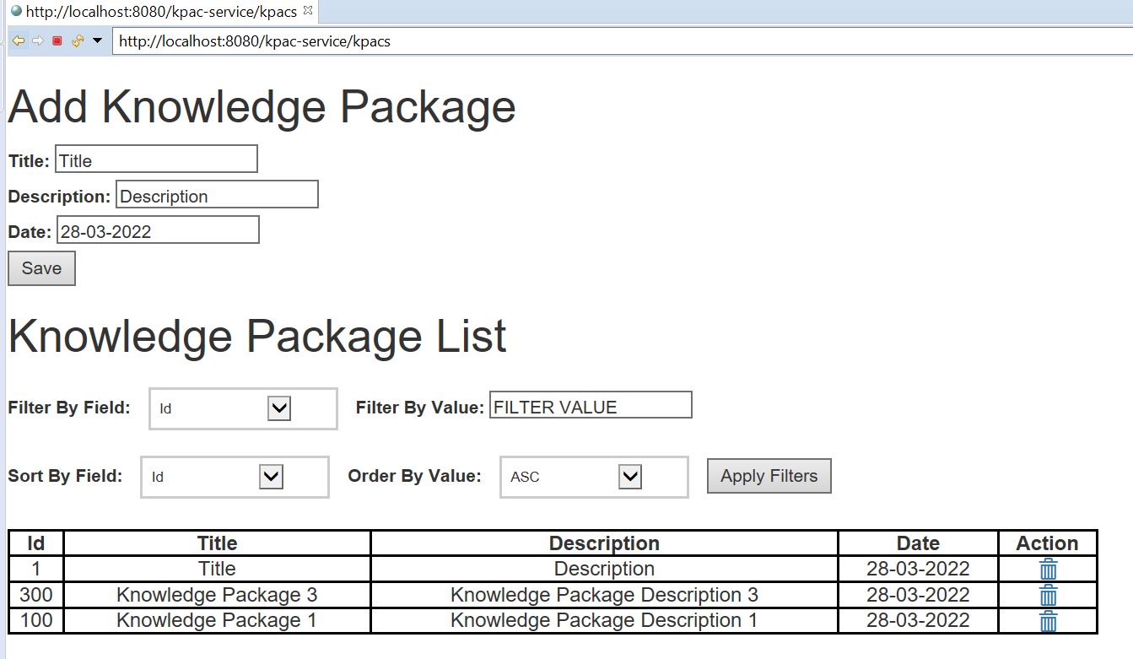

**Delete: with id:1 (removed from list see below)**

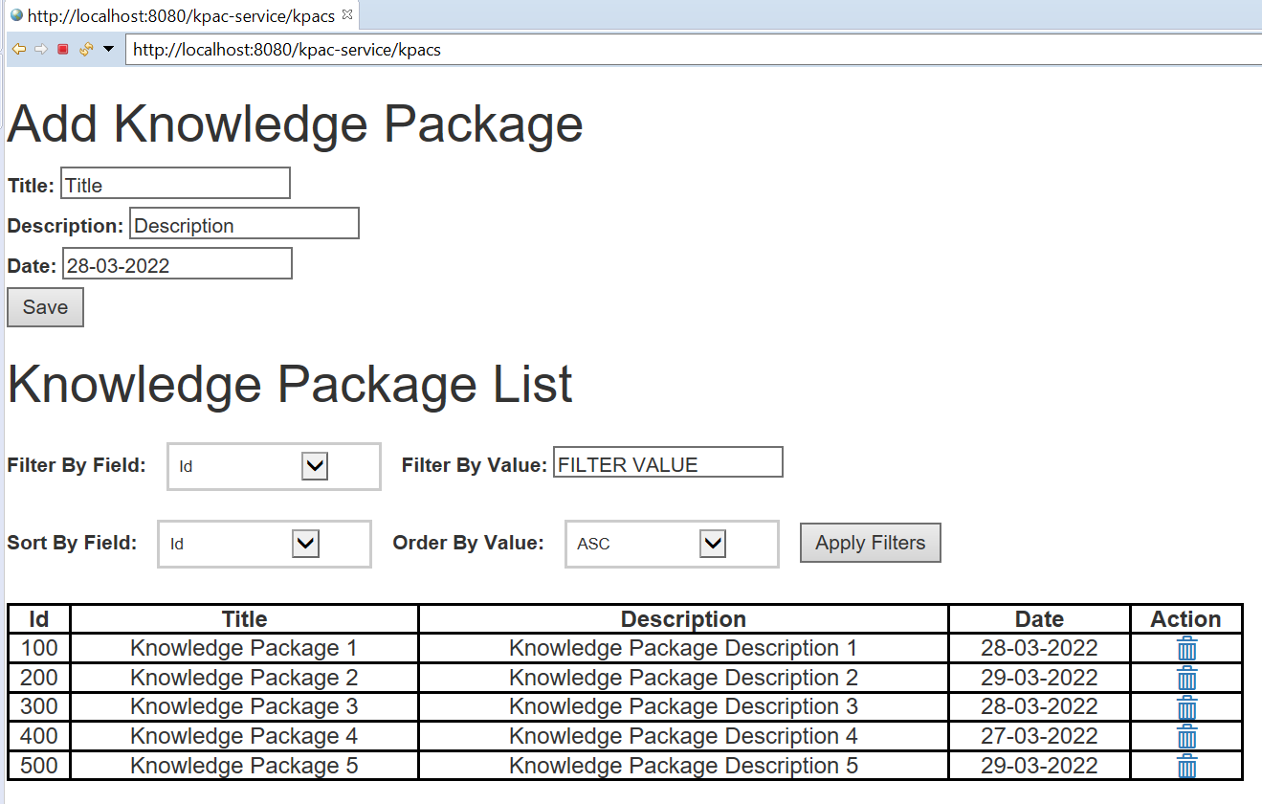

**Onclick of Knowledge Package Set:**

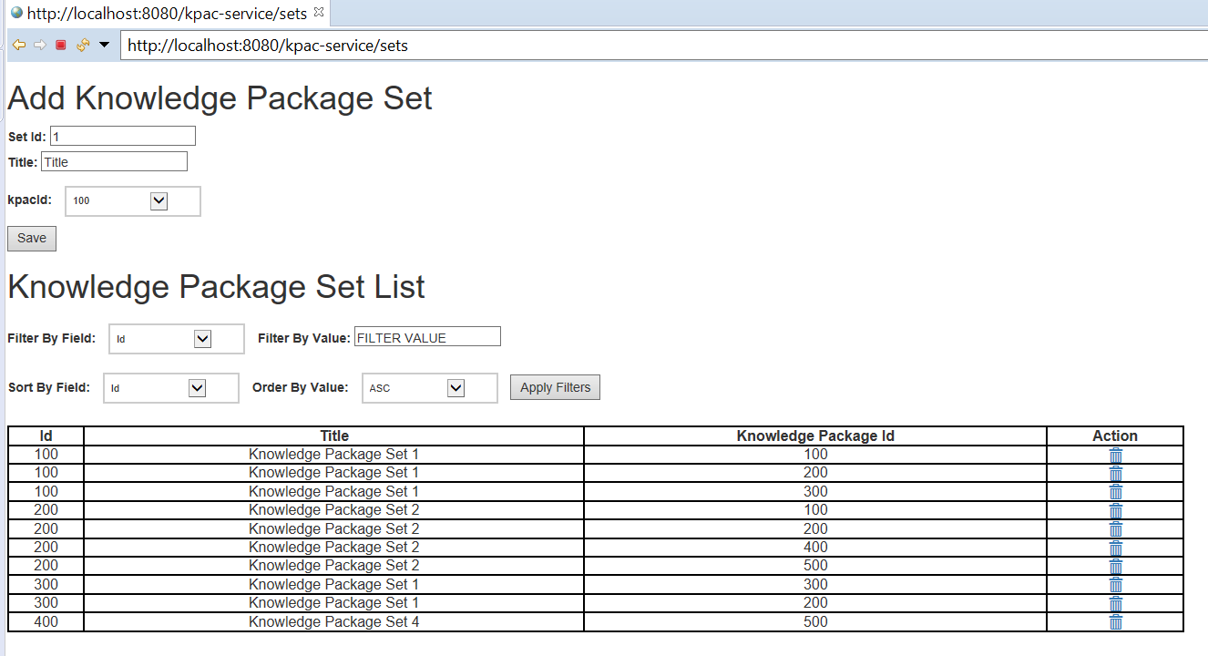

**Save Knowledge package set: onclick save button**

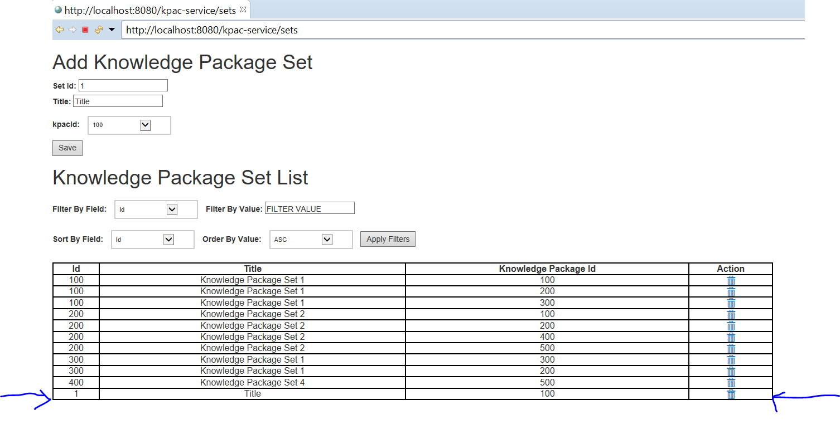

**On double click on table row 100, opens in new window:**

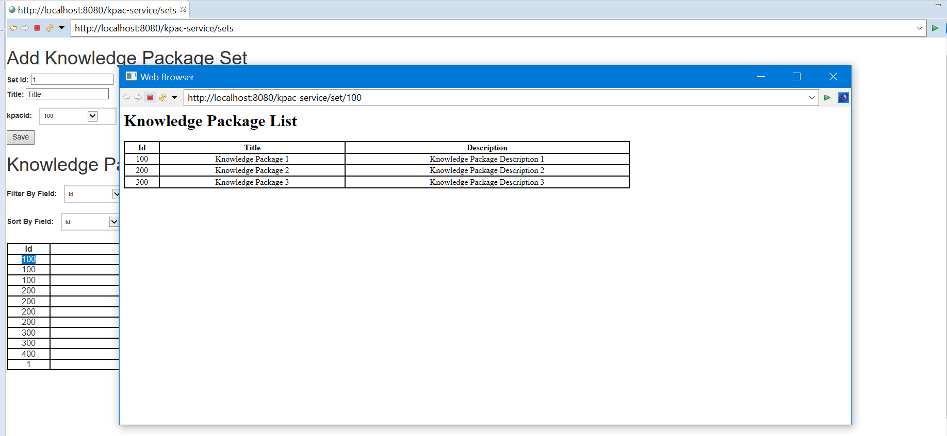

**Apply Filter:**

Example on Id: 100 with sort on Tittle field in asc

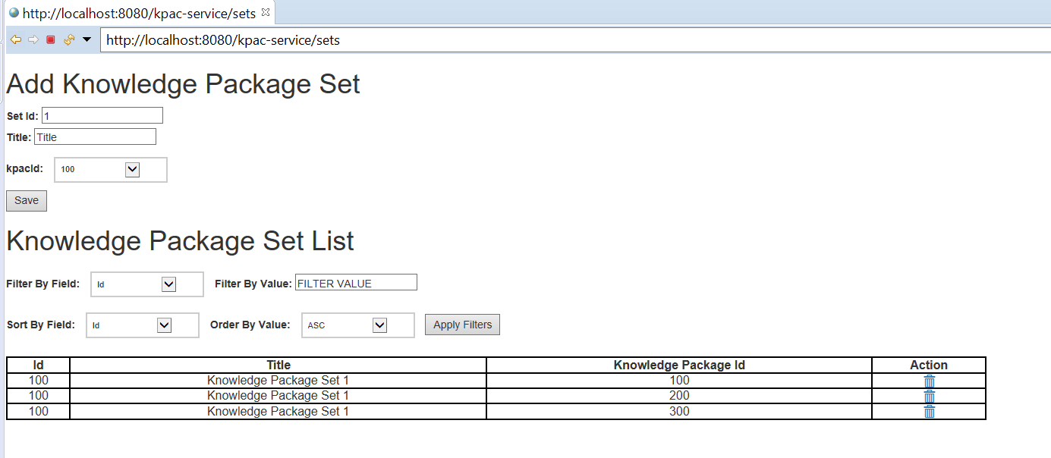

Example: filter on Tittle: Knowledge Package Set 1, sort on id desc order

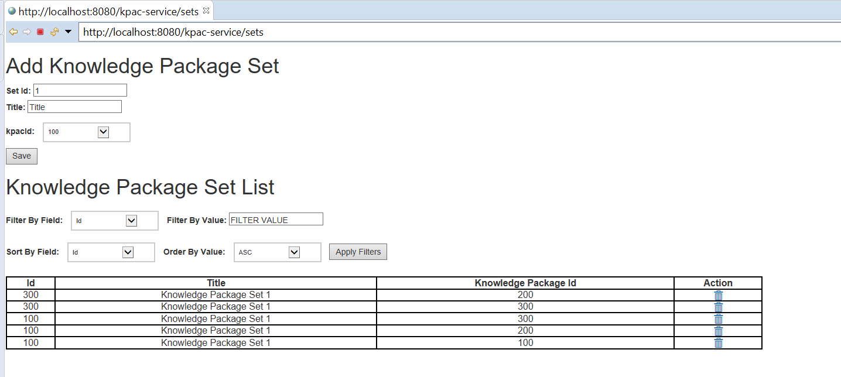

**Delete: Kpac set id 1, kpac set id 1 removed**

