**Chapter 4**

**RESULTS AND DISCUSSION**

This chapter represents the discussion of evaluation in terms of evaluation metrics, evaluation result and analysis and synthesis. The results were distinguished if the comparison of database help to improve and show which database are efficient and efficiency in a mobile environment.

**Evaluation Metrics**

The researchers conducted evaluation of the data gathered in testing procedure and analyzed how the MySQL and Firebase will had be a big impact in real-time database for GARDGIA application such as query process by computing the speed and accuracy of creating, updating, retrieving the data from speed of internet connection. The researcher will evaluate the procedure from simple query to huge data. The researchers conducted two different tests and different scenarios on insert, update, and delete operations. On the first test, the researchers used two tables to determine the result of the test.

**Evaluation Result**

The researchers analyze and test which more efficient and effectively used for GARDGIA application. The researchers test both database base on the query process, speed and accuracy of retrieving the data.

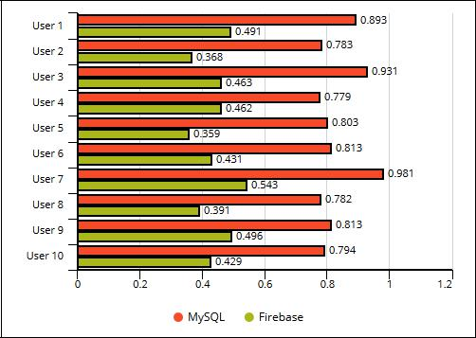

**Figure 3. Multiple Access Select Records**

The figure above shows testing of multiple access of users in selecting 1000 records in MySQL and Firebase. Each database tested in selecting records by different user at the same time. Researchers notice that firebase spends less time than MySQL.

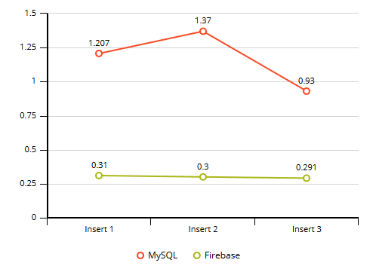

**Figure 4. Insert Record Test 1 Scenario in Android Lollipop**

In this figure, it shows the time execution of the insert operation of both MySQL and Firebase in android device with version of 5.1 Lollipop with the processor speed of 1.3GHz and 2GB of RAM. Each database tested the insert operation three times. The results in the first, second and third time in MySQL are 1.207, 1.370, and 0.930 milliseconds respectively, while in Firebase the results are all 0.310, 0.300 and 0.291 milliseconds. Figure 4 shows that there are big differences in times between MySQL and Firebase in executing insert operation in two tables/objects named dropoffsite and dropofflsite_loc.

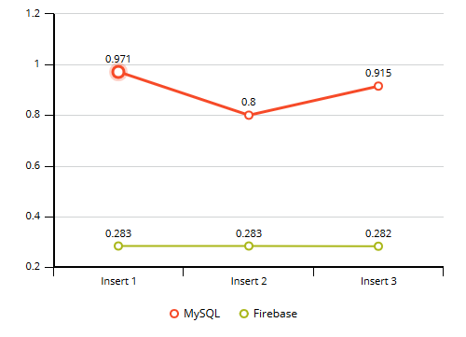

**Figure 5. Insert Record Test 1 Scenario in Android Nougat**

In this figure, it shows the time execution of the insert operation of both MySQL and Firebase in android device with version of Nougat 7.0 Nougat with the processor speed of 1.6GHz and 4GB of RAM. Each database tested the insert operation three times. The results in the first, second and third time in MySQL are 0.971, 0.800, and 0.915 milliseconds respectively, while in Firebase the results are all 0.283, 0.283 and 0.282 milliseconds. Figure 5 shows that there are big differences in times between MySQL and Firebase in executing insert operation in two tables/objects named dropoffsite and dropofflsite_loc.

Researchers analyze the test in two devices with different Android version and RAM memory. It shows that the insert operation in higher version of android like nougat can execute insert operation in small time than Lollipop version.

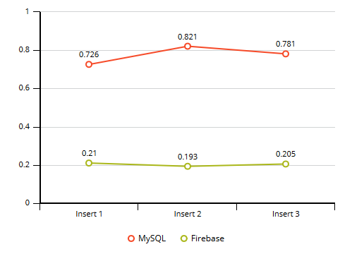

**Figure 6. Insert Record Test 2 Scenario in Android Lollipop**

In this figure, it shows the time execution of the insert record of user in both MySQL and Firebase in an android device with version of 5.1 Lollipop with the processor speed of 1.3GHz and 2GB of RAM. Each database tested the insert operation three times. The results in the first, second and third time in MySQL are 0.726, 0.821, and 0.781 milliseconds respectively, while in Firebase the results are all 0.210, 0.193 and 0.205 milliseconds. Figure 6 shows that there are big differences in times between MySQL and Firebase in executing Insert Operation.

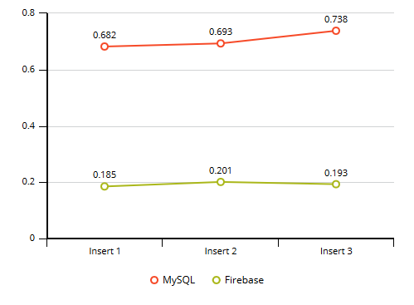

**Figure 7. Insert Record Test 2 Scenario in Android Nougat**

In this figure, it shows the time execution of the insert record of user in both MySQL and Firebase in an android device with version of 7.0 Nougat with the processor speed of 1.6GHz and 4GB of RAM. Each database tested the insert operation three times. The results in the first, second and third time in MySQL are 0.682, 0.693, and 0.738 milliseconds respectively, while in Firebase the results are all 0.185, 0.201 and 0.193 milliseconds. Figure 7 shows that there are big differences in times between MySQL and Firebase in executing insert operation in one table/object named user.

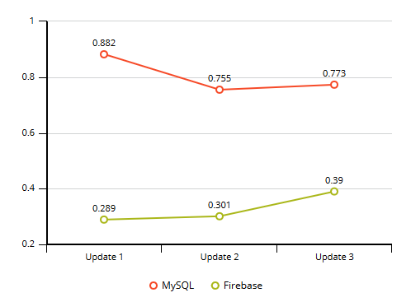

**Figure 8. Update Record Test 1 Scenario in Android Lollipop**

In this figure, it shows the time execution of the update operation of both MySQL and Firebase in android device with version of 5.1 Lollipop with the processor speed of 1.3GHz and 2GB of RAM. Each database tested the update operation three times. The results in the first, second and third time in MySQL are 0.882, 0.755, and 0.773 milliseconds respectively, while in Firebase the results are all 0.289, 0.301 and 0.390 milliseconds. Figure 8 shows that there are big differences in times between MySQL and Firebase in executing update operation in two tables/objects named user and user_loc.

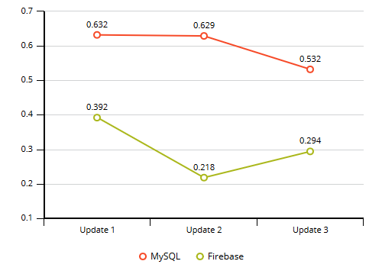

**Figure 9. Update Record Test 1 Scenario in Android Nougat**

In this figure, it shows the time execution of the insert operation of both MySQL and Firebase in android device with version of Nougat 7.0 Nougat with the processor speed of 1.6GHz and 4GB of RAM. Each database tested the update operation three times. The results in the first, second and third time in MySQL are 0.632, 0.629, and 0.532 milliseconds respectively, while in Firebase the results are all 0.392, 0.218 and 0.294 milliseconds. Figure 9 shows that there are big differences in times between MySQL and Firebase in executing update operation in two tables/objects named user and user_loc.

Researchers analyze the test in two devices with different Android version. It shows that the update operation in higher version of android like nougat can execute update operation in small time than Lollipop version.

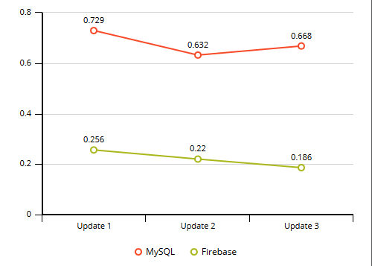

**Figure 10. Update Record Test 2 Scenario in Android Lollipop**

In this figure, it shows the time execution of the update record of user name in both MySQL and Firebase in an android device with version of 5.1 Lollipop with the processor speed of 1.3GHz and 2GB of RAM. Each database tested the update operation three times. The results in the first, second and third time in MySQL are 0.882, 0.755, and 0.773 milliseconds respectively, while in Firebase the results are all 0.289, 0.301 and 0.390 milliseconds. Figure 10 shows that there are big differences in times between MySQL and Firebase in executing update operation in one table/object named user.

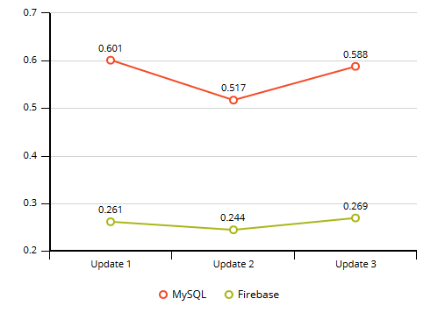

**Figure 11. Update Record Test 2 Scenario in Android Nougat**

In this figure, it shows the time execution of the update record of user name in both MySQL and Firebase in an android device with version of 7.0 Nougat with the processor speed of 1.6GHz and 4GB of RAM. Each database tested the update operation three times. The results in the first, second and third time in MySQL are 0.729, 0.632, and 0.668 milliseconds respectively, while in Firebase the results are 0.256, 0.220 and 0.186 milliseconds. Figure 11 shows that there are big differences in times between MySQL and Firebase in executing update operation in one table/object named user.

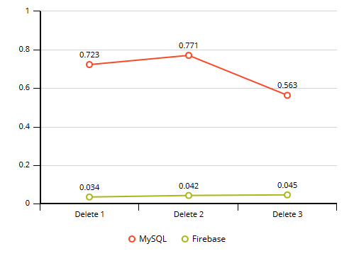

**Figure 12. Delete Record Test 1 Scenario in Android Lollipop**

In this figure, it shows the time execution of the delete operation of both MySQL and Firebase in android device with version of 5.1 Lollipop with the processor speed of 1.3GHz and 2GB of RAM. Each database tested the delete operation three times. The results in the first, second and third time in MySQL are 0.723, 0.771 and 0.563 milliseconds respectively, while in Firebase the results are all 0.034, 0.042 and 0.045 milliseconds. Figure 12 shows that there are big differences in times between MySQL and Firebase in executing delete operation in two tables/objects named dropoffsite and dropoffsite_loc.

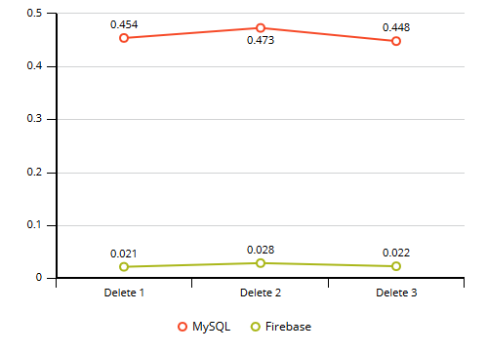

**Figure 13. Delete Record Test 1 Scenario in Android Nougat**

In this figure, it shows the time execution of the delete operation of both MySQL and Firebase in android device with version of Nougat 7.0 Nougat with the processor speed of 1.6GHz and 4GB of RAM. Each database tested the delete operation three times. The results in the first, second and third time in MySQL are 0.454, 0.473 and 0.448 milliseconds respectively, while in Firebase the results are all 0.021, 0.028 and 0.022 milliseconds. Figure 13 shows that there are big differences in times between MySQL and Firebase in executing delete operation in two tables/objects named dropoffsite and dropoffsite_loc.

Researchers analyze the test in two devices with different Android version. It shows that the insert operation in higher version of android like nougat can execute delete operation in small time than Lollipop version.

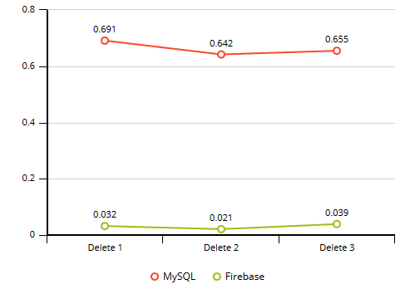

**Figure 14. Delete Record Test 2 Scenario in Android Lollipop**

In this figure, it shows the time execution of the delete record of user account in both MySQL and Firebase in an android device with version of Lollipop with the processor speed of 1.3GHz and 2GB of RAM. Each database tested the delete operation three times. The results in the first, second and third time in MySQL are 0.691, 0.642 and 0.655 milliseconds respectively, while in Firebase the results are all 0.032, 0.021 and 0.039 milliseconds. Figure 14 shows that there are big differences in times between MySQL and Firebase in executing delete operation in one table/object named user.

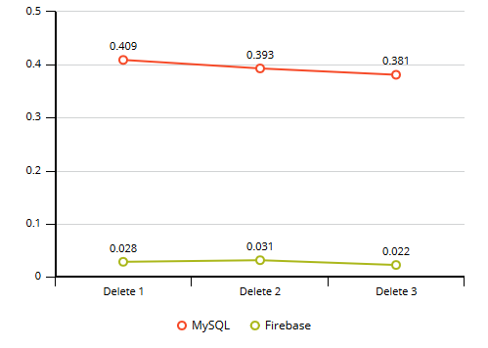

**Figure 15. Delete Record Test 2 Scenario in Android Nougat**

In this figure, it shows the time execution of the delete record of user account in both MySQL and Firebase in an android device with version of Nougat 7.0 Nougat with the processor speed of 1.6GHz and 4GB of RAM. Each database tested the delete operation three times. The results in the first, second and third time in MySQL are 0.409, 0.393 and 0.381 milliseconds respectively, while in Firebase the results are 0.021, 0.028 and 0.022 milliseconds. Figure 15 shows that there are big differences in times between MySQL and Firebase in executing delete operation in one table/object named user.

**Analysis and Synthesis**

The researchers came up to test GARDGIA application in different device with testing procedure from simple query process in four basic operations.

The select operation by multiple access of 10 users were executed by MySQL and Firebase. From the graphs, the researchers notice that Firebase spends less time than MySQL, for performing select operations.

In insert operation, update and delete operation of MySQL and Firebase it shows that higher version of android phone has the capability to execute operation in small amount of time. If device need to work online, Processor and RAM of the phone have big factor and can affect the performance in executing process or task in android device. It also advantages to android phone with large RAM size.

The researchers analyze the overall test procedure and found out that Firebase provided lower execution times than MySQL in all four basic operations, and also in multiple access. Thus, the above comparison, proves that for Firebase has a good performance and it is preferred over MySQL based on GARDGIA’s application.

**Survey**

The researchers conducted a survey to able to understand which database are popular or commonly used in mobile application. The researchers invited IT Students and IT Professional who have already learn and use Firebase to answer the survey form regarding in the study. It helps the researchers to analyze which database can benefit to use in project such as mobile application by IT students and IT Professional.

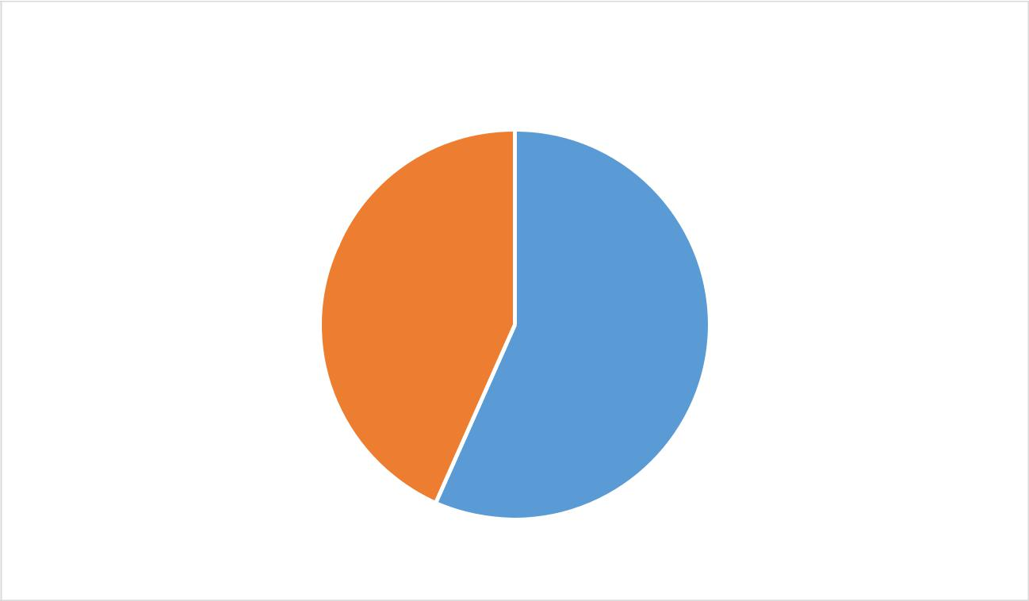

Which database is easy to use when it comes to writing

queries?

 MySQL  Firebase

**Figure 16. Results of Discussion in Writing Queries**

Evaluators evaluated that MySQL are better in writing queries with the ratings of 56.7% than Firebase with the rating of 43.3%.

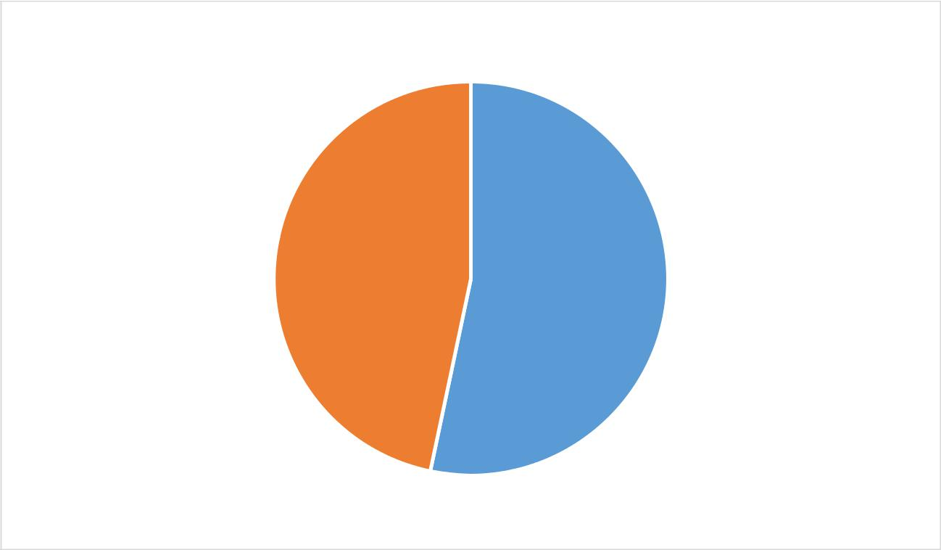

Which database is easy to learn?

MySQL  Firebase

**Figure 17. Results of Discussion in Learnability**

When it comes to learnability, MySQL give ratings of 53.3% and Firebase

with ratings of 46.7%.

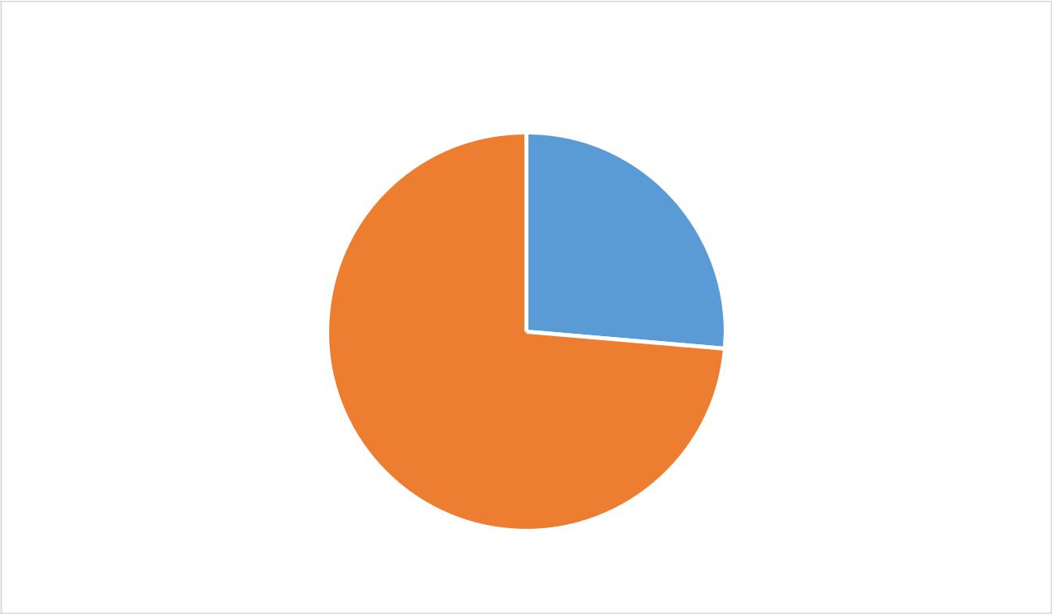

Which database is easy to integrate when it comes to

building a mobile application?

MySQL  Firebase

**Figure 18. Results of Discussion in Building Mobile application**

Evaluators respond that Firebase with the ratings of 83.3% has better in building mobile application with easy integration than MySQL with the ratings 16.7 %.

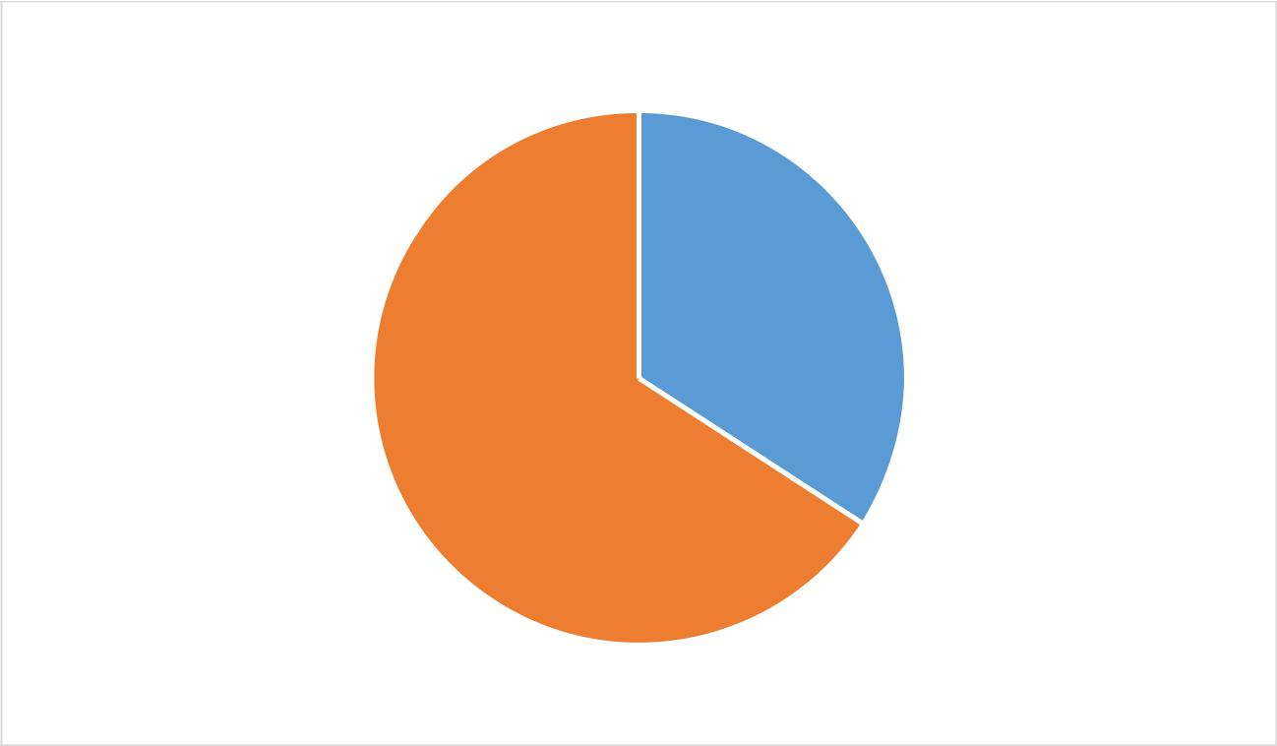

Which database has a better maintainability features?

MySQL  Firebase

**Figure 19. Results of Discussion in Maintainability**

When it comes to capability of maintainability, both group give MySQL ratings of 43.3% while Firebase ratings of 56.7%.

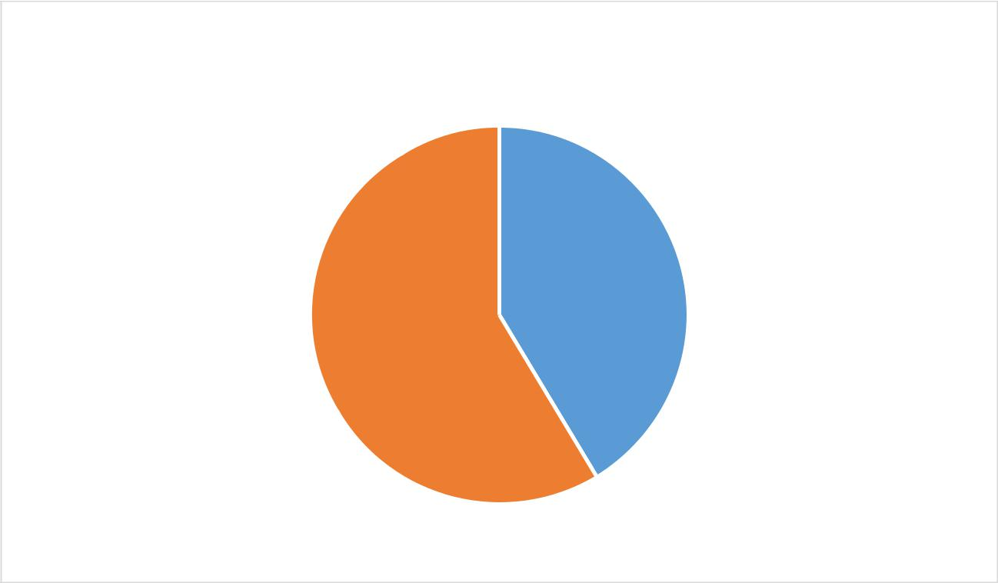

Which database has a better compatibility when it used in

different android OS version?

MySQL  Firebase

**Figure 20. Results of Discussion in Compatibility**

Both groups evaluated that Firebase with the ratings of 60% has better

compatibility in different android version than MySQL with 40%.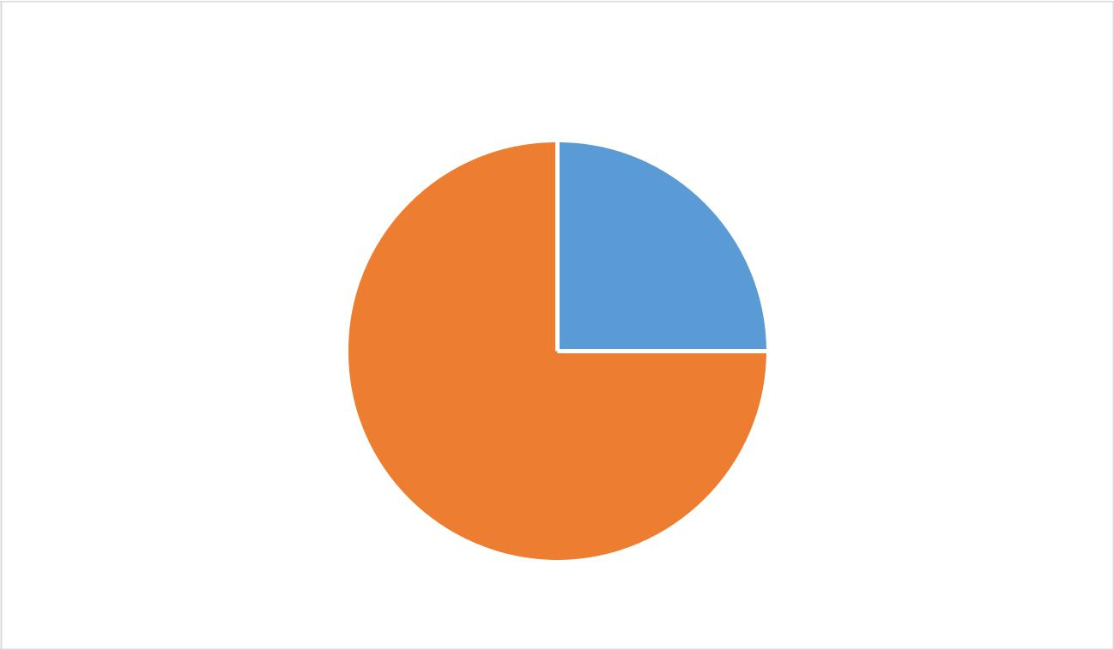

Which database has a better performance when handling

big data?

* MySQL  Firebase

**Figure 21. Results of Discussion in Big Data**

When it comes in handling big data, both group also evaluated that Firebase has more capability in handling big data with the ratings of 60% than MySQL with the ratings of 40%.

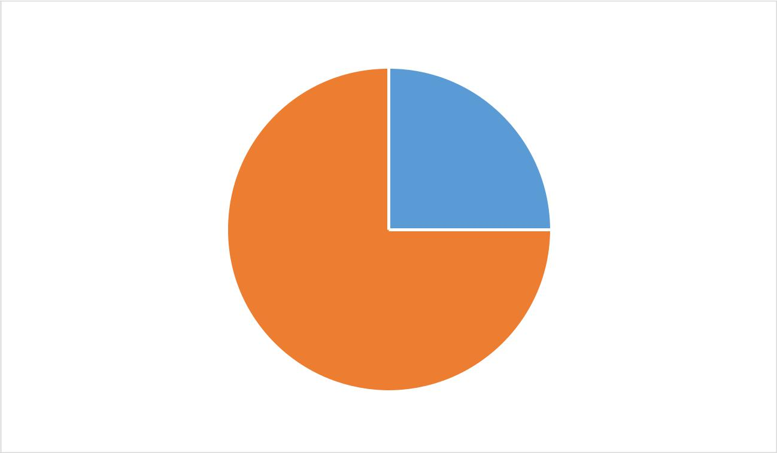

What database do you prefer to use in mobile application?

MySQL  Firebase

**Figure 22. Results of Discussion in preferred to use in Mobile Application**

Both group also evaluated that Firebase are preferred to use in mobile applications as database with the ratings of 80% than MySQL with the ratings of 20%.

In conclusion, respondents still choose that MySQL has better writing of query and easy to learn. But overall the survey form respondents conclude that Firebase has more capability than MySQL.

**Table 8. Summary of Survey**

|  |  |  |
| --- | --- | --- |
| SURVEY QUESTIONS | MYSQL | FIREBASE |
| Which database is easy to use when it comes to writing queries? | 53.1 % | 46.9% |
| Which database is easy to learn? | 51% | 49 % |
| Which database is easy to integrate when it comes to building a mobile application? | 15.6 % | 84.4% |
| Which database has a better maintainability features? | 40.6 % | 59.4 % |
| Which database has a better compatibility when it used in different android version? | 37.5 | 62.5 |
| Which database has a better performance when handling big data? | 37.5% | 62.5 % |
| What database do you prefer to use in mobile application? | 18.8 % | 81.3% |

The summary of survey questionnaire created by the researchers can help to overview the survey form easy. It enables to the readers to view the user’s feedback in which in the MySQL and Firebase are better in mobile application. In overview of survey questionnaire, majority of the evaluators suggest that Firebase has more capability than MySQL.

**Internet**

**TCP/IP**

Request

**Internet**

**TCP/IP**



JSON Array

JSON Object

Request to PHP

WS runs DB Query



**FIREBASE**



**PHP Web Server**



**MySQL**



Response



Query Result

WS Generate JSON data

WS Generate JSON data

JSON Array

JSON Object

**Figure 23. Conceptual Processing of MySQL and Firebase**

In this figure, the left side shows the process of firebase database which the data JSON array and JSON object from the mobile application has been automatically converted into JSON format then returns it back. While, on the right side of the figure shows the process of MySQL coming from the mobile application then, transmit it to the PHP web server then goes to the MySQL database return to the PHP web server then converts the result into JSON format then goes back to the mobile application.

**Table 9. Comparison Table Features of MySQL and Firebase**

|  |  |
| --- | --- |
| **MySQL** | **Firebase** |
| Database management | Realtime Database |
|  | Authentication |
| Live charts to monitor MySQL server activity like connections, processes, CPU/memory usage, etc. | Performance Monitoring |
|  | Google Analytics |
| Intuitive web interface |  |
| Administering multiple servers | Hosting |
| Import data from CSV and SQL |  |
| Export data to various formats: CSV, SQL, XML, PDF |  |
|  | App Indexing |
| Creating PDF graphics of the database layout | Crashlytics |
| Creating complex queries using query-by-example (QBE) |  |
|  | Test Lab for Android |
| Searching globally in a database or a subset of it |  |
|  | Predictions |
| Transforming stored data into any format using a set of predefined functions, like displaying BLOB-data as image or download-link |  |
|  | Remote Config |
|  | AdWords |
|  | Dynamic Links |
|  | Invites |
|  | AdMob |
|  | Cloud Firestore |
|  | Cloud Functions |
|  | Cloud Messaging |
|  | Cloud Storage |

The table shows the list of MySQL and Firebase. Based on the list of features the firebase has more features than MySQL that can help developers to build better mobile application that gives efficient database.

**Table 10. Comparison Table of MySQL and Firebase**

|  |  |  |
| --- | --- | --- |
| **Name** | **MySQL** | **Firebase** |
| Description | RDBMS | Cloud-based |
| Primary database model | RDBMS | Document store |
| License | Open source | Commercial |
| Cloud base | No | Yes |
| Server OS | Linux, Windows | Hosted |
| Schema | Yes | Schema-free |
| SQL | Yes | No |
| API and other access | ADD.net, JDBC, ODBC | Android, IOS, Javascript |
| Data organizing type | Normalization | De-normalization |

The table shows how the MySQL is different to Firebase when it comes in description, primary database model, license, cloud base, server OS, schema, SQL, API and other access and data organizing types.