**DAND Wrangle And Analyze Project**

**Act Report**

**By Hamad Sami AlAssafi**

Table of Contents

**Introduction:** 2

**Analysis and visualization:** 3

**Question 1: What are the most source of the tweets in our dataset** 3

**Question 2: What are the most image number in each image** 4

**Question 3: What is the most popular dog type in our dataset** 4

**Question 4: What is the average rating of the dogs:** 4

## **Introduction:**

After I finished the wrangling process, the analysis begins by creating master dataframe that contains all the dataframes. In our master dataframe we have multiple columns and I will go through them one by one to understand our dataset and make wise analyses in our process:

* **1-(tweet_id) the Tweet ID**
* **2-(**in_reply_to_status_id) means **if the tweet is reply tweet then it should have it unique ID**
* **3-(**in_reply_to_user_id**) If the tweet is a reply tweet then the value will be an integer of the original Tweet’s author id**
* **4-(**timestamp**) When the author has published the tweet**
* **5-(**source**) The source of the tweet (whether it has been tweeted from Phone Computer etc..)**
* **6-(**text**) The content of the tweet**
* **7-(**retweeted_status_id**) It shows what tweet has been retweeted based on tweet ID**
* **8-(**retweeted_status_user_id**) ID for the person who retweet that certain tweet**
* **9-(**retweeted_status_timestamp**) When the tweet has been retweeted**
* **10-(**expanded_urls**) Tweet URL**
* **11-(Rating) The rating of the dog**
* **12-(**name**) The name of the dog**
* **13&14&15&16-(**doggo, floofer, pupper, puppo**) Different criteria for the dogs that determine their age and their type**
* **17-(**jpg_url**) Image(s) url for the dog in each tweet**
* **18-(img_num) Number of images in each tweet**
* **19- (p1) Is the algorithm's #1 prediction for the image in the tweet**
* **20-(p1_conf) Is how confident the algorithm is in its #1 prediction**
* **21-(p1_dog) Is whether or not the #1 prediction is a breed of dog**
* **22-(p2) Is the algorithm's second most likely prediction**
* **23-(p2_conf) Is how confident the algorithm is in its #2 prediction**
* **24-(p2_dog) Is whether or not the #2 prediction is a breed of dog**
* **25-(p3) Is the algorithm's third most likely prediction**
* **26-(p3_conf) Is how confident the algorithm is in its #3 prediction**
* **27-(p3_dog) Is whether or not the #3 prediction is a breed of dog**
* **28-(favourites) How many people click the favourite button for the tweet**
* **29-(retweets) How many people click the retweet button for the tweet**

## **Analysis and visualization:**

I have explored the dataset and came up with four questions two of them with visualizations using (matplotlib):

**Question 1: What are the most source of the tweets in our dataset** 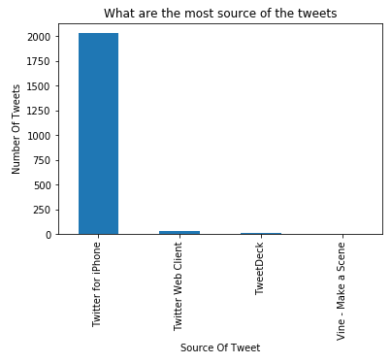

The most tweets have been tweeted from (Twitter application in IPhone)

### **Question 2: What are the most image number in each image**

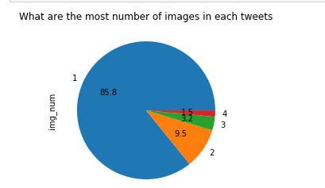

Most of the tweets have only one image with (85.8) percent

### **Question 3: What is the most popular dog type in our dataset**

pupper 229

doggo 75

puppo 29

floofer 3

Is it shown the most popular dog type in our data set is (pupper) with (229) dog

### **Question 4: What is the average rating of the dogs:**

1.7672621921776919

Is it shown the average (mean) is 1.7672621921776919, and in average it considered as good average.

Thank you for reading, I hope it is useful insights and visualizations.