**Voice Recognition Robot (V-ReC)**

**Project Objective:**

Create a voice recognition robot that takes in the user's voice as an input and performs certain set of predefined instructions.

**Execution of the Project:**

1. We will use the following actuators:

* Left Wheel Motor
* Right Wheel Motor
* Low-side Drivers on the BAM (LD0-LD2)
* Digital Outputs on the BAM (DO0-DO2)

2. We will be making a COM port connection over Bluetooth. In simple words, we will connect the irobot Create to our laptops using BAM(Bluetooth Access Module) through UART Communication(Universal Asynchronous Receiver / Transmitter). We will then give the voice commands through our laptop microphone.

3. After connecting the Bluetooth to our computer, we will be ready to send data.

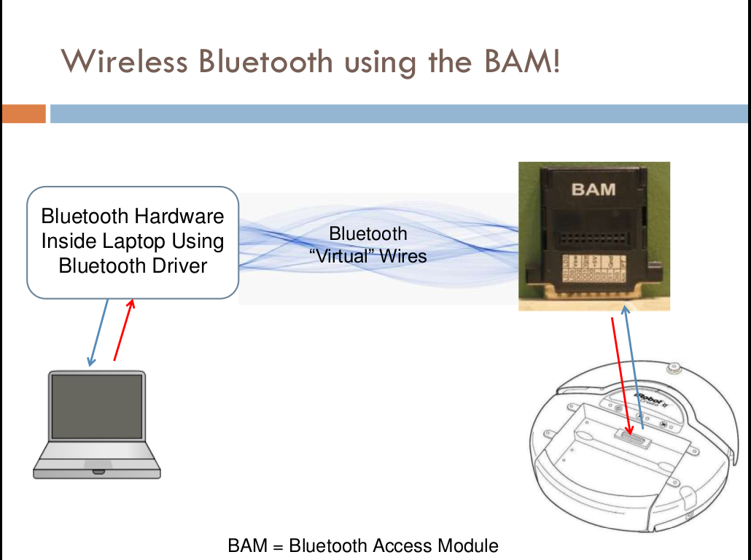

4. We will use software such as EZ Builder Software or Player Stage where we will write the code and the corresponding phrases for each function call of the commands to be spoken by the user to robot.

**Implementation of project:**

The irobot will be able to perform atleast 5 actions depending on the input. The 5 commands will be:

* Turn Right
* Turn Left
* Go Straight
* Follow a square trajectory
* Follow a triangular trajectory

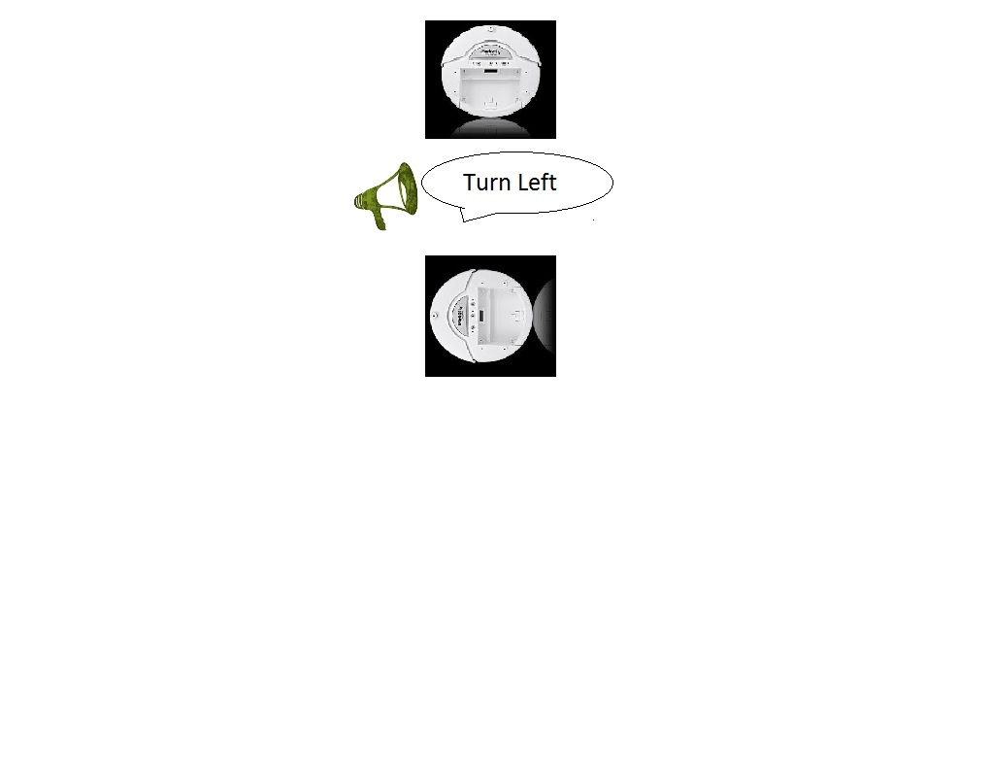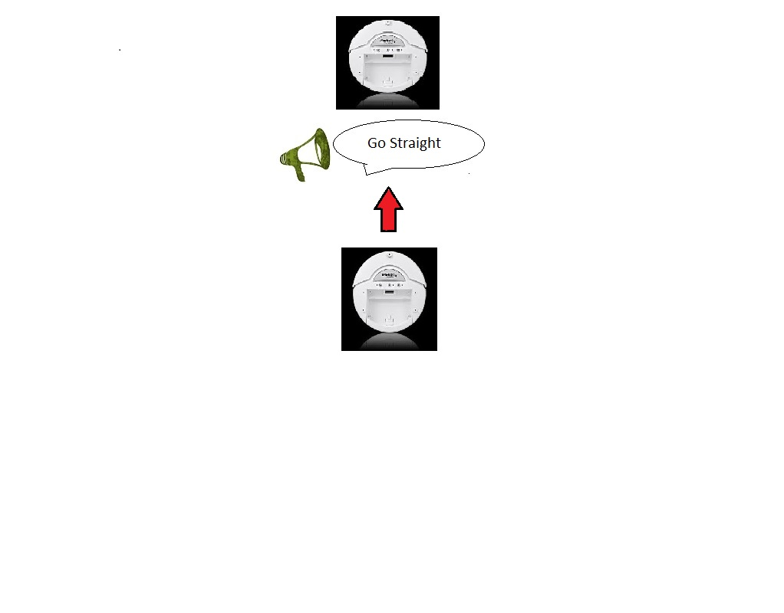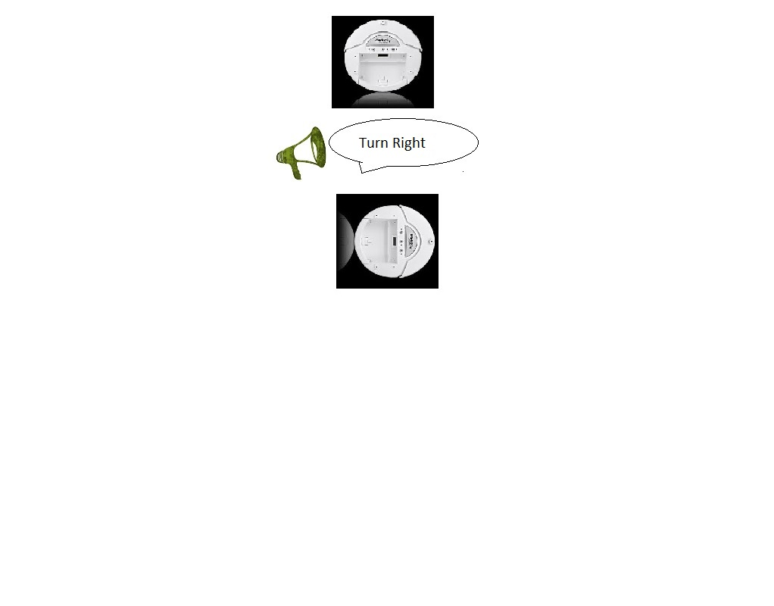

**Team Members:**

1. Raghav Bhatnagar (IMT2014042)
2. Shravan Kumar (IMT2014010)
3. P.Seetarama Raju (IMT2014038)
4. Suprgya Bhushan (IMT2014056)
5. Rahul Ambati (IMT2014043)
6. Dharma Raja (IMT2014062)
7. Rampalli Karthik (IMT2014046)