**IIITB Hackathon**

**APP**

RestroQ

**TEAM**

Gaurav Koley

Lakshay Jindal

Harika Rajavaram

Shreyak Upadhyay

Suprgya Bhushan

**IDEA**

This app is made for the objective for reducing traffic congestion in the city. During the weekend times, many people go out for eating out leading to long wait queues in each restaurant due to which traffic increases. Further, many eatouts don’t take reservations beforehand. Hence, the user would choose a restaurant; put in his/her approximate arrival time and the number of persons about to dine. The app gives the approximate waiting time the user (and group) has to face at that arrival time; the app also allows the user to place himself/herself in the waiting queue to get a table in one or more restaurants. The app works to ensure that each customer of a restaurant has minimum waiting time. This will indirectly make an impact on the traffic in the city.

**DESCRIPTION**

There would be two apps - Merchant app, Customer app.

**Merchant App**

This app would be with the restaurant owners / managers. They would be able to see the customers who have joined the waiting queue through the app or by physically being present at the restaurant. As customers get seated at the tables, the entries from the merchant app get striked off.

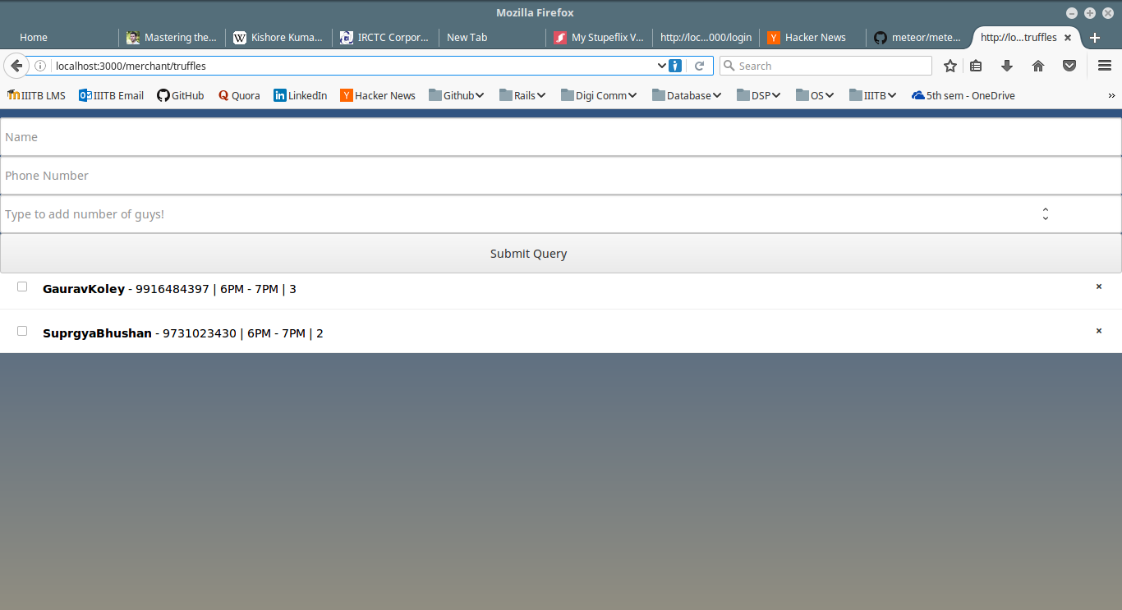

Merchant Page - (here “Truffles” Restaurant page for its queues)

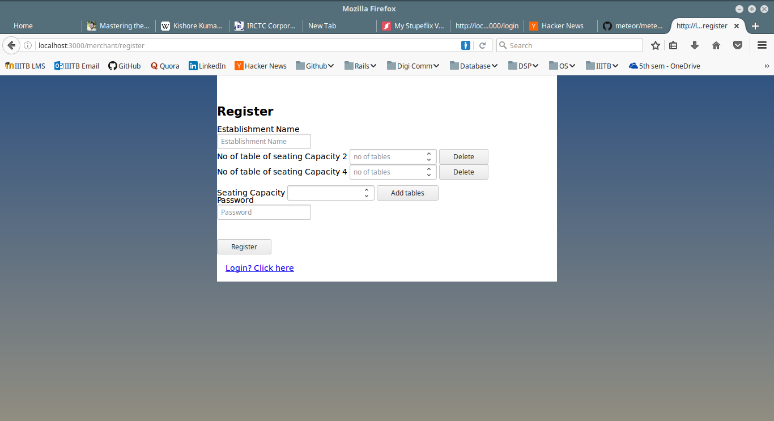

Merchant Register page (Name and Number of Seatings)

**Customer App**

This app lists all the restaurants. The user can select any restaurant, put in his / her details (including arrival time,number of seats required). The user would be able to see the probable waiting time at his / her arrival. If the user chooses to join the waiting queue, then he / she can adjust his arrival time based on at what time he / she is going to get a table.

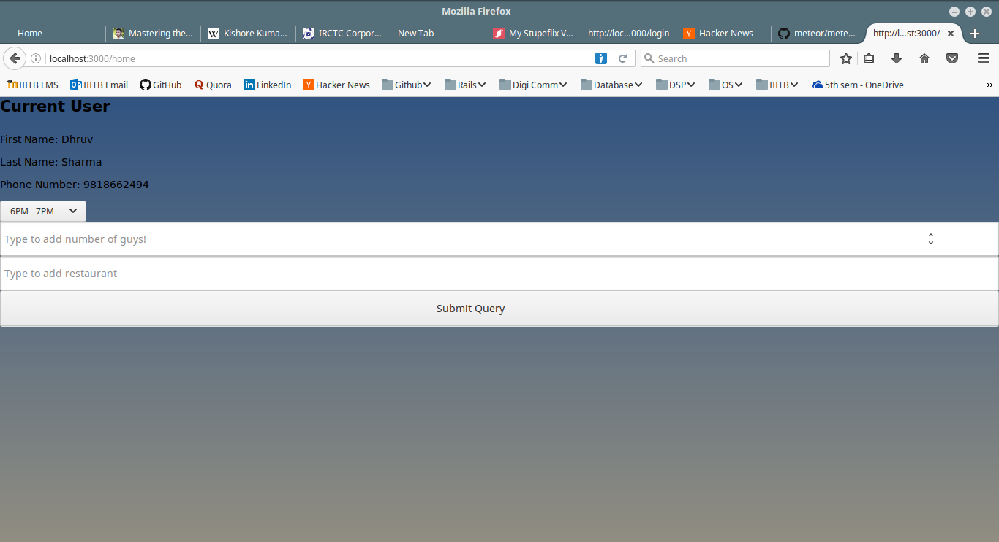

Client Page

**WEB/MOBILE APP STRUCTURE**

i) Understanding and working with the code will require the knowledge of the following:

* **JavaScript (Back-end)**
* **HTML/CSS (Front-end)**
* **MeteorJS** (Library for source code) – A Library which lets us make a web app and a mobile app simultaneously.

<https://github.com/meteor/meteor>

* **MongoDB -** association of the merchant and client database through database.

ii) a) There would be two apps - Merchant app, Customer/Client app. Respective Login and Register pages for both merchant and customer.

b) Also the login page will lead to the individual customer and merchant profile pages and we will be able to see the customer’s restaurant queues and similarly for the merchant. The client will also be able to see the waiting time at each restaurant.

iii) There is also an algorithm for determining the waiting time of the customers.

**END**