Supria

Supria_paul@uri.edu

Relationship between defoliation and weather parameters throuhg Principal Component Analysis

Author: Supria Paul

***Introduction:***

The gypsy moth, Lymantria dispar Linnaeus, is one of the most notorious pests of deciduous trees in the Eastern United States. These pests are responsible to alter the forest landcover in certain month. They are defoliated close to a million or more forested acres each year since 1980. It has reported that 12.9 million acres were defoliated in 1981. This is an area larger than Rhode Island, Massachusetts, and Connecticut combined. When trees are visibly defoliated during periods of infestation, gypsy moth larvae crawl up and down walls, across roads, over outdoor furniture, and even inside homes.

Rhode Island experienced the defoliation of 226,800 acres of forestland during the spring of 2015 and 2016 (figure 1). The significant outbreak happened in 1985 and the total area of defoliation is 411,800 acres. Most of the literature review arguing that drought increases the likelihood of defoliation. For example, Sarah Hart are using satellite image on spruce beetle infestations and comparing it to data on summer, winter and multi-year drought events. They found that droughts increase the likelihood of spruce beetle outbreaks. Moreover, the affected area was experiencing abnormally dry or moderate drought conditions. Also, it had received 25-75% of normal precipitation during the preceding 30/60/90 day periods. Because these weather conditions accelerate the hatching of gypsy moth caterpillar eggs. There was hypothesis if these dry conditions persist, it will limit the ability of the deciduous trees to recover and begin producing leaves again during the remainder of the summer seasons. Therefore, the ecological consequences of gypsy moth outbreaks can become serious. It has reported that deciduous trees can normally withstand one or two years of defoliation by caterpillars. But, three or more successive years of severe defoliation can result in widespread tree mortality. From the previous studies indicate that weather parameters have impact on defoliation area. Most of studies did analysis on the image analysis. None of them did not conduct on statistical analysis. In this studies, I will conduct principal component analysis among weather parameters with leaf area index. So that I can come up which parameters have co-related with leaf are index(defoliation).

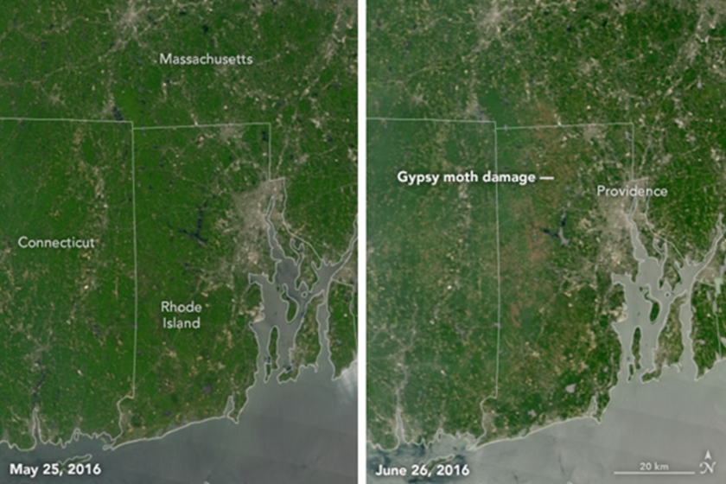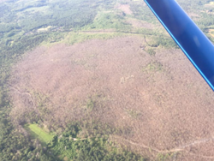

Figure 1: Forest changes in Rhode Island and Forewarn Satalitate

***Hypothesis or Research Questions:***

1. Gypsy moth damage on the particular month is not only consequence of drought but also of solar radiation, max temperature, minimum temperature, relative humidity. The effects of combination of weather parameters on the leaf area are more prominent.
2. The leaf area will decrease if there exists drought and wind. Decreasing of leaf area means there was possible damage by gypsy moth.

***Expected results:***

The expected results will that what will statistical p-value after doing regression analysis through Principal component(PCA) analysis. This value will indicate what will be co-relation between target(LAI) and predictor variables.

1. Regression analysis is done based on particular month specially may month for 20 years.
2. Second Regression analysis is done based on whole month of whole years.
3. Result compares how R-square is changed based on length of datasets.