

**Installation Guide for DHI Deployment Process**

**www.brillio.com**

Table of Contents

1 Installing Python Application 3

1.1 Download the Python Installer binaries 3

1.2 Run the Executable Installer 3

1.2.1 Select Customize installation: 4

1.2.2 Click Next : 5

1.3 Once the installation is over, you will see a Python Setup Successful window. 6

1.4 Add Python to environmental variables 7

1.5 Verify the Python Installation 8

2 Installing MySQL (Windows) 9

2.1 Installation Process 9

2.1.1 By using command line (Download and Extraction): 9

2.1.2 Configuring MySql: 9

2.2 Creating User for mysql : 9

2.3 Creating database and importing data to it: 10

3 Installing Java-Server Tomcat (Windows) 11

3.1 Installation Process 11

3.1.1 By using command line (Download and Extraction): 11

3.1.2 Starting Tomcat Server: 11

3.1.3 Stopping Tomcat Server: 11

4 Deploying Java WAR In Tomcat (Windows) 13

4.1 Copy the war file from source folder to web-apps folder 13

4.2 Edit the catalina.properties file 13

4.3 Start the tomcat server 13

# Installing Python Application

## Download the Python Installer binaries

Open the official Python website in your web browser. Navigate to the Downloads tab for Windows.

Choose the latest Python 3 release. In our example, we choose the latest Python 3.7.3 version.

Click on the link to download Windows x86 executable installer if you are using a 32-bit installer. In case your Windows installation is a 64-bit system, then download Windows x86-64 executable installer.

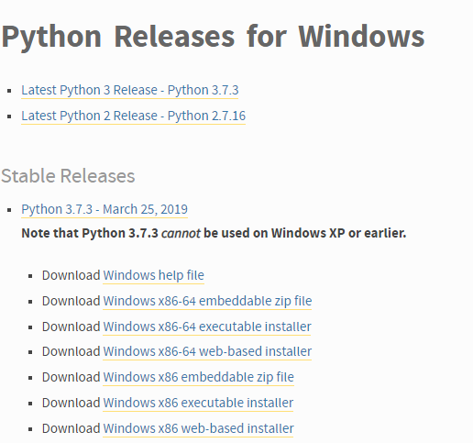

## Run the Executable Installer

Once the installer is downloaded, run the Python installer.

Check the Install launcher for all users check box. Further, you may check the Add Python 3.7 to path check box to include the interpreter in the execution path.

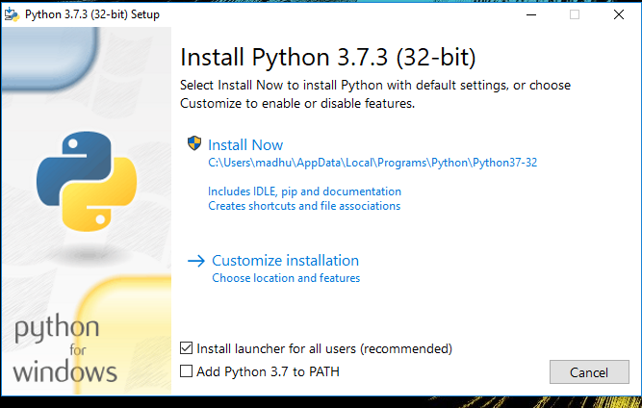

### Select Customize installation:

Choose the optional features by checking the following check boxes:

* Documentation
* pip
* tcl/tk and IDLE (to install tkinter and IDLE)
* Python test suite (to install the standard library test suite of Python)
* Install the global launcher for `.py` files. This makes it easier to start Python
* Install for all users.



### Click Next :

This takes you to Advanced Options available while installing Python. Here, select the Install for all users and Add Python to environment variables check boxes.

Optionally, you can select the Associate files with Python, Create shortcuts for installed applications and other advanced options. Make note of the python installation directory displayed in this step. You would need it for the next step.

After selecting the Advanced options, click Install to start installation.

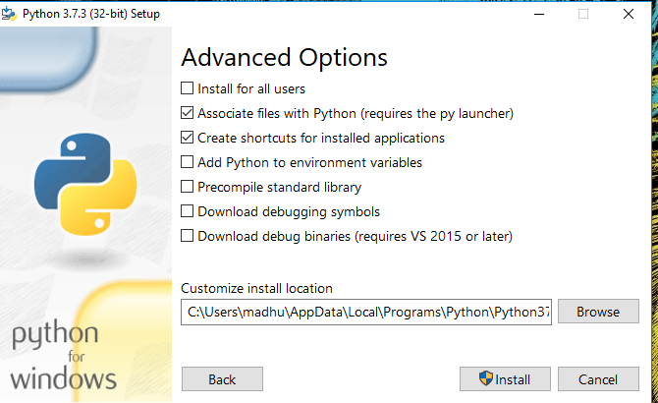

## Once the installation is over, you will see a Python Setup Successful window.

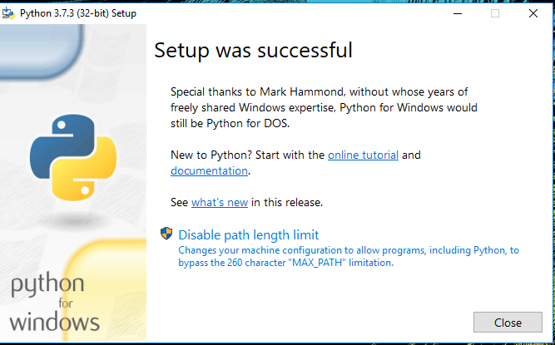

## Add Python to environmental variables

The last (optional) step in the installation process is to add Python Path to the System Environment variables. This step is done to access Python through the command line. In case you have added Python to environment variables while setting the Advanced options during the installation procedure, you can avoid this step. Else, this step is done manually as follows.

In the Start menu, search for “advanced system settings”. Select “View advanced system settings”. In the “System Properties” window, click on the “Advanced” tab and then click on the “Environment Variables” button.

Locate the Python installation directory on your system. If you followed the steps exactly as above, python will be installed in below locations:

C:\Program Files (x86)\Python37-32: for 32-bit installation

C:\Program Files\Python37-32: for 64-bit installation

The folder name may be different from “Python37-32” if you installed a different version. Look for a folder whose name starts with Python.

Append the following entries to PATH variable as shown below:

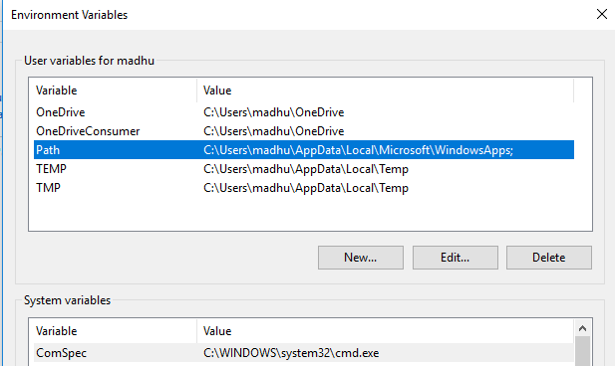

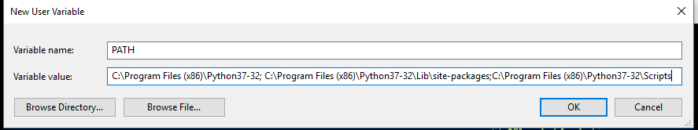

## Verify the Python Installation

You have now successfully installed Python 3.7.3 on Windows 10. You can verify if the Python installation is successful either through the command line or through the IDLE app that gets installed along with the installation.

Search for the command prompt and type “python”. You can see that Python 3.7.3 is successfully installed.

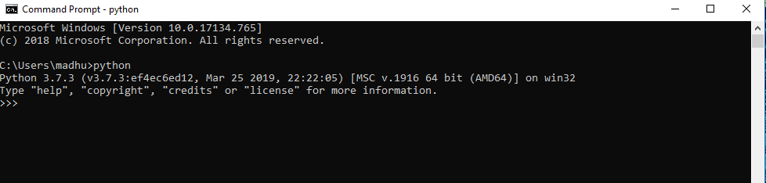

An alternate way to reach python is to search for “Python” in the start menu and clicking on IDLE (Python 3.7 64-bit). You can start coding in Python using the Integrated Development Environment(IDLE).

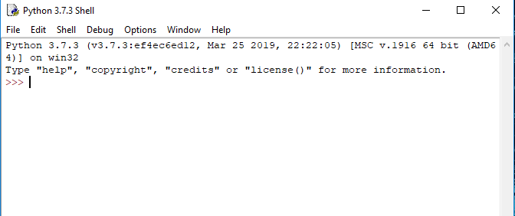

# Installing MySQL (Windows)

## Installation Process

MySql can be installed using mysql windows installer or via Zip Archive,

### By using command line (Download and Extraction):

By using java zip Archive, we can extract the file and place in any of the drive or folder then are done with the installation.

The java zip folder can be downloaded from below link:

<https://dev.mysql.com/downloads/mysql/5.7.html#downloads>

After downloading the mysql archive file, below is the steps to extract the zip using command line :

* Go to the folder where zip file resides.

In my case : D:\>cd C:\Users\test_user1\Documents\Dockerizing_Java_Components

* Type the command as “jar xf <zip file name>

### Configuring MySql:

After installation we need to configure and initialize the mysql database in order to start working in mysql environment.

* Go to mysql home folder then bin.

*Example : C:\Users\test_user1\Documents\Dockerizing_Java_Components\mysql-5.7.25-winx64>cd bin*

* Run the command as :
* *mysqld --initialize-insecure*
* *mysqld –console*



## Creating User for mysql :

After configuring the mysql, we need to create the user to mysql database. Below are the steps need to be followed :

* Open command prompt, and switch to mysql console.

*Example : mysql -u root –p*

* The above command will enable the user with mysql console, and to create user use below command.

*CREATE USER 'newuser'@'localhost' IDENTIFIED BY 'password';*

*Example : CREATE USER 'root'@'localhost' IDENTIFIED BY 'root';*

* Granting permission to the created user, so that we can perform different operation with the database.

*GRANT ALL PRIVILEGES ON * . * TO 'newuser'@'localhost';*

*Example : GRANT ALL PRIVILEGES ON * . * TO 'root'@'localhost';*

*FLUSH PRIVILEGES;*

## Creating database and importing data to it:

* Creating a new database, use below command

*CREATE DATABASE database-name;*

*Example : CREATE DATABASE ekg;*

* Selecting the database

*USE database-name;*

*Example : USE ekg;*

* Importing data from the self-contained sql dump.

*mysql -u root1-p root ekg < dump_file_name*

*Example : mysql -u root1-p root ekg < C:\Users\test_user1\Desktop\Dump20190221.sql*

# Installing Java-Server Tomcat (Windows)

## Installation Process

Tomcat is used as java based server for deploying Java WAR file in the form of Java Web Application.

Tomcat can be installed using Apache Tomcat windows installer or via Zip Archive.

### By using command line (Download and Extraction):

By using tomcat zip Archive, we can extract the file and place in any of the drive or folder then are done with the installation.

The apache tomcat zip folder can be downloaded from below link:

<https://tomcat.apache.org/download-80.cgi>

After downloading the tomcat archive file, below is the steps to extract the zip using command line :

* Go to the folder where zip file resides.

In my case : D:\>cd C:\Users\test_user1\Documents\Dockerizing_Java_Components

* Type the command as “jar xf <zip file name>

### Starting Tomcat Server:

In order to start the tomcat server, we need to go to the tomcat home/bin folder, and issue below command in the cmd.

* Go tomcat home/bin directory

*cd apache-tomcat-8.0.53/bin;*

* To start the server, this will automatically deploy all the war files, which are present in the web-apps folder of tomcat directory

*startup.bat;*

*Note :*

*1.On typing startup.bat, it will deploy all the wars present in web-apps folder and will open an extra-terminal showing the logs of the application deployed.*

*2. To check whether the server started or not, open any web-browser and type localhot:<port number>, it will open the page showing tomcat logo/symbol.*

**

### Stopping Tomcat Server:

In order to stop the tomcat server, we need to go to the tomcat home/bin folder, and issue below command in the cmd.

* Go tomcat home/bin directory

*cd apache-tomcat-8.0.53/bin;*

* To stop the server

*shutdown.bat;*

# Deploying Java WAR In Tomcat (Windows)

## Copy the war file from source folder to web-apps folder

Copy the java build(war) file to tomcat web-apps folder present in (Tomcat-Home-Folder/webapps),

* Move/copy the war file from source to destination(web-apps)

*Copy <source-file-path> <destination-folder-path>;*

*Copy C:\Users\admin123\Downloads\ekg-0.0.1-SNAPSHOT.war C:\IPSolution\apache-tomcat-8.0.53\webapps;*

## Edit the catalina.properties file

For configuring application specific configurations, we need to add the path for application related configuration path in the catalina.properties file.

* Edit the catalina.propertie file, present in “tomcat-home-folder\conf” folder, need to add below configuration path to it.

*<configuration_key_name>=<configuration_path>*

*Example : brillio.ekg.base.config.path=C:/Users/admin123/Documents/ekg/ekg_configuration*



## Start the tomcat server

In order to start the tomcat server, we need to go to the tomcat home/bin folder, and issue below command in the cmd.

* Go tomcat home/bin directory

*cd apache-tomcat-8.0.53/bin;*

* To start the server, this will automatically deploy all the war files, which are present in the web-apps folder of tomcat directory

*startup.bat;*

*Note :*

*1.On typing startup.bat, it will deploy all the wars present in web-apps folder and will open an extra-terminal showing the logs of the application deployed.*

*2. To check whether the server started or not, open any web-browser and type localhot:<port number>, it will open the page showing tomcat logo/symbol.*

**