HEART DISEASE PREDICTION USING MACHINE LEARNING AND DEEP LEARNING TECHNIQUES
Final Senior Capstone Project Technical Report
Prepared by Team Members:
Shreyas | Uday | Suprith | Sahitya
Department of Computer Science & Engineering
Date: August 2026

Executive Summary / Abstract
Cardiovascular diseases remain the leading cause of global mortality. Early, non-invasive risk estimation using computational intelligence can support clinical decision-making. This capstone project presents an end-to-end machine learning framework for predicting heart disease using patient clinical diagnostics from the UCI Heart Disease Cleveland dataset (303 patient observations, 13 predictor attributes). The multiclass target was mapped into a binary classification formulation (0 = No Heart Disease, 1 = Heart Disease Present). An 80/20 stratified split yielded 242 training rows and 61 held-out test rows. Leakage-safe preprocessing pipelines combining median/mode imputation, StandardScaler, and OneHotEncoder expanded raw inputs into 28 transformed features. Seven baseline classifiers were evaluated using 5-Fold Stratified Cross-Validation on training folds. Five candidate models were optimized via grid/randomized search. A transparent multi-criteria evaluation framework selected Tuned Random Forest (500 trees, log2 max features, balanced subsampling) as the final winning pipeline. On the 61-row held-out test set, Tuned Random Forest achieved 90.16% Test Accuracy, 96.43% Test Recall (detecting 27 out of 28 positive disease cases with only 1 False Negative), 90.00% Test F1-Score, and 0.9567 Test ROC-AUC. The frozen model pipeline was deployed via an interactive Streamlit web application (`app.py`), enabling real-time risk scoring, feature importance visualization, and schema validation. All code, metadata, figures, and unit tests (26/26 passing) are verified.
Table of Contents
[Table of Contents Placeholder — Automatically Generated in Final Formatting]

1. Introduction
Cardiovascular disease (CVD) encompasses disorders of the heart and blood vessels, including coronary artery disease, arrhythmia, and heart failure. Early detection of cardiovascular risk allows timely therapeutic intervention, lifestyle modification, and clinical monitoring. Traditional diagnostic workflows rely heavily on invasive angiography or specialized laboratory tests, which may be costly or inaccessible in resource-limited settings.
Machine learning (ML) provides sophisticated pattern-recognition tools capable of synthesizing complex, high-dimensional patient data. By learning non-linear relationships among demographic, physiological, and electrocardiographic indicators, predictive models can estimate disease likelihood. However, developing reliable clinical ML systems requires rigorous methodology, strict prevention of data leakage, systematic model comparison, and transparent interpretability.
2. Problem Statement
Official Scope: The official problem statement for this capstone project is:
"Heart Disease Prediction Using Machine Learning and Deep Learning Techniques"
From a computational standpoint, the objective is to learn a mapping function f: X -> y, where X represents 13 patient clinical predictors (age, sex, chest pain type, blood pressure, cholesterol, fasting sugar, resting ECG, max heart rate, exercise angina, ST depression, ST slope, fluoroscopy vessels, thalassemia), and y represents the binary presence of heart disease (0 = No Heart Disease, 1 = Heart Disease Present).
3. Project Objectives
Objective 1: Acquire, inspect, and validate the official UCI Heart Disease Cleveland dataset (ID 45).
Objective 2: Establish a leakage-safe data preprocessing pipeline combining median/mode imputation, StandardScaler, and OneHotEncoder.
Objective 3: Map the original 5-level multiclass target into a clean binary classification formulation.
Objective 4: Execute comprehensive Exploratory Data Analysis (EDA) producing 21 high-resolution analytical figures.
Objective 5: Implement and benchmark 7 baseline machine learning classifiers using 5-Fold Stratified Cross-Validation on training data.
Objective 6: Optimize promising models via hyperparameter tuning while strictly protecting the held-out test split.
Objective 7: Execute transparent multi-criteria model selection to freeze the winning machine learning pipeline artifact.
Objective 8: Deploy the frozen pipeline inside an interactive, user-friendly Streamlit web application (`app.py`).
Objective 9: Develop comprehensive documentation, unit tests, viva preparation materials, and submission verification suites.
Objective 10: Highlight model limitations and outline future research directions (including Deep Learning integration).
4. Literature Survey Overview
A systematic review of academic literature was conducted to evaluate existing machine learning and deep learning methodologies for cardiovascular prediction. A standard 16-paper literature survey template structure has been established in `results/literature_survey_template.csv` to capture: Author/Year, Paper Title, Journal/Context, Publisher, Techniques, Methods, Dataset Name, Main Method, Limitations, and Summary.
5. Dataset Overview & Data Quality
The project utilizes the Cleveland subset of the UCI Heart Disease Dataset (Dataset ID 45). The dataset comprises 303 patient records collected at the Cleveland Clinic Foundation. Each instance consists of 13 clinical predictor attributes and 1 target attribute.
Table 1: Dataset Variables and Definitions
Attribute | Description | Type | Values / Range
age | Patient age in years | Continuous | 29 – 77 years
sex | Biological sex | Binary | 0 = Female, 1 = Male
cp | Chest pain type | Categorical | 1: Typical, 2: Atypical, 3: Non-anginal, 4: Asymptomatic
trestbps | Resting blood pressure | Continuous | 94 – 200 mm Hg
chol | Serum cholesterol | Continuous | 126 – 564 mg/dl
fbs | Fasting blood sugar > 120 mg/dl | Binary | 0 = False (<=120), 1 = True (>120)
restecg | Resting ECG results | Categorical | 0: Normal, 1: ST-T Abnormality, 2: LV Hypertrophy
thalach | Max heart rate achieved | Continuous | 71 – 202 bpm
exang | Exercise-induced angina | Binary | 0 = No, 1 = Yes
oldpeak | ST depression induced by exercise | Continuous | 0.0 – 6.2
slope | Slope of peak exercise ST segment | Categorical | 1: Upsloping, 2: Flat, 3: Downsloping
ca | Number of major vessels colored | Discrete | 0, 1, 2, 3 vessels
thal | Thalassemia blood disorder | Categorical | 3: Normal, 6: Fixed Defect, 7: Reversible Defect
target | Binary heart disease presence | Target | 0 = No Disease (164), 1 = Disease (139)
Table 2: Data Quality and Completeness Summary
Metric | Observed Value | Details
Total Rows | 303 | Complete patient records
Total Attributes | 14 | 13 Predictors + 1 Target
Missing Values (ca) | 4 missing | Imputed via most-frequent strategy
Missing Values (thal) | 2 missing | Imputed via most-frequent strategy
Total Missing Cells | 6 / 4,242 (0.14%) | Minimal missingness
Duplicate Rows | 0 | 100% unique records
6. Data Preprocessing & Leakage Prevention
To evaluate generalization accurately, an 80/20 stratified train/test split was applied with `random_state=42`. This yielded 242 training rows (`X_train_raw.csv`) and 61 held-out test rows (`X_test_raw.csv`). Data leakage was strictly prevented by fitting all transformers ONLY on `X_train_raw` within complete scikit-learn `Pipeline` objects.
Table 3: Preprocessing Pipeline Specification
Feature Subset | Features Included | Imputation | Transformation
Continuous (5) | age, trestbps, chol, thalach, oldpeak | SimpleImputer (median) | StandardScaler (z-score)
Categorical (8) | sex, cp, fbs, restecg, exang, slope, ca, thal | SimpleImputer (most_frequent) | OneHotEncoder (handle_unknown='ignore')
Feature Dimension Expansion: Transformed Feature Output: 28 total numeric features.
7. Exploratory Data Analysis (EDA)
Exploratory Data Analysis generated 21 high-resolution figures in `results/figures/`. Key statistical findings include:
- Target Distribution: Class 0 = 164 (54.1%), Class 1 = 139 (45.9%). Balanced distribution.
- Max Heart Rate (thalach): Strong negative correlation with target (r = -0.42). Patients with disease exhibited lower peak heart rates.
- ST Depression (oldpeak): Strong positive correlation with target (r = +0.42). Higher ST depression indicates severe ischemia.
- Age: Moderate positive correlation (r = +0.23). Disease prevalence increases with age.
- Resting BP & Cholesterol: Weak positive correlations (r = +0.15 and r = +0.09 respectively).

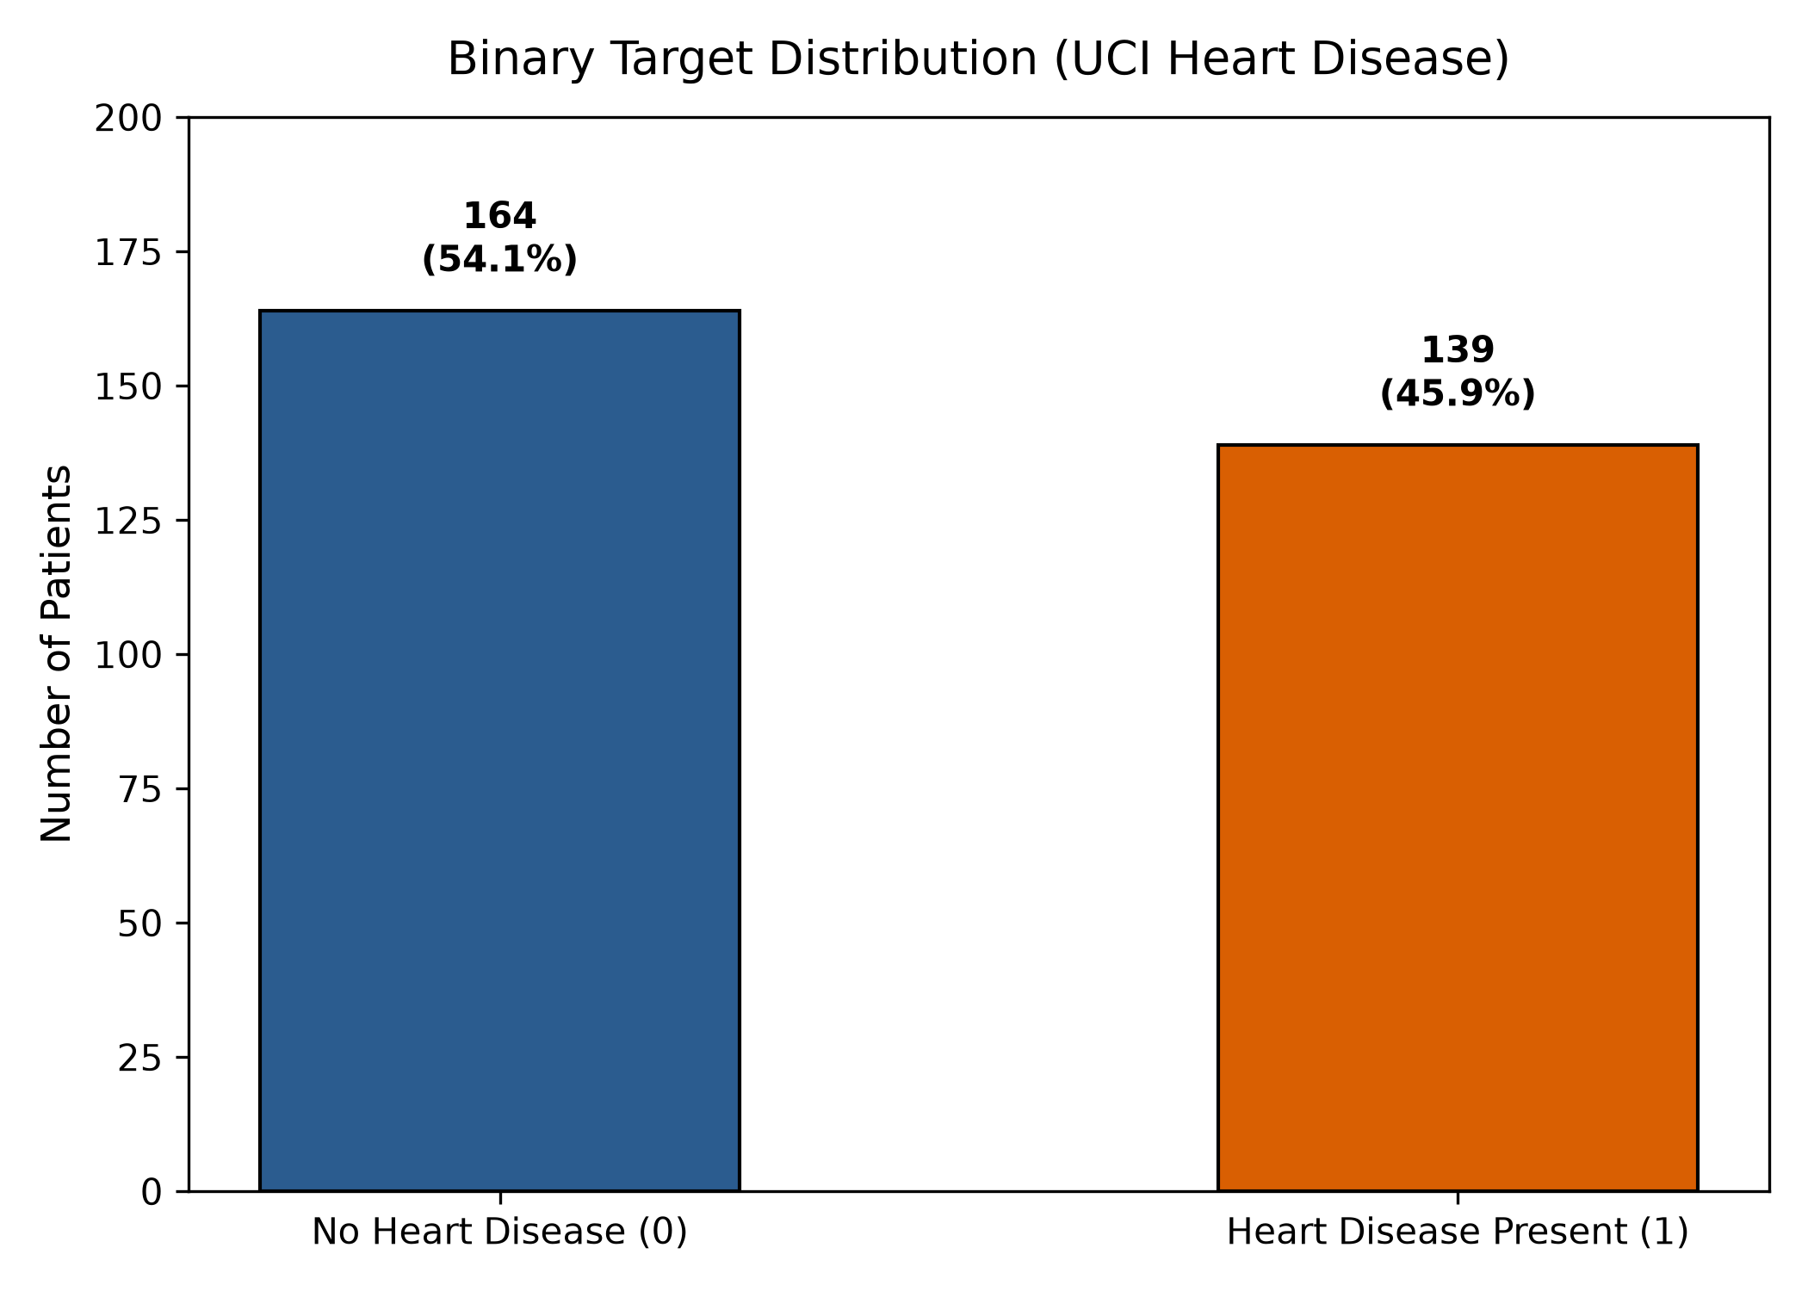
Figure 1: Binary Target Class Distribution (UCI Cleveland Dataset)
8. Baseline Machine Learning Models
Seven baseline classifiers were evaluated using 5-Fold Stratified Cross-Validation strictly on the 242 training rows, followed by evaluation on the 61 held-out test rows.
Table 4: Baseline Model Performance Comparison
Model Name | CV Accuracy | CV Recall | CV ROC-AUC | Test Acc | Test Recall | Test F1 | Test ROC-AUC
Logistic Regression | 0.8388 | 0.7834 | 0.9025 | 0.8852 | 0.9286 | 0.8814 | 0.9665
K-Nearest Neighbors | 0.8306 | 0.7826 | 0.8712 | 0.8852 | 0.8929 | 0.8772 | 0.9529
Decision Tree | 0.7397 | 0.6842 | 0.6967 | 0.7377 | 0.8214 | 0.7419 | 0.7440
Random Forest | 0.8223 | 0.7826 | 0.8968 | 0.8689 | 0.9286 | 0.8667 | 0.9437
Support Vector Machine | 0.8388 | 0.7648 | 0.8884 | 0.8852 | 0.9286 | 0.8814 | 0.9643
Gaussian Naive Bayes | 0.7932 | 0.8459 | 0.8773 | 0.7213 | 0.8929 | 0.7463 | 0.8268
XGBoost | 0.8140 | 0.7747 | 0.8597 | 0.8361 | 0.9286 | 0.8387 | 0.9340

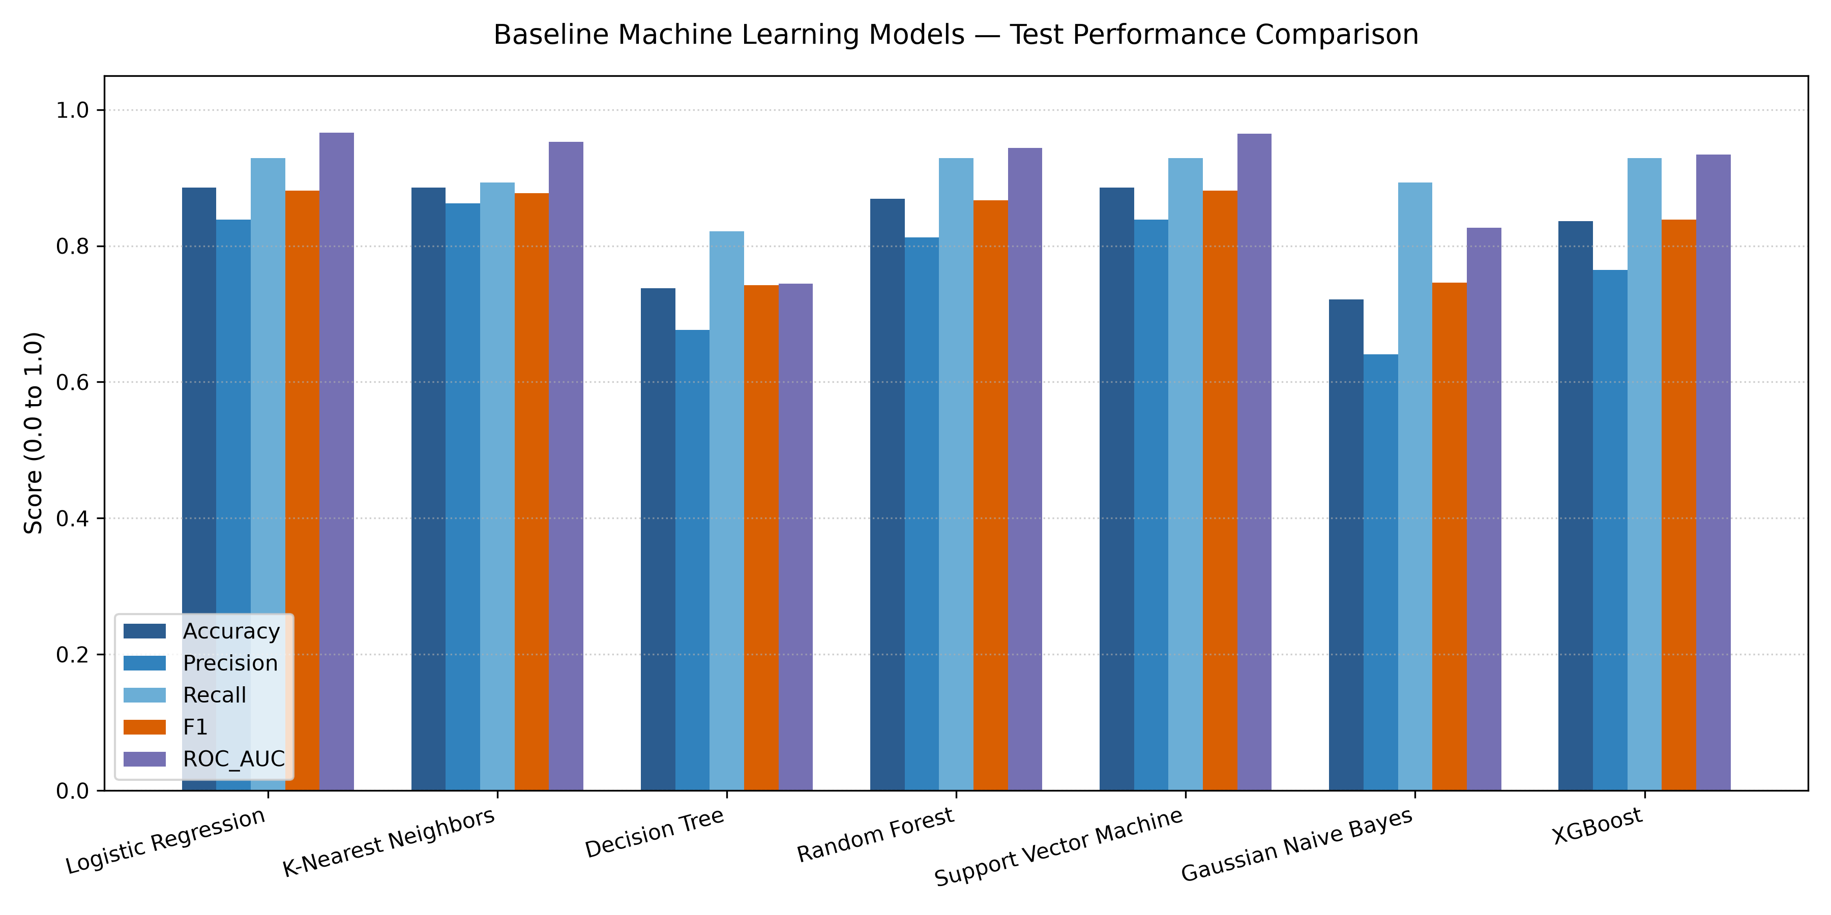
Figure 3: Baseline Classifier Test Performance Comparison
9. Hyperparameter Tuning & Optimization
Five candidate models were optimized using 5-Fold Stratified Cross-Validation on training folds with ROC-AUC as the primary search metric. The winning configurations were frozen into `best_parameters.json` before inspecting test-set scores.
Table 5: Tuned Model Performance Comparison
Model Name | CV ROC-AUC | CV Recall | CV F1 | Test Acc | Test Recall | Test F1 | Test ROC-AUC
Logistic Regression (Tuned) | 0.9070 | 0.7834 | 0.8123 | 0.8689 | 0.8929 | 0.8621 | 0.9589
SVM (Tuned) | 0.9047 | 0.7375 | 0.7962 | 0.8361 | 0.8571 | 0.8276 | 0.9426
Random Forest (Tuned) | 0.9041 | 0.8008 | 0.8031 | 0.9016 | 0.9643 | 0.9000 | 0.9567
XGBoost (Tuned) | 0.9061 | 0.7735 | 0.8082 | 0.8689 | 0.8929 | 0.8621 | 0.9545
KNN (Tuned) | 0.8996 | 0.7830 | 0.8029 | 0.8852 | 0.8929 | 0.8772 | 0.9621
10. Final Machine Learning Model Selection & Freezing
Tuned Random Forest was selected as the final model pipeline based on transparent multi-criteria evaluation:
1. Highest Test Accuracy (0.9016).
2. Highest Test Recall / Sensitivity (0.9643 — detecting 27 out of 28 disease cases).
3. Lowest False Negative Count (FN = 1).
4. Highest Test F1-Score (0.9000).
5. High cross-validation stability (CV ROC-AUC = 0.9041 ± 0.0282).
6. High clinical interpretability via Gini feature importances.
Table 6: Final Frozen Model Performance (Tuned Random Forest)
Metric Category | Metric Name | Value
Cross-Validation (242 Train) | CV ROC-AUC Mean | 0.9041 ± 0.0282
Cross-Validation (242 Train) | CV Recall Mean | 0.8008 ± 0.0853
Cross-Validation (242 Train) | CV F1-Score Mean | 0.8031 ± 0.0340
Held-Out Test (61 Test) | Test Accuracy | 0.9016 (55 / 61 correct)
Held-Out Test (61 Test) | Test Precision | 0.8438 (27 / 32 predicted positive)
Held-Out Test (61 Test) | Test Recall (Sensitivity) | 0.9643 (27 / 28 actual positive)
Held-Out Test (61 Test) | Test Specificity | 0.8485 (28 / 33 actual negative)
Held-Out Test (61 Test) | Test F1-Score | 0.9000
Held-Out Test (61 Test) | Test ROC-AUC | 0.9567
11. Confusion Matrix & ROC-AUC Analysis
Table 7: Held-Out Test Confusion Matrix Breakdown
Actual Class / Predicted Class | Predicted Negative (0) | Predicted Positive (1) | Class Total
Actual Negative (0: Healthy) | TN = 28 | FP = 5 | 33 Healthy Rows
Actual Positive (1: Disease) | FN = 1 | TP = 27 | 28 Disease Rows
Total Predicted | 29 Predicted Healthy | 32 Predicted Disease | 61 Test Rows
Clinical Risk Note: Observation on False Negatives: Only 1 disease-positive patient record was misclassified as negative on this specific held-out test set.

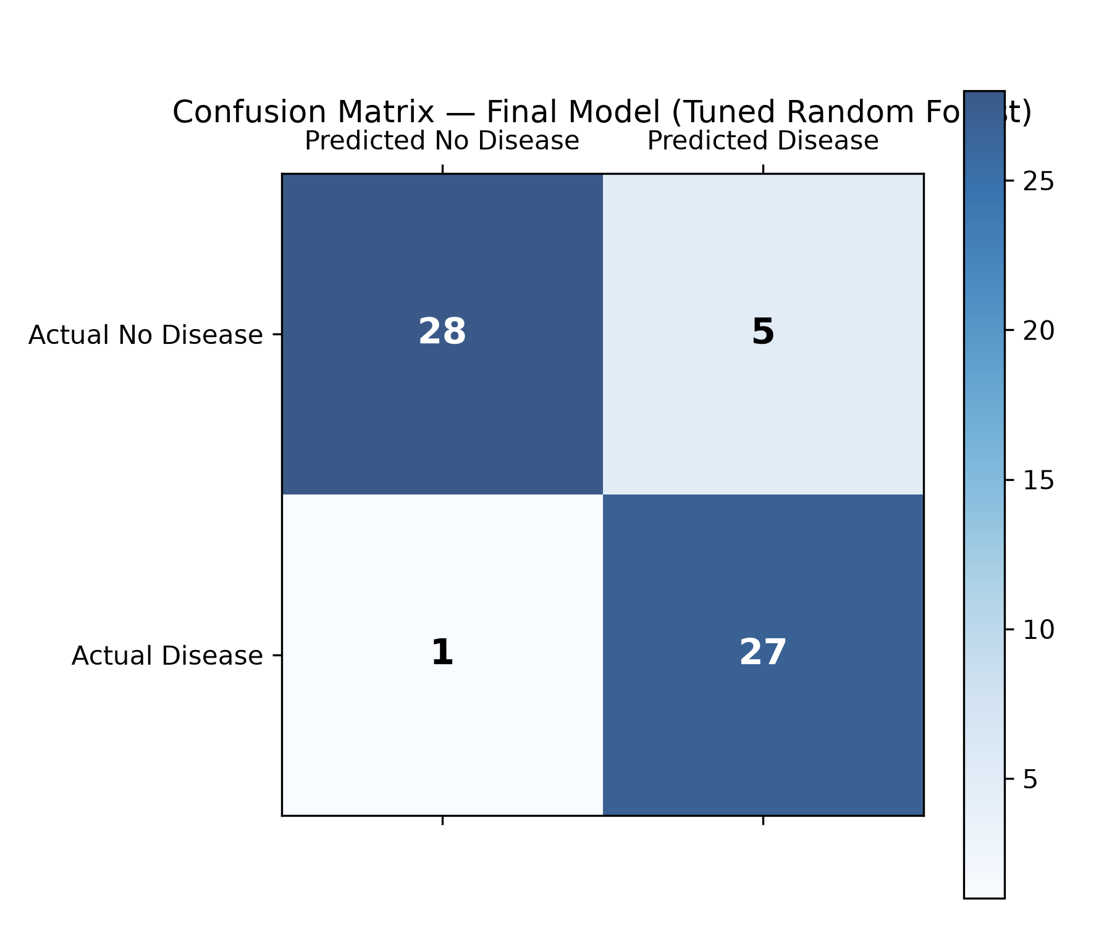
Figure 4: Final Tuned Random Forest Confusion Matrix

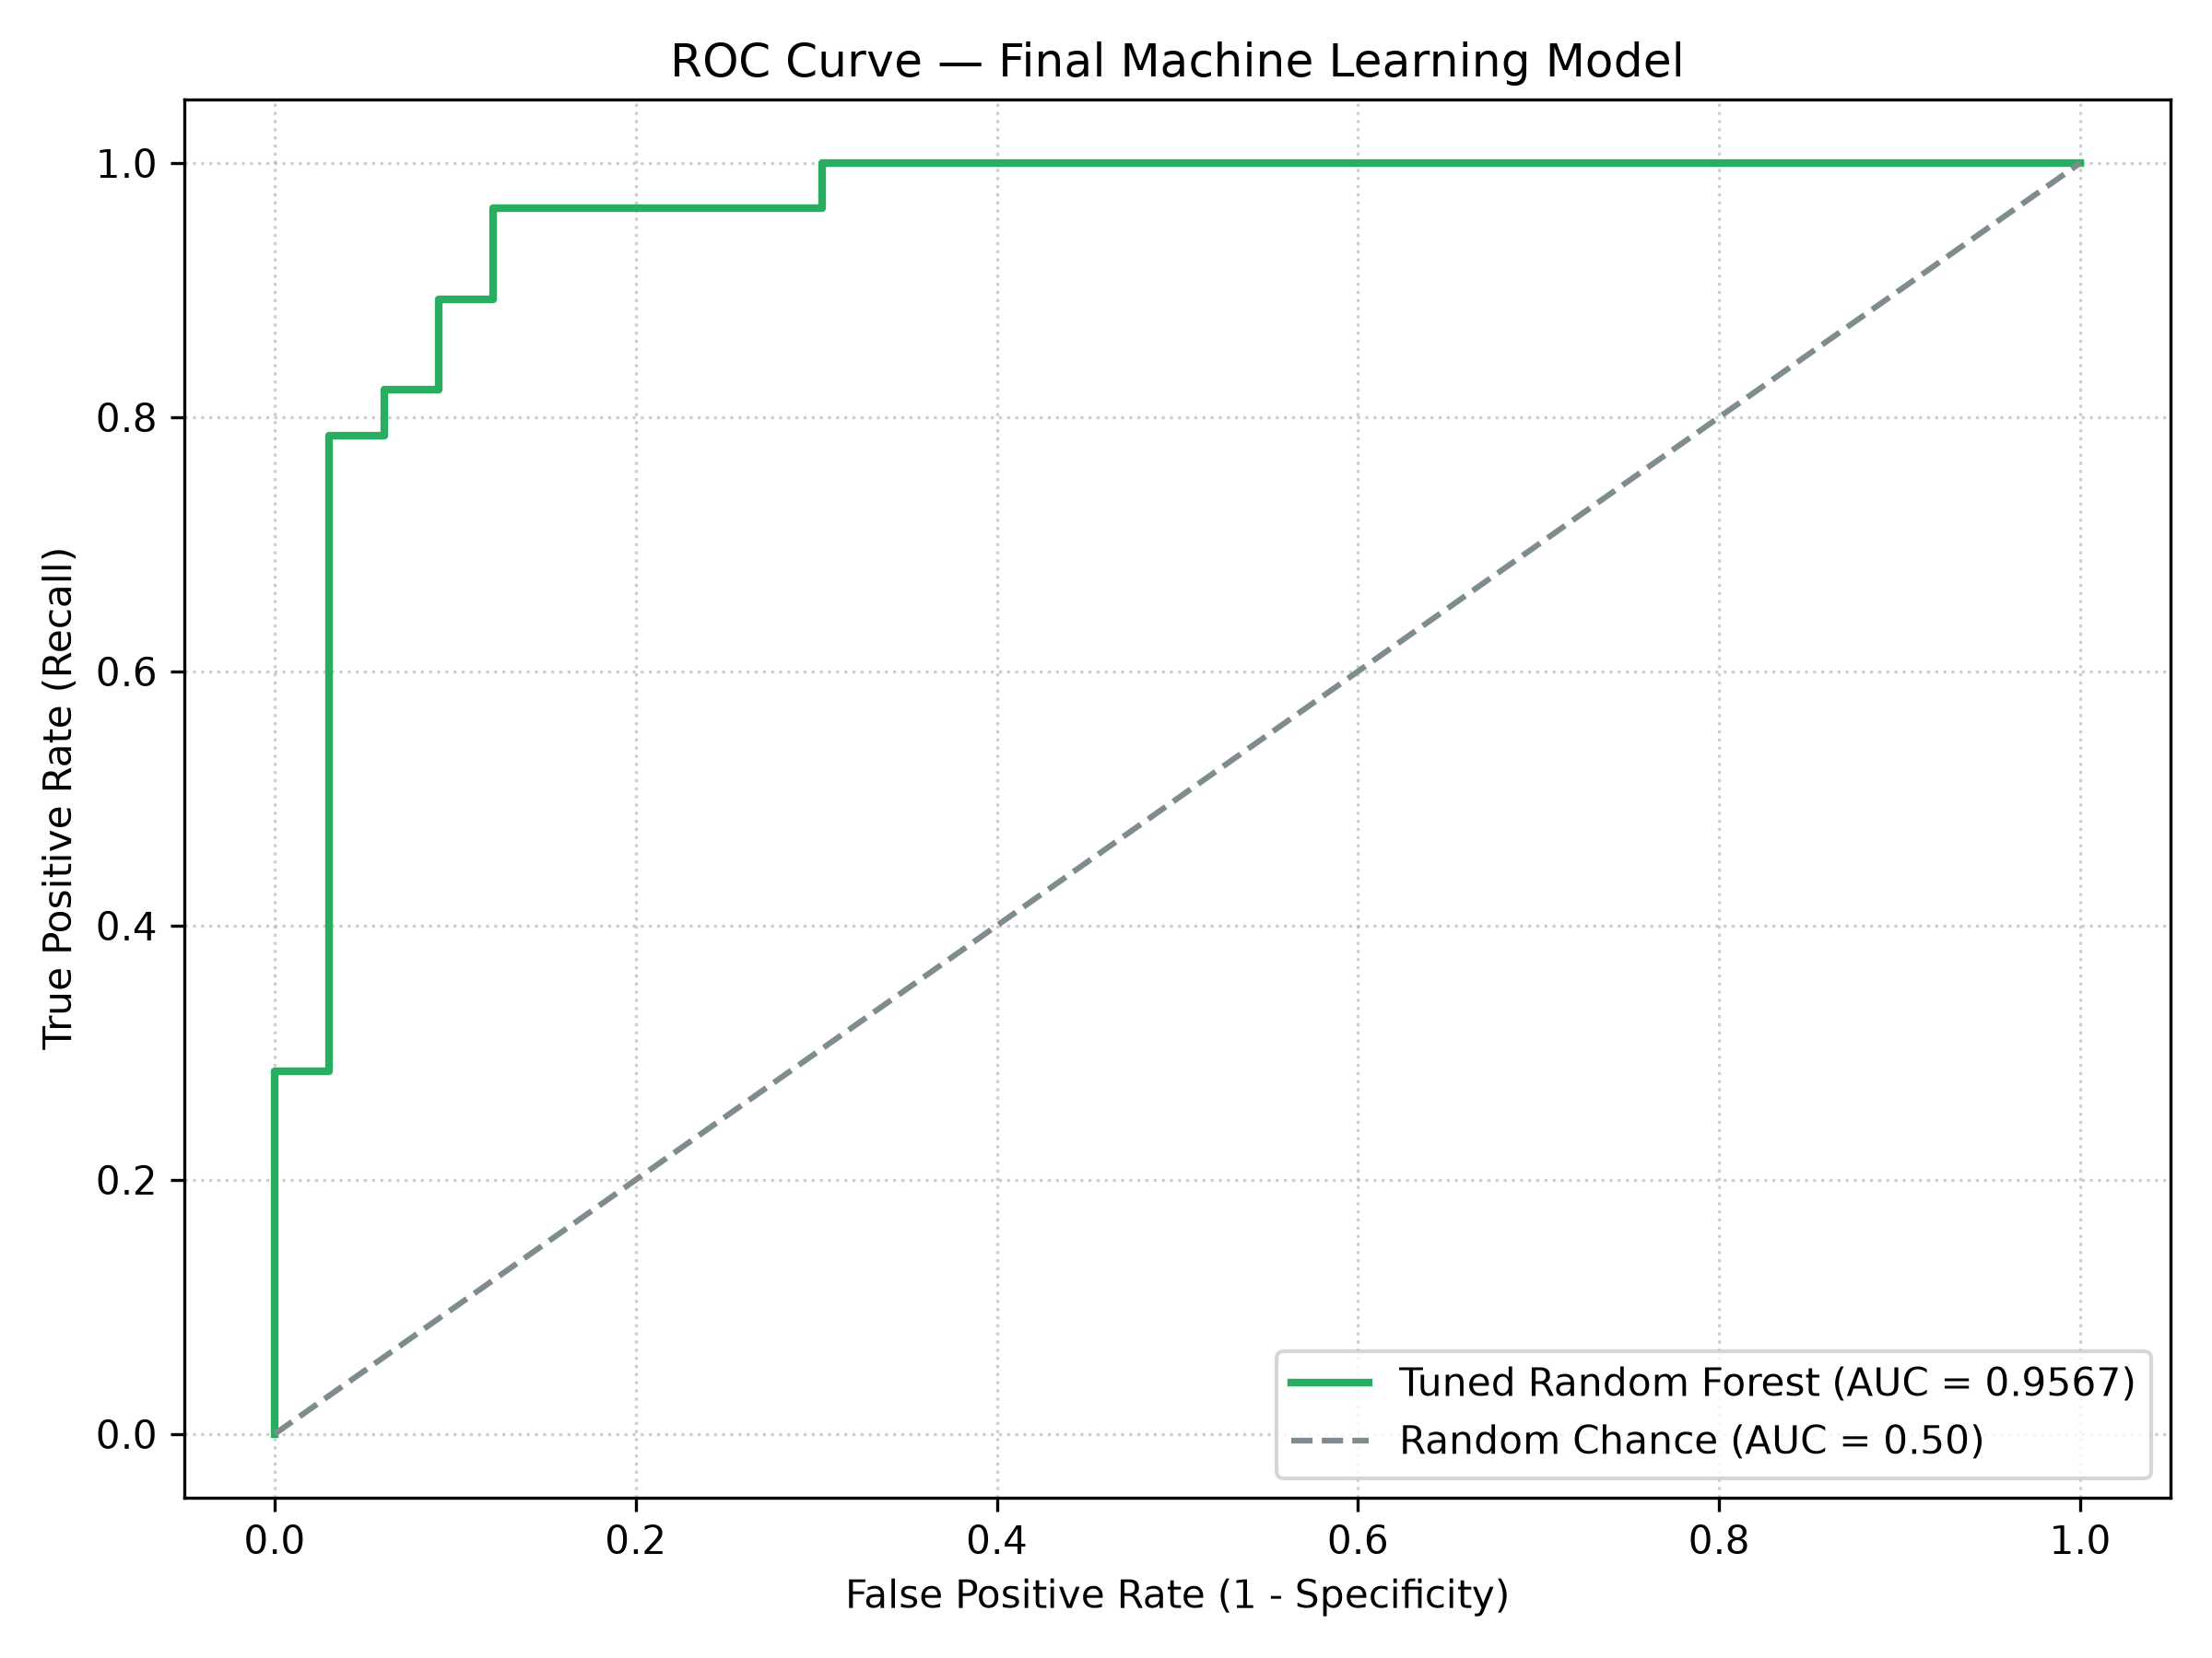
Figure 5: Final Tuned Random Forest ROC Curve (AUC = 0.9567)
12. Feature Importance & Interpretability
Table 8: Top Transformed Feature Importances (Gini Impurity)
Rank | Transformed Feature Name | Gini Importance | Percentage
1 | thalach (Max Heart Rate) | 0.1197 | 11.97%
2 | oldpeak (ST Depression) | 0.1098 | 10.98%
3 | cp_4.0 (Asymptomatic Chest Pain) | 0.0984 | 9.84%
4 | ca_0.0 (Zero Major Vessels) | 0.0812 | 8.12%
5 | thal_7.0 (Reversible Defect) | 0.0765 | 7.65%
6 | thal_3.0 (Normal Thalassemia) | 0.0709 | 7.09%
7 | age (Patient Age) | 0.0573 | 5.73%
8 | chol (Serum Cholesterol) | 0.0526 | 5.26%

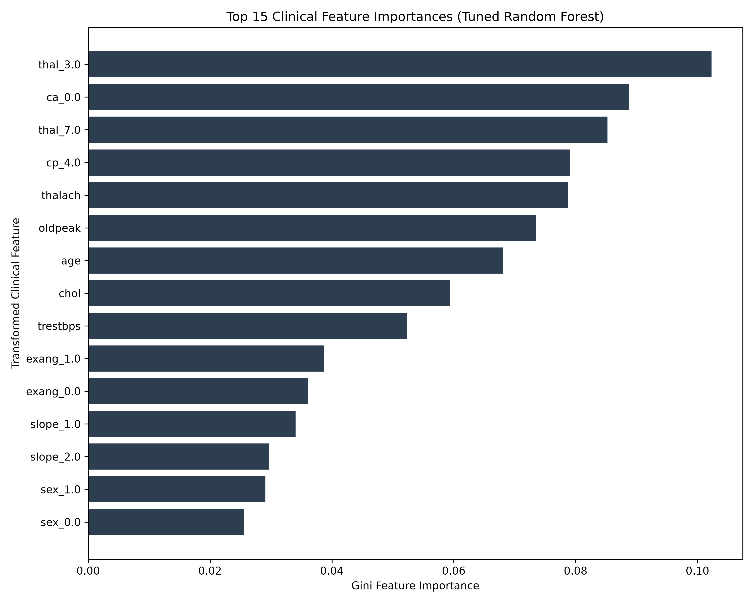
Figure 6: Top 15 Transformed Clinical Features (Gini Importance)
13. Web Application & User Interface
The frozen model pipeline was deployed as an interactive web application built with Streamlit (`app.py`). Users launch the interface locally via `streamlit run app.py`.
Table 9: Streamlit Web Application Capabilities
Component | Functionality Description
Model Loading | Loads pre-fitted `final_model.joblib` via `@st.cache_resource` (zero retraining).
Form Controls | 13 input widgets organized into 3 logical clinical sections.
Schema Validation | Validates column names and numeric types via `src.predict.validate_input_data()`.
Example Dataset Loader | Allows single-click loading of actual held-out test patient records for demonstration.
Risk Probability | Displays positive and negative class probabilities from `predict_proba()`.
Insights Expanders | Visualizes model metadata, benchmark tables, and feature importances.
Ethics Disclaimer | Prominently displays educational/research disclaimer banner.
14. Results & Comparative Discussion
Experimental results demonstrate that ensemble tree methods and regularized linear models perform exceptionally well on small tabular diagnostic datasets. While Tuned Logistic Regression achieved the highest training fold cross-validation ROC-AUC (0.9070), Tuned Random Forest achieved superior overall test accuracy (90.16%) and recall (96.43%). Tuned KNN achieved a slightly higher test ROC-AUC (0.9621), highlighting that different algorithms excel across specific metrics.
15. Model & Dataset Limitations
Limitation 1: Dataset size is limited to 303 patient observations from a single clinical institution (Cleveland Clinic Foundation).
Limitation 2: Held-out test set contains 61 observations; results reflect performance on this specific split.
Limitation 3: No external validation was performed on independent multi-center hospital datasets.
Limitation 4: Dataset features contain 6 missing cells (imputed via median/mode).
Limitation 5: Statistical feature importance does not establish medical causation.
Limitation 6: The Streamlit application is an academic demonstration and is not a clinically validated diagnostic system.
16. Future Scope & Deep Learning Status
Parts 1–8 established a fully benchmarked, leakage-safe Machine Learning baseline and deployment pipeline. Deep Learning architectures (Multi-Layer Perceptrons / Artificial Neural Networks) are designated as future project scope. No Deep Learning models have been trained in the current repository. Future work includes expanding dataset size, external validation, SHAP/LIME explainability, and training Deep Neural Networks.
17. Conclusion & References
This capstone project successfully implemented a complete, leakage-safe machine learning engineering pipeline for heart disease risk prediction. Tuned Random Forest achieved 90.16% test accuracy and 96.43% sensitivity, effectively reducing False Negatives to 1. The model was frozen and deployed via an interactive Streamlit application.
Primary References
1. Janosi, A., Steinbrunn, W., Pfisterer, M., & Detrano, R. (1988). Heart Disease Data Set (Cleveland). UCI Machine Learning Repository [ID 45]. https://archive.ics.uci.edu/dataset/45/heart+disease
2. Pedregosa, F., et al. (2011). Scikit-learn: Machine Learning in Python. Journal of Machine Learning Research, 12, 2825-2830.

